Ebyte LoRa E22 device for Arduino, esp32 or esp8266: specs and basic use – 1

BY [RENZO MISCHIANTI](https://mischianti.org/author/reef/) · PUBLISHED 25 SEPTEMBER 2020 · UPDATED 16 JUNE 2023

**Spread the love**

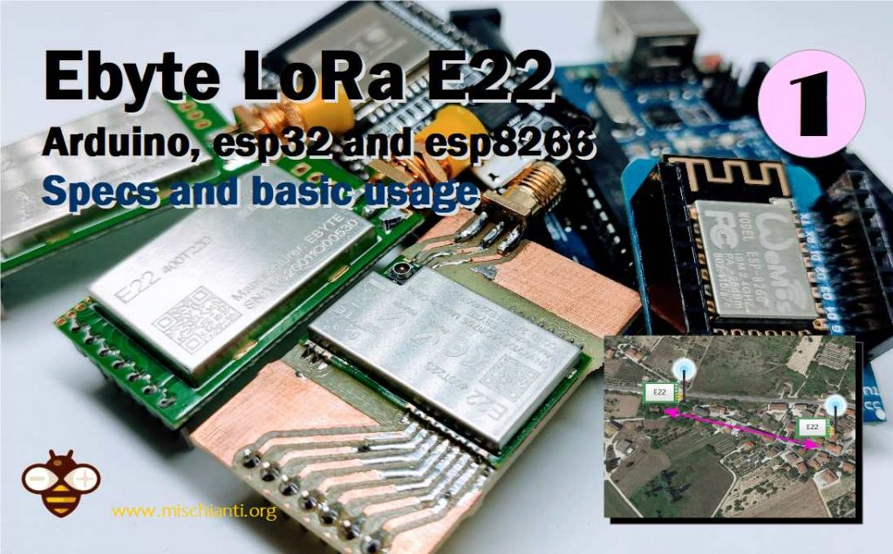

Ebyte LoRa E22 device for Arduino, esp32 or esp8266 specs basic usage

**LoRa or Long Range wireless data telemetry** is a technology pioneered by Semtech that operates at a lower frequency than NRF24L01 (433 MHz, 868 MHz, or 916 MHz against 2.4 GHz for the NRF24L01) but at thrice the distance (from 4000m to 10000m).

[Support Forum](https://mischianti.org/forums/forum/mischiantis-libraries/ebyte-lora-e22-uart-devices-sx1262-sx1268/)

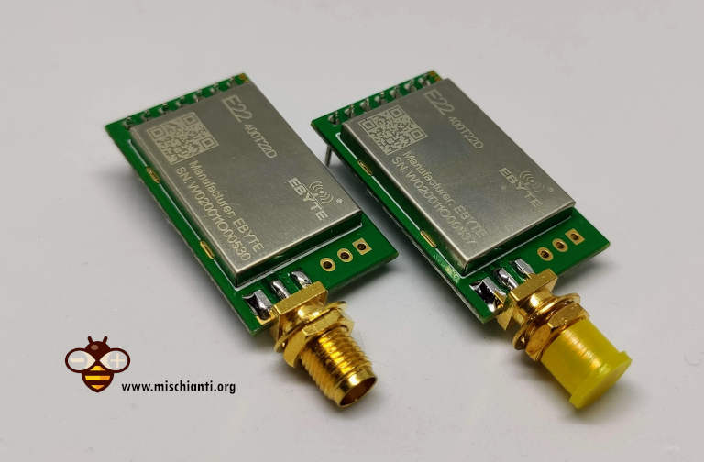Ebyte LoRa E22 device for Arduino, esp32 or esp8266 2 devices

You can find here [AliExpress (433MHz 5.5Km)](https://s.click.aliexpress.com/e/_DlLGLbF) - [AliExpress (433MHz 10Km)](https://s.click.aliexpress.com/e/_DCGzJIt) - [AliExpress (868MHz 915Mhz 5.5Km)](https://s.click.aliexpress.com/e/_DczWHrb) - [AliExpress (868MHz 915Mhz 10Km)](https://s.click.aliexpress.com/e/_DeoQrNn)

**We are going to test E22-400T22D and E22-400T22S**. It is a wireless transceiver module, operates at 410 493 MHz based on original RFIC SX1268 from SEMTECH, transparent transmission is available, TTL level. The module adopts LORA spread spectrum technology.

Like the little brother e22 the module features **FEC Forward Error Correction algorithm**, which ensure its **high coding efficiency & good correction performance**. In the case of sudden interference, it can correct the interfered data packets automatically, so that the reliability and transmission range are improved correspondingly. **But without FEC, those da te packets can only be dropped**.  
And with the rigorous encryption & decryption, data interception becomes pointless. The function of **data compression can decrease the transmission time** & probability of being interference, while improving the reliability & transmission efficiency.

[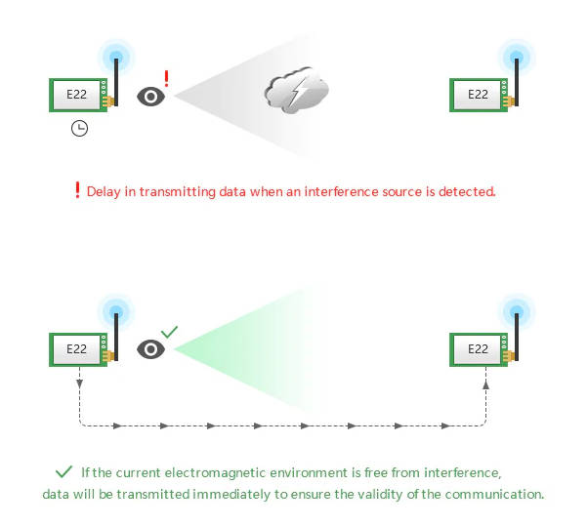](https://mischianti.org/wp-content/uploads/2020/07/Ebyte-LoRa-E22-device-for-Arduino-esp32-or-esp8266-carrier-sense.jpg)Ebyte LoRa E22 device for Arduino, esp32 or esp8266 carrier sense

But more than e22 this module have a **carrier sense** features, that wait transmission if there are some air interference, can be used like a **repeater**, have **watchdog** that if there is an error device restart and continue working, have **deep sleep** for better power saving, and first the sx1268 with **less power grant more power**.

[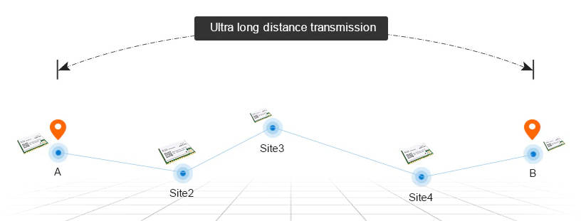](https://mischianti.org/wp-content/uploads/2020/07/Ebyte-LoRa-E22-device-repeater-relay-function-ultra-long-distance.jpg)Ebyte LoRa E22 device repeater relay function ultra long distance

**Remotely configure** or read wireless module parameters by sending command packets wirelessly.

And finally have an important features the **RSSI**, you can check the signal strenght on all message sended.

[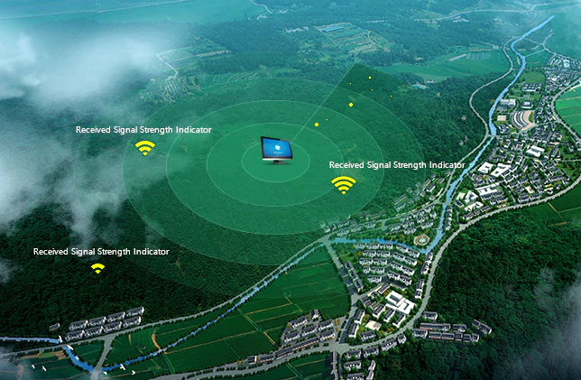](https://mischianti.org/wp-content/uploads/2020/07/Ebyte-LoRa-E22-device-for-Arduino-esp32-or-esp8266-RSSI-signal-strength.jpg)Ebyte LoRa E22 device for Arduino, esp32 or esp8266 RSSI signal strength

* [Operating and transmission type](https://mischianti.org/ebyte-lora-e22-device-for-arduino-esp32-or-esp8266-specs-and-basic-usage-1/#Operating_and_transmission_type)
  + [Transmission](https://mischianti.org/ebyte-lora-e22-device-for-arduino-esp32-or-esp8266-specs-and-basic-usage-1/#Transmission)
    - [Transparent transmission](https://mischianti.org/ebyte-lora-e22-device-for-arduino-esp32-or-esp8266-specs-and-basic-usage-1/#Transparent_transmission)
    - [Fixed transmission](https://mischianti.org/ebyte-lora-e22-device-for-arduino-esp32-or-esp8266-specs-and-basic-usage-1/#Fixed_transmission)
  + [Normal mode](https://mischianti.org/ebyte-lora-e22-device-for-arduino-esp32-or-esp8266-specs-and-basic-usage-1/#Normal_mode)
  + [Wake-up mode and power-saving mode](https://mischianti.org/ebyte-lora-e22-device-for-arduino-esp32-or-esp8266-specs-and-basic-usage-1/#Wake-up_mode_and_power-saving_mode)
  + [Program/sleep mode](https://mischianti.org/ebyte-lora-e22-device-for-arduino-esp32-or-esp8266-specs-and-basic-usage-1/#Programsleep_mode)
* [Specifications](https://mischianti.org/ebyte-lora-e22-device-for-arduino-esp32-or-esp8266-specs-and-basic-usage-1/#Specifications)
* [Pinout](https://mischianti.org/ebyte-lora-e22-device-for-arduino-esp32-or-esp8266-specs-and-basic-usage-1/#Pinout)
* [Normal mode connection](https://mischianti.org/ebyte-lora-e22-device-for-arduino-esp32-or-esp8266-specs-and-basic-usage-1/#Normal_mode_connection)
  + [Connecting Wemos D1 mini (esp8266) for a basic usage](https://mischianti.org/ebyte-lora-e22-device-for-arduino-esp32-or-esp8266-specs-and-basic-usage-1/#Connecting_Wemos_D1_mini_esp8266_for_a_basic_usage)
  + [Connecting esp32 for a basic usage](https://mischianti.org/ebyte-lora-e22-device-for-arduino-esp32-or-esp8266-specs-and-basic-usage-1/#Connecting_esp32_for_a_basic_usage)
  + [Connecting Arduino MKR for a basic usage](https://mischianti.org/ebyte-lora-e22-device-for-arduino-esp32-or-esp8266-specs-and-basic-usage-1/#Connecting_Arduino_MKR_for_a_basic_usage)
  + [Connecting Arduino for a basic usage](https://mischianti.org/ebyte-lora-e22-device-for-arduino-esp32-or-esp8266-specs-and-basic-usage-1/#Connecting_Arduino_for_a_basic_usage)
* [Simple communication sketch](https://mischianti.org/ebyte-lora-e22-device-for-arduino-esp32-or-esp8266-specs-and-basic-usage-1/#Simple_communication_sketch)
  + [Arduino sketch](https://mischianti.org/ebyte-lora-e22-device-for-arduino-esp32-or-esp8266-specs-and-basic-usage-1/#Arduino_sketch)
  + [Wemos D1 mini sketch](https://mischianti.org/ebyte-lora-e22-device-for-arduino-esp32-or-esp8266-specs-and-basic-usage-1/#Wemos_D1_mini_sketch)
  + [esp32 sketch](https://mischianti.org/ebyte-lora-e22-device-for-arduino-esp32-or-esp8266-specs-and-basic-usage-1/#esp32_sketch)
  + [Arduino MKR sketch](https://mischianti.org/ebyte-lora-e22-device-for-arduino-esp32-or-esp8266-specs-and-basic-usage-1/#Arduino_MKR_sketch)
* [Library](https://mischianti.org/ebyte-lora-e22-device-for-arduino-esp32-or-esp8266-specs-and-basic-usage-1/#Library)
  + [Arduino sketch](https://mischianti.org/ebyte-lora-e22-device-for-arduino-esp32-or-esp8266-specs-and-basic-usage-1/#Arduino_sketch-2)
  + [Wemos D1 (esp8266) sketch](https://mischianti.org/ebyte-lora-e22-device-for-arduino-esp32-or-esp8266-specs-and-basic-usage-1/#Wemos_D1_esp8266_sketch)
  + [esp32 sketch](https://mischianti.org/ebyte-lora-e22-device-for-arduino-esp32-or-esp8266-specs-and-basic-usage-1/#esp32_sketch-2)
  + [Arduino MKR sketch](https://mischianti.org/ebyte-lora-e22-device-for-arduino-esp32-or-esp8266-specs-and-basic-usage-1/#Arduino_MKR_sketch-2)
* [Thanks](https://mischianti.org/ebyte-lora-e22-device-for-arduino-esp32-or-esp8266-specs-and-basic-usage-1/#Thanks)

Operating and transmission type

This device have some interesting function:

Transmission

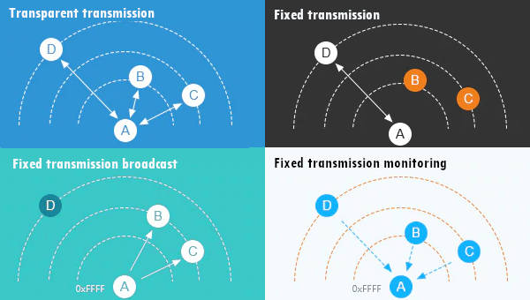LoRa E22 transmitting scenarios

Transparent transmission

This can be considered like a “Demo mode”, by default you can send message to all device of same configured address and channel.

Fixed transmission

This type of transmission you can specify an address and a channel where where you want send the message.  
You can send message to a:

* Specified device with a predeterminated Address Low, Address High and Channel.

[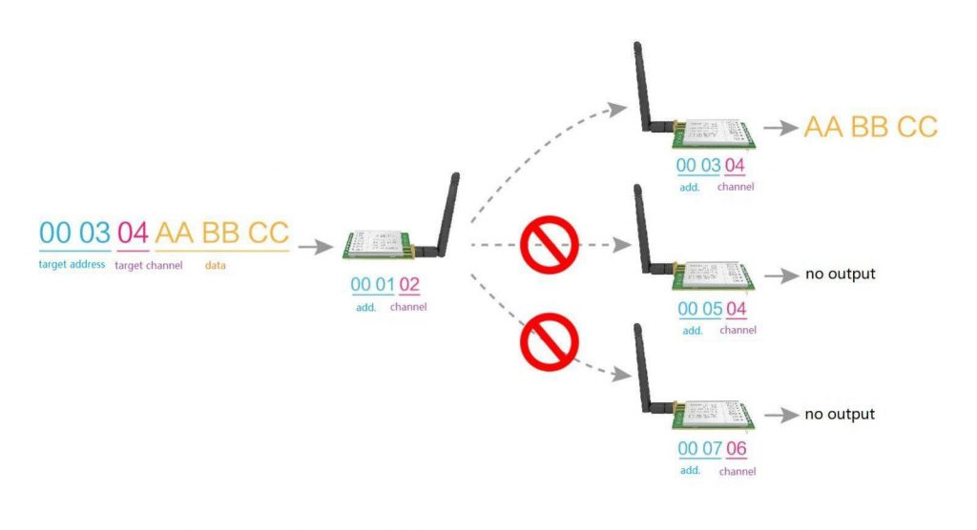](https://mischianti.org/wp-content/uploads/2019/10/fixedMessageToASpecifiedDevice.jpg)LoRa E22 Fixed message to a specified device

* Broadcast a message on predeterminated Channel.

[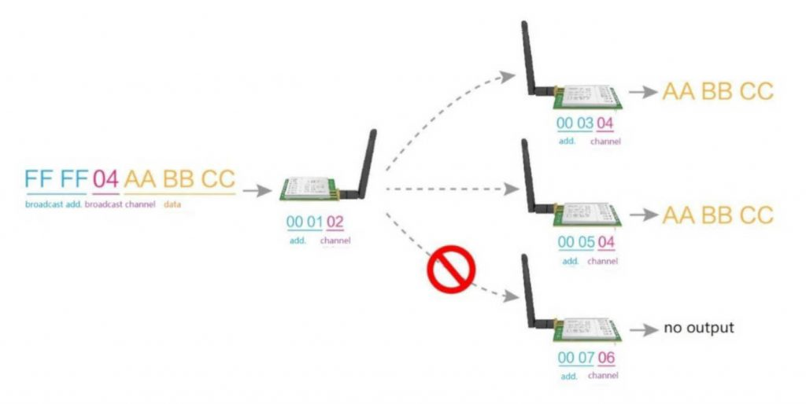](https://mischianti.org/wp-content/uploads/2019/10/broadcastMessageToASpecifiedChannelDevice.jpg)Broadcast message to a set of channel devices

Normal mode

Simply send message.

[](https://www.pcbway.com/?from=mischianti723)

Wake-up mode and power-saving mode

As you can intend if a device is in Wake-up mode can “wake” one or more devices that are in power-saving mode with a preamble communication.

Program/sleep mode

With this configuration you can change configuration of your device.

Specifications

Here’s the specifications for the module:

|  |  |  |  |  |
| --- | --- | --- | --- | --- |
| Main Parameters | Value | | | Remarks |
| Min. | Typical | Max |
| Operating voltage（V） | 2.3 | 5.0 | 5.5 | ≥5.0 V ensures output power |
| Communication level（V） | – | 3.3 | – | For 5V TTL, it may be at risk of burning down |
| Operating temperature（℃） | -40 | – | 85 | Industrial design |
| Operating frequency（MHz） | 410.125 | 433.125 | 493.125 | Support ISM band |
| TX Current(mA) | – | 110 | – | Instant power consumption |
| RX current（mA） | – | 12 | – | – |
| Sleep current（μA） | – | 2 | – | Software is shut down |
| Max Tx power（dBm） | 21.5 | 22.0 | 22.5 | – |
| Receiving sensitivity（dBm） | -146 | -147 | -148 | Air data rate is 0.3 kbps |
| Air data rate（bps） | 0.3k | 2.4k | 62.5k | Controlled via user’s programming |

|  |  |  |
| --- | --- | --- |
| Main parameter | Description | Remarks |
| Distance for reference | 5km | Test condition：clear and open area, antenna gain: 5dBi，antenna height:2.5m，air data rate: 2.4kbps |
| TX length | 240 Byte | Can be configured via command as 32/64/128/240 bytes per packet totransmit |
| Buffer | 1000 Byte | – |
| Modulation | LoRa | New generation LoRa modulation technology |
| Communication interface | UART | TTL level |
| Package | DIP | – |
| Connector | 1*7*2.54mm | – |
| Size | 21*36 mm | – |
| Antenna | SMA | 50 ohm impedance |

* Communication Interface: UART – 8N1, 8E1, 8O1, Eight kinds of UART baud Rate, from 1200 to 115200bps (Default: 9600)

| **Electronic parameter** | **Min.** | **Typ.** | **Max.** | **Unit** | **Condition** |
| --- | --- | --- | --- | --- | --- |
| Power supply | 3.3 | 3.6 | 5.5 | V |  |
| Communication level | 3.0 | 3.3 | 3.6 | V |  |
| Transmitting current | 95 | 100 | 105 | mA | 22dBm（160mW） |
| Receiving current | 6 | 6.5 | 7 | mA |  |
| Sleep current | 1 | 2 | 3 | nA |  |
| Operating temperature | -40 | 20 | +85 | ℃ |  |
| Operating humidity | 10 | 60 | 90 | % |  |
| Storage temperature | -40 | 20 | +125 | ℃ |  |

You must pay attention on communication level that differ from power supply, the second can receive voltage like 3.3v (esp8266 and esp32) and 5v (Arduino), but the first want a 3.3v, so to connecto to an Arduino you must use a Voltage divider ([Voltage divider: calculator and application](https://mischianti.org/voltage-divider-calculator-and-application/)) to prevent damage to the device.

Pinout

[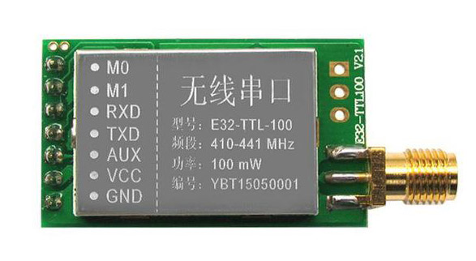](https://mischianti.org/wp-content/uploads/2019/09/ebyte-lora-exx-pinout-1.jpg)sx1278 sx1276 wireless lora uart module serial 3000m arduino 433 rf

| **Pin No.** | **Pin item** | **Pin direction** | **Pin application** |
| --- | --- | --- | --- |
| 1 | M0 | Input（weak pull-up） | Work with M1 & decide the four operating modes.Floating is not allowed, can be ground. |
| 2 | M1 | Input（weak pull-up） | Work with M0 & decide the four operating modes.Floating is not allowed, can be ground. |
| 3 | RXD | Input | TTL UART inputs, connects to external (MCU, PC) TXD outputpin. Can be configured as open-drain or pull-up input. |
| 4 | TXD | Output | TTL UART outputs, connects to external RXD (MCU, PC) input pin. Can be configured as open-drain or push-pull output |
| 5 | AUX | Output | To indicate module’s working status & wakes up the external MCU. During the procedure of self-check initialization, the pin outputs low level. Can be configured as open-drain output orpush-pull output (floating is allowed). |
| 6 | VCC |  | Power supply 2.3V~5.5V DC |
| 7 | GND |  | Ground |

As you can see you can set various modes via M0 and M1 pins.

[](https://www.sunfounder.com/?ref=fz59AUVD)

| **Mode** | **M1** | **M0** | **Explanation** |
| --- | --- | --- | --- |
| Normal | 0 | 0 | UART and wireless channel are open, transparent transmission is on |
| WOR mode | 0 | 1 | Can be defined as WOR transmitter and WOR receiver |
| Configuration mode | 1 | 0 | Users can access the register through the serial port to control the working state of the module |
| Deep sleep mode | 1 | 1 | Sleep mode. |

Normal mode connection

For the next simple test we are going to use Normal mode.

Connecting Wemos D1 mini (esp8266) for a basic usage

esp8266 have the advantage to have same voltage of communication interface so the connection schema is more simple than Arduino.

[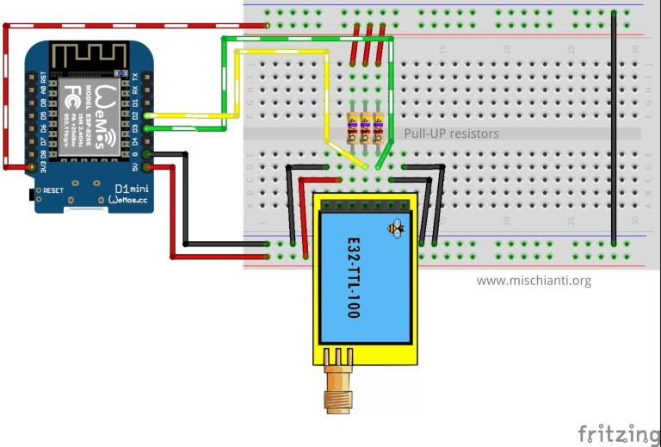](https://mischianti.org/wp-content/uploads/2019/09/LoRa_E32-TTL-100_WemosD1_VD_PU_bb-e1569566707815.jpg)LoRa E22-TTL-100 Wemos D1 breadboard

It’s important to add pull-up resistor (4,7Kohm) to get good stability.

| **E22** | **WeMos** |
| --- | --- |
| M0 | GND (Set normal mode) |
| M1 | GND (Set normal mode) |
| RX | PIN D2 (PullUP 4,7KΩ) |
| TX | PIN D3 (PullUP 4,7KΩ) |
| AUX | Not connected |
| VCC | 3.3v |
| GND | GND |

Connecting esp32 for a basic usage

As WeMos, esp32 logic works at 3.3v but It have 3 HardwareSerial, so we are going to use Serial2.

[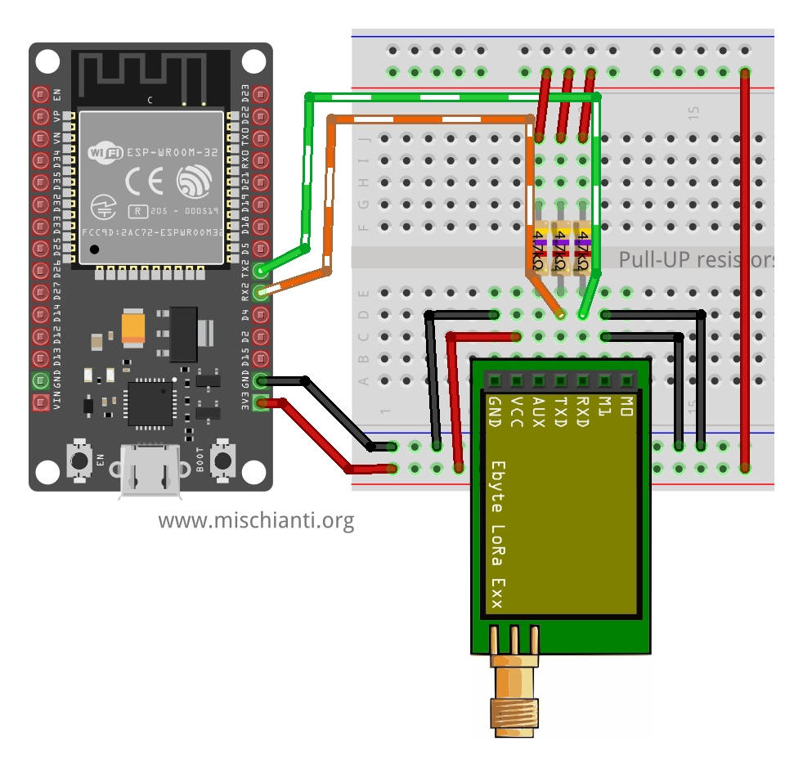](https://mischianti.org/wp-content/uploads/2020/07/Ebyte-LoRa-E22-device-esp32-dev-kit-v1-breadboard-transparent.jpg)Ebyte LoRa E22 device esp32 dev kit v1 breadboard transparent transmission (normal mode)

| **E22** | **esp32** |
| --- | --- |
| M0 | GND (Set normal mode) |
| M1 | GND (Set normal mode) |
| RX | TX2 (PullUP 4,7KΩ) |
| TX | RX2 (PullUP 4,7KΩ) |
| AUX | Not connected |
| VCC | 3.3v |
| GND | GND |

Connecting Arduino MKR for a basic usage

Ebyte LoRa Exx Arduino MKR WiFi 1010 normal mode connected breadboard

| **E22** | **Arduino MKR** |
| --- | --- |
| M0 | GND (Set normal mode) |
| M1 | GND (Set normal mode) |
| TX | PIN 14 Tx (PullUP 4,7KΩ) |
| RX | PIN 13 Rx (PullUP 4,7KΩ) |
| AUX | PIN 1 (PullUP 4,7KΩ) |
| VCC | 5V |
| GND | GND |

Connecting Arduino for a basic usage

Arduino working voltage is 5v, so we need to add a voltage divider on RX pin of LoRa module to prevent damage, you can get more information here [Voltage divider: calculator and application](https://mischianti.org/voltage-divider-calculator-and-application/).

You can use a 2Kohm resistor to GND and 1Kohm from signal than put together on RX.

[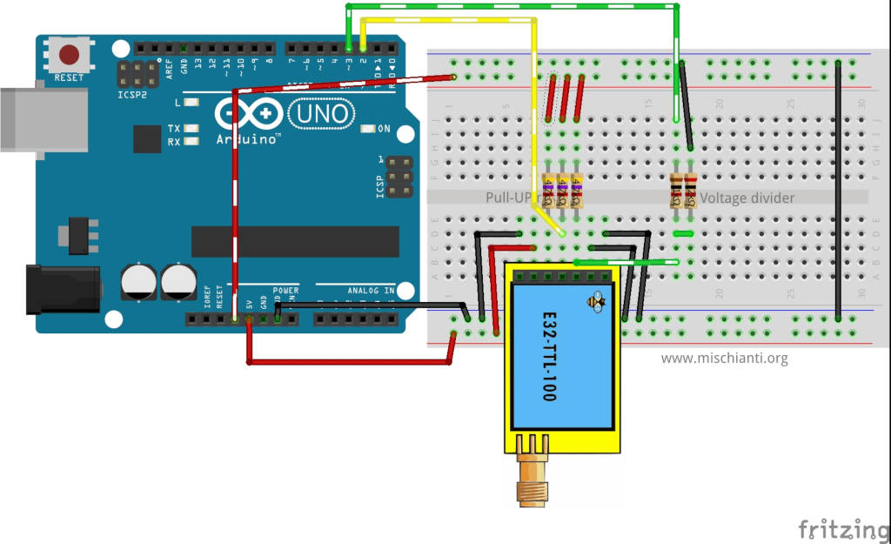](https://mischianti.org/wp-content/uploads/2019/09/LoRa_E32-TTL-100_Arduino_VD_PU_bb-e1569566634311.jpg)LoRa E22-TTL-100 Arduino breadboard

| **E22** | **Arduino** |
| --- | --- |
| M0 | GND (Set normal mode) |
| M1 | GND (Set normal mode) |
| RX | PIN D2 (PullUP 4,7KΩ & Voltage divider) |
| TX | PIN D3 (PullUP 4,7KΩ) |
| AUX | Not connected |
| VCC | 3.3v |
| GND | GND |

Simple communication sketch

If you put to 0 M1 and M0 pin you enter in “Normal” mode, than you can receive and trasmit all the data from device A to B, this modality is defined “Trasparent transmission”.

**You can use 2 Arduinos or 2 Wemos D1 mini or one of kind.**

At start send a message and if you write on serial from one of device the text is transferred to the other device. You can use 2 Arduinos or 2 Wemos or one and one as you prefer.

Arduino sketch

|  |  |
| --- | --- |
| 1  2  3  4  5  6  7  8  9  10  11  12  13  14  15  16  17  18  19  20  21  22  23  24  25  26  27  28  29  30  31  32  33  34  35  36  37  38  39 | /*   * LoRa E22   * Start device or reset to send a message   * [https://mischianti.org](https://mischianti.org/)   *   * E22        ----- Arduino UNO   * M0         ----- GND   * M1         ----- GND   * TX         ----- PIN 2 (PullUP)   * RX         ----- PIN 3 (PullUP & Voltage divider)   * AUX        ----- Not connected   * VCC        ----- 3.3v/5v   * GND        ----- GND   *   */  #include "Arduino.h"    #include <SoftwareSerial.h>    SoftwareSerial mySerial(2, 3); // Arduino RX --> e22 TX - Arduino TX --> e22 RX    **void** setup() {    Serial.begin(9600);    delay(500);      Serial.println("Hi, I'm going to send message!");      mySerial.begin(9600);    mySerial.println("Hello, world?");  }    **void** loop() {  **if** (mySerial.available()) {      Serial.write(mySerial.read());    }  **if** (Serial.available()) {      mySerial.write(Serial.read());    }  } |

Wemos D1 mini sketch

|  |  |
| --- | --- |
| 1  2  3  4  5  6  7  8  9  10  11  12  13  14  15  16  17  18  19  20  21  22  23  24  25  26  27  28  29  30  31  32  33  34  35  36  37  38 | /*   * LoRa E22   * Start device or reset to send a message   * [https://mischianti.org](https://mischianti.org/)   *   * E22         ----- Wemos D1 mini   * M0         ----- GND   * M1         ----- GND   * TX         ----- PIN D2 (PullUP)   * RX         ----- PIN D3 (PullUP)   * AUX        ----- Not connected   * VCC        ----- 3.3v/5v   * GND        ----- GND   *   */  #include "Arduino.h"  #include <SoftwareSerial.h>    SoftwareSerial mySerial(D2, D3); // WeMos RX --> e22 TX - WeMos TX --> e22 RX    **void** setup() {    Serial.begin(9600);    delay(500);      Serial.println("Hi, I'm going to send message!");      mySerial.begin(9600);    mySerial.println("Hello, world?");  }    **void** loop() {  **if** (mySerial.available()) {      Serial.write(mySerial.read());    }  **if** (Serial.available()) {      mySerial.write(Serial.read());    }  } |

esp32 sketch

|  |  |
| --- | --- |
| 1  2  3  4  5  6  7  8  9  10  11  12  13  14  15  16  17  18  19  20  21  22  23  24  25  26  27  28  29  30  31  32  33  34  35 | /*   * LoRa E22   * Start device or reset to send a message   * [https://mischianti.org](https://mischianti.org/)   *   * E22        ----- esp32   * M0         ----- GND   * M1         ----- GND   * TX         ----- RX2 (PullUP)   * RX         ----- TX2 (PullUP)   * AUX        ----- Not connected   * VCC        ----- 3.3v/5v   * GND        ----- GND   *   */  #include "Arduino.h"    **void** setup() {    Serial.begin(9600);    delay(500);      Serial.println("Hi, I'm going to send message!");      Serial2.begin(9600);    Serial2.println("Hello, world?");  }    **void** loop() {  **if** (Serial2.available()) {      Serial.write(Serial2.read());    }  **if** (Serial.available()) {      Serial2.write(Serial.read());    }  } |

Arduino MKR sketch

|  |  |
| --- | --- |
| 1  2  3  4  5  6  7  8  9  10  11  12  13  14  15  16  17  18  19  20  21  22  23  24  25  26  27  28  29  30  31  32  33  34  35 | /*   * LoRa E22   * Start device or reset to send a message   * [https://mischianti.org](https://mischianti.org/)   *   * E22        ----- Arduino MKR   * M0         ----- 2 (or GND)   * M1         ----- 3 (or GND)   * RX         ----- 14 (PullUP)   * TX         ----- 13 (PullUP)   * AUX        ----- 1  (PullUP)   * VCC        ----- 3.3v/5v   * GND        ----- GND   *   */  #include "Arduino.h"    **void** **setup**() {    Serial.begin(9600);    delay(500);      Serial.println("Hi, I'm going to send message!");      Serial1.begin(9600);    Serial1.println("Hello, world?");  }    **void** **loop**() {  **if** (Serial1.available()) {      Serial.write(Serial1.read());    }  **if** (Serial.available()) {      Serial1.write(Serial.read());    }  } |

But this basic usage is quite unusefully, so in the next chapter we are going to use my library and go in deep of device features.

Library

EByte LoRa E22 E32 Arduino library manager

Here the last example with [my library](https://github.com/xreef/LoRa_E32_Series_Library):

Arduino sketch

|  |  |
| --- | --- |
| 1  2  3  4  5  6  7  8  9  10  11  12  13  14  15  16  17  18  19  20  21  22  23  24  25  26  27  28  29  30  31  32  33  34  35  36  37  38  39  40  41  42  43  44  45  46  47  48  49  50  51  52  53 | /*   * LoRa E22   * Write on serial to transfer a message to other device   * [https://mischianti.org](https://mischianti.org/)   *   * E22        ----- Arduino UNO   * M0         ----- GND   * M1         ----- GND   * TX         ----- PIN 2 (PullUP)   * RX         ----- PIN 3 (PullUP & Voltage divider)   * AUX        ----- Not connected   * VCC        ----- 3.3v/5v   * GND        ----- GND   *   */  #include "Arduino.h"  #include "LoRa_E22.h"    LoRa_E22 e22ttl(2, 3); // Arduino RX --> e22 TX - Arduino TX --> e22 RX    **void** setup() {    Serial.begin(9600);    delay(500);      Serial.println("Hi, I'm going to send message!");      // Startup all pins and UART    e22ttl.begin();      // Send message    ResponseStatus rs = e22ttl.sendMessage("Hello, world?");    // Check If there is some problem of successfully send    Serial.println(rs.getResponseDescription());  }    **void** loop() {      // If something available  **if** (e22ttl.available()>1) {        // read the String message      ResponseContainer rc = e22ttl.receiveMessage();      // Is something goes wrong print error  **if** (rc.status.code!=1){          rc.status.getResponseDescription();      }**else**{          // Print the data received          Serial.println(rc.data);      }    }  **if** (Serial.available()) {        String input = Serial.readString();        e22ttl.sendMessage(input);    }  } |

Wemos D1 (esp8266) sketch

|  |  |
| --- | --- |
| 1  2  3  4  5  6  7  8  9  10  11  12  13  14  15  16  17  18  19  20  21  22  23  24  25  26  27  28  29  30  31  32  33  34  35  36  37  38  39  40  41  42  43  44  45  46  47  48  49  50  51  52  53 | /*   * LoRa E22   * Start device or reset to send a message   * [https://mischianti.org](https://mischianti.org/)   *   * E22        ----- Wemos D1 mini   * M0         ----- GND   * M1         ----- GND   * TX         ----- PIN D2 (PullUP)   * RX         ----- PIN D3 (PullUP)   * AUX        ----- Not connected   * VCC        ----- 3.3v/5v   * GND        ----- GND   *   */  #include "Arduino.h"  #include "LoRa_E22.h"    LoRa_E22 e22ttl(D2, D3); // WeMos RX --> e22 TX - WeMos TX --> e22 RX    **void** setup() {    Serial.begin(9600);    delay(500);      Serial.println("Hi, I'm going to send message!");      // Startup all pins and UART    e22ttl.begin();      // Send message    ResponseStatus rs = e22ttl.sendMessage("Hello, world?");    // Check If there is some problem of successfully send    Serial.println(rs.getResponseDescription());  }    **void** loop() {      // If something available  **if** (e22ttl.available()>1) {        // read the String message      ResponseContainer rc = e22ttl.receiveMessage();      // Is something goes wrong print error  **if** (rc.status.code!=1){          rc.status.getResponseDescription();      }**else**{          // Print the data received          Serial.println(rc.data);      }    }  **if** (Serial.available()) {        String input = Serial.readString();        e22ttl.sendMessage(input);    }  } |

esp32 sketch

|  |  |
| --- | --- |
| 1  2  3  4  5  6  7  8  9  10  11  12  13  14  15  16  17  18  19  20  21  22  23  24  25  26  27  28  29  30  31  32  33  34  35  36  37  38  39  40  41  42  43  44  45  46  47  48  49  50  51  52  53 | /*   * LoRa E22   * Start device or reset to send a message   * [https://mischianti.org](https://mischianti.org/)   *   * E22        ----- esp32   * M0         ----- GND   * M1         ----- GND   * TX         ----- RX2 (PullUP)   * RX         ----- TX2 (PullUP)   * AUX        ----- Not connected   * VCC        ----- 3.3v/5v   * GND        ----- GND   *   */  #include "Arduino.h"  #include "LoRa_E22.h"    LoRa_E22 e22ttl(&Serial2); // WeMos RX --> e22 TX - WeMos TX --> e22 RX    **void** setup() {    Serial.begin(9600);    delay(500);      Serial.println("Hi, I'm going to send message!");      // Startup all pins and UART    e22ttl.begin();      // Send message    ResponseStatus rs = e22ttl.sendMessage("Hello, world?");    // Check If there is some problem of successfully send    Serial.println(rs.getResponseDescription());  }    **void** loop() {      // If something available  **if** (e22ttl.available()>1) {        // read the String message      ResponseContainer rc = e22ttl.receiveMessage();      // Is something goes wrong print error  **if** (rc.status.code!=1){          rc.status.getResponseDescription();      }**else**{          // Print the data received          Serial.println(rc.data);      }    }  **if** (Serial.available()) {        String input = Serial.readString();        e22ttl.sendMessage(input);    }  } |

Arduino MKR sketch

|  |  |
| --- | --- |
| 1  2  3  4  5  6  7  8  9  10  11  12  13  14  15  16  17  18  19  20  21  22  23  24  25  26  27  28  29  30  31  32  33  34  35  36  37  38  39  40  41  42  43  44  45  46  47  48  49  50  51  52  53 | /*   * LoRa E22   * Start device or reset to send a message   * [https://mischianti.org](https://mischianti.org/)   *   * E22        ----- Arduino MKR   * M0         ----- GND   * M1         ----- GND   * RX         ----- 14 (PullUP)   * TX         ----- 13 (PullUP)   * AUX        ----- 1  (PullUP)   * VCC        ----- 3.3v/5v   * GND        ----- GND   *   */  #include "Arduino.h"  #include "LoRa_E22.h"    LoRa_E22 e22ttl(&Serial1); // WeMos RX --> e22 TX - WeMos TX --> e22 RX    **void** setup() {    Serial.begin(9600);    delay(500);      Serial.println("Hi, I'm going to send message!");      // Startup all pins and UART    e22ttl.begin();      // Send message    ResponseStatus rs = e22ttl.sendMessage("Hello, world?");    // Check If there is some problem of successfully send    Serial.println(rs.getResponseDescription());  }    **void** loop() {      // If something available  **if** (e22ttl.available()>1) {        // read the String message      ResponseContainer rc = e22ttl.receiveMessage();      // Is something goes wrong print error  **if** (rc.status.code!=1){          rc.status.getResponseDescription();      }**else**{          // Print the data received          Serial.println(rc.data);      }    }  **if** (Serial.available()) {        String input = Serial.readString();        e22ttl.sendMessage(input);    }  } |

If you have already change configuration you must restore base parameter:

|  |  |
| --- | --- |
| 1  2  3  4  5  6  7  8 | //  If you have ever change configuration you must restore It      ResponseStructContainer c;      c = e22ttl.getConfiguration();      Configuration configuration = *(Configuration*) c.data;      Serial.println(c.status.getResponseDescription());      configuration.CHAN = 0x17;      configuration.OPTION.fixedTransmission = FT_TRANSPARENT_TRANSMISSION;      e22ttl.setConfiguration(configuration, WRITE_CFG_PWR_DWN_SAVE); |

but we are going to see It better in the next article.

Thanks

Ebyte LoRa E22 device for Arduino, esp32 or esp8266: library – 2

BY [RENZO MISCHIANTI](https://mischianti.org/author/reef/) · PUBLISHED 28 JANUARY 2021 · UPDATED 11 FEBRUARY 2024

**Spread the love**

**LoRa or Long Range wireless data telemetry** is a technology pioneered by Semtech that operates at a lower frequency than NRF24L01 (433 MHz, 868 MHz, or 916 MHz against 2.4 GHz for the NRF24L01) but at thrice the distance (from 4000m to 10000m).

[Support Forum](https://mischianti.org/forums/forum/mischiantis-libraries/ebyte-lora-e22-uart-devices-sx1262-sx1268/)

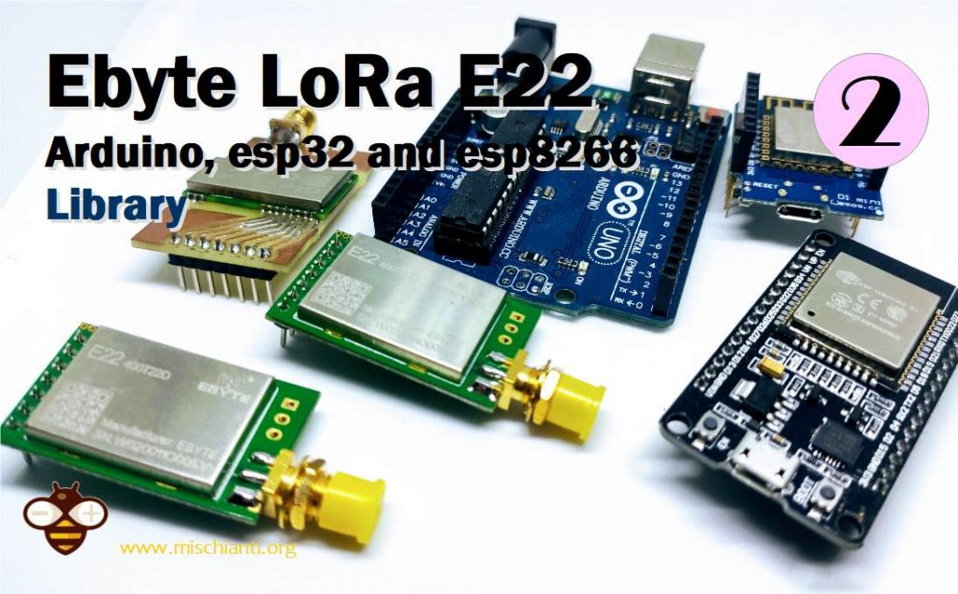

Ebyte LoRa E22 device for Arduino, esp32 or esp8266 Library

I created a library to manage EBYTE E22 based on the Semtech SX1268 series of LoRa devices, a very powerful, simple, and cheap device.

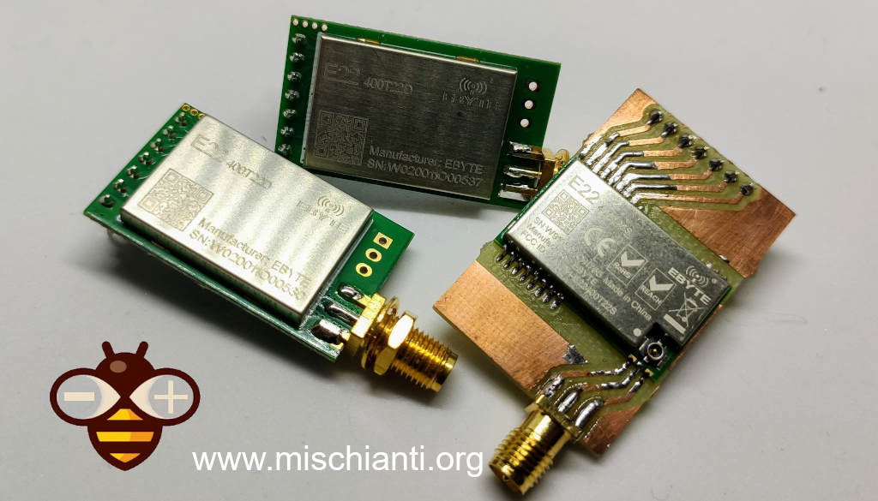Ebyte LoRa E22 device for Arduino, esp32 or esp8266 3 devices module SMD

You can find here [AliExpress (433MHz 5.5Km)](https://s.click.aliexpress.com/e/_DlLGLbF) - [AliExpress (433MHz 10Km)](https://s.click.aliexpress.com/e/_DCGzJIt) - [AliExpress (868MHz 915Mhz 5.5Km)](https://s.click.aliexpress.com/e/_DczWHrb) - [AliExpress (868MHz 915Mhz 10Km)](https://s.click.aliexpress.com/e/_DeoQrNn)

* [Library](https://mischianti.org/ebyte-lora-e22-device-for-arduino-esp32-or-esp8266-library-part-2/#Library)
* [Pinout](https://mischianti.org/ebyte-lora-e22-device-for-arduino-esp32-or-esp8266-library-part-2/#Pinout)
* [Fully connected schema](https://mischianti.org/ebyte-lora-e22-device-for-arduino-esp32-or-esp8266-library-part-2/#Fully_connected_schema)
  + [AUX pin](https://mischianti.org/ebyte-lora-e22-device-for-arduino-esp32-or-esp8266-library-part-2/#AUX_pin)
  + [esp8266](https://mischianti.org/ebyte-lora-e22-device-for-arduino-esp32-or-esp8266-library-part-2/#esp8266)
  + [esp32](https://mischianti.org/ebyte-lora-e22-device-for-arduino-esp32-or-esp8266-library-part-2/#esp32)
  + [Arduino](https://mischianti.org/ebyte-lora-e22-device-for-arduino-esp32-or-esp8266-library-part-2/#Arduino)
  + [Arduino MKR WiFi 1010](https://mischianti.org/ebyte-lora-e22-device-for-arduino-esp32-or-esp8266-library-part-2/#Arduino_MKR_WiFi_1010)
* [Constructor](https://mischianti.org/ebyte-lora-e22-device-for-arduino-esp32-or-esp8266-library-part-2/#Constructor)
* [Begin](https://mischianti.org/ebyte-lora-e22-device-for-arduino-esp32-or-esp8266-library-part-2/#Begin)
* [Configuration and information method](https://mischianti.org/ebyte-lora-e22-device-for-arduino-esp32-or-esp8266-library-part-2/#Configuration_and_information_method)
  + [Response container](https://mischianti.org/ebyte-lora-e22-device-for-arduino-esp32-or-esp8266-library-part-2/#Response_container)
  + [ResponseStatus](https://mischianti.org/ebyte-lora-e22-device-for-arduino-esp32-or-esp8266-library-part-2/#ResponseStatus)
  + [ResponseContainer](https://mischianti.org/ebyte-lora-e22-device-for-arduino-esp32-or-esp8266-library-part-2/#ResponseContainer)
  + [ResponseStructContainer](https://mischianti.org/ebyte-lora-e22-device-for-arduino-esp32-or-esp8266-library-part-2/#ResponseStructContainer)
* [getConfiguration and setConfiguration](https://mischianti.org/ebyte-lora-e22-device-for-arduino-esp32-or-esp8266-library-part-2/#getConfiguration_and_setConfiguration)
  + [Basic configuration option](https://mischianti.org/ebyte-lora-e22-device-for-arduino-esp32-or-esp8266-library-part-2/#Basic_configuration_option)
    - [SPED detail](https://mischianti.org/ebyte-lora-e22-device-for-arduino-esp32-or-esp8266-library-part-2/#SPED_detail)
    - [SPED detail](https://mischianti.org/ebyte-lora-e22-device-for-arduino-esp32-or-esp8266-library-part-2/#SPED_detail-2)
    - [OPTION detail](https://mischianti.org/ebyte-lora-e22-device-for-arduino-esp32-or-esp8266-library-part-2/#OPTION_detail)
      * [Sub packet setting](https://mischianti.org/ebyte-lora-e22-device-for-arduino-esp32-or-esp8266-library-part-2/#Sub_packet_setting)
      * [RSSI Ambient noise enable](https://mischianti.org/ebyte-lora-e22-device-for-arduino-esp32-or-esp8266-library-part-2/#RSSI_Ambient_noise_enable)
      * [Transmission power](https://mischianti.org/ebyte-lora-e22-device-for-arduino-esp32-or-esp8266-library-part-2/#Transmission_power)
    - [TRANSMISSION_MODE Detail](https://mischianti.org/ebyte-lora-e22-device-for-arduino-esp32-or-esp8266-library-part-2/#TRANSMISSION_MODE_Detail)
      * [Enable RSSI](https://mischianti.org/ebyte-lora-e22-device-for-arduino-esp32-or-esp8266-library-part-2/#Enable_RSSI)
      * [Transmission type](https://mischianti.org/ebyte-lora-e22-device-for-arduino-esp32-or-esp8266-library-part-2/#Transmission_type)
      * [Enable repeater function](https://mischianti.org/ebyte-lora-e22-device-for-arduino-esp32-or-esp8266-library-part-2/#Enable_repeater_function)
      * [Monitor data before transmission](https://mischianti.org/ebyte-lora-e22-device-for-arduino-esp32-or-esp8266-library-part-2/#Monitor_data_before_transmission)
      * [WOR](https://mischianti.org/ebyte-lora-e22-device-for-arduino-esp32-or-esp8266-library-part-2/#WOR)
      * [WOR cycle](https://mischianti.org/ebyte-lora-e22-device-for-arduino-esp32-or-esp8266-library-part-2/#WOR_cycle)
* [Check buffer](https://mischianti.org/ebyte-lora-e22-device-for-arduino-esp32-or-esp8266-library-part-2/#Check_buffer)
* [Send receive messages](https://mischianti.org/ebyte-lora-e22-device-for-arduino-esp32-or-esp8266-library-part-2/#Send_receive_messages)
  + [Normal transmission mode](https://mischianti.org/ebyte-lora-e22-device-for-arduino-esp32-or-esp8266-library-part-2/#Normal_transmission_mode)
    - [Manage structure](https://mischianti.org/ebyte-lora-e22-device-for-arduino-esp32-or-esp8266-library-part-2/#Manage_structure)
    - [Read partial structure](https://mischianti.org/ebyte-lora-e22-device-for-arduino-esp32-or-esp8266-library-part-2/#Read_partial_structure)
  + [Fixed mode instead of normal mode](https://mischianti.org/ebyte-lora-e22-device-for-arduino-esp32-or-esp8266-library-part-2/#Fixed_mode_instead_of_normal_mode)
    - [Fixed transmission](https://mischianti.org/ebyte-lora-e22-device-for-arduino-esp32-or-esp8266-library-part-2/#Fixed_transmission)
* [Wireless configuration](https://mischianti.org/ebyte-lora-e22-device-for-arduino-esp32-or-esp8266-library-part-2/#Wireless_configuration)
* [Thanks](https://mischianti.org/ebyte-lora-e22-device-for-arduino-esp32-or-esp8266-library-part-2/#Thanks)

Library

You can find my library [here](https://github.com/xreef/EByte_LoRa_E22_Series_Library).

And It’s available on Arduino IDE library manager.

EByte LoRa E22 E32 Arduino library manager

To download.

Click the [DOWNLOADS](https://github.com/xreef/EByte_LoRa_E22_Series_Library/archive/master.zip)button in the top right corner, rename the uncompressed folder LoRa_E22.

Check that the LoRa_E22 folder contains LoRa_E22.cpp and LoRa_E22.h.

Place the LoRa_E22 library folder your /libraries/ folder.

You may need to create the libraries subfolder if its your first library.

Restart the IDE.

Pinout

[](https://mischianti.org/wp-content/uploads/2019/09/ebyte-lora-exx-pinout-1.jpg)sx1278 sx1276 wireless lora uart module serial 3000m arduino 433 rf

| **Pin No.** | **Pin item** | **Pin direction** | **Pin application** |
| --- | --- | --- | --- |
| 1 | M0 | Input（weak pull-up） | Work with M1 & decide the four operating modes.Floating is not allowed, can be ground. |
| 2 | M1 | Input（weak pull-up） | Work with M0 & decide the four operating modes.Floating is not allowed, can be ground. |
| 3 | RXD | Input | TTL UART inputs, connects to external (MCU, PC) TXD outputpin. Can be configured as open-drain or pull-up input. |
| 4 | TXD | Output | TTL UART outputs, connects to external RXD (MCU, PC) inputpin. Can be configured as open-drain or push-pull output |
| 5 | AUX | Output | Per indicare lo stato di funzionamento del modulo e riattivare l’MCU esterno. Durante la procedura di inizializzazione di autocontrollo, il pin emette una bassa tensione. Può essere configurato come uscita open-drain o output push-pull (è consentito non metterlo a terra, ma se hai problemi, ad esempio ti si freeze il dispositivo è preferibile mettere una restistenza di pull-up da 4.7k o meglio collegarlo al dispositivo). |
| 6 | VCC |  | Power supply 2.3V~5.5V DC |
| 7 | GND |  | Ground |

As you can see you can set various modes via M0 and M1 pins.

| **Mode** | **M1** | **M0** | **Explanation** |
| --- | --- | --- | --- |
| Normal | 0 | 0 | UART and wireless channel are open, transparent transmission is on (Supports configuration over air via special command) |
| WOR Mode | 0 | 1 | Can be defined as WOR transmitter and WOR receiver |
| Configuration mode | 1 | 0 | Users can access the register through the serial port to control the working state of the module |
| Deep sleep mode | 1 | 1 | Sleep mode |

There are some pins that can be use in a static way, but If you connect It to the microcontroller and configure they in the library you gain in performance and you can control all mode via software, but we are going to explain better next.

Fully connected schema

As I already say It’s not important to connect all pin to the output of microcontroller, you can put M0 and M1 pins to HIGH or LOW to get desidered configuration, and **if you don’t connect AUX the library set a reasonable delay to be sure that the operation is complete** (**If you have trouble** **like freeze device, you must put a pull-up 4.7k resistor or better connect to the device.** ).

AUX pin

When transmitting data can be used to wake up external MCU and return HIGH on data transfer finish.

[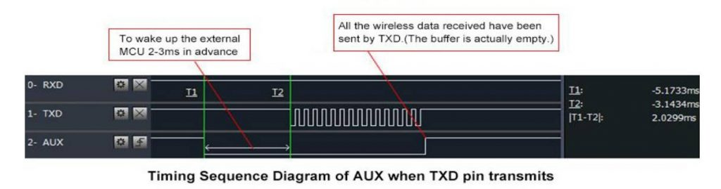](https://mischianti.org/wp-content/uploads/2019/10/e32auxPinOnTransmission.jpg)LoRa E32 AUX Pin on transmission

When receiving AUX going LOW and return HIGH when buffer is empty.

[](https://www.sunfounder.com/?ref=fz59AUVD)

[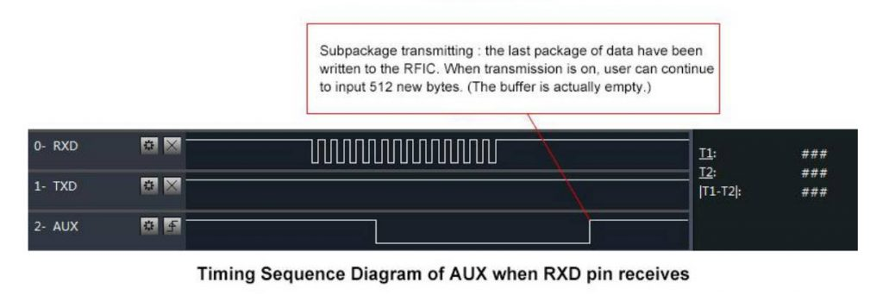](https://mischianti.org/wp-content/uploads/2019/10/e32auxPinOnReception.jpg)LoRa e32 AUX pin on reception

It’s also used for self checking to restore normal operation (on power-on and sleep/program mode).

[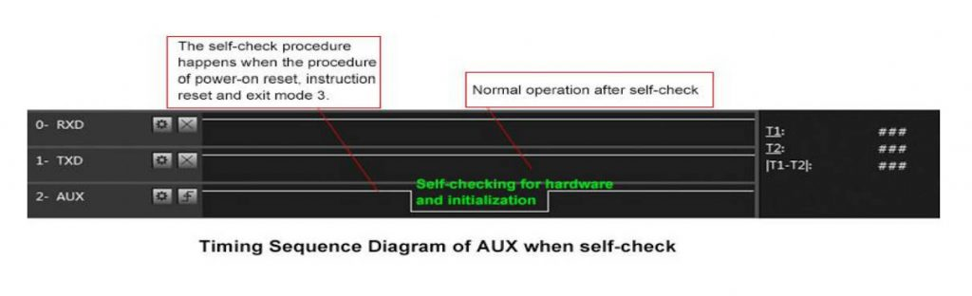](https://mischianti.org/wp-content/uploads/2019/10/e32auxPinOnSelfCheck.jpg)LoRa e32 AUX pin on self-check

esp8266

esp8266 connection schema is more simple because It work at the same voltage of logical communications (3.3v).

[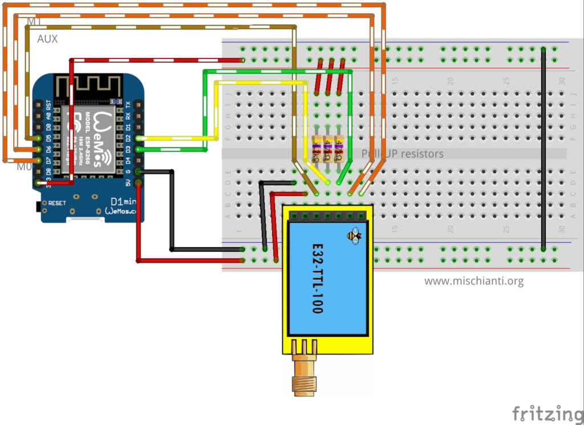](https://mischianti.org/wp-content/uploads/2019/10/LoRa_E32-TTL-100_WemosD1_VD_PU_FullyConnected_bb-e1570517387323.jpg)LoRa E32 TTL 100 Wemos D1 fully connected

It’s important to add pull-up resistor (4,7Kohm) to get good stability.

| **E22** | **esp8266** |
| --- | --- |
| M0 | D7 |
| M1 | D6 |
| TX | PIN D2 (PullUP 4,7KΩ) |
| RX | PIN D3 (PullUP 4,7KΩ) |
| AUX | PIN D5 (PullUP 4,7KΩ) |
| VCC | 5V (but work with less power in 3.3v) |
| GND | GND |

esp32

Similar connection schema for esp32, but for RX and TX we use RX2 and TX2, because by default esp32 doesn’t have SoftwareSerial but have 3 Serial.

[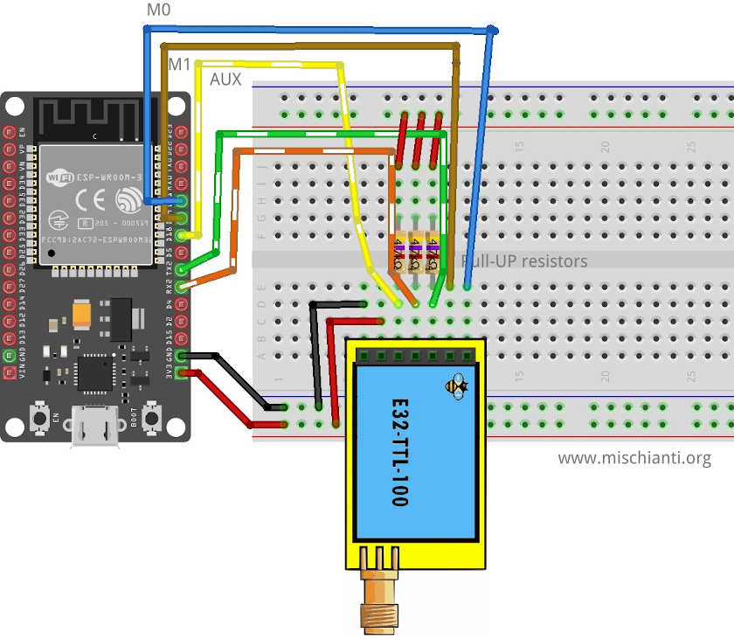](https://mischianti.org/wp-content/uploads/2020/08/Ebyte-LoRa-E22-device-esp32-dev-kit-v1-breadboard-full-connection.jpg)Ebyte LoRa E22 device esp32 dev kit v1 breadboard full connection

| **E22** | **esp32** |
| --- | --- |
| M0 | D21 |
| M1 | D19 |
| TX | PIN RX2 (PullUP 4,7KΩ) |
| RX | PIN TX3 (PullUP 4,7KΩ) |
| AUX | PIN D18 (PullUP 4,7KΩ) |
| VCC | 5V (but work with less power in 3.3v) |
| GND | GND |

Arduino

Arduino working voltage is 5v, so we need to add a voltage divider on RX pin M0 and M1 of LoRa module to prevent damage, you can get more information here [Voltage divider: calculator and application](https://mischianti.org/voltage-divider-calculator-and-application/).

You can use a 2Kohm resistor to GND and 1Kohm from signal than put together on RX.

[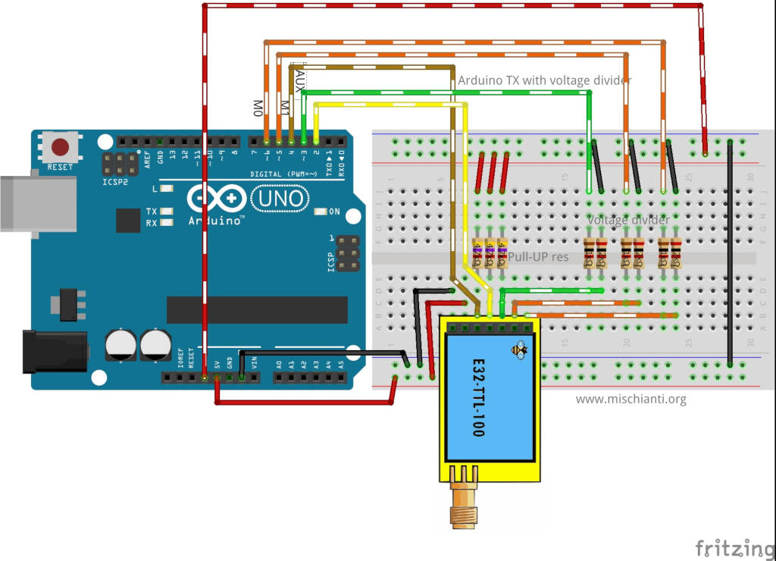](https://mischianti.org/wp-content/uploads/2019/10/LoRa_E32-TTL-100_Arduino_VD_PU_FullyConnected_bb-e1570517268668.jpg)LoRa E32 TTL 100 Arduino fully connected

|  |  |
| --- | --- |
| M0 | 7 (voltage divider) |
| M1 | 6 (voltage divider) |
| TX | PIN 2 (PullUP 4,7KΩ) |
| RX | PIN 3 (PullUP 4,7KΩ & Voltage divider) |
| AUX | PIN 5 (PullUP 4,7KΩ) |
| VCC | 5V |
| GND | GND |

Arduino MKR WiFi 1010

Ebyte LoRa Exx Arduino MKR WiFi 1010 Fully connected breadboard

|  |  |
| --- | --- |
| M0 | 2 (voltage divider) |
| M1 | 3 (voltage divider) |
| TX | PIN 14 Tx (PullUP 4,7KΩ) |
| RX | PIN 13 Rx (PullUP 4,7KΩ) |
| AUX | PIN 1 (PullUP 4,7KΩ) |
| VCC | 5V |
| GND | GND |

Constructor

I made a set of quite numerous constructors, because we can have more options and situations to manage.

|  |  |
| --- | --- |
| 1  2  3 | LoRa_E22(byte txE22pin, byte rxE22pin, UART_BPS_RATE bpsRate = UART_BPS_RATE_9600);  LoRa_E22(byte txE22pin, byte rxE22pin, byte auxPin, UART_BPS_RATE bpsRate = UART_BPS_RATE_9600);  LoRa_E22(byte txE22pin, byte rxE22pin, byte auxPin, byte m0Pin, byte m1Pin, UART_BPS_RATE bpsRate = UART_BPS_RATE_9600); |

First set of constructor are create to delegate the manage of Serial and other pins to the library.

* txE22pin and rxE22pin is the pin to connect to UART and they are **mandatory**.
* auxPin is a pin that check the operation, transmission and receiving status (we are going to explain better next), that pin **It isn’t mandatory**, if you don’t set It I apply a delay to permit the operation to complete itself (with latency, i**f you have trouble, like freeze device, you must put a pull-up 4.7k resistor or better connect to the device** ).
* m0pin and m1Pin are the pins to change operation MODE (see the table upper), I think **this pins in “production” are going to connect directly HIGH or LOW**, but for test they are usefully to be managed by the library.
* bpsRate is the boudrate of SoftwareSerial normally is 9600 (the only baud rate in programmin/sleep mode)

A simple example is

|  |  |
| --- | --- |
| 1  2  3  4 | #include "LoRa_E22.h"    LoRa_E32 e22ttl100(2, 3);  // e22 TX e22 RX  // LoRa_E32 e32ttl100(2, 3, 5, 6, 7);  // e22 TX e22 RX |

We can use directly a SoftwareSerial with another constructor

|  |  |
| --- | --- |
| 1  2  3 | LoRa_E22(HardwareSerial* serial, UART_BPS_RATE bpsRate = UART_BPS_RATE_9600);  LoRa_E22(HardwareSerial* serial, byte auxPin, UART_BPS_RATE bpsRate = UART_BPS_RATE_9600);  LoRa_E22(HardwareSerial* serial, byte auxPin, byte m0Pin, byte m1Pin, UART_BPS_RATE bpsRate = UART_BPS_RATE_9600); |

The example upper with this constructor can be do like so.

|  |  |
| --- | --- |
| 1  2  3  4  5  6 | #include <SoftwareSerial.h>  #include "LoRa_E22.h"    SoftwareSerial mySerial(2, 3); // e22 TX e22 RX  LoRa_E22 e22ttl100(&mySerial);  // LoRa_E22 e22ttl100(&mySerial, 5, 7, 6); |

The last set of constructor is to permit to use an HardwareSerial instead of SoftwareSerial.

|  |  |
| --- | --- |
| 1  2  3 | LoRa_E22(SoftwareSerial* serial, UART_BPS_RATE bpsRate = UART_BPS_RATE_9600);  LoRa_E22(SoftwareSerial* serial, byte auxPin, UART_BPS_RATE bpsRate = UART_BPS_RATE_9600);  LoRa_E22(SoftwareSerial* serial, byte auxPin, byte m0Pin, byte m1Pin, UART_BPS_RATE bpsRate = UART_BPS_RATE_9600); |

For esp32 you have 3 additional constructor to permit to manage pins for HardWare serial

|  |  |
| --- | --- |
| 1  2  3 | LoRa_E22(byte txE22pin, byte rxE22pin, HardwareSerial* serial, UART_BPS_RATE bpsRate = UART_BPS_RATE_9600, uint32_t serialConfig = SERIAL_8N1);  LoRa_E22(byte txE22pin, byte rxE22pin, HardwareSerial* serial, byte auxPin, UART_BPS_RATE bpsRate = UART_BPS_RATE_9600, uint32_t serialConfig = SERIAL_8N1);  LoRa_E22(byte txE22pin, byte rxE22pin, HardwareSerial* serial, byte auxPin, byte m0Pin, byte m1Pin, UART_BPS_RATE bpsRate = UART_BPS_RATE_9600, uint32_t serialConfig = SERIAL_8N1); |

Begin

The begin command is used to startup Serial and pins in input and output mode.

|  |  |
| --- | --- |
| 1 | **void** begin(); |

in execution is

[](https://www.pcbway.com/?from=mischianti723)

|  |  |
| --- | --- |
| 1  2 | // Startup all pins and UART  e22ttl100.begin(); |

Configuration and information method

There a set of methods for manage configuration and get information of the device.

|  |  |
| --- | --- |
| 1  2  3  4  5  6 | ResponseStructContainer getConfiguration();  ResponseStatus setConfiguration(Configuration configuration, PROGRAM_COMMAND saveType = WRITE_CFG_PWR_DWN_LOSE);    ResponseStructContainer getModuleInformation();  **void** printParameters(**struct** Configuration configuration);  ResponseStatus resetModule(); |

Response container

To simplify the manage of response I create a set of container, for me very usefully to manage errors and return generic data.

ResponseStatus

This is a status container and have 2 simple entry point, with this you can get the status code and the description of status code

|  |  |
| --- | --- |
| 1  2 | Serial.println(c.getResponseDescription()); // Description of code  Serial.println(c.code); // 1 if Success |

The code are

|  |  |
| --- | --- |
| 1  2  3  4  5  6  7  8  9  10  11 | SUCCESS = 1,  ERR_E22_UNKNOWN,  ERR_E22_NOT_SUPPORT,  ERR_E22_NOT_IMPLEMENT,  ERR_E22_NOT_INITIAL,  ERR_E22_INVALID_PARAM,  ERR_E22_DATA_SIZE_NOT_MATCH,  ERR_E22_BUF_TOO_SMALL,  ERR_E22_TIMEOUT,  ERR_E22_HARDWARE,  ERR_E22_HEAD_NOT_RECOGNIZED |

ResponseContainer

This container is created to manage String response and have 2 entry point.

data with the string returned from message and status an instance of RepsonseStatus.

|  |  |
| --- | --- |
| 1  2  3  4  5 | ResponseContainer rs = e22ttl.receiveMessage();  String message = rs.data;    Serial.println(rs.status.getResponseDescription());  Serial.println(message); |

but this command go to read all the data in the buffer, if you receive 3 message you are going to read all 3 message in one time, my simple solution is to use an end character to send at the end of message, to default I use \0 (null character)

|  |  |
| --- | --- |
| 1  2  3  4  5  6  7  8 | ResponseContainer rs = e22ttl.receiveMessageUntil();          // You can specify a custom delimiter also  // ResponseContainer rs = e22ttl.receiveMessageUntil('|');    String message = rs.data;    Serial.println(rs.status.getResponseDescription());  Serial.println(message); |

This version of device support RSSI also, to read that parameter (if you specify in the configuration that you want send also that), you can use

|  |  |
| --- | --- |
| 1  2  3  4  5  6 | ResponseContainer rc = e22ttl.receiveMessageRSSI();  String message = rs.data;    Serial.println(rs.status.getResponseDescription());  Serial.println(message);          Serial.print("RSSI: "); Serial.println(rc.rssi, DEC); |

ResponseStructContainer

This is the more “complex” container, I use this to manage structure, It has the same entry point of ResponseContainer but data is a void pointer to manage complex structure.

|  |  |
| --- | --- |
| 1  2  3  4  5  6  7 | ResponseStructContainer c;  c = e22ttl100.getConfiguration();  // It's important get configuration pointer before all other operation  Configuration configuration = *(Configuration*) c.data;  Serial.println(c.status.getResponseDescription());  Serial.println(c.status.code);      c.close(); |

If you receive a structure message with RSSI you can use

[](https://www.sunfounder.com/?ref=fz59AUVD)

|  |  |
| --- | --- |
| 1  2  3  4  5  6  7  8 | ResponseStructContainer rsc = e22ttl.receiveMessageRSSI(**sizeof**(Message));  Serial.println(rsc.status.getResponseDescription());  **struct** Message message = *(Message*) rsc.data;  Serial.println(message.type);  Serial.println(message.message);  Serial.println(*(**float**\*)(message.temperature));  Serial.print("RSSI: "); Serial.println(rsc.rssi, DEC);          rsc.close(); |

Every time you use a ResponseStructContainer you must close It with close()

getConfiguration and setConfiguration

The first method is getConfiguration, you can use It to retrieve all data stored on the device.

|  |  |
| --- | --- |
| 1 | ResponseStructContainer getConfiguration(); |

Here an usage example.

|  |  |
| --- | --- |
| 1  2  3  4  5  6  7  8 | ResponseStructContainer c;  c = e32ttl100.getConfiguration();  // It's important get configuration pointer before all other operation  Configuration configuration = *(Configuration*) c.data;  Serial.println(c.status.getResponseDescription());  Serial.println(c.status.code);      Serial.println(configuration.SPED.getUARTBaudRate());       c.close(); |

Structure of configuration have all data of settings, and I add a series of function to get all description of single data.

|  |  |
| --- | --- |
| 1  2  3  4  5  6  7  8  9  10  11  12  13  14  15  16  17  18  19  20 | configuration.ADDL = 0x03; // First part of address  configuration.ADDH = 0x00; // Second part  configuration.NETID = 0x00; // NETID used for repeater function    configuration.CHAN = 23; // Communication channel    configuration.SPED.uartBaudRate = UART_BPS_9600; // Serial baud rate  configuration.SPED.airDataRate = AIR_DATA_RATE_010_24; // Air baud rate  configuration.SPED.uartParity = MODE_00_8N1; // Parity bit    configuration.OPTION.subPacketSetting = SPS_240_00; // Packet size  configuration.OPTION.RSSIAmbientNoise = RSSI_AMBIENT_NOISE_DISABLED; // Need to send special command  configuration.OPTION.transmissionPower = POWER_22; // Device power    configuration.TRANSMISSION_MODE.enableRSSI = RSSI_DISABLED; // Enable RSSI info  configuration.TRANSMISSION_MODE.fixedTransmission = FT_TRANSPARENT_TRANSMISSION; // Transmission type  configuration.TRANSMISSION_MODE.enableRepeater = REPEATER_DISABLED; // Enable repeater mode  configuration.TRANSMISSION_MODE.enableLBT = LBT_DISABLED; // Check interference  configuration.TRANSMISSION_MODE.WORTransceiverControl = WOR_RECEIVER; // Enable WOR mode  configuration.TRANSMISSION_MODE.WORPeriod = WOR_2000_011; // WOR timing |

You have the equivalent function for all attribute to get all description:

|  |  |
| --- | --- |
| 1  2  3  4  5  6  7  8  9  10  11  12  13  14  15  16  17  18  19  20  21  22 | DEBUG_PRINT(F("HEAD : "));  DEBUG_PRINT(configuration.COMMAND, HEX);DEBUG_PRINT(" ");DEBUG_PRINT(configuration.STARTING_ADDRESS, HEX);DEBUG_PRINT(" ");DEBUG_PRINTLN(configuration.LENGHT, HEX);  DEBUG_PRINTLN(F(" "));  DEBUG_PRINT(F("AddH : "));  DEBUG_PRINTLN(configuration.ADDH, HEX);  DEBUG_PRINT(F("AddL : "));  DEBUG_PRINTLN(configuration.ADDL, HEX);  DEBUG_PRINT(F("NetID : "));  DEBUG_PRINTLN(configuration.NETID, HEX);  DEBUG_PRINTLN(F(" "));  DEBUG_PRINT(F("Chan : "));  DEBUG_PRINT(configuration.CHAN, DEC); DEBUG_PRINT(" -> "); DEBUG_PRINTLN(configuration.getChannelDescription());  DEBUG_PRINTLN(F(" "));  DEBUG_PRINT(F("SpeedParityBit     : "));  DEBUG_PRINT(configuration.SPED.uartParity, BIN);DEBUG_PRINT(" -> "); DEBUG_PRINTLN(configuration.SPED.getUARTParityDescription());  DEBUG_PRINT(F("SpeedUARTDatte     : "));  DEBUG_PRINT(configuration.SPED.uartBaudRate, BIN);DEBUG_PRINT(" -> "); DEBUG_PRINTLN(configuration.SPED.getUARTBaudRateDescription());  DEBUG_PRINT(F("SpeedAirDataRate   : "));  DEBUG_PRINT(configuration.SPED.airDataRate, BIN);DEBUG_PRINT(" -> "); DEBUG_PRINTLN(configuration.SPED.getAirDataRateDescription());  DEBUG_PRINTLN(F(" "));  DEBUG_PRINT(F("OptionSubPacketSett: "));  DEBUG_PRINT(configuration.OPTION.subPacketSetting, BIN);DEBUG_PRINT(" -> "); DEBUG_PRINTLN(configuration.OPTION.getSubPacketSetting());  DEBUG_PRINT(F("OptionTranPower    : "));  DEBUG_PRINT(configuration.OPTION.transmissionPower, BIN);DEBUG_PRINT(" -> "); DEBUG_PRINTLN(configuration.OPTION.getTransmissionPowerDescription());  DEBUG_PRINT(F("OptionRSSIAmbientNo: "));  DEBUG_PRINT(configuration.OPTION.RSSIAmbientNoise, BIN);DEBUG_PRINT(" -> "); DEBUG_PRINTLN(configuration.OPTION.getRSSIAmbientNoiseEnable());  DEBUG_PRINTLN(F(" "));  DEBUG_PRINT(F("TransModeWORPeriod : "));  DEBUG_PRINT(configuration.TRANSMISSION_MODE.WORPeriod, BIN);DEBUG_PRINT(" -> "); DEBUG_PRINTLN(configuration.TRANSMISSION_MODE.getWORPeriodByParamsDescription());  DEBUG_PRINT(F("TransModeTransContr: "));  DEBUG_PRINT(configuration.TRANSMISSION_MODE.WORTransceiverControl, BIN);DEBUG_PRINT(" -> "); DEBUG_PRINTLN(configuration.TRANSMISSION_MODE.getWORTransceiverControlDescription());  DEBUG_PRINT(F("TransModeEnableLBT : "));  DEBUG_PRINT(configuration.TRANSMISSION_MODE.enableLBT, BIN);DEBUG_PRINT(" -> "); DEBUG_PRINTLN(configuration.TRANSMISSION_MODE.getLBTEnableByteDescription());  DEBUG_PRINT(F("TransModeEnableRSSI: "));  DEBUG_PRINT(configuration.TRANSMISSION_MODE.enableRSSI, BIN);DEBUG_PRINT(" -> "); DEBUG_PRINTLN(configuration.TRANSMISSION_MODE.getRSSIEnableByteDescription());  DEBUG_PRINT(F("TransModeEnabRepeat: "));  DEBUG_PRINT(configuration.TRANSMISSION_MODE.enableRepeater, BIN);DEBUG_PRINT(" -> "); DEBUG_PRINTLN(configuration.TRANSMISSION_MODE.getRepeaterModeEnableByteDescription());  DEBUG_PRINT(F("TransModeFixedTrans: "));  DEBUG_PRINT(configuration.TRANSMISSION_MODE.fixedTransmission, BIN);DEBUG_PRINT(" -> "); DEBUG_PRINTLN(configuration.TRANSMISSION_MODE.getFixedTransmissionDescription()); |

In the same way, setConfiguration wants a configuration structure, so I think the better way to manage configuration is to retrieve the current one, apply the only change you need and set It again.

|  |  |
| --- | --- |
| 1 | ResponseStatus setConfiguration(Configuration configuration, PROGRAM_COMMAND saveType = WRITE_CFG_PWR_DWN_LOSE); |

configuration is the structure previously shown, saveType permit to you to choose if the change becomes permanently of only for the current session.

|  |  |
| --- | --- |
| 1  2  3  4  5  6  7  8  9  10  11  12  13  14  15  16  17  18  19  20  21  22  23  24  25  26  27  28  29  30  31  32  33  34  35 | ResponseStructContainer c;  c = e32ttl100.getConfiguration();  // It's important get configuration pointer before all other operation  Configuration configuration = *(Configuration*) c.data;  Serial.println(c.status.getResponseDescription());  Serial.println(c.status.code);    printParameters(configuration);  configuration.ADDL = 0x03; // First part of address  configuration.ADDH = 0x00; // Second part  configuration.NETID = 0x00; // NETID used for repeater function    configuration.CHAN = 23; // Communication channel    configuration.SPED.uartBaudRate = UART_BPS_9600; // Serial baud rate  configuration.SPED.airDataRate = AIR_DATA_RATE_010_24; // Air baud rate  configuration.SPED.uartParity = MODE_00_8N1; // Parity bit    configuration.OPTION.subPacketSetting = SPS_240_00; // Packet size  configuration.OPTION.RSSIAmbientNoise = RSSI_AMBIENT_NOISE_DISABLED; // Need to send special command  configuration.OPTION.transmissionPower = POWER_22; // Device power    configuration.TRANSMISSION_MODE.enableRSSI = RSSI_DISABLED; // Enable RSSI info  configuration.TRANSMISSION_MODE.fixedTransmission = FT_TRANSPARENT_TRANSMISSION; // Transmission type  configuration.TRANSMISSION_MODE.enableRepeater = REPEATER_DISABLED; // Enable repeater mode  configuration.TRANSMISSION_MODE.enableLBT = LBT_DISABLED; // Check interference  configuration.TRANSMISSION_MODE.WORTransceiverControl = WOR_RECEIVER; // Enable WOR mode  configuration.TRANSMISSION_MODE.WORPeriod = WOR_2000_011; // WOR timing    // Set configuration changed and set to not hold the configuration  ResponseStatus rs = e32ttl100.setConfiguration(configuration, WRITE_CFG_PWR_DWN_LOSE);  Serial.println(rs.getResponseDescription());  Serial.println(rs.code);  printParameters(configuration);      c.close() |

The parameter are all managed as constant:

Basic configuration option

| **Name** | **Description** | **Address** |
| --- | --- | --- |
| ADDH | High address byte of module (the default 00H) | 00H |
| ADDL | Low address byte of module (the default 00H) | 01H |
| SPED | Information about data rate parity bit and Air data rate | 02H |
| OPTION | Type of transmission, packet size, allow special message | 03H |
| CHAN | Communication channel（410M + CHAN*1M）, default 17H (433MHz), **valid only for 433MHz device** check below to check the correct frequency of your device | 04H |
| TRANSMISSION_MODE | A lot of parameter that specify the transmission modality | 06H |
| CRYPT | Encryption to avoid interception | 07H |

SPED detail

UART Parity bit: *UART mode can be different between communication parties*

SPED detail

UART Parity bit: *UART mode can be different between communication parties*

| **UART parity bit** | **Constant value** |
| --- | --- |
| 8N1 (default) | MODE_00_8N1 |
| 8O1 | MODE_01_8O1 |
| 8E1 | MODE_10_8E1 |
| 8N1 (equal to 00) | MODE_11_8N1 |

UART baud rate: UART baud rate can be different between communication parties, The UART baud rate has nothing to do with wireless transmission parameters & won’t affect the wireless transmit / receive features.

| **TTL UART baud rate（bps）** | **Constant value** |
| --- | --- |
| 1200 | UART_BPS_1200 |
| 2400 | UART_BPS_2400 |
| 4800 | UART_BPS_4800 |
| 9600 (default) | UART_BPS_9600 |
| 19200 | UART_BPS_19200 |
| 38400 | UART_BPS_38400 |
| 57600 | UART_BPS_57600 |
| 115200 | UART_BPS_115200 |

Air data rate: The lower the air data rate, the longer the transmitting distance, better anti- interference performance and longer transmitting time, The air data rate must keep the same for both communication parties.

| **Air data rate（bps）** | **Constant value** |
| --- | --- |
| 0.3k | AIR_DATA_RATE_000_03 |
| 1.2k | AIR_DATA_RATE_001_12 |
| 2.4k (default) | AIR_DATA_RATE_010_24 |
| 4.8k | AIR_DATA_RATE_011_48 |
| 9.6k | AIR_DATA_RATE_100_96 |
| 19.2k | AIR_DATA_RATE_101_192 |
| 38.4k | AIR_DATA_RATE_110_384 |
| 62.5k | AIR_DATA_RATE_111_625 |

OPTION detail

Sub packet setting

This is the max length of the packet.

When the data is smaller than the sub packet length, the serial output of the receiving end is an uninterrupted continuous output. When the data is larger than the sub packet length, the receiving end serial port will output the sub packet.

| **Packet size** | **Constant value** |
| --- | --- |
| 240bytes (default) | SPS_240_00 |
| 128bytes | SPS_128_01 |
| 64bytes | SPS_064_10 |
| 32bytes | SPS_032_11 |

RSSI Ambient noise enable

This command can enable/disable the management type of RSSI, It’s important to manage the remote configuration, pay attention isn’t the RSSI parameter in the message.

When enabled, the C0 C1 C2 C3 command can be sent in the transmitting mode or WOR transmitting mode to read the register. Register 0x00: Current ambient noise rssi Register 0X01: rssi when the data was received last time.

| **RSSI Ambient noise enable** | **Constant value** |
| --- | --- |
| Enable | RSSI_AMBIENT_NOISE_ENABLED |
| Disable (default) | RSSI_AMBIENT_NOISE_DISABLED |

Transmission power

You can change this set of constant by apply a define like so:

|  |  |
| --- | --- |
| 1 | #define E22_22 // default value without set |

Applicable for **E22 with 22dBm as max power.**  
Low power transmission is not recommended due to its low power supply efficiency.

| **Transmission power (approximation)** | **Constant value** |
| --- | --- |
| 22dBm (default) | POWER_22 |
| 17dBm | POWER_17 |
| 13dBm | POWER_13 |
| 10dBm | POWER_10 |

Applicable for **E22 with 30dBm as max power.**  
Low power transmission is not recommended due to its low power supply efficiency.

|  |  |  |
| --- | --- | --- |
| 1 | #define E22_30 | |
| **Transmission power (approximation)** | **Constant value** |
| 30dBm (default) | POWER_30 |
| 27dBm | POWER_27 |
| 24dBm | POWER_24 |
| 21dBm | POWER_21 |

You can configure Channel frequency also with this define:

|  |  |
| --- | --- |
| 1  2  3  4  5  6 | // One of  #define FREQUENCY_433  #define FREQUENCY_170  #define FREQUENCY_470  #define FREQUENCY_868  #define FREQUENCY_915 |

TRANSMISSION_MODE Detail

Enable RSSI

When enabled, the module receives wireless data and it will follow an RSSI strength byte after output via the serial port TXD

| **Enable RSSI** | **Constant value** |
| --- | --- |
| Enable | RSSI_ENABLED |
| Disable (default) | RSSI_DISABLED |

Transmission type

Transmission mode: in fixed transmission mode, the first three bytes of each user’s data frame can be used as high/low address and channel. The module changes its address and channel when transmit. And it will revert to original setting after complete the process.

| **Fixed transmission enabling bit** | **Constant value** |
| --- | --- |
| Fixed transmission mode | FT_FIXED_TRANSMISSION |
| Transparent transmission mode (default) | FT_TRANSPARENT_TRANSMISSION |

Enable repeater function

| **Enable repeater** | **Constant value** |
| --- | --- |
| Enable repeater | REPEATER_ENABLED |
| Disable repeater (default) | REPEATER_DISABLED |

Monitor data before transmission

When enabled, wireless data will be monitored before it is transmitted, which can avoid interference to a certain extent, but may cause data delay.

| **LBT enable byte** | **Constant value** |
| --- | --- |
| Enable | LBT_ENABLED |
| Disable (default) | LBT_DISABLED |

WOR

**WOR transmitter:** the module receiving and transmitting functions are turned on, and a wake-up code is added when transmitting data. Receiving is turned on.

**WOR receiver:** the module is unable to transmit data and works in WOR monitoring mode. The monitoring period is as follows (WOR cycle), which can save a lot of power.

| **WOR** | **Constant value** |
| --- | --- |
| WOR transmitter | WOR_TRANSMITTER |
| WOR receiver (default) | WOR_RECEIVER |

WOR cycle

If WOR is transmitting: after the WOR receiver receives the wireless data and outputs it through the serial port, it will wait for 1000ms before entering the WOR again. Users can input the serial port data and return it via the wireless during this period. Each serial byte will be refreshed for 1000ms. Users must transmit the first byte within 1000ms.

* Period T = (1 + WOR) * 500ms, maximum 4000ms, minimum 500ms
* The longer the WOR monitoring interval period, the lower the average power consumption, but
* the greater the data delay
* **Both the transmitter and the receiver must be the same (very important).**

| **Wireless wake-up time** | **Constant value** |
| --- | --- |
| 500ms | WAKE_UP_500 |
| 1000ms | WAKE_UP_1000 |
| 1500ms | WAKE_UP_1500 |
| 2000ms (default) | WAKE_UP_2000 |
| 2500ms | WAKE_UP_2500 |
| 3000ms | WAKE_UP_3000 |
| 3500ms | WAKE_UP_3500 |
| 4000ms | WAKE_UP_4000 |

Check buffer

First we must introduce a simple but usefully method to check if something is in the receiving buffer

|  |  |
| --- | --- |
| 1 | **int** available(); |

It’s simply return how many bytes you have in the current stream.

Send receive messages

Normal transmission mode

Normal/Transparent transmission mode is used to send messages to all device with same address and channel.

LoRa E32 transmitting scenarios, lines are channels

There are a lot of method to send/receive message, we are going to explain in detail:

|  |  |
| --- | --- |
| 1  2 | ResponseStatus sendMessage(**const** String message);  ResponseContainer receiveMessage(); |

First method is sendMessage and is used to send a String to a device in **Normal mode**.

|  |  |
| --- | --- |
| 1  2 | ResponseStatus rs = e22ttl.sendMessage("Prova");  Serial.println(rs.getResponseDescription()); |

The other device simply do on the loop

|  |  |
| --- | --- |
| 1  2  3  4  5  6 | **if** (e32ttl.available()  > 1){      ResponseContainer rs = e32ttl.receiveMessage();      String message = rs.data; // First ever get the data      Serial.println(rs.status.getResponseDescription());      Serial.println(message);  } |

Pay attention if you receive multiple message in the buffer and you don’t want read all in one time you must use ResponseContainer rs = e32ttl.receiveMessageUntil(); with a delimiter put on the end of sending message.

If you enabled the RSSI you must use receiveMessageRSSI.

Manage structure

If you want send a complex structure you can use this method

|  |  |
| --- | --- |
| 1  2 | ResponseStatus sendMessage(**const** **void** *message, **const** **uint8_t** size);  ResponseStructContainer receiveMessage(**const** **uint8_t** size); |

It’s used to send structure, for example:

|  |  |
| --- | --- |
| 1  2  3  4  5  6  7  8 | **struct** Messaggione {  **char** type[5];  **char** message[8];  **bool** mitico;  };  **struct** Messaggione messaggione = {"TEMP", "Peple", **true**};      ResponseStatus rs = e22ttl.sendMessage(&messaggione, **sizeof**(Messaggione));  Serial.println(rs.getResponseDescription()); |

and the other side you can receive the message so

|  |  |
| --- | --- |
| 1  2  3  4  5 | ResponseStructContainer rsc = e22ttl.receiveMessage(**sizeof**(Messaggione));  **struct** Messaggione messaggione = *(Messaggione*) rsc.data;  Serial.println(messaggione.message);  Serial.println(messaggione.mitico);          rsc.close(); |

If you enabled the RSSI you must use receiveMessageRSSI.

Read partial structure

If you want to read the first part of the message to manage more types of structure you can use this method.

|  |  |
| --- | --- |
| 1 | ResponseContainer receiveInitialMessage(**const** **uint8_t** size); |

I create It to receive a string with type or other to identify the strucuture to load.

|  |  |
| --- | --- |
| 1  2  3  4  5  6  7  8  9  10  11  12  13  14  15  16  17  18 | **struct** Messaggione { // Partial structure without type  **char** message[8];  **bool** mitico;  };    **char** type[5]; // first part of structure  ResponseContainer rs = e32ttl.receiveInitialMessage(**sizeof**(type));          // Put string in a char array (not needed)  **memcpy** ( type, rs.data.c_str(), **sizeof**(type) );    Serial.println("READ TYPE: ");  Serial.println(rs.status.getResponseDescription());  Serial.println(type);            // Read the rest of structure  ResponseStructContainer rsc = e32ttl.receiveMessage(**sizeof**(Messaggione));  **struct** Messaggione messaggione = *(Messaggione*) rsc.data;          rsc.close(); |

Fixed mode instead of normal mode

At same manner I create a set of method to use with fixed transmission

Fixed transmission

**You need to change only the sending method, because the destination device don’t receive the preamble with Address and Channel quando settato il fixed mode.**

So for String message you have

|  |  |
| --- | --- |
| 1  2 | ResponseStatus sendFixedMessage(byte ADDH, byte ADDL, byte CHAN, **const** String message);  ResponseStatus sendBroadcastFixedMessage(byte CHAN, **const** String message); |

and for structure you have

|  |  |
| --- | --- |
| 1  2 | ResponseStatus sendFixedMessage(byte ADDH, byte ADDL, byte CHAN, **const** **void** *message, **const** **uint8_t** size);  ResponseStatus sendBroadcastFixedMessage(byte CHAN, **const** **void** *message, **const** **uint8_t** size ); |

Here a simple example

|  |  |
| --- | --- |
| 1  2 | ResponseStatus rs = e22ttl.sendFixedMessage(0, 0, 0x17, &messaggione, **sizeof**(Messaggione));  //  ResponseStatus rs = e22ttl.sendFixedMessage(0, 0, 0x17, "Ciao"); |

Fixed transmission have more scenarios

LoRa E32 transmitting scenarios, lines are channels

If you send to a specific device (second scenarios Fixed transmission) you must add ADDL, ADDH and CHAN to identify It directly.

|  |  |
| --- | --- |
| 1 | ResponseStatus rs = e22ttl.sendFixedMessage(2, 2, 0x17, "Message to a device"); |

If you want send a message to all device in a specified Channel you can use this method.

|  |  |
| --- | --- |
| 1 | ResponseStatus rs = e22ttl.sendBroadcastFixedMessage(0x17, "Message to a devices of a channel"); |

If you want receive all broadcast message in the network you must set your ADDH and ADDL with BROADCAST_ADDRESS.

|  |  |
| --- | --- |
| 1  2  3  4  5  6  7  8  9  10  11  12  13  14  15  16  17 | ResponseStructContainer c;  c = e22ttl100.getConfiguration();  // It's important get configuration pointer before all other operation  Configuration configuration = *(Configuration*) c.data;  Serial.println(c.status.getResponseDescription());  Serial.println(c.status.code);    printParameters(configuration);  configuration.ADDL = BROADCAST_ADDRESS;  configuration.ADDH = BROADCAST_ADDRESS;    // Set configuration changed and set to not hold the configuration  ResponseStatus rs = e32ttl100.setConfiguration(configuration, WRITE_CFG_PWR_DWN_LOSE);  Serial.println(rs.getResponseDescription());  Serial.println(rs.code);  printParameters(configuration);      c.close(); |

Wireless configuration

This device supports wireless configuration with special commands but seems not to work, I ask to EBYTE but no response was received.

I implement a command that send the packet in the correct way (tested with logic analyzer) but seems not to work.

By the way, first you muset activate RSSI noise environment, than you can use the command like so:

|  |  |
| --- | --- |
| 1  2  3  4  5  6  7  8  9  10  11  12  13  14  15  16  17  18  19  20  21  22  23  24  25  26  27  28 | Configuration configuration;      configuration.ADDL = 0x13;    configuration.ADDH = 0x13;    configuration.NETID = 0x00;      configuration.CHAN = 23;      configuration.SPED.uartBaudRate = UART_BPS_9600;    configuration.SPED.airDataRate = AIR_DATA_RATE_010_24;    configuration.SPED.uartParity = MODE_00_8N1;      configuration.OPTION.subPacketSetting = SPS_240_00;    configuration.OPTION.RSSIAmbientNoise = RSSI_AMBIENT_NOISE_DISABLED;    configuration.OPTION.transmissionPower = POWER_22;      configuration.TRANSMISSION_MODE.enableRSSI = RSSI_DISABLED;    configuration.TRANSMISSION_MODE.fixedTransmission = FT_FIXED_TRANSMISSION;    configuration.TRANSMISSION_MODE.enableRepeater = REPEATER_DISABLED;    configuration.TRANSMISSION_MODE.enableLBT = LBT_DISABLED;    configuration.TRANSMISSION_MODE.WORTransceiverControl = WOR_TRANSMITTER;    configuration.TRANSMISSION_MODE.WORPeriod = WOR_2000_011;      // Send message  ResponseStatus rs = e22ttl100.sendConfigurationMessage(0, DESTINATION_ADDL, 23, &configuration);  // Check If there is some problem of successfully send  Serial.println(rs.getResponseDescription()); |

Thanks

Ebyte LoRa E22 device for Arduino, esp32 or esp8266: configuration – 3

BY [RENZO MISCHIANTI](https://mischianti.org/author/reef/) · PUBLISHED 29 MARCH 2022 · UPDATED 16 JUNE 2023

**Spread the love**

**LoRa or Long Range wireless data telemetry** is a technology pioneered by Semtech that operates at a lower frequency than NRF24L01 (433 MHz, 868 MHz, or 916 MHz against 2.4 GHz for the NRF24L01) but at thrice the distance (from 4000m to 10000m).

Now we try to examine better how to configure the Ebyte E22 UART LoRa device based on SX1262/SX1268 Wireless Modules.

[Support Forum](https://mischianti.org/forums/forum/mischiantis-libraries/ebyte-lora-e22-uart-devices-sx1262-sx1268/)

Ebyte LoRa E22 device for Arduino, esp32 or esp8266 Configuration

You can find here [AliExpress (433MHz 5.5Km)](https://s.click.aliexpress.com/e/_DlLGLbF) - [AliExpress (433MHz 10Km)](https://s.click.aliexpress.com/e/_DCGzJIt) - [AliExpress (868MHz 915Mhz 5.5Km)](https://s.click.aliexpress.com/e/_DczWHrb) - [AliExpress (868MHz 915Mhz 10Km)](https://s.click.aliexpress.com/e/_DeoQrNn)

I created this library to manage EBYTE E22 especially to simplify the configuration process because can be very tedious.

[](https://mischianti.org/wp-content/uploads/2019/09/ebyte-lora-exx-pinout-1.jpg)sx1278 sx1276 wireless lora uart module serial 3000m arduino 433 rf

**If you have device freezing problems, you must put a pull-up 4.7k resistor or better connect to the device AUX pin.**

* [Library](https://mischianti.org/ebyte-lora-e22-device-for-arduino-esp32-or-esp8266-configuration-3/#Library)
* [Connection schemas for programming](https://mischianti.org/ebyte-lora-e22-device-for-arduino-esp32-or-esp8266-configuration-3/#Connection_schemas_for_programming)
  + [Normal configuration (transparent)](https://mischianti.org/ebyte-lora-e22-device-for-arduino-esp32-or-esp8266-configuration-3/#Normal_configuration_transparent)
  + [Wiring for programming/sleep mode](https://mischianti.org/ebyte-lora-e22-device-for-arduino-esp32-or-esp8266-configuration-3/#Wiring_for_programmingsleep_mode)
* [Basic configuration option](https://mischianti.org/ebyte-lora-e22-device-for-arduino-esp32-or-esp8266-configuration-3/#Basic_configuration_option)
  + [Get configuration](https://mischianti.org/ebyte-lora-e22-device-for-arduino-esp32-or-esp8266-configuration-3/#Get_configuration)
  + [Set configuration](https://mischianti.org/ebyte-lora-e22-device-for-arduino-esp32-or-esp8266-configuration-3/#Set_configuration)
* [Thanks](https://mischianti.org/ebyte-lora-e22-device-for-arduino-esp32-or-esp8266-configuration-3/#Thanks)

Library

You can find my library [here](https://github.com/xreef/EByte_LoRa_E22_Series_Library), and It’s available on Arduino IDE library manager.

EByte LoRa E22 E32 Arduino library manager

To download.

Click the [DOWNLOADS](https://github.com/xreef/EByte_LoRa_E22_Series_Library/archive/master.zip)button in the top right corner, rename the uncompressed folder LoRa_E22.

Check that the LoRa_E22 folder contains LoRa_E22.cpp and LoRa_E22.h.

Place the LoRa_E22 library folder in your /libraries/ folder.

You may need to create the libraries subfolder if it’s your first library.

Restart the IDE.

Connection schemas for programming

For the basic usage, we had used a specified configuration for Arduino. Still, you are working only in “Normal mode” in that configuration. Now we will manage only the needed pins dynamic (RX, TX) to simplify the programming process and the others in a static way.

| **Mode** | **M1** | **M0** | **Explanation** |
| --- | --- | --- | --- |
| Normal | 0 | 0 | UART and wireless channel are open, transparent transmission is on (Supports configuration over air via special command) |
| WOR Mode | 0 | 1 | Can be defined as WOR transmitter and WOR receiver |
| Configuration mode | 1 | 0 | Users can access the register through the serial port to control the working state of the module |
| Deep sleep mode | 1 | 1 | Sleep mode |

Normal configuration (transparent)

Ebyte LoRa E32 E22 E220 Arduino UNO normal mode breadboard

|  |  |
| --- | --- |
| M0 | GND (Set normal mode) |
| M1 | GND (Set normal mode) |
| TX | PIN 2 (PullUP 4,7KΩ) |
| RX | PIN 3 (PullUP 4,7KΩ & Voltage divider) |
| AUX | Not connected |
| VCC | 5v |
| GND | GND |

and this configuration for Wemos D1 mini:

Ebyte LoRa E32 E22 E220 Wemos D1 normal mode breadboard

|  |  |
| --- | --- |
| M0 | GND (Set normal mode) |
| M1 | GND (Set normal mode) |
| TX | PIN D2 (PullUP 4,7KΩ) |
| RX | PIN D3 (PullUP 4,7KΩ) |
| AUX | Not connected |
| VCC | 3.3v/5v |
| GND | GND |

ESP-32:

Ebyte LoRa E32 E22 E220 ESP32 DEV KIT V1 normal mode breadboard

|  |  |
| --- | --- |
| M0 | GND (Set normal mode) |
| M1 | GND (Set normal mode) |
| RX | TX2 (PullUP 4,7KΩ) |
| TX | RX2 (PullUP 4,7KΩ) |
| AUX | Not connected (PullUP 4,7KΩ) |
| VCC | 3.3v/5v |
| GND | GND |

Arduino MKR WiFi 1010:

[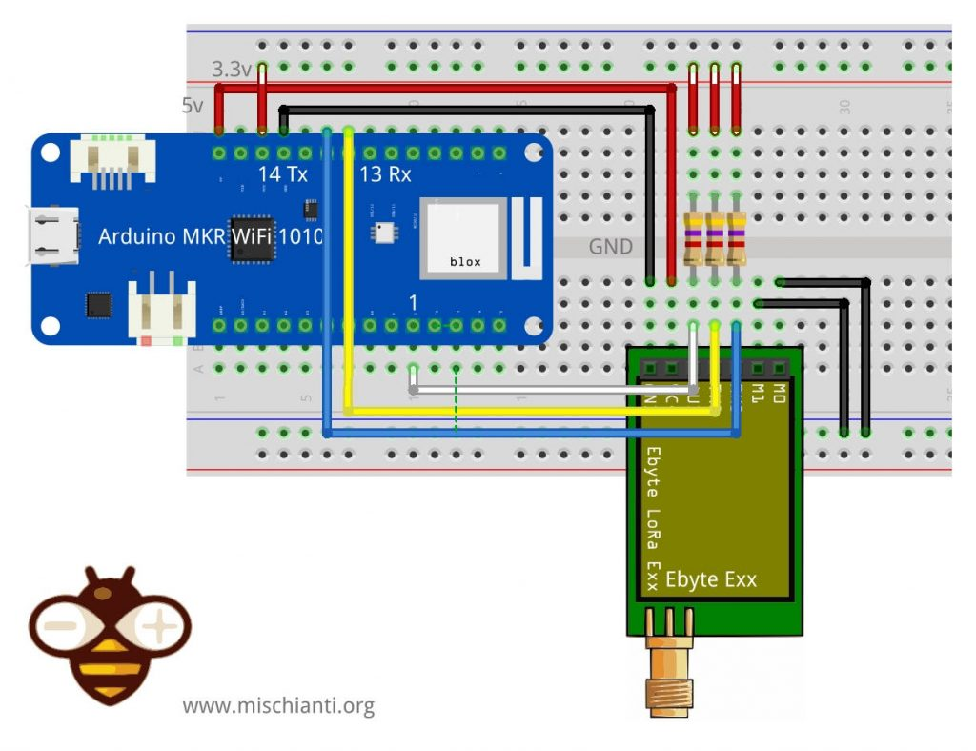](https://mischianti.org/wp-content/uploads/2021/12/Ebyte_LoRa_Exx_Arduino_MKR_WiFi_1010_normal_mode_connected_breadboard.jpg)Ebyte LoRa Exx Arduino MKR WiFi 1010 normal mode connected breadboard

|  |  |
| --- | --- |
| M0 | GND (Set normal mode) |
| M1 | GND (Set normal mode) |
| TX | PIN 14 Tx (PullUP 4,7KΩ) |
| RX | PIN 13 Rx (PullUP 4,7KΩ) |
| AUX | Not connected (PullUP 4,7KΩ) |
| VCC | 3.3v/5v |
| GND | GND |

Wiring for programming/sleep mode

**To configure It, you must set M0 to GND and M1 to high (remember to use 3.3v).**

But If you connect all pins, the library sets HIGH or LOW the pins as needed without a problem.

Ebyte LoRa E22 Wemos D1 configuration mode breadboard

|  |  |
| --- | --- |
| M0 | GND (Set programming/sleep mode) |
| M1 | VCC (Set programming/sleep mode) |
| TX | PIN D2 (PullUP 4,7KΩ) |
| RX | PIN D3 (PullUP 4,7KΩ) |
| AUX | Not connected |
| VCC | 3.3v/5v |
| GND | GND |

Ebyte LoRa E22 Arduino UNO configuration mode breadboard

|  |  |
| --- | --- |
| M0 | GND (Set programming/sleep mode) |
| M1 | 3.3v (Set programming/sleep mode) |
| TX | PIN 2 (PullUP 4,7KΩ) |
| TX | PIN 3 (PullUP 4,7KΩ & Voltage divider) |
| AUX | Not connected |
| VCC | 5v |
| GND | GND |

Ebyte LoRa E22 ESP32 DEV KIT V1 configuration mode breadboard

|  |  |
| --- | --- |
| M0 | GND (Set programming/sleep mode) |
| M1 | 3.3v (Set programming/sleep mode) |
| RX | TX2 (PullUP 4,7KΩ) |
| TX | RX2 (PullUP 4,7KΩ) |
| AUX | Not connected |
| VCC | 3.3v/5v |
| GND | GND |

LoRa E22 Arduino MKR WiFi 1010 sleep config mode breadboard

|  |  |
| --- | --- |
| M0 | GND (Set programming/sleep mode) |
| M1 | 3.3v (Set programming/sleep mode) |
| TX | PIN 14 Tx (PullUP 4,7KΩ) |
| RX | PIN 13 Rx (PullUP 4,7KΩ) |
| AUX | Not connected (PullUP 4,7KΩ) |
| VCC | 3.3v/5v |
| GND | GND |

In this mode, you can manage the configuration of the device

Basic configuration option

| **Name** | **Description** | **Address** |
| --- | --- | --- |
| ADDH | High address byte of the module (the default 00H) | 00H |
| ADDL | Low address byte of the module (the default 00H) | 01H |
| NETID | Network address, used to distinguish the network. | 02H |
| SPED | Information about data rate parity bit and Air data rate | 03H |
| OPTION | Type of transmission, pull-up settings, wake-up time, FEC, Transmission power | 04H |
| CHAN | Communication channel（410M + CHAN*1M）, default 17H (433MHz), **valid only for 433MHz device** | 05H |
| TRANSMISSION_MODE | All transmission parameters | 06H |
| CRTYPT_H | User encryption | 07H |
| CRTYPT_L | User encryption | 08H |

You can find configuration options in the Library article.

Get configuration

Arduino example sketch

|  |  |
| --- | --- |
| 1  2  3  4  5  6  7  8  9  10  11  12  13  14  15  16  17  18  19  20  21  22  23  24  25  26  27  28  29  30  31  32  33  34  35  36  37  38  39  40  41  42  43  44  45  46  47  48  49  50  51  52  53  54  55  56  57  58  59  60  61  62  63  64  65  66  67  68  69  70  71  72  73  74  75  76  77  78  79  80  81  82  83  84  85  86  87  88  89  90  91  92  93  94  95  96  97  98  99  100  101  102  103  104  105  106  107  108  109  110  111  112  113  114  115  116  117  118  119  120  121  122  123 | /*   * EByte LoRa E22   * Get configuration.   * [https://mischianti.org](https://mischianti.org/)   *   * E22        ----- Arduino   * M0         ----- 7 (or GND)   * M1         ----- 6 (or HIGH)   * RX         ----- 4 (PullUP)   * TX         ----- 5 (PullUP)   * AUX        ----- 3  (PullUP)   * VCC        ----- 3.3v/5v   * GND        ----- GND   *   */  #include "Arduino.h"  #include "LoRa_E22.h"    // ---------- esp8266 pins --------------  //LoRa_E22 e22ttl(RX, TX, AUX, M0, M1);  // Arduino RX <-- e22 TX, Arduino TX --> e22 RX  //LoRa_E22 e22ttl(D3, D4, D5, D7, D6); // Arduino RX <-- e22 TX, Arduino TX --> e22 RX AUX M0 M1  //LoRa_E22 e22ttl(D2, D3); // Config without connect AUX and M0 M1    //#include <SoftwareSerial.h>  //SoftwareSerial mySerial(D2, D3); // Arduino RX <-- e22 TX, Arduino TX --> e22 RX  //LoRa_E22 e22ttl(&mySerial, D5, D7, D6); // AUX M0 M1  // -------------------------------------    // ---------- Arduino pins --------------  LoRa_E22 e22ttl(4, 5, 3, 7, 6); // Arduino RX <-- e22 TX, Arduino TX --> e22 RX AUX M0 M1  //LoRa_E22 e22ttl(4, 5); // Config without connect AUX and M0 M1    //#include <SoftwareSerial.h>  //SoftwareSerial mySerial(4, 5); // Arduino RX <-- e22 TX, Arduino TX --> e22 RX  //LoRa_E22 e22ttl(&mySerial, 3, 7, 6); // AUX M0 M1  // -------------------------------------    // ------------- Arduino MKR WiFi 1010 -------------  // LoRa_E220 e22ttl(&Serial1, 2, 4, 6); //  RX AUX M0 M1  // -------------------------------------------------    // ---------- esp32 pins --------------  //LoRa_E22 e22ttl(&Serial2, 18, 21, 19); //  RX AUX M0 M1    //LoRa_E22 e22ttl(&Serial2, 22, 4, 18, 21, 19, UART_BPS_RATE_9600); //  esp32 RX <-- e22 TX, esp32 TX --> e22 RX AUX M0 M1  // -------------------------------------    **void** printParameters(struct Configuration configuration);  **void** printModuleInformation(struct ModuleInformation moduleInformation);    **void** **setup**() {      Serial.begin(9600);  **while**(**!**Serial){};      delay(500);        Serial.println();          // Startup all pins and UART      e22ttl.begin();        ResponseStructContainer c;      c **=** e22ttl.getConfiguration();      // It's important get configuration pointer before all other operation      Configuration configuration **=** **\***(Configuration**\***) c.data;      Serial.println(c.status.getResponseDescription());      Serial.println(c.status.code);        printParameters(configuration);        ResponseStructContainer cMi;      cMi **=** e22ttl.getModuleInformation();      // It's important get information pointer before all other operation      ModuleInformation mi **=** **\***(ModuleInformation**\***)cMi.data;        Serial.println(cMi.status.getResponseDescription());      Serial.println(cMi.status.code);        printModuleInformation(mi);  }    **void** **loop**() {    }  **void** printParameters(struct Configuration configuration) {      Serial.println("----------------------------------------");        Serial.print(F("HEAD : "));  Serial.print(configuration.COMMAND, HEX);Serial.print(" ");Serial.print(configuration.STARTING_ADDRESS, HEX);Serial.print(" ");Serial.println(configuration.LENGHT, HEX);      Serial.println(F(" "));      Serial.print(F("AddH : "));  Serial.println(configuration.ADDH, HEX);      Serial.print(F("AddL : "));  Serial.println(configuration.ADDL, HEX);      Serial.print(F("NetID : "));  Serial.println(configuration.NETID, HEX);      Serial.println(F(" "));      Serial.print(F("Chan : "));  Serial.print(configuration.CHAN, DEC); Serial.print(" -> "); Serial.println(configuration.getChannelDescription());      Serial.println(F(" "));      Serial.print(F("SpeedParityBit     : "));  Serial.print(configuration.SPED.uartParity, BIN);Serial.print(" -> "); Serial.println(configuration.SPED.getUARTParityDescription());      Serial.print(F("SpeedUARTDatte     : "));  Serial.print(configuration.SPED.uartBaudRate, BIN);Serial.print(" -> "); Serial.println(configuration.SPED.getUARTBaudRateDescription());      Serial.print(F("SpeedAirDataRate   : "));  Serial.print(configuration.SPED.airDataRate, BIN);Serial.print(" -> "); Serial.println(configuration.SPED.getAirDataRateDescription());      Serial.println(F(" "));      Serial.print(F("OptionSubPacketSett: "));  Serial.print(configuration.OPTION.subPacketSetting, BIN);Serial.print(" -> "); Serial.println(configuration.OPTION.getSubPacketSetting());      Serial.print(F("OptionTranPower    : "));  Serial.print(configuration.OPTION.transmissionPower, BIN);Serial.print(" -> "); Serial.println(configuration.OPTION.getTransmissionPowerDescription());      Serial.print(F("OptionRSSIAmbientNo: "));  Serial.print(configuration.OPTION.RSSIAmbientNoise, BIN);Serial.print(" -> "); Serial.println(configuration.OPTION.getRSSIAmbientNoiseEnable());      Serial.println(F(" "));      Serial.print(F("TransModeWORPeriod : "));  Serial.print(configuration.TRANSMISSION_MODE.WORPeriod, BIN);Serial.print(" -> "); Serial.println(configuration.TRANSMISSION_MODE.getWORPeriodByParamsDescription());      Serial.print(F("TransModeTransContr: "));  Serial.print(configuration.TRANSMISSION_MODE.WORTransceiverControl, BIN);Serial.print(" -> "); Serial.println(configuration.TRANSMISSION_MODE.getWORTransceiverControlDescription());      Serial.print(F("TransModeEnableLBT : "));  Serial.print(configuration.TRANSMISSION_MODE.enableLBT, BIN);Serial.print(" -> "); Serial.println(configuration.TRANSMISSION_MODE.getLBTEnableByteDescription());      Serial.print(F("TransModeEnableRSSI: "));  Serial.print(configuration.TRANSMISSION_MODE.enableRSSI, BIN);Serial.print(" -> "); Serial.println(configuration.TRANSMISSION_MODE.getRSSIEnableByteDescription());      Serial.print(F("TransModeEnabRepeat: "));  Serial.print(configuration.TRANSMISSION_MODE.enableRepeater, BIN);Serial.print(" -> "); Serial.println(configuration.TRANSMISSION_MODE.getRepeaterModeEnableByteDescription());      Serial.print(F("TransModeFixedTrans: "));  Serial.print(configuration.TRANSMISSION_MODE.fixedTransmission, BIN);Serial.print(" -> "); Serial.println(configuration.TRANSMISSION_MODE.getFixedTransmissionDescription());          Serial.println("----------------------------------------");  }  **void** printModuleInformation(struct ModuleInformation moduleInformation) {      Serial.println("----------------------------------------");      Serial.print(F("HEAD: "));  Serial.print(moduleInformation.COMMAND, HEX);Serial.print(" ");Serial.print(moduleInformation.STARTING_ADDRESS, HEX);Serial.print(" ");Serial.println(moduleInformation.LENGHT, DEC);        Serial.print(F("Model no.: "));  Serial.println(moduleInformation.model, HEX);      Serial.print(F("Version  : "));  Serial.println(moduleInformation.version, HEX);      Serial.print(F("Features : "));  Serial.println(moduleInformation.features, HEX);      Serial.println("----------------------------------------");    } |

Here is the result of the sketch

|  |  |
| --- | --- |
| 1  2  3  4  5  6  7  8  9  10  11  12  13  14  15  16  17  18  19  20  21  22  23  24  25  26  27  28  29  30  31  32  33  34 | Success  1  ----------------------------------------  HEAD : C1 0 9    AddH : 0  AddL : 3  NetID : 0    Chan : 23 -> 433MHz    SpeedParityBit     : 0 -> 8N1 (Default)  SpeedUARTDatte     : 11 -> 9600bps (default)  SpeedAirDataRate   : 10 -> 2.4kbps (default)    OptionSubPacketSett: 0 -> 240bytes (default)  OptionTranPower    : 0 -> 22dBm (Default)  OptionRSSIAmbientNo: 0 -> Disabled (default)    TransModeWORPeriod : 0 -> 500ms  TransModeTransContr: 0 -> WOR Receiver (default)  TransModeEnableLBT : 0 -> Disabled (default)  TransModeEnableRSSI: 0 -> Disabled (default)  TransModeEnabRepeat: 0 -> Disabled (default)  TransModeFixedTrans: 1 -> Fixed transmission (first three bytes can be used as high/low address and channel)  ----------------------------------------  Success  1  ----------------------------------------  HEAD: C1 80 7  Model no.: 16  Version  : A  Features : 0  ---------------------------------------- |

As you can see, I add a lot of constructors for every device, if you change the first configuration you can switch the device with the same code.

[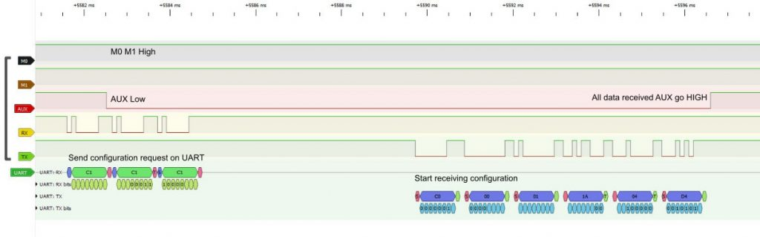](https://mischianti.org/wp-content/uploads/2019/12/E32_request_configuration_logic_analyzer.jpg)LoRa E32 request configuration logic analyzer Arduino

To get the correct information, I add some #define to change the device type (same #define manage more other devices, I create only one for type for simplicity).

|  |  |
| --- | --- |
| 1  2 | #define E22_22  #define E22_30 |

**You can select only one of them**. The parameter changes the Transmission power constant as described in the configuration schema.

In the same manner, you can select one reference frequences

|  |  |
| --- | --- |
| 1  2  3  4  5 | #define FREQUENCY_433  #define FREQUENCY_170  #define FREQUENCY_470  #define FREQUENCY_868  #define FREQUENCY_915 |

**You can choose** only one of them. The parameter changes the reference frequencies only for display purposes,

Set configuration

Naturally, when you have a configuration you want to change It for your purpose, I think you can get the configuration from a device, modify what you want and set It.

But in the example sketch, I add a set of configuration commented, you can uncomment the config you want, and in the other examples in the library, there is a reference to the relative configuration to apply.

Ricorda che il parametro saveType è fondamentale per mantenere le opzioni al riavvio del dispositivo, WRITE_CFG_PWR_DWN_LOSE naturalmente perderai le impostazioni con WRITE_CFG_PWR_DWN_SAVE non perderai le impostazioni.

Here is an Arduino Nano 33 IoT sketch:

|  |  |
| --- | --- |
| 1  2  3  4  5  6  7  8  9  10  11  12  13  14  15  16  17  18  19  20  21  22  23  24  25  26  27  28  29  30  31  32  33  34  35  36  37  38  39  40  41  42  43  44  45  46  47  48  49  50  51  52  53  54  55  56  57  58  59  60  61  62  63  64  65  66  67  68  69  70  71  72  73  74  75  76  77  78  79  80  81  82  83  84  85  86  87  88  89  90  91  92  93  94  95  96  97  98  99  100  101  102  103  104  105  106  107  108  109  110  111  112  113  114  115  116  117  118  119  120  121  122  123  124  125  126  127  128  129  130  131  132  133  134  135  136  137  138  139  140  141  142  143  144  145  146  147  148  149  150  151  152  153  154  155  156  157  158  159  160  161  162  163  164  165  166  167  168  169  170  171  172  173  174  175  176  177  178  179  180  181  182  183  184  185  186  187  188  189  190  191  192  193  194  195  196  197  198  199  200  201  202  203  204  205  206  207  208  209  210  211  212  213  214  215  216  217  218  219  220  221  222  223  224  225  226  227  228  229  230  231  232  233  234  235  236  237  238  239  240  241  242  243  244  245  246  247  248  249  250  251  252  253  254  255  256  257  258  259  260  261  262  263  264  265  266  267  268  269  270  271  272  273  274  275  276  277  278  279  280  281  282  283  284  285  286  287  288  289  290  291  292  293  294  295  296  297  298  299  300  301  302  303  304  305  306  307  308  309  310  311  312  313  314  315  316  317  318  319  320  321  322  323  324  325  326  327  328  329  330  331  332  333  334  335  336  337  338  339  340  341  342  343  344  345  346  347  348  349  350  351  352  353  354  355  356  357  358  359  360  361  362  363  364  365  366  367  368  369  370  371  372  373 | /*   * LoRa E22-TTL-100   * Get configuration.   * [https://mischianti.org](https://mischianti.org/)   *   * E22        ----- Arduino Nano 33 IoT   * M0         ----- 4 (or GND)   * M1         ----- 6 (or HIGH)   * RX         ----- TX (PullUP)   * TX         ----- RX (PullUP)   * AUX        ----- 2  (PullUP)   * VCC        ----- 3.3v/5v   * GND        ----- GND   *   */  #include "Arduino.h"  #include "LoRa_E22.h"    // ---------- esp8266 pins --------------  //LoRa_E22 e22ttl(RX, TX, AUX, M0, M1);  // Arduino RX <-- e22 TX, Arduino TX --> e22 RX  //LoRa_E22 e22ttl(D3, D4, D5, D7, D6); // Arduino RX <-- e22 TX, Arduino TX --> e22 RX AUX M0 M1  //LoRa_E22 e22ttl(D2, D3); // Config without connect AUX and M0 M1    //#include <SoftwareSerial.h>  //SoftwareSerial mySerial(D2, D3); // Arduino RX <-- e22 TX, Arduino TX --> e22 RX  //LoRa_E22 e22ttl(&mySerial, D5, D7, D6); // AUX M0 M1  // -------------------------------------    // ---------- Arduino pins --------------  // LoRa_E22 e22ttl(4, 5, 3, 7, 6); // Arduino RX <-- e22 TX, Arduino TX --> e22 RX AUX M0 M1  //LoRa_E22 e22ttl(4, 5); // Config without connect AUX and M0 M1    //#include <SoftwareSerial.h>  //SoftwareSerial mySerial(4, 5); // Arduino RX <-- e22 TX, Arduino TX --> e22 RX  //LoRa_E22 e22ttl(&mySerial, 3, 7, 6); // AUX M0 M1  // -------------------------------------    // ------------- Arduino Nano 33 IoT -------------  LoRa_E22 e22ttl(**&**Serial1, 2, 4, 6); //  RX AUX M0 M1  // -------------------------------------------------    // ------------- Arduino MKR WiFi 1010 -------------  // LoRa_E22 e22ttl(&Serial1, 2, 4, 6); //  RX AUX M0 M1  // -------------------------------------------------    // ---------- esp32 pins --------------  //LoRa_E22 e22ttl(&Serial2, 18, 21, 19); //  RX AUX M0 M1    //LoRa_E22 e22ttl(&Serial2, 22, 4, 18, 21, 19, UART_BPS_RATE_9600); //  esp32 RX <-- e22 TX, esp32 TX --> e22 RX AUX M0 M1  // -------------------------------------    **void** printParameters(struct Configuration configuration);  **void** printModuleInformation(struct ModuleInformation moduleInformation);    **void** **setup**() {      Serial.begin(9600);  **while**(**!**Serial){};      delay(500);        Serial.println();          // Startup all pins and UART      e22ttl.begin();        ResponseStructContainer c;      c **=** e22ttl.getConfiguration();      // It's important get configuration pointer before all other operation      Configuration configuration **=** **\***(Configuration**\***) c.data;      Serial.println(c.status.getResponseDescription());      Serial.println(c.status.code);        printParameters(configuration);        configuration.ADDL **=** 0x03;      configuration.ADDH **=** 0x00;      configuration.NETID **=** 0x00;        configuration.CHAN **=** 23;          //  ----------------------- DEFAULT TRANSPARENT -----------------------          configuration.ADDL **=** 0x03;          configuration.ADDH **=** 0x00;          configuration.NETID **=** 0x00;            configuration.CHAN **=** 23;            configuration.SPED.uartBaudRate **=** UART_BPS_9600;          configuration.SPED.airDataRate **=** AIR_DATA_RATE_010_24;          configuration.SPED.uartParity **=** MODE_00_8N1;            configuration.OPTION.subPacketSetting **=** SPS_240_00;          configuration.OPTION.RSSIAmbientNoise **=** RSSI_AMBIENT_NOISE_DISABLED;          configuration.OPTION.transmissionPower **=** POWER_22;            configuration.TRANSMISSION_MODE.enableRSSI **=** RSSI_DISABLED;          configuration.TRANSMISSION_MODE.fixedTransmission **=** FT_TRANSPARENT_TRANSMISSION;          configuration.TRANSMISSION_MODE.enableRepeater **=** REPEATER_DISABLED;          configuration.TRANSMISSION_MODE.enableLBT **=** LBT_DISABLED;          configuration.TRANSMISSION_MODE.WORTransceiverControl **=** WOR_RECEIVER;          configuration.TRANSMISSION_MODE.WORPeriod **=** WOR_2000_011;      //  ----------------------- DEFAULT TRANSPARENT WITH RSSI -----------------------      //  configuration.ADDL = 0x03;      //  configuration.ADDH = 0x00;      //  configuration.NETID = 0x00;      //      //  configuration.CHAN = 23;      //      //  configuration.SPED.uartBaudRate = UART_BPS_9600;      //  configuration.SPED.airDataRate = AIR_DATA_RATE_010_24;      //  configuration.SPED.uartParity = MODE_00_8N1;      //      //  configuration.OPTION.subPacketSetting = SPS_240_00;      //  configuration.OPTION.RSSIAmbientNoise = RSSI_AMBIENT_NOISE_DISABLED;      //  configuration.OPTION.transmissionPower = POWER_22;      //      //  configuration.TRANSMISSION_MODE.enableRSSI = RSSI_ENABLED;      //  configuration.TRANSMISSION_MODE.fixedTransmission = FT_TRANSPARENT_TRANSMISSION;      //  configuration.TRANSMISSION_MODE.enableRepeater = REPEATER_DISABLED;      //  configuration.TRANSMISSION_MODE.enableLBT = LBT_DISABLED;      //  configuration.TRANSMISSION_MODE.WORTransceiverControl = WOR_RECEIVER;      //  configuration.TRANSMISSION_MODE.WORPeriod = WOR_2000_011;      //  ----------------------- FIXED SENDER -----------------------  //          configuration.ADDL = 0x02;  //          configuration.ADDH = 0x00;  //          configuration.NETID = 0x00;  //  //          configuration.CHAN = 23;  //  //          configuration.SPED.uartBaudRate = UART_BPS_9600;  //          configuration.SPED.airDataRate = AIR_DATA_RATE_010_24;  //          configuration.SPED.uartParity = MODE_00_8N1;  //  //          configuration.OPTION.subPacketSetting = SPS_240_00;  //          configuration.OPTION.RSSIAmbientNoise = RSSI_AMBIENT_NOISE_DISABLED;  //          configuration.OPTION.transmissionPower = POWER_22;  //  //          configuration.TRANSMISSION_MODE.enableRSSI = RSSI_DISABLED;  //          configuration.TRANSMISSION_MODE.fixedTransmission = FT_FIXED_TRANSMISSION;  //          configuration.TRANSMISSION_MODE.enableRepeater = REPEATER_DISABLED;  //          configuration.TRANSMISSION_MODE.enableLBT = LBT_DISABLED;  //          configuration.TRANSMISSION_MODE.WORTransceiverControl = WOR_TRANSMITTER;  //          configuration.TRANSMISSION_MODE.WORPeriod = WOR_2000_011;      //      //  ----------------------- FIXED RECEIVER -----------------------  //          configuration.ADDL = 0x03;  //          configuration.ADDH = 0x00;  //          configuration.NETID = 0x00;  //  //          configuration.CHAN = 23;  //  //          configuration.SPED.uartBaudRate = UART_BPS_9600;  //          configuration.SPED.airDataRate = AIR_DATA_RATE_010_24;  //          configuration.SPED.uartParity = MODE_00_8N1;  //  //          configuration.OPTION.subPacketSetting = SPS_240_00;  //          configuration.OPTION.RSSIAmbientNoise = RSSI_AMBIENT_NOISE_DISABLED;  //          configuration.OPTION.transmissionPower = POWER_22;  //  //          configuration.TRANSMISSION_MODE.enableRSSI = RSSI_DISABLED;  //          configuration.TRANSMISSION_MODE.fixedTransmission = FT_FIXED_TRANSMISSION;  //          configuration.TRANSMISSION_MODE.enableRepeater = REPEATER_DISABLED;  //          configuration.TRANSMISSION_MODE.enableLBT = LBT_DISABLED;  //          configuration.TRANSMISSION_MODE.WORTransceiverControl = WOR_RECEIVER;  //          configuration.TRANSMISSION_MODE.WORPeriod = WOR_2000_011;      //  ----------------------- FIXED SENDER RSSI -----------------------      //      configuration.ADDL = 0x02;      //      configuration.ADDH = 0x00;      //      configuration.NETID = 0x00;      //      //      configuration.CHAN = 23;      //      //      configuration.SPED.uartBaudRate = UART_BPS_9600;      //      configuration.SPED.airDataRate = AIR_DATA_RATE_010_24;      //      configuration.SPED.uartParity = MODE_00_8N1;      //      //      configuration.OPTION.subPacketSetting = SPS_240_00;      //      configuration.OPTION.RSSIAmbientNoise = RSSI_AMBIENT_NOISE_DISABLED;      //      configuration.OPTION.transmissionPower = POWER_22;      //      //      configuration.TRANSMISSION_MODE.enableRSSI = RSSI_ENABLED;      //      configuration.TRANSMISSION_MODE.fixedTransmission = FT_FIXED_TRANSMISSION;      //      configuration.TRANSMISSION_MODE.enableRepeater = REPEATER_DISABLED;      //      configuration.TRANSMISSION_MODE.enableLBT = LBT_DISABLED;      //      configuration.TRANSMISSION_MODE.WORTransceiverControl = WOR_TRANSMITTER;      //      configuration.TRANSMISSION_MODE.WORPeriod = WOR_2000_011;      //      //  ----------------------- FIXED RECEIVER RSSI -----------------------      //      configuration.ADDL = 0x03;      //      configuration.ADDH = 0x00;      //      configuration.NETID = 0x00;      //      //      configuration.CHAN = 23;      //      //      configuration.SPED.uartBaudRate = UART_BPS_9600;      //      configuration.SPED.airDataRate = AIR_DATA_RATE_010_24;      //      configuration.SPED.uartParity = MODE_00_8N1;      //      //      configuration.OPTION.subPacketSetting = SPS_240_00;      //      configuration.OPTION.RSSIAmbientNoise = RSSI_AMBIENT_NOISE_DISABLED;      //      configuration.OPTION.transmissionPower = POWER_22;      //      //      configuration.TRANSMISSION_MODE.enableRSSI = RSSI_ENABLED;      //      configuration.TRANSMISSION_MODE.fixedTransmission = FT_FIXED_TRANSMISSION;      //      configuration.TRANSMISSION_MODE.enableRepeater = REPEATER_DISABLED;      //      configuration.TRANSMISSION_MODE.enableLBT = LBT_DISABLED;      //      configuration.TRANSMISSION_MODE.WORTransceiverControl = WOR_RECEIVER;      //      configuration.TRANSMISSION_MODE.WORPeriod = WOR_2000_011;        //  ----------------------- WOR SENDER -----------------------      //      configuration.ADDL = 0x02;      //      configuration.ADDH = 0x00;      //      configuration.NETID = 0x00;      //      //      configuration.CHAN = 23;      //      //      configuration.SPED.uartBaudRate = UART_BPS_9600;      //      configuration.SPED.airDataRate = AIR_DATA_RATE_010_24;      //      configuration.SPED.uartParity = MODE_00_8N1;      //      //      configuration.OPTION.subPacketSetting = SPS_240_00;      //      configuration.OPTION.RSSIAmbientNoise = RSSI_AMBIENT_NOISE_DISABLED;      //      configuration.OPTION.transmissionPower = POWER_22;      //      //      configuration.TRANSMISSION_MODE.enableRSSI = RSSI_DISABLED;      //      configuration.TRANSMISSION_MODE.fixedTransmission = FT_FIXED_TRANSMISSION;      //      configuration.TRANSMISSION_MODE.enableRepeater = REPEATER_DISABLED;      //      configuration.TRANSMISSION_MODE.enableLBT = LBT_DISABLED;      //      configuration.TRANSMISSION_MODE.WORTransceiverControl = WOR_TRANSMITTER;      //      configuration.TRANSMISSION_MODE.WORPeriod = WOR_2000_011;      //      //  ----------------------- WOR RECEIVER -----------------------  //          configuration.ADDL = 0x03;  //          configuration.ADDH = 0x00;  //          configuration.NETID = 0x00;  //  //          configuration.CHAN = 23;  //  //          configuration.SPED.uartBaudRate = UART_BPS_9600;  //          configuration.SPED.airDataRate = AIR_DATA_RATE_010_24;  //          configuration.SPED.uartParity = MODE_00_8N1;  //  //          configuration.OPTION.subPacketSetting = SPS_240_00;  //          configuration.OPTION.RSSIAmbientNoise = RSSI_AMBIENT_NOISE_DISABLED;  //          configuration.OPTION.transmissionPower = POWER_22;  //  //          configuration.TRANSMISSION_MODE.enableRSSI = RSSI_DISABLED;  //          configuration.TRANSMISSION_MODE.fixedTransmission = FT_FIXED_TRANSMISSION;  //          configuration.TRANSMISSION_MODE.enableRepeater = REPEATER_DISABLED;  //          configuration.TRANSMISSION_MODE.enableLBT = LBT_DISABLED;  //          configuration.TRANSMISSION_MODE.WORTransceiverControl = WOR_RECEIVER;  //          configuration.TRANSMISSION_MODE.WORPeriod = WOR_500_000;      //  ----------------------- BROADCAST MESSAGE 1 -----------------------  //          configuration.ADDL = 0x04;  //          configuration.ADDH = 0x00;  //          configuration.NETID = 0x00;  //  //          configuration.CHAN = 23;  //  //          configuration.SPED.uartBaudRate = UART_BPS_9600;  //          configuration.SPED.airDataRate = AIR_DATA_RATE_010_24;  //          configuration.SPED.uartParity = MODE_00_8N1;  //  //          configuration.OPTION.subPacketSetting = SPS_240_00;  //          configuration.OPTION.RSSIAmbientNoise = RSSI_AMBIENT_NOISE_DISABLED;  //          configuration.OPTION.transmissionPower = POWER_22;  //  //          configuration.TRANSMISSION_MODE.enableRSSI = RSSI_DISABLED;  //          configuration.TRANSMISSION_MODE.fixedTransmission = FT_FIXED_TRANSMISSION;  //          configuration.TRANSMISSION_MODE.enableRepeater = REPEATER_DISABLED;  //          configuration.TRANSMISSION_MODE.enableLBT = LBT_DISABLED;  //          configuration.TRANSMISSION_MODE.WORTransceiverControl = WOR_RECEIVER;  //          configuration.TRANSMISSION_MODE.WORPeriod = WOR_2000_011;      //  ----------------------- BROADCAST MESSAGE 2 -----------------------  //          configuration.ADDL = 0x05;  //          configuration.ADDH = 0x00;  //          configuration.NETID = 0x00;  //  //          configuration.CHAN = 23;  //  //          configuration.SPED.uartBaudRate = UART_BPS_9600;  //          configuration.SPED.airDataRate = AIR_DATA_RATE_010_24;  //          configuration.SPED.uartParity = MODE_00_8N1;  //  //          configuration.OPTION.subPacketSetting = SPS_240_00;  //          configuration.OPTION.RSSIAmbientNoise = RSSI_AMBIENT_NOISE_DISABLED;  //          configuration.OPTION.transmissionPower = POWER_22;  //  //          configuration.TRANSMISSION_MODE.enableRSSI = RSSI_DISABLED;  //          configuration.TRANSMISSION_MODE.fixedTransmission = FT_FIXED_TRANSMISSION;  //          configuration.TRANSMISSION_MODE.enableRepeater = REPEATER_DISABLED;  //          configuration.TRANSMISSION_MODE.enableLBT = LBT_DISABLED;  //          configuration.TRANSMISSION_MODE.WORTransceiverControl = WOR_RECEIVER;  //          configuration.TRANSMISSION_MODE.WORPeriod = WOR_2000_011;      //  ----------------------- BROADCAST MESSAGE 3 -----------------------      //      configuration.ADDL = 0x06;      //      configuration.ADDH = 0x00;      //      configuration.NETID = 0x00;      //      //      configuration.CHAN = 23;      //      //      configuration.SPED.uartBaudRate = UART_BPS_9600;      //      configuration.SPED.airDataRate = AIR_DATA_RATE_010_24;      //      configuration.SPED.uartParity = MODE_00_8N1;      //      //      configuration.OPTION.subPacketSetting = SPS_240_00;      //      configuration.OPTION.RSSIAmbientNoise = RSSI_AMBIENT_NOISE_DISABLED;      //      configuration.OPTION.transmissionPower = POWER_22;      //      //      configuration.TRANSMISSION_MODE.enableRSSI = RSSI_DISABLED;      //      configuration.TRANSMISSION_MODE.fixedTransmission = FT_FIXED_TRANSMISSION;      //      configuration.TRANSMISSION_MODE.enableRepeater = REPEATER_DISABLED;      //      configuration.TRANSMISSION_MODE.enableLBT = LBT_DISABLED;      //      configuration.TRANSMISSION_MODE.WORTransceiverControl = WOR_RECEIVER;      //      configuration.TRANSMISSION_MODE.WORPeriod = WOR_2000_011;        // Set configuration changed and set to not hold the configuration      ResponseStatus rs **=** e22ttl.setConfiguration(configuration, WRITE_CFG_PWR_DWN_SAVE);      Serial.println(rs.getResponseDescription());      Serial.println(rs.code);        c **=** e22ttl.getConfiguration();      // It's important get configuration pointer before all other operation      configuration **=** **\***(Configuration**\***) c.data;      Serial.println(c.status.getResponseDescription());      Serial.println(c.status.code);        printParameters(configuration);  }    **void** **loop**() {    }  **void** printParameters(struct Configuration configuration) {      Serial.println("----------------------------------------");        Serial.print(F("HEAD : "));  Serial.print(configuration.COMMAND, HEX);Serial.print(" ");Serial.print(configuration.STARTING_ADDRESS, HEX);Serial.print(" ");Serial.println(configuration.LENGHT, HEX);      Serial.println(F(" "));      Serial.print(F("AddH : "));  Serial.println(configuration.ADDH, HEX);      Serial.print(F("AddL : "));  Serial.println(configuration.ADDL, HEX);      Serial.print(F("NetID : "));  Serial.println(configuration.NETID, HEX);      Serial.println(F(" "));      Serial.print(F("Chan : "));  Serial.print(configuration.CHAN, DEC); Serial.print(" -> "); Serial.println(configuration.getChannelDescription());      Serial.println(F(" "));      Serial.print(F("SpeedParityBit     : "));  Serial.print(configuration.SPED.uartParity, BIN);Serial.print(" -> "); Serial.println(configuration.SPED.getUARTParityDescription());      Serial.print(F("SpeedUARTDatte     : "));  Serial.print(configuration.SPED.uartBaudRate, BIN);Serial.print(" -> "); Serial.println(configuration.SPED.getUARTBaudRateDescription());      Serial.print(F("SpeedAirDataRate   : "));  Serial.print(configuration.SPED.airDataRate, BIN);Serial.print(" -> "); Serial.println(configuration.SPED.getAirDataRateDescription());      Serial.println(F(" "));      Serial.print(F("OptionSubPacketSett: "));  Serial.print(configuration.OPTION.subPacketSetting, BIN);Serial.print(" -> "); Serial.println(configuration.OPTION.getSubPacketSetting());      Serial.print(F("OptionTranPower    : "));  Serial.print(configuration.OPTION.transmissionPower, BIN);Serial.print(" -> "); Serial.println(configuration.OPTION.getTransmissionPowerDescription());      Serial.print(F("OptionRSSIAmbientNo: "));  Serial.print(configuration.OPTION.RSSIAmbientNoise, BIN);Serial.print(" -> "); Serial.println(configuration.OPTION.getRSSIAmbientNoiseEnable());      Serial.println(F(" "));      Serial.print(F("TransModeWORPeriod : "));  Serial.print(configuration.TRANSMISSION_MODE.WORPeriod, BIN);Serial.print(" -> "); Serial.println(configuration.TRANSMISSION_MODE.getWORPeriodByParamsDescription());      Serial.print(F("TransModeTransContr: "));  Serial.print(configuration.TRANSMISSION_MODE.WORTransceiverControl, BIN);Serial.print(" -> "); Serial.println(configuration.TRANSMISSION_MODE.getWORTransceiverControlDescription());      Serial.print(F("TransModeEnableLBT : "));  Serial.print(configuration.TRANSMISSION_MODE.enableLBT, BIN);Serial.print(" -> "); Serial.println(configuration.TRANSMISSION_MODE.getLBTEnableByteDescription());      Serial.print(F("TransModeEnableRSSI: "));  Serial.print(configuration.TRANSMISSION_MODE.enableRSSI, BIN);Serial.print(" -> "); Serial.println(configuration.TRANSMISSION_MODE.getRSSIEnableByteDescription());      Serial.print(F("TransModeEnabRepeat: "));  Serial.print(configuration.TRANSMISSION_MODE.enableRepeater, BIN);Serial.print(" -> "); Serial.println(configuration.TRANSMISSION_MODE.getRepeaterModeEnableByteDescription());      Serial.print(F("TransModeFixedTrans: "));  Serial.print(configuration.TRANSMISSION_MODE.fixedTransmission, BIN);Serial.print(" -> "); Serial.println(configuration.TRANSMISSION_MODE.getFixedTransmissionDescription());          Serial.println("----------------------------------------");  }  **void** printModuleInformation(struct ModuleInformation moduleInformation) {      Serial.println("----------------------------------------");      Serial.print(F("HEAD: "));  Serial.print(moduleInformation.COMMAND, HEX);Serial.print(" ");Serial.print(moduleInformation.STARTING_ADDRESS, HEX);Serial.print(" ");Serial.println(moduleInformation.LENGHT, DEC);        Serial.print(F("Model no.: "));  Serial.println(moduleInformation.model, HEX);      Serial.print(F("Version  : "));  Serial.println(moduleInformation.version, HEX);      Serial.print(F("Features : "));  Serial.println(moduleInformation.features, HEX);      Serial.println("----------------------------------------");    } |

Here is the result on the console

|  |  |
| --- | --- |
| 1  2  3  4  5  6  7  8  9  10  11  12  13  14  15  16  17  18  19  20  21  22  23  24  25  26  27  28  29  30  31  32  33  34  35  36  37  38  39  40  41  42  43  44  45  46  47  48  49  50  51  52  53  54  55  56  57  58  59  60  61  62  63  64  65  66  67  68  69  70  71  72  73  74  75  76  77  78  79  80  81  82  83  84  85  86  87  88  89  90  91  92  93 | Connetti alla porta seriale COM19 a 115200    Success  1  ----------------------------------------  HEAD : C1 0 9    AddH : 0  AddL : 3  NetID : 0    Chan : 23 -> 433MHz    SpeedParityBit     : 0 -> 8N1 (Default)  SpeedUARTDatte     : 11 -> 9600bps (default)  SpeedAirDataRate   : 10 -> 2.4kbps (default)    OptionSubPacketSett: 0 -> 240bytes (default)  OptionTranPower    : 0 -> 22dBm (Default)  OptionRSSIAmbientNo: 0 -> Disabled (default)    TransModeWORPeriod : 0 -> 500ms  TransModeTransContr: 0 -> WOR Receiver (default)  TransModeEnableLBT : 0 -> Disabled (default)  TransModeEnableRSSI: 0 -> Disabled (default)  TransModeEnabRepeat: 0 -> Disabled (default)  TransModeFixedTrans: 1 -> Fixed transmission (first three bytes can be used as high/low address and channel)  ----------------------------------------  Success  1  ----------------------------------------  HEAD: C1 80 7  Model no.: 16  Version  : A  Features : 0  ----------------------------------------    Connetti alla porta seriale COM19 a 115200    Success  1  ----------------------------------------  HEAD : C1 0 9    AddH : 0  AddL : 3  NetID : 0    Chan : 23 -> 433MHz    SpeedParityBit     : 0 -> 8N1 (Default)  SpeedUARTDatte     : 11 -> 9600bps (default)  SpeedAirDataRate   : 10 -> 2.4kbps (default)    OptionSubPacketSett: 0 -> 240bytes (default)  OptionTranPower    : 0 -> 22dBm (Default)  OptionRSSIAmbientNo: 0 -> Disabled (default)    TransModeWORPeriod : 0 -> 500ms  TransModeTransContr: 0 -> WOR Receiver (default)  TransModeEnableLBT : 0 -> Disabled (default)  TransModeEnableRSSI: 0 -> Disabled (default)  TransModeEnabRepeat: 0 -> Disabled (default)  TransModeFixedTrans: 1 -> Fixed transmission (first three bytes can be used as high/low address and channel)  ----------------------------------------  Success  1  Success  1  ----------------------------------------  HEAD : C1 0 9    AddH : 0  AddL : 3  NetID : 0    Chan : 23 -> 433MHz    SpeedParityBit     : 0 -> 8N1 (Default)  SpeedUARTDatte     : 11 -> 9600bps (default)  SpeedAirDataRate   : 10 -> 2.4kbps (default)    OptionSubPacketSett: 0 -> 240bytes (default)  OptionTranPower    : 0 -> 22dBm (Default)  OptionRSSIAmbientNo: 0 -> Disabled (default)    TransModeWORPeriod : 11 -> 2000ms (default)  TransModeTransContr: 0 -> WOR Receiver (default)  TransModeEnableLBT : 0 -> Disabled (default)  TransModeEnableRSSI: 0 -> Disabled (default)  TransModeEnabRepeat: 0 -> Disabled (default)  TransModeFixedTrans: 0 -> Transparent transmission (default)  ---------------------------------------- |

The library is quite simple, but in the next chapter, we will test various device options.

Thanks

Ebyte LoRa E22 device for Arduino, esp32 or esp8266: fixed transmission, broadcast, monitor, and RSSI – 4

BY [RENZO MISCHIANTI](https://mischianti.org/author/reef/) · 4 APRIL 2022

**Spread the love**

We will now understand the various transmission types of our E22 UART LoRa device based on popular Semtech’s SX1262 and SX1268 RF chips.

[Support Forum](https://mischianti.org/forums/forum/mischiantis-libraries/ebyte-lora-e22-uart-devices-sx1262-sx1268/)

Ebyte LoRa E22 device for Arduino, esp32 or esp8266 fixed transmission and RSSI

Here a selection of LoRa devices [AliExpress (433MHz 5.5Km)](https://s.click.aliexpress.com/e/_DlLGLbF) - [AliExpress (433MHz 10Km)](https://s.click.aliexpress.com/e/_DCGzJIt) - [AliExpress (868MHz 915Mhz 5.5Km)](https://s.click.aliexpress.com/e/_DczWHrb) - [AliExpress (868MHz 915Mhz 10Km)](https://s.click.aliexpress.com/e/_DeoQrNn)

In the first part, we’ve used a transparent transmission, so we send to all and receive from all that have the same address e channel.

LoRa E32 transmitting scenarios

But It isn’t a standard scenario, and we usually want to send to a specified point and receive a response.

**If you have trouble with the device’s freeze, you must put a pull-up 4.7k resistor or better connect to the device AUX pin.**

* [Normal mode](https://mischianti.org/ebyte-lora-e22-device-for-arduino-esp32-or-esp8266-fixed-transmission-broadcast-monitor-and-rssi-4/#Normal_mode)
  + [Transparent transmission](https://mischianti.org/ebyte-lora-e22-device-for-arduino-esp32-or-esp8266-fixed-transmission-broadcast-monitor-and-rssi-4/#Transparent_transmission)
  + [Transparent transmission and RSSI](https://mischianti.org/ebyte-lora-e22-device-for-arduino-esp32-or-esp8266-fixed-transmission-broadcast-monitor-and-rssi-4/#Transparent_transmission_and_RSSI)
* [Fixed transmission](https://mischianti.org/ebyte-lora-e22-device-for-arduino-esp32-or-esp8266-fixed-transmission-broadcast-monitor-and-rssi-4/#Fixed_transmission)
  + [Fixed transmission: point to point](https://mischianti.org/ebyte-lora-e22-device-for-arduino-esp32-or-esp8266-fixed-transmission-broadcast-monitor-and-rssi-4/#Fixed_transmission_point_to_point)
  + [Fixed transmission with RSSI:](https://mischianti.org/ebyte-lora-e22-device-for-arduino-esp32-or-esp8266-fixed-transmission-broadcast-monitor-and-rssi-4/#Fixed_transmission_with_RSSI)
  + [Fixed transmission: broadcast](https://mischianti.org/ebyte-lora-e22-device-for-arduino-esp32-or-esp8266-fixed-transmission-broadcast-monitor-and-rssi-4/#Fixed_transmission_broadcast)
  + [Fixed transmission: monitoring](https://mischianti.org/ebyte-lora-e22-device-for-arduino-esp32-or-esp8266-fixed-transmission-broadcast-monitor-and-rssi-4/#Fixed_transmission_monitoring)
* [Thanks](https://mischianti.org/ebyte-lora-e22-device-for-arduino-esp32-or-esp8266-fixed-transmission-broadcast-monitor-and-rssi-4/#Thanks)

Normal mode

For normal transmission, you must set M0 and M1 to LOW, and It’s better if you connect the AUX pin to have a better synchronization, but not needed. You can check the connection of the AUX pin in the library complete example connection, and you only must add the PIN to the constructor.

Ebyte LoRa E32 E22 E220 Arduino UNO normal mode breadboard

|  |  |
| --- | --- |
| M0 | GND (Set normal mode) |
| M1 | GND (Set normal mode) |
| TX | PIN 2 (PullUP 4,7KΩ) |
| RX | PIN 3 (PullUP 4,7KΩ & Voltage divider) |
| AUX | Not connected (PullUP 4,7KΩ) |
| VCC | 5v |
| GND | GND |

and this configuration for Wemos D1 mini:

Ebyte LoRa E32 E22 E220 Wemos D1 normal mode breadboard

|  |  |
| --- | --- |
| M0 | GND (Set normal mode) |
| M1 | GND (Set normal mode) |
| TX | PIN D2 (PullUP 4,7KΩ) |
| RX | PIN D3 (PullUP 4,7KΩ) |
| AUX | Not connected (PullUP 4,7KΩ) |
| VCC | 3.3v/5v |
| GND | GND |

ESP-32:

Ebyte LoRa E32 E22 E220 ESP32 DEV KIT V1 normal mode breadboard

|  |  |
| --- | --- |
| M0 | GND (Set normal mode) |
| M1 | GND (Set normal mode) |
| RX | TX2 (PullUP 4,7KΩ) |
| TX | RX2 (PullUP 4,7KΩ) |
| AUX | Not connected (PullUP 4,7KΩ) |
| VCC | 3.3v/5v |
| GND | GND |

Arduino MKR WiFi 1010:

[](https://mischianti.org/wp-content/uploads/2021/12/Ebyte_LoRa_Exx_Arduino_MKR_WiFi_1010_normal_mode_connected_breadboard.jpg)Ebyte LoRa Exx Arduino MKR WiFi 1010 normal mode connected breadboard

|  |  |
| --- | --- |
| M0 | GND (Set normal mode) |
| M1 | GND (Set normal mode) |
| TX | PIN 14 Tx (PullUP 4,7KΩ) |
| RX | PIN 13 Rx (PullUP 4,7KΩ) |
| AUX | Not connected (PullUP 4,7KΩ) |
| VCC | 3.3v/5v |
| GND | GND |

So you must only instantiate the constructor.

|  |  |
| --- | --- |
| 1  2  3  4  5  6  7  8  9  10  11  12  13  14  15  16  17  18  19  20  21  22  23  24  25  26  27  28  29  30  31  32 | // ---------- esp8266 pins --------------  //LoRa_E22 e22ttl(RX, TX, AUX, M0, M1);  // Arduino RX <-- e22 TX, Arduino TX --> e22 RX  //LoRa_E22 e22ttl(D3, D4, D5, D7, D6); // Arduino RX <-- e22 TX, Arduino TX --> e22 RX AUX M0 M1  //LoRa_E22 e22ttl(D2, D3); // Config without connect AUX and M0 M1    //#include <SoftwareSerial.h>  //SoftwareSerial mySerial(D2, D3); // Arduino RX <-- e22 TX, Arduino TX --> e22 RX  //LoRa_E22 e22ttl(&mySerial, D5, D7, D6); // AUX M0 M1  // -------------------------------------    // ---------- Arduino pins --------------  LoRa_E22 e22ttl(4, 5, 3, 7, 6); // Arduino RX <-- e22 TX, Arduino TX --> e22 RX AUX M0 M1  //LoRa_E22 e22ttl(4, 5); // Config without connect AUX and M0 M1    //#include <SoftwareSerial.h>  //SoftwareSerial mySerial(4, 5); // Arduino RX <-- e22 TX, Arduino TX --> e22 RX  //LoRa_E22 e22ttl(&mySerial, 3, 7, 6); // AUX M0 M1  // -------------------------------------    // ------------- Arduino Nano 33 IoT -------------  // LoRa_E22 e22ttl(&Serial1, 2, 4, 6); //  RX AUX M0 M1  // -------------------------------------------------    // ------------- Arduino MKR WiFi 1010 -------------  // LoRa_E22 e22ttl(&Serial1, 2, 4, 6); //  RX AUX M0 M1  // -------------------------------------------------    // ---------- esp32 pins --------------  //LoRa_E22 e22ttl(&Serial2, 18, 21, 19); //  RX AUX M0 M1    //LoRa_E22 e22ttl(&Serial2, 22, 4, 18, 21, 19, UART_BPS_RATE_9600); //  esp32 RX <-- e22 TX, esp32 TX --> e22 RX AUX M0 M1  // ------------------------------------- |

Transparent transmission

Generic sketch, select the correct constructor for every device:

|  |  |
| --- | --- |
| 1  2  3  4  5  6  7  8  9  10  11  12  13  14  15  16  17  18  19  20  21  22  23  24  25  26  27  28  29  30  31  32  33  34  35  36  37  38  39  40  41  42  43  44  45  46  47  48  49  50  51  52  53  54  55  56  57  58  59  60  61  62  63  64  65  66  67  68  69  70  71  72  73  74  75  76  77  78  79  80  81  82  83  84  85  86  87  88  89  90 | /*   * LoRa E22   * send a transparent message, you must check that the transmitter and receiver have the same   * CHANNEL ADDL and ADDH   *   * Renzo Mischianti <[https://mischianti.org](https://mischianti.org/)>   * <https://mischianti.org/category/my-libraries/ebyte-lora-e22-devices/>   *   * E22        ----- Arduino   * M0         ----- 7 (or GND)   * M1         ----- 6 (or GND)   * RX         ----- 4 (PullUP)   * TX         ----- 5 (PullUP)   * AUX        ----- 3  (PullUP)   * VCC        ----- 3.3v/5v   * GND        ----- GND   *   */    #include "Arduino.h"  #include "LoRa_E22.h"    // ---------- esp8266 pins --------------  //LoRa_E22 e22ttl(RX, TX, AUX, M0, M1);  // Arduino RX <-- e22 TX, Arduino TX --> e22 RX  //LoRa_E22 e22ttl(D3, D4, D5, D7, D6); // Arduino RX <-- e22 TX, Arduino TX --> e22 RX AUX M0 M1  //LoRa_E22 e22ttl(D2, D3); // Config without connect AUX and M0 M1    //#include <SoftwareSerial.h>  //SoftwareSerial mySerial(D2, D3); // Arduino RX <-- e22 TX, Arduino TX --> e22 RX  //LoRa_E22 e22ttl(&mySerial, D5, D7, D6); // AUX M0 M1  // -------------------------------------    // ---------- Arduino pins --------------  LoRa_E22 e22ttl(4, 5, 3, 7, 6); // Arduino RX <-- e22 TX, Arduino TX --> e22 RX AUX M0 M1  //LoRa_E22 e22ttl(4, 5); // Config without connect AUX and M0 M1    //#include <SoftwareSerial.h>  //SoftwareSerial mySerial(4, 5); // Arduino RX <-- e22 TX, Arduino TX --> e22 RX  //LoRa_E22 e22ttl(&mySerial, 3, 7, 6); // AUX M0 M1  // -------------------------------------    // ---------- esp32 pins --------------  // LoRa_E22 e22ttl(&Serial2, 18, 21, 19); //  RX AUX M0 M1    //LoRa_E22 e22ttl(&Serial2, 22, 4, 18, 21, 19, UART_BPS_RATE_9600); //  esp32 RX <-- e22 TX, esp32 TX --> e22 RX AUX M0 M1  // -------------------------------------    **void** **setup**() {    Serial.begin(9600);    delay(500);      // Startup all pins and UART    e22ttl.begin();    //  If you have ever change configuration you must restore It  //  ResponseStructContainer c;  //  c = e22ttl.getConfiguration();  //  Configuration configuration = *(Configuration*) c.data;  //  Serial.println(c.status.getResponseDescription());  //  configuration.CHAN = 0x17;  //  configuration.OPTION.fixedTransmission = FT_TRANSPARENT_TRANSMISSION;  //  e22ttl.setConfiguration(configuration, WRITE_CFG_PWR_DWN_SAVE);      Serial.println("Hi, I'm going to send message!");      // Send message    ResponseStatus rs **=** e22ttl.sendMessage("Hello, world?");    // Check If there is some problem of succesfully send    Serial.println(rs.getResponseDescription());  }    **void** **loop**() {      // If something available  **if** (e22ttl.available()>1) {        // read the String message      ResponseContainer rc **=** e22ttl.receiveMessage();      // Is something goes wrong print error  **if** (rc.status.code**!=**1){          Serial.println(rc.status.getResponseDescription());      }**else**{          // Print the data received          Serial.println(rc.status.getResponseDescription());          Serial.println(rc.data);      }    }  **if** (Serial.available()) {        String input **=** Serial.readString();        e22ttl.sendMessage(input);    }  } |

If you have already changed the configuration, you must restore the default parameters:

|  |  |
| --- | --- |
| 1  2  3  4  5  6  7  8  9  10  11  12  13  14  15  16  17  18  19  20  21  22  23  24  25  26  27 | //  If you have ever change configuration you must restore It      ResponseStructContainer c;      c **=** e22ttl.getConfiguration();      Configuration configuration **=** **\***(Configuration**\***) c.data;      Serial.println(c.status.getResponseDescription());      configuration.ADDL **=** 0x03;      configuration.ADDH **=** 0x00;      configuration.NETID **=** 0x00;        configuration.CHAN **=** 23;        configuration.SPED.uartBaudRate **=** UART_BPS_9600;      configuration.SPED.airDataRate **=** AIR_DATA_RATE_010_24;      configuration.SPED.uartParity **=** MODE_00_8N1;        configuration.OPTION.subPacketSetting **=** SPS_240_00;      configuration.OPTION.RSSIAmbientNoise **=** RSSI_AMBIENT_NOISE_DISABLED;      configuration.OPTION.transmissionPower **=** POWER_22;        configuration.TRANSMISSION_MODE.enableRSSI **=** RSSI_DISABLED;      configuration.TRANSMISSION_MODE.fixedTransmission **=** FT_TRANSPARENT_TRANSMISSION;      configuration.TRANSMISSION_MODE.enableRepeater **=** REPEATER_DISABLED;      configuration.TRANSMISSION_MODE.enableLBT **=** LBT_DISABLED;      configuration.TRANSMISSION_MODE.WORTransceiverControl **=** WOR_RECEIVER;      configuration.TRANSMISSION_MODE.WORPeriod **=** WOR_2000_011;      e22ttl.setConfiguration(configuration, WRITE_CFG_PWR_DWN_SAVE);      c.close(); |

Transparent transmission and RSSI

[](https://mischianti.org/forums/topic/constructor-difference-and-hardwareserial-and-softwareserial-difference/ebyte-lora-e22-device-for-arduino-esp32-or-esp8266-3-devices-module-smd/)Ebyte LoRa E22 device for Arduino, esp32, or esp8266 three devices module SMD

In [telecommunications](https://en.wikipedia.org/wiki/Telecommunications), a **received signal strength indicator (RSSI) measures** the [power](https://en.wikipedia.org/wiki/Electric_power) present in a received [radio](https://en.wikipedia.org/wiki/Radio) signal.

RSSI is usually invisible to a user of a receiving device. However, because signal strength can vary greatly and affect functionality in [wireless networking](https://en.wikipedia.org/wiki/Wireless_LAN), [IEEE 802.11](https://en.wikipedia.org/wiki/IEEE_802.11) devices often make the measurement available to users.

This device supports RSSI, and in some situations, It’s very useful. To use It, you must activate the configuration flag.

|  |  |
| --- | --- |
| 1  2  3  4  5  6  7  8  9  10  11  12  13  14  15  16  17  18  19  20  21  22  23  24  25  26  27 | //  If you have ever change configuration you must restore It      ResponseStructContainer c;      c **=** e22ttl.getConfiguration();      Configuration configuration **=** **\***(Configuration**\***) c.data;      Serial.println(c.status.getResponseDescription());      configuration.ADDL **=** 0x03;      configuration.ADDH **=** 0x00;      configuration.NETID **=** 0x00;        configuration.CHAN **=** 23;        configuration.SPED.uartBaudRate **=** UART_BPS_9600;      configuration.SPED.airDataRate **=** AIR_DATA_RATE_010_24;      configuration.SPED.uartParity **=** MODE_00_8N1;        configuration.OPTION.subPacketSetting **=** SPS_240_00;      configuration.OPTION.RSSIAmbientNoise **=** RSSI_AMBIENT_NOISE_DISABLED;      configuration.OPTION.transmissionPower **=** POWER_22;        configuration.TRANSMISSION_MODE.enableRSSI **=** RSSI_ENABLED;      configuration.TRANSMISSION_MODE.fixedTransmission **=** FT_TRANSPARENT_TRANSMISSION;      configuration.TRANSMISSION_MODE.enableRepeater **=** REPEATER_DISABLED;      configuration.TRANSMISSION_MODE.enableLBT **=** LBT_DISABLED;      configuration.TRANSMISSION_MODE.WORTransceiverControl **=** WOR_RECEIVER;      configuration.TRANSMISSION_MODE.WORPeriod **=** WOR_2000_011;      e22ttl.setConfiguration(configuration, WRITE_CFG_PWR_DWN_SAVE);      c.close(); |

After configuration, we can go to use the method created to manage the RSSI value: receiveMessageRSSI().

For the transmitter, all the process was managed by configuration; only the receiver must use a “special” method to retrieve the value. So the previous sketch becomes like so:

|  |  |
| --- | --- |
| 1  2  3  4  5  6  7  8  9  10  11  12  13  14  15  16  17  18  19  20  21  22  23  24  25  26  27  28  29  30  31  32  33  34  35  36  37  38  39  40  41  42  43  44  45  46  47  48  49  50  51  52  53  54  55  56  57  58  59  60  61  62  63  64  65  66  67  68  69  70  71  72  73  74  75  76  77  78  79  80  81  82  83  84  85 | /*   * LoRa E22   * send a transparent message, you must check that the transmitter and receiver have the same   * CHANNEL ADDL and ADDH   *   * Pai attention e22 support RSSI, if you want use that functionality you must enable RSSI on configuration   * configuration.TRANSMISSION_MODE.enableRSSI = RSSI_ENABLED;   *   * Renzo Mischianti <[https://mischianti.org](https://mischianti.org/)>   * <https://mischianti.org/category/my-libraries/ebyte-lora-e22-devices/>   *   */    #include "Arduino.h"  #include "LoRa_E22.h"    // ---------- esp8266 pins --------------  //LoRa_E22 e22ttl(RX, TX, AUX, M0, M1);  // Arduino RX <-- e22 TX, Arduino TX --> e22 RX  // LoRa_E22 e22ttl(D3, D4, D5, D7, D6); // Arduino RX <-- e22 TX, Arduino TX --> e22 RX AUX M0 M1  //LoRa_E22 e22ttl(D2, D3); // Config without connect AUX and M0 M1    //#include <SoftwareSerial.h>  //SoftwareSerial mySerial(D2, D3); // Arduino RX <-- e22 TX, Arduino TX --> e22 RX  //LoRa_E22 e22ttl(&mySerial, D5, D7, D6); // AUX M0 M1  // -------------------------------------    // ---------- Arduino pins --------------  LoRa_E22 e22ttl(4, 5, 3, 7, 6); // Arduino RX <-- e22 TX, Arduino TX --> e22 RX AUX M0 M1  //LoRa_E22 e22ttl(4, 5); // Config without connect AUX and M0 M1    //#include <SoftwareSerial.h>  //SoftwareSerial mySerial(4, 5); // Arduino RX <-- e22 TX, Arduino TX --> e22 RX  //LoRa_E22 e22ttl(&mySerial, 3, 7, 6); // AUX M0 M1  // -------------------------------------    // ------------- Arduino Nano 33 IoT -------------  // LoRa_E22 e22ttl(&Serial1, 2, 4, 6); //  RX AUX M0 M1  // -------------------------------------------------    // ------------- Arduino MKR WiFi 1010 -------------  // LoRa_E22 e22ttl(&Serial1, 2, 4, 6); //  RX AUX M0 M1  // -------------------------------------------------    // ---------- esp32 pins --------------  //LoRa_E22 e22ttl(&Serial2, 18, 21, 19); //  RX AUX M0 M1    //LoRa_E22 e22ttl(&Serial2, 22, 4, 18, 21, 19, UART_BPS_RATE_9600); //  esp32 RX <-- e22 TX, esp32 TX --> e22 RX AUX M0 M1  // -------------------------------------    **void** **setup**() {    Serial.begin(9600);    delay(500);      // Startup all pins and UART    e22ttl.begin();      Serial.println("Hi, I'm going to send message!");      // Send message    ResponseStatus rs **=** e22ttl.sendMessage("Hello, world?");    // Check If there is some problem of succesfully send    Serial.println(rs.getResponseDescription());  }    **void** **loop**() {      // If something available  **if** (e22ttl.available()>1) {        // read the String message      ResponseContainer rc **=** e22ttl.receiveMessageRSSI();      // Is something goes wrong print error  **if** (rc.status.code**!=**1){          Serial.println(rc.status.getResponseDescription());      }**else**{          // Print the data received          Serial.println(rc.status.getResponseDescription());          Serial.println(rc.data);            Serial.print("RSSI: "); Serial.println(rc.rssi, DEC);      }    }  **if** (Serial.available()) {        String input **=** Serial.readString();        e22ttl.sendMessage(input);    }  } |

Fixed transmission

For fixed transmission, you must set M0 and M1 to LOW, and It’s better to connect the AUX pin to have a better synchronization.

Fixed transmission: point to point

To use this type of transmission, we must set a parameter on configuration and set a specified address for every device.

[](https://mischianti.org/wp-content/uploads/2019/10/fixedMessageToASpecifiedDevice.jpg)LoRa E32 Fixed message to a specified device

So first, we must set M0 to LOW and M1 pin to HIGH to enter on program/sleep mode and set the correct address and fixed transmission flag.

If we want to replicate the condition of the sender in the upper image, we must do this configuration.

|  |  |
| --- | --- |
| 1  2  3  4  5  6  7  8  9  10  11  12  13  14  15  16  17  18  19  20  21  22  23  24  25 | ResponseStructContainer c;  c **=** e22ttl.getConfiguration();  Configuration configuration **=** **\***(Configuration**\***) c.data;  configuration.ADDL **=** 0x02;  configuration.ADDH **=** 0x00;  configuration.NETID **=** 0x00;    configuration.CHAN **=** 23;    configuration.SPED.uartBaudRate **=** UART_BPS_9600;  configuration.SPED.airDataRate **=** AIR_DATA_RATE_010_24;  configuration.SPED.uartParity **=** MODE_00_8N1;    configuration.OPTION.subPacketSetting **=** SPS_240_00;  configuration.OPTION.RSSIAmbientNoise **=** RSSI_AMBIENT_NOISE_DISABLED;  configuration.OPTION.transmissionPower **=** POWER_22;    configuration.TRANSMISSION_MODE.enableRSSI **=** RSSI_DISABLED;  configuration.TRANSMISSION_MODE.fixedTransmission **=** FT_FIXED_TRANSMISSION;  configuration.TRANSMISSION_MODE.enableRepeater **=** REPEATER_DISABLED;  configuration.TRANSMISSION_MODE.enableLBT **=** LBT_DISABLED;  configuration.TRANSMISSION_MODE.WORTransceiverControl **=** WOR_TRANSMITTER;  configuration.TRANSMISSION_MODE.WORPeriod **=** WOR_2000_011;  e22ttl.setConfiguration(configuration, WRITE_CFG_PWR_DWN_SAVE);  c.close(); |

Then for the receiver device, we must set this configuration.

|  |  |
| --- | --- |
| 1  2  3  4  5  6  7  8  9  10  11  12  13  14  15  16  17  18  19  20  21  22  23  24  25 | ResponseStructContainer c;  c **=** e22ttl.getConfiguration();  Configuration configuration **=** **\***(Configuration**\***) c.data;  configuration.ADDL **=** 0x03;  configuration.ADDH **=** 0x00;  configuration.NETID **=** 0x00;    configuration.CHAN **=** 23;    configuration.SPED.uartBaudRate **=** UART_BPS_9600;  configuration.SPED.airDataRate **=** AIR_DATA_RATE_010_24;  configuration.SPED.uartParity **=** MODE_00_8N1;    configuration.OPTION.subPacketSetting **=** SPS_240_00;  configuration.OPTION.RSSIAmbientNoise **=** RSSI_AMBIENT_NOISE_DISABLED;  configuration.OPTION.transmissionPower **=** POWER_22;    configuration.TRANSMISSION_MODE.enableRSSI **=** RSSI_DISABLED;  configuration.TRANSMISSION_MODE.fixedTransmission **=** FT_FIXED_TRANSMISSION;  configuration.TRANSMISSION_MODE.enableRepeater **=** REPEATER_DISABLED;  configuration.TRANSMISSION_MODE.enableLBT **=** LBT_DISABLED;  configuration.TRANSMISSION_MODE.WORTransceiverControl **=** WOR_RECEIVER;  configuration.TRANSMISSION_MODE.WORPeriod **=** WOR_2000_011;  e22ttl.setConfiguration(configuration, WRITE_CFG_PWR_DWN_SAVE);  c.close(); |

Now we can send a message to the specified device.

|  |  |
| --- | --- |
| 1  2  3  4  5 | #define DESTINATION_ADDL 2  // Send message  ResponseStatus rs **=** e22ttl.sendFixedMessage(0, DESTINATION_ADDL, 23, "Hello, world?");  // Check If there is some problem of succesfully send  Serial.println(rs.getResponseDescription()); |

The receiver is like the transparent one because the device manages the address and channel.

|  |  |
| --- | --- |
| 1  2  3  4  5  6  7  8  9  10  11  12  13  14  15  16 | **void** **loop**()  {      // If something available  **if** (e22ttl.available()>1) {        // read the String message      ResponseContainer rc **=** e22ttl.receiveMessage();      // Is something goes wrong print error  **if** (rc.status.code**!=**1){          Serial.println(rc.status.getResponseDescription());      }**else**{          // Print the data received          Serial.println(rc.status.getResponseDescription());          Serial.println(rc.data);      }    }  } |

Pay attention to these lines of code:

|  |  |
| --- | --- |
| 15  16  17  18  19 | // With FIXED SENDER configuration  // #define DESTINATION_ADDL 3    // With FIXED RECEIVER configuration  #define DESTINATION_ADDL 2 |

You must uncomment the correct DESTINATION_ADDL for the sender and the receiver.

Arduino MKR WiFi 1010 on the breadboard with Ebyte LoRa E22

Sender and receive sketch:

|  |  |
| --- | --- |
| 1  2  3  4  5  6  7  8  9  10  11  12  13  14  15  16  17  18  19  20  21  22  23  24  25  26  27  28  29  30  31  32  33  34  35  36  37  38  39  40  41  42  43  44  45  46  47  48  49  50  51  52  53  54  55  56  57  58  59  60  61  62  63  64  65  66  67  68  69  70  71  72  73  74  75  76  77  78  79  80  81  82  83  84  85  86  87  88  89  90  91  92  93  94  95  96  97  98  99  100  101  102  103  104  105  106  107  108  109  110  111  112  113  114  115  116  117  118  119  120  121  122  123  124  125  126  127  128  129  130  131  132  133  134 | /*   * EBYTE LoRa E22   * Send a string message to a fixed point ADDH ADDL CHAN 0 2 23   *   * Write a string on serial monitor or reset to resend default value.   *   * Send a fixed point message, you must check that the transmitter and receiver have different   * CHANNEL ADDL or ADDH, check down the correct configuration   *   * Renzo Mischianti <[https://mischianti.org](https://mischianti.org/)>   * <https://mischianti.org/category/my-libraries/ebyte-lora-e22-devices/>   *   */    // With FIXED SENDER configuration  // #define DESTINATION_ADDL 3    // With FIXED RECEIVER configuration  #define DESTINATION_ADDL 2    #include "Arduino.h"  #include "LoRa_E22.h"    // ---------- esp8266 pins --------------  //LoRa_E22 e22ttl(RX, TX, AUX, M0, M1);  // Arduino RX <-- e22 TX, Arduino TX --> e22 RX  // LoRa_E22 e22ttl(D3, D4, D5, D7, D6); // Arduino RX <-- e22 TX, Arduino TX --> e22 RX AUX M0 M1  //LoRa_E22 e22ttl(D2, D3); // Config without connect AUX and M0 M1    //#include <SoftwareSerial.h>  //SoftwareSerial mySerial(D2, D3); // Arduino RX <-- e22 TX, Arduino TX --> e22 RX  //LoRa_E22 e22ttl(&mySerial, D5, D7, D6); // AUX M0 M1  // -------------------------------------    // ---------- Arduino pins --------------  LoRa_E22 e22ttl(4, 5, 3, 7, 6); // Arduino RX <-- e22 TX, Arduino TX --> e22 RX AUX M0 M1  //LoRa_E22 e22ttl(4, 5); // Config without connect AUX and M0 M1    //#include <SoftwareSerial.h>  //SoftwareSerial mySerial(4, 5); // Arduino RX <-- e22 TX, Arduino TX --> e22 RX  //LoRa_E22 e22ttl(&mySerial, 3, 7, 6); // AUX M0 M1  // -------------------------------------    // ------------- Arduino Nano 33 IoT -------------  // LoRa_E22 e22ttl(&Serial1, 2, 4, 6); //  RX AUX M0 M1  // -------------------------------------------------    // ------------- Arduino MKR WiFi 1010 -------------  // LoRa_E22 e22ttl(&Serial1, 2, 4, 6); //  RX AUX M0 M1  // -------------------------------------------------    // ---------- esp32 pins --------------  //LoRa_E22 e22ttl(&Serial2, 18, 21, 19); //  RX AUX M0 M1    //LoRa_E22 e22ttl(&Serial2, 22, 4, 18, 21, 19, UART_BPS_RATE_9600); //  esp32 RX <-- e22 TX, esp32 TX --> e22 RX AUX M0 M1  // -------------------------------------    **void** printParameters(struct Configuration configuration);    **void** **setup**() {    Serial.begin(9600);    delay(500);      // Startup all pins and UART    e22ttl.begin();        ResponseStructContainer c;      c **=** e22ttl.getConfiguration();      // It's important get configuration pointer before all other operation      Configuration configuration **=** **\***(Configuration**\***) c.data;      Serial.println(c.status.getResponseDescription());      Serial.println(c.status.code);        printParameters(configuration);      c.close();        Serial.println("Hi, I'm going to send message!");      // Send message    ResponseStatus rs **=** e22ttl.sendFixedMessage(0, DESTINATION_ADDL, 23, "Hello, world?");    // Check If there is some problem of succesfully send    Serial.println(rs.getResponseDescription());  }    **void** **loop**() {      // If something available  **if** (e22ttl.available()>1) {        // read the String message      ResponseContainer rc **=** e22ttl.receiveMessage();        // Is something goes wrong print error  **if** (rc.status.code**!=**1){          Serial.println(rc.status.getResponseDescription());      }**else**{          // Print the data received          Serial.println(rc.status.getResponseDescription());          Serial.println(rc.data);      }    }  **if** (Serial.available()) {        String input **=** Serial.readString();        e22ttl.sendFixedMessage(0, DESTINATION_ADDL, 23, input);    }  }    **void** printParameters(struct Configuration configuration) {      Serial.println("----------------------------------------");        Serial.print(F("HEAD : "));  Serial.print(configuration.COMMAND, HEX);Serial.print(" ");Serial.print(configuration.STARTING_ADDRESS, HEX);Serial.print(" ");Serial.println(configuration.LENGHT, HEX);      Serial.println(F(" "));      Serial.print(F("AddH : "));  Serial.println(configuration.ADDH, HEX);      Serial.print(F("AddL : "));  Serial.println(configuration.ADDL, HEX);      Serial.print(F("NetID : "));  Serial.println(configuration.NETID, HEX);      Serial.println(F(" "));      Serial.print(F("Chan : "));  Serial.print(configuration.CHAN, DEC); Serial.print(" -> "); Serial.println(configuration.getChannelDescription());      Serial.println(F(" "));      Serial.print(F("SpeedParityBit     : "));  Serial.print(configuration.SPED.uartParity, BIN);Serial.print(" -> "); Serial.println(configuration.SPED.getUARTParityDescription());      Serial.print(F("SpeedUARTDatte     : "));  Serial.print(configuration.SPED.uartBaudRate, BIN);Serial.print(" -> "); Serial.println(configuration.SPED.getUARTBaudRateDescription());      Serial.print(F("SpeedAirDataRate   : "));  Serial.print(configuration.SPED.airDataRate, BIN);Serial.print(" -> "); Serial.println(configuration.SPED.getAirDataRateDescription());      Serial.println(F(" "));      Serial.print(F("OptionSubPacketSett: "));  Serial.print(configuration.OPTION.subPacketSetting, BIN);Serial.print(" -> "); Serial.println(configuration.OPTION.getSubPacketSetting());      Serial.print(F("OptionTranPower    : "));  Serial.print(configuration.OPTION.transmissionPower, BIN);Serial.print(" -> "); Serial.println(configuration.OPTION.getTransmissionPowerDescription());      Serial.print(F("OptionRSSIAmbientNo: "));  Serial.print(configuration.OPTION.RSSIAmbientNoise, BIN);Serial.print(" -> "); Serial.println(configuration.OPTION.getRSSIAmbientNoiseEnable());      Serial.println(F(" "));      Serial.print(F("TransModeWORPeriod : "));  Serial.print(configuration.TRANSMISSION_MODE.WORPeriod, BIN);Serial.print(" -> "); Serial.println(configuration.TRANSMISSION_MODE.getWORPeriodByParamsDescription());      Serial.print(F("TransModeTransContr: "));  Serial.print(configuration.TRANSMISSION_MODE.WORTransceiverControl, BIN);Serial.print(" -> "); Serial.println(configuration.TRANSMISSION_MODE.getWORTransceiverControlDescription());      Serial.print(F("TransModeEnableLBT : "));  Serial.print(configuration.TRANSMISSION_MODE.enableLBT, BIN);Serial.print(" -> "); Serial.println(configuration.TRANSMISSION_MODE.getLBTEnableByteDescription());      Serial.print(F("TransModeEnableRSSI: "));  Serial.print(configuration.TRANSMISSION_MODE.enableRSSI, BIN);Serial.print(" -> "); Serial.println(configuration.TRANSMISSION_MODE.getRSSIEnableByteDescription());      Serial.print(F("TransModeEnabRepeat: "));  Serial.print(configuration.TRANSMISSION_MODE.enableRepeater, BIN);Serial.print(" -> "); Serial.println(configuration.TRANSMISSION_MODE.getRepeaterModeEnableByteDescription());      Serial.print(F("TransModeFixedTrans: "));  Serial.print(configuration.TRANSMISSION_MODE.fixedTransmission, BIN);Serial.print(" -> "); Serial.println(configuration.TRANSMISSION_MODE.getFixedTransmissionDescription());          Serial.println("----------------------------------------");  } |

Fixed transmission with RSSI:

[](https://mischianti.org/ebyte-lora-e22-device-for-arduino-esp32-or-esp8266-rssi-signal-strength/)Ebyte LoRa E22 device for Arduino, esp32 or esp8266 RSSI signal strength

To manage RSSI, It’s must be enabled via configuration, so the configuration for the sender becomes like this:

|  |  |
| --- | --- |
| 1  2  3  4  5  6  7  8  9  10  11  12  13  14  15  16  17  18  19  20  21  22  23  24  25  26  27 | ResponseStructContainer c;  c **=** e22ttl.getConfiguration();  Configuration configuration **=** **\***(Configuration**\***) c.data;    configuration.ADDL **=** 0x02;  configuration.ADDH **=** 0x00;  configuration.NETID **=** 0x00;    configuration.CHAN **=** 23;    configuration.SPED.uartBaudRate **=** UART_BPS_9600;  configuration.SPED.airDataRate **=** AIR_DATA_RATE_010_24;  configuration.SPED.uartParity **=** MODE_00_8N1;    configuration.OPTION.subPacketSetting **=** SPS_240_00;  configuration.OPTION.RSSIAmbientNoise **=** RSSI_AMBIENT_NOISE_DISABLED;  configuration.OPTION.transmissionPower **=** POWER_22;    configuration.TRANSMISSION_MODE.enableRSSI **=** RSSI_ENABLED;  configuration.TRANSMISSION_MODE.fixedTransmission **=** FT_FIXED_TRANSMISSION;  configuration.TRANSMISSION_MODE.enableRepeater **=** REPEATER_DISABLED;  configuration.TRANSMISSION_MODE.enableLBT **=** LBT_DISABLED;  configuration.TRANSMISSION_MODE.WORTransceiverControl **=** WOR_TRANSMITTER;  configuration.TRANSMISSION_MODE.WORPeriod **=** WOR_2000_011;    e22ttl.setConfiguration(configuration, WRITE_CFG_PWR_DWN_SAVE);  c.close(); |

and for the receiver:

|  |  |
| --- | --- |
| 1  2  3  4  5  6  7  8  9  10  11  12  13  14  15  16  17  18  19  20  21  22  23  24  25  26  27 | ResponseStructContainer c;  c **=** e22ttl.getConfiguration();  Configuration configuration **=** **\***(Configuration**\***) c.data;    configuration.ADDL **=** 0x03;  configuration.ADDH **=** 0x00;  configuration.NETID **=** 0x00;    configuration.CHAN **=** 23;    configuration.SPED.uartBaudRate **=** UART_BPS_9600;  configuration.SPED.airDataRate **=** AIR_DATA_RATE_010_24;  configuration.SPED.uartParity **=** MODE_00_8N1;    configuration.OPTION.subPacketSetting **=** SPS_240_00;  configuration.OPTION.RSSIAmbientNoise **=** RSSI_AMBIENT_NOISE_DISABLED;  configuration.OPTION.transmissionPower **=** POWER_22;    configuration.TRANSMISSION_MODE.enableRSSI **=** RSSI_ENABLED;  configuration.TRANSMISSION_MODE.fixedTransmission **=** FT_FIXED_TRANSMISSION;  configuration.TRANSMISSION_MODE.enableRepeater **=** REPEATER_DISABLED;  configuration.TRANSMISSION_MODE.enableLBT **=** LBT_DISABLED;  configuration.TRANSMISSION_MODE.WORTransceiverControl **=** WOR_RECEIVER;  configuration.TRANSMISSION_MODE.WORPeriod **=** WOR_2000_011;    e22ttl.setConfiguration(configuration, WRITE_CFG_PWR_DWN_SAVE);  c.close(); |

Also, in this sketch, pay attention to these lines of code:

|  |  |
| --- | --- |
| 15  16  17  18  19 | // With FIXED SENDER configuration  // #define DESTINATION_ADDL 3    // With FIXED RECEIVER configuration  #define DESTINATION_ADDL 2 |

You must uncomment the correct DESTINATION_ADDL for the sender and the receiver.

And here is the sketch with RSSI:

|  |  |
| --- | --- |
| 1  2  3  4  5  6  7  8  9  10  11  12  13  14  15  16  17  18  19  20  21  22  23  24  25  26  27  28  29  30  31  32  33  34  35  36  37  38  39  40  41  42  43  44  45  46  47  48  49  50  51  52  53  54  55  56  57  58  59  60  61  62  63  64  65  66  67  68  69  70  71  72  73  74  75  76  77  78  79  80  81  82  83  84  85  86  87  88  89  90  91  92  93  94  95  96  97  98  99  100  101  102  103  104  105  106  107  108  109  110  111  112  113  114  115  116  117  118  119  120  121  122  123  124  125  126  127  128  129  130  131  132  133  134  135  136  137 | /*   * EBYTE LoRa E22   * Send a string message to a fixed point ADDH ADDL CHAN 0 2 23   *   * Write a string on serial monitor or reset to resend default value.   *   * Send a fixed point message, you must check that the transmitter and receiver have different   * CHANNEL ADDL or ADDH, check down the correct configuration   *   * Pai attention e22 support RSSI, if you want use that functionality you must enable RSSI on configuration   * configuration.TRANSMISSION_MODE.enableRSSI = RSSI_ENABLED;   *   * Renzo Mischianti <[https://mischianti.org](https://mischianti.org/)>   * <https://mischianti.org/category/my-libraries/ebyte-lora-e22-devices/>   *   */    // With FIXED SENDER configuration  // #define DESTINATION_ADDL 3    // With FIXED RECEIVER configuration  #define DESTINATION_ADDL 2    #include "Arduino.h"  #include "LoRa_E22.h"    // ---------- esp8266 pins --------------  //LoRa_E22 e22ttl(RX, TX, AUX, M0, M1);  // Arduino RX <-- e22 TX, Arduino TX --> e22 RX  // LoRa_E22 e22ttl(D3, D4, D5, D7, D6); // Arduino RX <-- e22 TX, Arduino TX --> e22 RX AUX M0 M1  //LoRa_E22 e22ttl(D2, D3); // Config without connect AUX and M0 M1    //#include <SoftwareSerial.h>  //SoftwareSerial mySerial(D2, D3); // Arduino RX <-- e22 TX, Arduino TX --> e22 RX  //LoRa_E22 e22ttl(&mySerial, D5, D7, D6); // AUX M0 M1  // -------------------------------------    // ---------- Arduino pins --------------  LoRa_E22 e22ttl(4, 5, 3, 7, 6); // Arduino RX <-- e22 TX, Arduino TX --> e22 RX AUX M0 M1  //LoRa_E22 e22ttl(4, 5); // Config without connect AUX and M0 M1    //#include <SoftwareSerial.h>  //SoftwareSerial mySerial(4, 5); // Arduino RX <-- e22 TX, Arduino TX --> e22 RX  //LoRa_E22 e22ttl(&mySerial, 3, 7, 6); // AUX M0 M1  // -------------------------------------    // ------------- Arduino Nano 33 IoT -------------  // LoRa_E22 e22ttl(&Serial1, 2, 4, 6); //  RX AUX M0 M1  // -------------------------------------------------    // ------------- Arduino MKR WiFi 1010 -------------  // LoRa_E22 e22ttl(&Serial1, 2, 4, 6); //  RX AUX M0 M1  // -------------------------------------------------    // ---------- esp32 pins --------------  //LoRa_E22 e22ttl(&Serial2, 18, 21, 19); //  RX AUX M0 M1    //LoRa_E22 e22ttl(&Serial2, 22, 4, 18, 21, 19, UART_BPS_RATE_9600); //  esp32 RX <-- e22 TX, esp32 TX --> e22 RX AUX M0 M1  // -------------------------------------    **void** printParameters(struct Configuration configuration);    **void** **setup**() {    Serial.begin(9600);    delay(500);      // Startup all pins and UART    e22ttl.begin();        ResponseStructContainer c;      c **=** e22ttl.getConfiguration();      // It's important get configuration pointer before all other operation      Configuration configuration **=** **\***(Configuration**\***) c.data;      Serial.println(c.status.getResponseDescription());      Serial.println(c.status.code);        printParameters(configuration);      c.close();        Serial.println("Hi, I'm going to send message!");      // Send message    ResponseStatus rs **=** e22ttl.sendFixedMessage(0, DESTINATION_ADDL, 23, "Hello, world?");    // Check If there is some problem of succesfully send    Serial.println(rs.getResponseDescription());  }    **void** **loop**() {      // If something available  **if** (e22ttl.available()>1) {        // read the String message      ResponseContainer rc **=** e22ttl.receiveMessageRSSI();      // Is something goes wrong print error  **if** (rc.status.code**!=**1){          Serial.println(rc.status.getResponseDescription());      }**else**{          // Print the data received          Serial.println(rc.status.getResponseDescription());          Serial.println(rc.data);          Serial.print("RSSI: "); Serial.println(rc.rssi, DEC);      }    }  **if** (Serial.available()) {        String input **=** Serial.readString();        e22ttl.sendFixedMessage(0, DESTINATION_ADDL, 23, input);    }  }    **void** printParameters(struct Configuration configuration) {      Serial.println("----------------------------------------");        Serial.print(F("HEAD : "));  Serial.print(configuration.COMMAND, HEX);Serial.print(" ");Serial.print(configuration.STARTING_ADDRESS, HEX);Serial.print(" ");Serial.println(configuration.LENGHT, HEX);      Serial.println(F(" "));      Serial.print(F("AddH : "));  Serial.println(configuration.ADDH, HEX);      Serial.print(F("AddL : "));  Serial.println(configuration.ADDL, HEX);      Serial.print(F("NetID : "));  Serial.println(configuration.NETID, HEX);      Serial.println(F(" "));      Serial.print(F("Chan : "));  Serial.print(configuration.CHAN, DEC); Serial.print(" -> "); Serial.println(configuration.getChannelDescription());      Serial.println(F(" "));      Serial.print(F("SpeedParityBit     : "));  Serial.print(configuration.SPED.uartParity, BIN);Serial.print(" -> "); Serial.println(configuration.SPED.getUARTParityDescription());      Serial.print(F("SpeedUARTDatte     : "));  Serial.print(configuration.SPED.uartBaudRate, BIN);Serial.print(" -> "); Serial.println(configuration.SPED.getUARTBaudRateDescription());      Serial.print(F("SpeedAirDataRate   : "));  Serial.print(configuration.SPED.airDataRate, BIN);Serial.print(" -> "); Serial.println(configuration.SPED.getAirDataRateDescription());      Serial.println(F(" "));      Serial.print(F("OptionSubPacketSett: "));  Serial.print(configuration.OPTION.subPacketSetting, BIN);Serial.print(" -> "); Serial.println(configuration.OPTION.getSubPacketSetting());      Serial.print(F("OptionTranPower    : "));  Serial.print(configuration.OPTION.transmissionPower, BIN);Serial.print(" -> "); Serial.println(configuration.OPTION.getTransmissionPowerDescription());      Serial.print(F("OptionRSSIAmbientNo: "));  Serial.print(configuration.OPTION.RSSIAmbientNoise, BIN);Serial.print(" -> "); Serial.println(configuration.OPTION.getRSSIAmbientNoiseEnable());      Serial.println(F(" "));      Serial.print(F("TransModeWORPeriod : "));  Serial.print(configuration.TRANSMISSION_MODE.WORPeriod, BIN);Serial.print(" -> "); Serial.println(configuration.TRANSMISSION_MODE.getWORPeriodByParamsDescription());      Serial.print(F("TransModeTransContr: "));  Serial.print(configuration.TRANSMISSION_MODE.WORTransceiverControl, BIN);Serial.print(" -> "); Serial.println(configuration.TRANSMISSION_MODE.getWORTransceiverControlDescription());      Serial.print(F("TransModeEnableLBT : "));  Serial.print(configuration.TRANSMISSION_MODE.enableLBT, BIN);Serial.print(" -> "); Serial.println(configuration.TRANSMISSION_MODE.getLBTEnableByteDescription());      Serial.print(F("TransModeEnableRSSI: "));  Serial.print(configuration.TRANSMISSION_MODE.enableRSSI, BIN);Serial.print(" -> "); Serial.println(configuration.TRANSMISSION_MODE.getRSSIEnableByteDescription());      Serial.print(F("TransModeEnabRepeat: "));  Serial.print(configuration.TRANSMISSION_MODE.enableRepeater, BIN);Serial.print(" -> "); Serial.println(configuration.TRANSMISSION_MODE.getRepeaterModeEnableByteDescription());      Serial.print(F("TransModeFixedTrans: "));  Serial.print(configuration.TRANSMISSION_MODE.fixedTransmission, BIN);Serial.print(" -> "); Serial.println(configuration.TRANSMISSION_MODE.getFixedTransmissionDescription());          Serial.println("----------------------------------------");  } |

Fixed transmission: broadcast

We can test the broadcast communication with the exact configuration of the address and channel.

[](https://mischianti.org/wp-content/uploads/2019/10/broadcastMessageToASpecifiedChannelDevice.jpg)Broadcast message to a set of channel devices

To do a test, you can create three devices with these three configurations:

Device 1:

|  |  |
| --- | --- |
| 1  2  3  4  5  6  7  8  9  10  11  12  13  14  15  16  17  18  19  20 | configuration.ADDL **=** 0x04;  configuration.ADDH **=** 0x00;  configuration.NETID **=** 0x00;    configuration.CHAN **=** 23;    configuration.SPED.uartBaudRate **=** UART_BPS_9600;  configuration.SPED.airDataRate **=** AIR_DATA_RATE_010_24;  configuration.SPED.uartParity **=** MODE_00_8N1;    configuration.OPTION.subPacketSetting **=** SPS_240_00;  configuration.OPTION.RSSIAmbientNoise **=** RSSI_AMBIENT_NOISE_DISABLED;  configuration.OPTION.transmissionPower **=** POWER_22;    configuration.TRANSMISSION_MODE.enableRSSI **=** RSSI_DISABLED;  configuration.TRANSMISSION_MODE.fixedTransmission **=** FT_FIXED_TRANSMISSION;  configuration.TRANSMISSION_MODE.enableRepeater **=** REPEATER_DISABLED;  configuration.TRANSMISSION_MODE.enableLBT **=** LBT_DISABLED;  configuration.TRANSMISSION_MODE.WORTransceiverControl **=** WOR_RECEIVER;  configuration.TRANSMISSION_MODE.WORPeriod **=** WOR_2000_011; |

Device 2:

|  |  |
| --- | --- |
| 1  2  3  4  5  6  7  8  9  10  11  12  13  14  15  16  17  18  19  20 | configuration.ADDL **=** 0x05;  configuration.ADDH **=** 0x00;  configuration.NETID **=** 0x00;    configuration.CHAN **=** 23;    configuration.SPED.uartBaudRate **=** UART_BPS_9600;  configuration.SPED.airDataRate **=** AIR_DATA_RATE_010_24;  configuration.SPED.uartParity **=** MODE_00_8N1;    configuration.OPTION.subPacketSetting **=** SPS_240_00;  configuration.OPTION.RSSIAmbientNoise **=** RSSI_AMBIENT_NOISE_DISABLED;  configuration.OPTION.transmissionPower **=** POWER_22;    configuration.TRANSMISSION_MODE.enableRSSI **=** RSSI_DISABLED;  configuration.TRANSMISSION_MODE.fixedTransmission **=** FT_FIXED_TRANSMISSION;  configuration.TRANSMISSION_MODE.enableRepeater **=** REPEATER_DISABLED;  configuration.TRANSMISSION_MODE.enableLBT **=** LBT_DISABLED;  configuration.TRANSMISSION_MODE.WORTransceiverControl **=** WOR_RECEIVER;  configuration.TRANSMISSION_MODE.WORPeriod **=** WOR_2000_011; |

Device 3:

|  |  |
| --- | --- |
| 1  2  3  4  5  6  7  8  9  10  11  12  13  14  15  16  17  18  19  20 | configuration.ADDL = 0x06;  configuration.ADDH = 0x00;  configuration.NETID = 0x00;    configuration.CHAN = 23;    configuration.SPED.uartBaudRate = UART_BPS_9600;  configuration.SPED.airDataRate = AIR_DATA_RATE_010_24;  configuration.SPED.uartParity = MODE_00_8N1;    configuration.OPTION.subPacketSetting = SPS_240_00;  configuration.OPTION.RSSIAmbientNoise = RSSI_AMBIENT_NOISE_DISABLED;  configuration.OPTION.transmissionPower = POWER_22;    configuration.TRANSMISSION_MODE.enableRSSI = RSSI_DISABLED;  configuration.TRANSMISSION_MODE.fixedTransmission = FT_FIXED_TRANSMISSION;  configuration.TRANSMISSION_MODE.enableRepeater = REPEATER_DISABLED;  configuration.TRANSMISSION_MODE.enableLBT = LBT_DISABLED;  configuration.TRANSMISSION_MODE.WORTransceiverControl = WOR_RECEIVER;  configuration.TRANSMISSION_MODE.WORPeriod = WOR_2000_011; |
| 1  2  3  4 | // Send message  ResponseStatus rs **=** e22ttl.sendBroadcastFixedMessage(23, "Hello, world?");  // Check If there is some problem of succesfully send  Serial.println(rs.getResponseDescription()); |

Or

|  |  |
| --- | --- |
| 1  2  3 | // Send message  ResponseStatus rs **=** e22ttl.sendFixedMessage(BROADCAST_ADDRESS, BROADCAST_ADDRESS, 4, "Send message to channel 4");    Serial.println(rs.getResponseDescription()); |

The receiver, as described, has the same code because the device manages the preamble with Address and Channel.

Here is the sender sketch:

|  |  |
| --- | --- |
| 1  2  3  4  5  6  7  8  9  10  11  12  13  14  15  16  17  18  19  20  21  22  23  24  25  26  27  28  29  30  31  32  33  34  35  36  37  38  39  40  41  42  43  44  45  46  47  48  49  50  51  52  53  54  55  56  57  58  59  60  61  62  63  64  65  66  67  68  69  70  71  72  73  74  75  76  77  78  79  80  81  82  83  84  85  86  87  88  89  90  91  92  93  94  95  96  97  98  99  100  101  102  103  104  105  106  107  108  109  110  111  112  113  114  115  116  117  118 | /*   * EBYTE LoRa E22   *   * Send a string message to the all devices of channel 23   *   * Write a string on serial monitor or reset to resend default value.   *   * Send a fixed message, you must check that the transmitter and receiver have different   * CHANNEL ADDL or ADDH, check the configuration down   *   * Pai attention e22 support RSSI, if you want use that functionality you must enable RSSI on configuration   * configuration.TRANSMISSION_MODE.enableRSSI = RSSI_ENABLED;   *   * and uncomment #define ENABLE_RSSI true in this sketch   *   * You must select 3 devices, and you must use the configuration   * BROADCAST MESSAGE 1   * BROADCAST MESSAGE 2   * BROADCAST MESSAGE 3   *   * Renzo Mischianti <[https://mischianti.org](https://mischianti.org/)>   * <https://mischianti.org/category/my-libraries/ebyte-lora-e22-devices/>   *   * E22        ----- Arduino   * M0         ----- 7 (or GND)   * M1         ----- 6 (or GND)   * RX         ----- 4 (PullUP)   * TX         ----- 5 (PullUP)   * AUX        ----- 3  (PullUP)   * VCC        ----- 3.3v/5v   * GND        ----- GND   *   */    // If you want use RSSI uncomment //#define ENABLE_RSSI true  // and use relative configuration with RSSI enabled  //#define ENABLE_RSSI true    #include "Arduino.h"  #include "LoRa_E22.h"    // ---------- esp8266 pins --------------  //LoRa_E22 e22ttl(RX, TX, AUX, M0, M1);  // Arduino RX <-- e22 TX, Arduino TX --> e22 RX  // LoRa_E22 e22ttl(D3, D4, D5, D7, D6); // Arduino RX <-- e22 TX, Arduino TX --> e22 RX AUX M0 M1  //LoRa_E22 e22ttl(D2, D3); // Config without connect AUX and M0 M1    //#include <SoftwareSerial.h>  //SoftwareSerial mySerial(D2, D3); // Arduino RX <-- e22 TX, Arduino TX --> e22 RX  //LoRa_E22 e22ttl(&mySerial, D5, D7, D6); // AUX M0 M1  // -------------------------------------    // ---------- Arduino pins --------------  LoRa_E22 e22ttl(4, 5, 3, 7, 6); // Arduino RX <-- e22 TX, Arduino TX --> e22 RX AUX M0 M1  //LoRa_E22 e22ttl(4, 5); // Config without connect AUX and M0 M1    //#include <SoftwareSerial.h>  //SoftwareSerial mySerial(4, 5); // Arduino RX <-- e22 TX, Arduino TX --> e22 RX  //LoRa_E22 e22ttl(&mySerial, 3, 7, 6); // AUX M0 M1  // -------------------------------------    // ------------- Arduino Nano 33 IoT -------------  // LoRa_E22 e22ttl(&Serial1, 2, 4, 6); //  RX AUX M0 M1  // -------------------------------------------------    // ------------- Arduino MKR WiFi 1010 -------------  // LoRa_E22 e22ttl(&Serial1, 2, 4, 6); //  RX AUX M0 M1  // -------------------------------------------------    // ---------- esp32 pins --------------  //LoRa_E22 e22ttl(&Serial2, 18, 21, 19); //  RX AUX M0 M1    //LoRa_E22 e22ttl(&Serial2, 22, 4, 18, 21, 19, UART_BPS_RATE_9600); //  esp32 RX <-- e22 TX, esp32 TX --> e22 RX AUX M0 M1  // -------------------------------------    **void** **setup**() {    Serial.begin(9600);    delay(500);      // Startup all pins and UART    e22ttl.begin();      Serial.println("Hi, I'm going to send message!");      // Send message    ResponseStatus rs **=** e22ttl.sendBroadcastFixedMessage(23, "Hello, world?");    // Check If there is some problem of succesfully send    Serial.println(rs.getResponseDescription());  }    **void** **loop**() {      // If something available  **if** (e22ttl.available()>1) {        // read the String message  #ifdef ENABLE_RSSI      ResponseContainer rc **=** e22ttl.receiveMessageRSSI();  #else      ResponseContainer rc **=** e22ttl.receiveMessage();  #endif      // Is something goes wrong print error  **if** (rc.status.code**!=**1){          Serial.println(rc.status.getResponseDescription());      }**else**{          // Print the data received          Serial.println(rc.status.getResponseDescription());          Serial.println(rc.data);  #ifdef ENABLE_RSSI          Serial.print("RSSI: "); Serial.println(rc.rssi, DEC);  #endif      }    }  **if** (Serial.available()) {        String input **=** Serial.readString();        ResponseStatus rs **=** e22ttl.sendBroadcastFixedMessage(23, input);        // Check If there is some problem of succesfully send        Serial.println(rs.getResponseDescription());      }  } |

Fixed transmission: monitoring

As you have already seen on the first schema, you can hear all messages in the specified channel, and you must configure your address like so, with an address equal to 0xFFFF.

|  |  |
| --- | --- |
| 1  2  3  4  5  6  7  8  9  10  11  12  13  14  15  16  17  18  19  20 | configuration.ADDL **=** BROADCAST_ADDRESS;  configuration.ADDH **=** BROADCAST_ADDRESS;  configuration.NETID **=** 0x00;    configuration.CHAN **=** 23;    configuration.SPED.uartBaudRate **=** UART_BPS_9600;  configuration.SPED.airDataRate **=** AIR_DATA_RATE_010_24;  configuration.SPED.uartParity **=** MODE_00_8N1;    configuration.OPTION.subPacketSetting **=** SPS_240_00;  configuration.OPTION.RSSIAmbientNoise **=** RSSI_AMBIENT_NOISE_DISABLED;  configuration.OPTION.transmissionPower **=** POWER_22;    configuration.TRANSMISSION_MODE.enableRSSI **=** RSSI_DISABLED;  configuration.TRANSMISSION_MODE.fixedTransmission **=** FT_FIXED_TRANSMISSION;  configuration.TRANSMISSION_MODE.enableRepeater **=** REPEATER_DISABLED;  configuration.TRANSMISSION_MODE.enableLBT **=** LBT_DISABLED;  configuration.TRANSMISSION_MODE.WORTransceiverControl **=** WOR_RECEIVER;  configuration.TRANSMISSION_MODE.WORPeriod **=** WOR_2000_011; |

To receive the messages:

|  |  |
| --- | --- |
| 1  2  3  4  5  6  7  8  9  10  11  12  13  14  15  16  17  18  19  20  21  22  23  24  25  26  27  28  29  30  31  32  33  34  35  36  37  38  39  40  41  42  43  44  45  46  47  48  49  50  51  52  53  54  55  56  57  58  59  60  61  62  63  64  65  66  67  68  69  70  71  72  73  74  75  76  77  78  79  80  81  82  83  84  85  86  87  88  89  90  91  92  93  94  95  96  97  98  99  100  101  102  103  104  105  106  107  108  109  110 | /*   * EBYTE LoRa E22   *   * Write a string on serial monitor or reset to resend default value.   *   * Send a fixed message, you must check that the transmitter and receiver have different   * CHANNEL ADDL or ADDH, check the configuration down   *   * Pai attention e22 support RSSI, if you want use that functionality you must enable RSSI on configuration   * configuration.TRANSMISSION_MODE.enableRSSI = RSSI_ENABLED;   *   * and uncomment #define ENABLE_RSSI true in this sketch   *   * Renzo Mischianti <[https://mischianti.org](https://mischianti.org/)>   * <https://mischianti.org/category/my-libraries/ebyte-lora-e22-devices/>   *   * E22        ----- Arduino   * M0         ----- 7 (or GND)   * M1         ----- 6 (or GND)   * RX         ----- 4 (PullUP)   * TX         ----- 5 (PullUP)   * AUX        ----- 3  (PullUP)   * VCC        ----- 3.3v/5v   * GND        ----- GND   *   */    #define DESTINATION_ADDL 3    // If you want use RSSI uncomment //#define ENABLE_RSSI true  // and use relative configuration with RSSI enabled  //#define ENABLE_RSSI true    #include "Arduino.h"  #include "LoRa_E22.h"    // ---------- esp8266 pins --------------  //LoRa_E22 e22ttl(RX, TX, AUX, M0, M1);  // Arduino RX <-- e22 TX, Arduino TX --> e22 RX  // LoRa_E22 e22ttl(D3, D4, D5, D7, D6); // Arduino RX <-- e22 TX, Arduino TX --> e22 RX AUX M0 M1  //LoRa_E22 e22ttl(D2, D3); // Config without connect AUX and M0 M1    //#include <SoftwareSerial.h>  //SoftwareSerial mySerial(D2, D3); // Arduino RX <-- e22 TX, Arduino TX --> e22 RX  //LoRa_E22 e22ttl(&mySerial, D5, D7, D6); // AUX M0 M1  // -------------------------------------    // ---------- Arduino pins --------------  LoRa_E22 e22ttl(4, 5, 3, 7, 6); // Arduino RX <-- e22 TX, Arduino TX --> e22 RX AUX M0 M1  //LoRa_E22 e22ttl(4, 5); // Config without connect AUX and M0 M1    //#include <SoftwareSerial.h>  //SoftwareSerial mySerial(4, 5); // Arduino RX <-- e22 TX, Arduino TX --> e22 RX  //LoRa_E22 e22ttl(&mySerial, 3, 7, 6); // AUX M0 M1  // -------------------------------------    // ------------- Arduino Nano 33 IoT -------------  // LoRa_E22 e22ttl(&Serial1, 2, 4, 6); //  RX AUX M0 M1  // -------------------------------------------------    // ------------- Arduino MKR WiFi 1010 -------------  // LoRa_E22 e22ttl(&Serial1, 2, 4, 6); //  RX AUX M0 M1  // -------------------------------------------------    // ---------- esp32 pins --------------  //LoRa_E22 e22ttl(&Serial2, 18, 21, 19); //  RX AUX M0 M1    //LoRa_E22 e22ttl(&Serial2, 22, 4, 18, 21, 19, UART_BPS_RATE_9600); //  esp32 RX <-- e22 TX, esp32 TX --> e22 RX AUX M0 M1  // -------------------------------------    **void** **setup**() {    Serial.begin(9600);    delay(500);      // Startup all pins and UART    e22ttl.begin();    //  Serial.println("Hi, I'm going to send message!");  //  //  // Send message  //  ResponseStatus rs = e22ttl.sendFixedMessage(0, DESTINATION_ADDL, 23, "Hello, world?");  //  // Check If there is some problem of succesfully send  //  Serial.println(rs.getResponseDescription());  }    **void** **loop**() {      // If something available  **if** (e22ttl.available()>1) {        // read the String message  #ifdef ENABLE_RSSI      ResponseContainer rc **=** e22ttl.receiveMessageRSSI();  #else      ResponseContainer rc **=** e22ttl.receiveMessage();  #endif      // Is something goes wrong print error  **if** (rc.status.code**!=**1){          Serial.println(rc.status.getResponseDescription());      }**else**{          // Print the data received          Serial.println(rc.status.getResponseDescription());          Serial.println(rc.data);  #ifdef ENABLE_RSSI          Serial.print("RSSI: "); Serial.println(rc.rssi, DEC);  #endif      }    }  **if** (Serial.available()) {        String input **=** Serial.readString();        e22ttl.sendFixedMessage(0, DESTINATION_ADDL, 23, input);    }  } |

Thanks

# Ebyte LoRa E32 device for Arduino, esp32 or esp8266: power saving and sending structured data – Part 5

BY [RENZO MISCHIANTI](https://mischianti.org/author/reef/) · PUBLISHED 3 DECEMBER 2019 · UPDATED 8 JUNE 2023

**Spread the love**

**0**

Shares

We will now understand how to send complex structures and manage power saving with our E32 UART LoRa device based on popular SX1276/SX1278 Wireless Modules.

[Support Forum](https://mischianti.org/forums/forum/mischiantis-libraries/ebyte-lora-e32-uart-devices/)

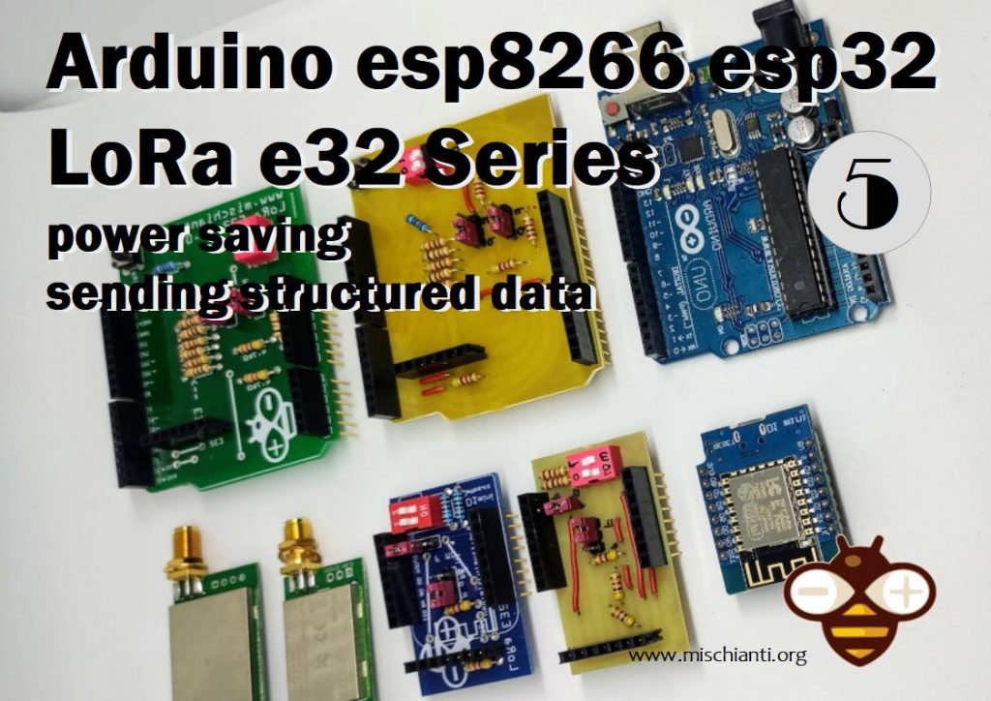LoRa EBYTE E32-TTL-100 Arduino Power saving and structured data

You can find here [AliExpress (433MHz 5Km)](https://s.click.aliexpress.com/e/eOHotRkU) - [AliExpress (433MHz 8Km)](https://s.click.aliexpress.com/e/_DkWxBOv) - [AliExpress (433MHz 16Km)](https://s.click.aliexpress.com/e/_DevlDR3) - [AliExpress (868MHz 915MHz 5.5Km)](https://s.click.aliexpress.com/e/_DDjTmop) - [AliExpress (868MHz 915MHz 8Km)](https://s.click.aliexpress.com/e/_DdCkJG5)

**If you have trouble** **with the device freeze, you must put a pull-up 4.7k resistor or better connect to the device AUX pin.**

[](https://mischianti.org/ebyte-lora-exx-pinout-1/)sx1278 sx1276 wireless lora uart module serial 3000m arduino 433 rf

Another interesting feature is the power saving configuration, and you can set M0 and M1 to do a wake-up from one device to another device in power-saving mode.

| **Mode** | **M1** | **M0** | **Explanation** |
| --- | --- | --- | --- |
| Normal | 0 | 0 | UART and the wireless channel is good to go |
| Wake-Up | 0 | 1 | Same as standard, but a preamble code is added to transmitted data for waking up the receiver. |
| Power-Saving | 1 | 0 | UART is disabled, and wireless is on WOR(wake on radio) mode, which means the device will turn on when data is received. Transmission is not allowed. |
| Sleep | 1 | 1 | Used in setting parameters. Transmitting and receiving are disabled. |

So we need to connect the sending device in Wake-Up mode **(If you fully connect the device, the library manage all modality for you)**:

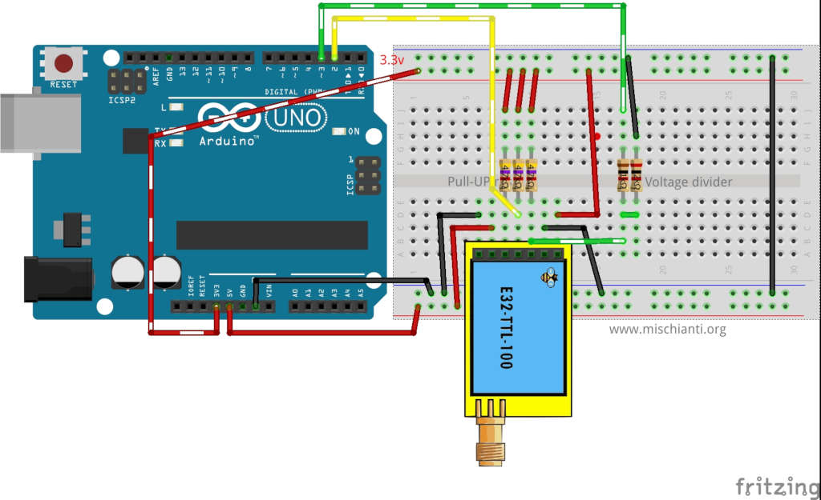

LoRa E32 Arduino Wake-Up connection

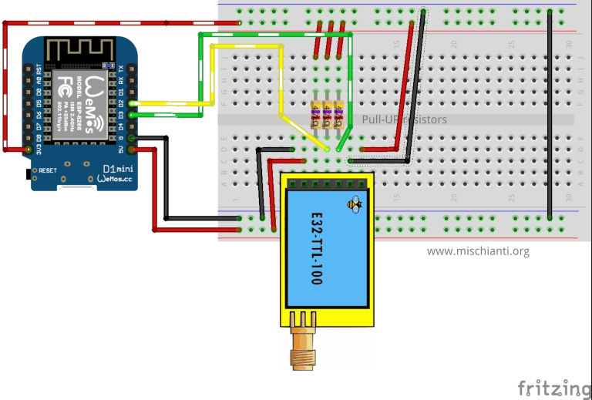

LoRa E32 Wemos D1 wake up connection

LoRa E32 E220 ESP32 DEV KIT V1 Wake UP WOR transmitting mode on breadboard

LoRa E32 E220 Arduino MKR WiFi 1010 Wake UP WOR transmitting mode on breadboard

And receiver device in power saving mode **(If you fully connected the device, the library do all modality for you)**:

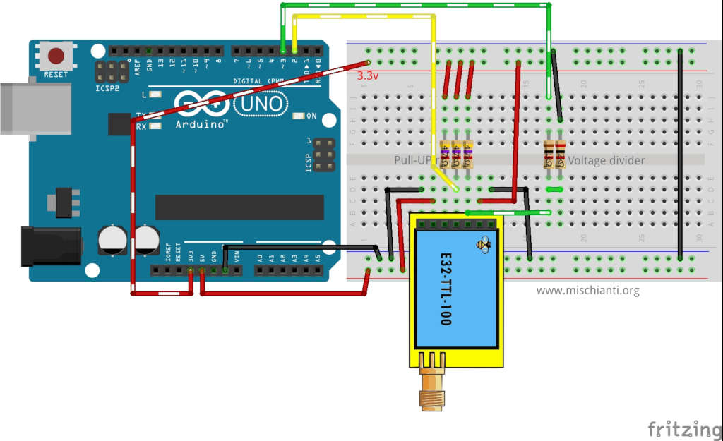LoRa E32 Arduino Power Saving connection

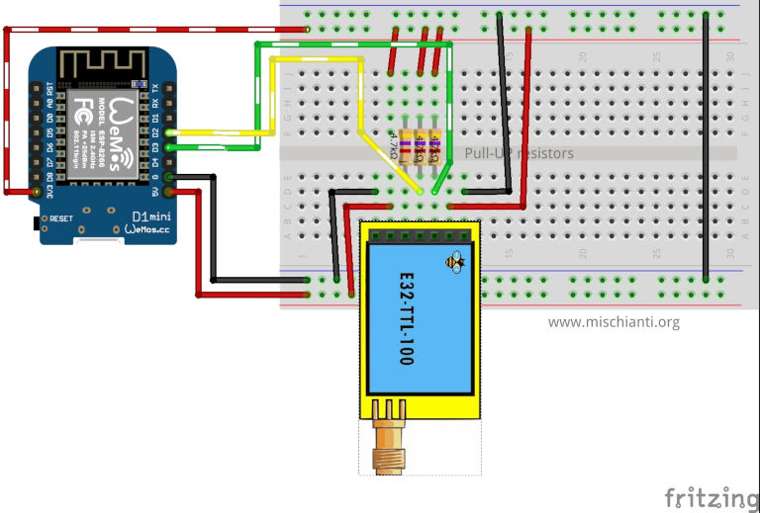LoRa E32 Wemos D1 power saving connection

LoRa E32 E220 ESP32 DEV KIT V1 Power saving, WOR receiving mode on the breadboard

LoRa E32 E220 Arduino MKR WiFi 1010 Power saving WOR receiving mode on the breadboard

Then you can use the sketch already posted.

* [Wake time](https://mischianti.org/lora-e32-device-for-arduino-esp32-or-esp8266-power-saving-and-sending-structured-data-part-5/#Wake_time)
* [Send complex structure](https://mischianti.org/lora-e32-device-for-arduino-esp32-or-esp8266-power-saving-and-sending-structured-data-part-5/#Send_complex_structure)
* [Read a piece of structure](https://mischianti.org/lora-e32-device-for-arduino-esp32-or-esp8266-power-saving-and-sending-structured-data-part-5/#Read_a_piece_of_structure)
* [Thanks](https://mischianti.org/lora-e32-device-for-arduino-esp32-or-esp8266-power-saving-and-sending-structured-data-part-5/#Thanks)

## Wake time

A critical configuration parameter is wake time, for the sender is important because It adds a long preamble to the message (long as wake time). This receiver use wake time as a pull interval time check.  
So if the receiver checks every 250ms (wake time) if there is a message if the sender adds a 2 seconds wake time, the receiver probably scans the message preamble, waits that arrive the actual message, read It and return to power save mode.

So If you want to maximize the power save, you must put minimal WAKE TIME to the sender and maximize WAKE TIME to the receiver; if you want more efficiency, you must do the inverse.

Sending sketch **(if you don’t make connection entirely**, remember that first, you must set configuration in program/sleep mode and then**return in specified modality)**

|  |  |
| --- | --- |
| 1  2  3  4  5  6  7  8  9  10  11  12  13  14  15  16  17  18  19  20  21  22  23  24  25  26  27  28  29  30  31  32  33  34  35  36  37  38  39  40  41  42  43  44  45  46  47  48  49  50  51  52  53  54  55  56  57  58  59  60  61  62  63  64  65  66  67  68  69  70  71  72  73  74  75  76  77  78  79  80  81  82  83  84  85  86  87  88  89  90  91  92  93  94  95  96  97  98  99  100  101  102  103  104  105  106  107  108  109  110 | /*   * LoRa E32-TTL-100   * Send fixed transmission message to a specified point.   * [https://mischianti.org](https://mischianti.org/)   *   * E32-TTL-100----- Arduino UNO or esp8266   * M0         ----- 3.3v (To config) 3.3v (To send) 7 (To dinamically manage)   * M1         ----- 3.3v (To config) GND  (To send) 6 (To dinamically manage)   * TX         ----- PIN 2 (PullUP)   * RX         ----- PIN 3 (PullUP & Voltage divider)   * AUX        ----- Not connected (5 if you connect)   * VCC        ----- 3.3v/5v   * GND        ----- GND   *   */  #include "Arduino.h"  #include "LoRa_E32.h"    // ---------- esp8266 pins --------------  //LoRa_E32 e32ttl(D2, D3, D5, D7, D6);  //LoRa_E32 e32ttl(D2, D3, D5, D7, D6); // Config without connect AUX and M0 M1  #include <SoftwareSerial.h>  SoftwareSerial mySerial(D2, D3); // e32 TX e32 RX  LoRa_E32 e32ttl(**&**mySerial, D5, D7, D6);    //#include <SoftwareSerial.h>  //SoftwareSerial mySerial(D2, D3); // e32 TX e32 RX  //LoRa_E32 e32ttl(&mySerial, D5, D7, D6);  // -------------------------------------    // ---------- Arduino pins --------------  //LoRa_E32 e32ttl(2, 3, 5, 7, 6);  //LoRa_E32 e32ttl(2, 3); // Config without connect AUX and M0 M1    //#include <SoftwareSerial.h>  //SoftwareSerial mySerial(2, 3); // e32 TX e32 RX  //LoRa_E32 e32ttl(&mySerial, 5, 7, 6);  // -------------------------------------    **void** printParameters(struct Configuration configuration);  **void** printModuleInformation(struct ModuleInformation moduleInformation);  //The setup function is called once at startup of the sketch  **void** **setup**()  {      Serial.begin(9600);  **while** (**!**Serial) {          ; // wait for serial port to connect. Needed for native USB      }      delay(100);        e32ttl.begin();          e32ttl.setMode(MODE_1_WAKE_UP);        // After set configuration comment set M0 and M1 to low      // and reboot if you directly set HIGH M0 and M1 to program      ResponseStructContainer c;      c **=** e32ttl.getConfiguration();      Configuration configuration **=** **\***(Configuration**\***) c.data;      configuration.ADDL **=** 0x01;      configuration.ADDH **=** 0x00;      configuration.CHAN **=** 0x04;      configuration.OPTION.fixedTransmission **=** FT_FIXED_TRANSMISSION;      configuration.OPTION.wirelessWakeupTime **=** WAKE_UP_2000;      e32ttl.setConfiguration(configuration, WRITE_CFG_PWR_DWN_SAVE);      printParameters(configuration);      // ---------------------------  }    // The loop function is called in an endless loop  **void** **loop**()  {      delay(2000);        Serial.println("Send message to 00 03 04");      ResponseStatus rs **=** e32ttl.sendFixedMessage(0, 3, 0x04, "Message to 00 03 04 device");      Serial.println(rs.getResponseDescription());  }    **void** printParameters(struct Configuration configuration) {      Serial.println("----------------------------------------");        Serial.print(F("HEAD : "));  Serial.print(configuration.HEAD, BIN);Serial.print(" ");Serial.print(configuration.HEAD, DEC);Serial.print(" ");Serial.println(configuration.HEAD, HEX);      Serial.println(F(" "));      Serial.print(F("AddH : "));  Serial.println(configuration.ADDH, BIN);      Serial.print(F("AddL : "));  Serial.println(configuration.ADDL, BIN);      Serial.print(F("Chan : "));  Serial.print(configuration.CHAN, DEC); Serial.print(" -> "); Serial.println(configuration.getChannelDescription());      Serial.println(F(" "));      Serial.print(F("SpeedParityBit     : "));  Serial.print(configuration.SPED.uartParity, BIN);Serial.print(" -> "); Serial.println(configuration.SPED.getUARTParityDescription());      Serial.print(F("SpeedUARTDatte  : "));  Serial.print(configuration.SPED.uartBaudRate, BIN);Serial.print(" -> "); Serial.println(configuration.SPED.getUARTBaudRate());      Serial.print(F("SpeedAirDataRate   : "));  Serial.print(configuration.SPED.airDataRate, BIN);Serial.print(" -> "); Serial.println(configuration.SPED.getAirDataRate());        Serial.print(F("OptionTrans        : "));  Serial.print(configuration.OPTION.fixedTransmission, BIN);Serial.print(" -> "); Serial.println(configuration.OPTION.getFixedTransmissionDescription());      Serial.print(F("OptionPullup       : "));  Serial.print(configuration.OPTION.ioDriveMode, BIN);Serial.print(" -> "); Serial.println(configuration.OPTION.getIODroveModeDescription());      Serial.print(F("OptionWakeup       : "));  Serial.print(configuration.OPTION.wirelessWakeupTime, BIN);Serial.print(" -> "); Serial.println(configuration.OPTION.getWirelessWakeUPTimeDescription());      Serial.print(F("OptionFEC          : "));  Serial.print(configuration.OPTION.fec, BIN);Serial.print(" -> "); Serial.println(configuration.OPTION.getFECDescription());      Serial.print(F("OptionPower        : "));  Serial.print(configuration.OPTION.transmissionPower, BIN);Serial.print(" -> "); Serial.println(configuration.OPTION.getTransmissionPowerDescription());        Serial.println("----------------------------------------");    }  **void** printModuleInformation(struct ModuleInformation moduleInformation) {      Serial.println("----------------------------------------");      Serial.print(F("HEAD BIN: "));  Serial.print(moduleInformation.HEAD, BIN);Serial.print(" ");Serial.print(moduleInformation.HEAD, DEC);Serial.print(" ");Serial.println(moduleInformation.HEAD, HEX);        Serial.print(F("Freq.: "));  Serial.println(moduleInformation.frequency, HEX);      Serial.print(F("Version  : "));  Serial.println(moduleInformation.version, HEX);      Serial.print(F("Features : "));  Serial.println(moduleInformation.features, HEX);      Serial.println("----------------------------------------");    } |

And receiving sketch **(if you don’t make connection entirely**, remember that first, you must set configuration in program/sleep mode and then**return in specified modality)**:

|  |  |
| --- | --- |
| 1  2  3  4  5  6  7  8  9  10  11  12  13  14  15  16  17  18  19  20  21  22  23  24  25  26  27  28  29  30  31  32  33  34  35  36  37  38  39  40  41  42  43  44  45  46  47  48  49  50  51  52  53  54  55  56  57  58  59  60  61  62  63  64  65  66  67  68  69  70  71  72  73  74  75  76  77  78  79  80  81  82  83  84  85  86  87  88  89  90  91  92  93  94  95  96  97  98  99  100  101  102  103  104  105  106  107  108  109  110  111  112  113 | /*   * LoRa E32-TTL-100   * Receive fixed transmission message on channel.   * [https://mischianti.org](https://mischianti.org/)   *   * E32-TTL-100----- Arduino UNO or esp8266   * M0         ----- 3.3v (To config) GND  (To send) 7 (To dinamically manage)   * M1         ----- 3.3v (To config) 3.3v (To send) 6 (To dinamically manage)   * TX         ----- PIN 2 (PullUP)   * RX         ----- PIN 3 (PullUP & Voltage divider)   * AUX        ----- Not connected (5 if you connect)   * VCC        ----- 3.3v/5v   * GND        ----- GND   *   */  #include "Arduino.h"  #include "LoRa_E32.h"    // ---------- esp8266 pins --------------  //LoRa_E32 e32ttl(D2, D3, D5, D7, D6);  //LoRa_E32 e32ttl(D2, D3); // Config without connect AUX and M0 M1    //#include <SoftwareSerial.h>  //SoftwareSerial mySerial(D2, D3);  // e32 TX e32 RX  //LoRa_E32 e32ttl(&mySerial, D5, D7, D6);  // -------------------------------------    // ---------- Arduino pins --------------  //LoRa_E32 e32ttl(2, 3, 5, 7, 6);  LoRa_E32 e32ttl(2, 3); // Config without connect AUX and M0 M1    //#include <SoftwareSerial.h>  //SoftwareSerial mySerial(2, 3); // e32 TX e32 RX  //LoRa_E32 e32ttl(&mySerial, 5, 7, 6);  // -------------------------------------  **void** printParameters(struct Configuration configuration);  **void** printModuleInformation(struct ModuleInformation moduleInformation);  //The setup function is called once at startup of the sketch  **void** **setup**()  {      Serial.begin(9600);  **while** (**!**Serial) {          ; // wait for serial port to connect. Needed for native USB      }      delay(100);        e32ttl.begin();          e32ttl.setMode(MODE_2_POWER_SAVING);    //  e32ttl.resetModule();      // After set configuration comment set M0 and M1 to low      // and reboot if you directly set HIGH M0 and M1 to program      ResponseStructContainer c;      c **=** e32ttl.getConfiguration();      Configuration configuration **=** **\***(Configuration**\***) c.data;      configuration.ADDL **=** 3;      configuration.ADDH **=** 0;      configuration.CHAN **=** 0x04;      configuration.OPTION.fixedTransmission **=** FT_FIXED_TRANSMISSION;      configuration.OPTION.wirelessWakeupTime **=** WAKE_UP_250;        e32ttl.setConfiguration(configuration, WRITE_CFG_PWR_DWN_SAVE);      printParameters(configuration);      // ---------------------------      Serial.println();      Serial.println("Start listening!");  }    // The loop function is called in an endless loop  **void** **loop**()  {  **if** (e32ttl.available()  > 1){          ResponseContainer rs **=** e32ttl.receiveMessage();          // First of all get the data          String message **=** rs.data;            Serial.println(rs.status.getResponseDescription());          Serial.println(message);      }  }    **void** printParameters(struct Configuration configuration) {      Serial.println("----------------------------------------");        Serial.print(F("HEAD : "));  Serial.print(configuration.HEAD, BIN);Serial.print(" ");Serial.print(configuration.HEAD, DEC);Serial.print(" ");Serial.println(configuration.HEAD, HEX);      Serial.println(F(" "));      Serial.print(F("AddH : "));  Serial.println(configuration.ADDH, DEC);      Serial.print(F("AddL : "));  Serial.println(configuration.ADDL, DEC);      Serial.print(F("Chan : "));  Serial.print(configuration.CHAN, DEC); Serial.print(" -> "); Serial.println(configuration.getChannelDescription());      Serial.println(F(" "));      Serial.print(F("SpeedParityBit     : "));  Serial.print(configuration.SPED.uartParity, BIN);Serial.print(" -> "); Serial.println(configuration.SPED.getUARTParityDescription());      Serial.print(F("SpeedUARTDatte  : "));  Serial.print(configuration.SPED.uartBaudRate, BIN);Serial.print(" -> "); Serial.println(configuration.SPED.getUARTBaudRate());      Serial.print(F("SpeedAirDataRate   : "));  Serial.print(configuration.SPED.airDataRate, BIN);Serial.print(" -> "); Serial.println(configuration.SPED.getAirDataRate());        Serial.print(F("OptionTrans        : "));  Serial.print(configuration.OPTION.fixedTransmission, BIN);Serial.print(" -> "); Serial.println(configuration.OPTION.getFixedTransmissionDescription());      Serial.print(F("OptionPullup       : "));  Serial.print(configuration.OPTION.ioDriveMode, BIN);Serial.print(" -> "); Serial.println(configuration.OPTION.getIODroveModeDescription());      Serial.print(F("OptionWakeup       : "));  Serial.print(configuration.OPTION.wirelessWakeupTime, BIN);Serial.print(" -> "); Serial.println(configuration.OPTION.getWirelessWakeUPTimeDescription());      Serial.print(F("OptionFEC          : "));  Serial.print(configuration.OPTION.fec, BIN);Serial.print(" -> "); Serial.println(configuration.OPTION.getFECDescription());      Serial.print(F("OptionPower        : "));  Serial.print(configuration.OPTION.transmissionPower, BIN);Serial.print(" -> "); Serial.println(configuration.OPTION.getTransmissionPowerDescription());        Serial.println("----------------------------------------");    }  **void** printModuleInformation(struct ModuleInformation moduleInformation) {      Serial.println("----------------------------------------");      Serial.print(F("HEAD BIN: "));  Serial.print(moduleInformation.HEAD, BIN);Serial.print(" ");Serial.print(moduleInformation.HEAD, DEC);Serial.print(" ");Serial.println(moduleInformation.HEAD, HEX);        Serial.print(F("Freq.: "));  Serial.println(moduleInformation.frequency, HEX);      Serial.print(F("Version  : "));  Serial.println(moduleInformation.version, HEX);      Serial.print(F("Features : "));  Serial.println(moduleInformation.features, HEX);      Serial.println("----------------------------------------");    } |

## Send complex structure

We can use string as we want, use It as JSON format, and so on, but if you’re going to use structured messages in native mode (byte array), It’s possible to send them.

The example code for the sender can be:

|  |  |
| --- | --- |
| 1  2  3  4  5  6  7  8  9  10 | struct Message {  **char** type[5] **=** "TEMP";  **char** message[8] **=** "Kitchen";  **byte** temperature[4];  } message;    **\***(**float\***)(message.temperature) **=** 19.2;    ResponseStatus rs **=** e32ttl.sendFixedMessage(0,3,4,**&**message, sizeof(Message));  Serial.println(rs.getResponseDescription()); |

and to receive:

|  |  |
| --- | --- |
| 1  2  3  4  5  6  7  8  9  10 | **if** (e32ttl.available()  > 1){        ResponseStructContainer rsc **=** e32ttl.receiveMessage(sizeof(Message));      struct Message message **=** **\***(Message**\***) rsc.data;      Serial.println(message.type);        Serial.println(**\***(**float\***)(message.temperature));      Serial.println(message.message);      free(rsc.data);  } |

Complete sender sketch:

|  |  |
| --- | --- |
| 1  2  3  4  5  6  7  8  9  10  11  12  13  14  15  16  17  18  19  20  21  22  23  24  25  26  27  28  29  30  31  32  33  34  35  36  37  38  39  40  41  42  43  44  45  46  47  48  49  50  51  52  53  54  55  56  57  58  59  60  61  62  63  64  65  66  67  68  69  70  71  72  73  74  75  76  77  78  79  80  81  82  83  84  85  86  87  88  89  90  91  92  93  94  95  96  97  98  99  100  101  102  103  104  105  106  107  108  109  110  111  112  113  114  115  116  117  118  119  120 | /*   * LoRa E32-TTL-100   * Send fixed transmission structured message to a specified point.   * [https://mischianti.org](https://mischianti.org/)   *   * E32-TTL-100----- Arduino UNO or esp8266   * M0         ----- 3.3v (To config) GND (To send) 7 (To dinamically manage)   * M1         ----- 3.3v (To config) GND (To send) 6 (To dinamically manage)   * TX         ----- PIN 2 (PullUP)   * RX         ----- PIN 3 (PullUP & Voltage divider)   * AUX        ----- Not connected (5 if you connect)   * VCC        ----- 3.3v/5v   * GND        ----- GND   *   */  #include "Arduino.h"  #include "LoRa_E32.h"    // ---------- esp8266 pins --------------  //LoRa_E32 e32ttl(D2, D3, D5, D7, D6);  //LoRa_E32 e32ttl(D2, D3, D5, D7, D6); // Config without connect AUX and M0 M1  #include <SoftwareSerial.h>  SoftwareSerial mySerial(D2, D3); // e32 TX e32 RX  LoRa_E32 e32ttl(**&**mySerial, D5, D7, D6);    //#include <SoftwareSerial.h>  //SoftwareSerial mySerial(D2, D3); // e32 TX e32 RX  //LoRa_E32 e32ttl(&mySerial, D5, D7, D6);  // -------------------------------------    // ---------- Arduino pins --------------  //LoRa_E32 e32ttl(2, 3, 5, 7, 6);  //LoRa_E32 e32ttl(2, 3); // Config without connect AUX and M0 M1    //#include <SoftwareSerial.h>  //SoftwareSerial mySerial(2, 3); // e32 TX e32 RX  //LoRa_E32 e32ttl(&mySerial, 5, 7, 6);  // -------------------------------------    **void** printParameters(struct Configuration configuration);  **void** printModuleInformation(struct ModuleInformation moduleInformation);  //The setup function is called once at startup of the sketch  **void** **setup**()  {      Serial.begin(9600);  **while** (**!**Serial) {          ; // wait for serial port to connect. Needed for native USB      }      delay(100);        e32ttl.begin();      // After set configuration comment set M0 and M1 to low      // and reboot if you directly set HIGH M0 and M1 to program      ResponseStructContainer c;      c **=** e32ttl.getConfiguration();      Configuration configuration **=** **\***(Configuration**\***) c.data;      configuration.ADDL **=** 0x01;      configuration.ADDH **=** 0x00;      configuration.CHAN **=** 0x02;      configuration.OPTION.fixedTransmission **=** FT_FIXED_TRANSMISSION;      e32ttl.setConfiguration(configuration, WRITE_CFG_PWR_DWN_SAVE);      printParameters(configuration);      // ---------------------------  }  struct Message {  **char** type[5];  **char** message[8];  **int** temperature;  } message;    **int** i **=** 0;  // The loop function is called in an endless loop  **void** **loop**()  {      delay(2500);      i**++**;      struct Message {  **char** type[5] **=** "TEMP";  **char** message[8] **=** "Kitchen";  **byte** temperature[4];      } message;    **\***(**float\***)(message.temperature) **=** 19.2;        ResponseStatus rs **=** e32ttl.sendFixedMessage(0,3,4,**&**message, sizeof(Message));      Serial.println(rs.getResponseDescription());  }    **void** printParameters(struct Configuration configuration) {      Serial.println("----------------------------------------");        Serial.print(F("HEAD : "));  Serial.print(configuration.HEAD, BIN);Serial.print(" ");Serial.print(configuration.HEAD, DEC);Serial.print(" ");Serial.println(configuration.HEAD, HEX);      Serial.println(F(" "));      Serial.print(F("AddH : "));  Serial.println(configuration.ADDH, BIN);      Serial.print(F("AddL : "));  Serial.println(configuration.ADDL, BIN);      Serial.print(F("Chan : "));  Serial.print(configuration.CHAN, DEC); Serial.print(" -> "); Serial.println(configuration.getChannelDescription());      Serial.println(F(" "));      Serial.print(F("SpeedParityBit     : "));  Serial.print(configuration.SPED.uartParity, BIN);Serial.print(" -> "); Serial.println(configuration.SPED.getUARTParityDescription());      Serial.print(F("SpeedUARTDatte  : "));  Serial.print(configuration.SPED.uartBaudRate, BIN);Serial.print(" -> "); Serial.println(configuration.SPED.getUARTBaudRate());      Serial.print(F("SpeedAirDataRate   : "));  Serial.print(configuration.SPED.airDataRate, BIN);Serial.print(" -> "); Serial.println(configuration.SPED.getAirDataRate());        Serial.print(F("OptionTrans        : "));  Serial.print(configuration.OPTION.fixedTransmission, BIN);Serial.print(" -> "); Serial.println(configuration.OPTION.getFixedTransmissionDescription());      Serial.print(F("OptionPullup       : "));  Serial.print(configuration.OPTION.ioDriveMode, BIN);Serial.print(" -> "); Serial.println(configuration.OPTION.getIODroveModeDescription());      Serial.print(F("OptionWakeup       : "));  Serial.print(configuration.OPTION.wirelessWakeupTime, BIN);Serial.print(" -> "); Serial.println(configuration.OPTION.getWirelessWakeUPTimeDescription());      Serial.print(F("OptionFEC          : "));  Serial.print(configuration.OPTION.fec, BIN);Serial.print(" -> "); Serial.println(configuration.OPTION.getFECDescription());      Serial.print(F("OptionPower        : "));  Serial.print(configuration.OPTION.transmissionPower, BIN);Serial.print(" -> "); Serial.println(configuration.OPTION.getTransmissionPowerDescription());        Serial.println("----------------------------------------");    }  **void** printModuleInformation(struct ModuleInformation moduleInformation) {      Serial.println("----------------------------------------");      Serial.print(F("HEAD BIN: "));  Serial.print(moduleInformation.HEAD, BIN);Serial.print(" ");Serial.print(moduleInformation.HEAD, DEC);Serial.print(" ");Serial.println(moduleInformation.HEAD, HEX);        Serial.print(F("Freq.: "));  Serial.println(moduleInformation.frequency, HEX);      Serial.print(F("Version  : "));  Serial.println(moduleInformation.version, HEX);      Serial.print(F("Features : "));  Serial.println(moduleInformation.features, HEX);      Serial.println("----------------------------------------");    } |

Complete receiver sketch:

|  |  |
| --- | --- |
| 1  2  3  4  5  6  7  8  9  10  11  12  13  14  15  16  17  18  19  20  21  22  23  24  25  26  27  28  29  30  31  32  33  34  35  36  37  38  39  40  41  42  43  44  45  46  47  48  49  50  51  52  53  54  55  56  57  58  59  60  61  62  63  64  65  66  67  68  69  70  71  72  73  74  75  76  77  78  79  80  81  82  83  84  85  86  87  88  89  90  91  92  93  94  95  96  97  98  99  100  101  102  103  104  105  106  107  108  109  110  111  112  113  114  115  116  117  118  119  120 | /*   * LoRa E32-TTL-100   * Receive fixed transmission message on channel.   * [https://mischianti.org](https://mischianti.org/)   *   * E32-TTL-100----- Arduino UNO or esp8266   * M0         ----- 3.3v (To config) GND (To send) 7 (To dinamically manage)   * M1         ----- 3.3v (To config) GND (To send) 6 (To dinamically manage)   * TX         ----- PIN 2 (PullUP)   * RX         ----- PIN 3 (PullUP & Voltage divider)   * AUX        ----- Not connected (5 if you connect)   * VCC        ----- 3.3v/5v   * GND        ----- GND   *   */  #include "Arduino.h"  #include "LoRa_E32.h"    // ---------- esp8266 pins --------------  //LoRa_E32 e32ttl(D2, D3, D5, D7, D6);  //LoRa_E32 e32ttl(D2, D3); // Config without connect AUX and M0 M1    //#include <SoftwareSerial.h>  //SoftwareSerial mySerial(D2, D3); // e32 TX e32 RX  //LoRa_E32 e32ttl(&mySerial, D5, D7, D6);  // -------------------------------------    // ---------- Arduino pins --------------  //LoRa_E32 e32ttl(2, 3, 5, 7, 6);  LoRa_E32 e32ttl(2, 3, 4); // Config without connect AUX and M0 M1    //#include <SoftwareSerial.h>  //SoftwareSerial mySerial(2, 3); // e32 TX e32 RX  //LoRa_E32 e32ttl(&mySerial, 5, 7, 6);  // -------------------------------------  **void** printParameters(struct Configuration configuration);  **void** printModuleInformation(struct ModuleInformation moduleInformation);  //The setup function is called once at startup of the sketch  **void** **setup**()  {      Serial.begin(9600);  **while** (**!**Serial) {          ; // wait for serial port to connect. Needed for native USB      }      delay(100);        e32ttl.begin();    //  e32ttl.resetModule();      // After set configuration comment set M0 and M1 to low      // and reboot if you directly set HIGH M0 and M1 to program      ResponseStructContainer c;      c **=** e32ttl.getConfiguration();      Configuration configuration **=** **\***(Configuration**\***) c.data;      configuration.ADDL **=** 3;      configuration.ADDH **=** 0;      configuration.CHAN **=** 0x04;      configuration.OPTION.fixedTransmission **=** FT_FIXED_TRANSMISSION;        e32ttl.setConfiguration(configuration, WRITE_CFG_PWR_DWN_SAVE);      printParameters(configuration);      // ---------------------------      Serial.println();      Serial.println("Start listening!");      e32ttl.setMode(MODE_2_POWER_SAVING);    }  struct Message {  **char** type[5];  **char** message[8];  **byte** temperature[4];  };    // The loop function is called in an endless loop  **void** **loop**()  {  **if** (e32ttl.available()  > 1){            ResponseStructContainer rsc **=** e32ttl.receiveMessage(sizeof(Message));          struct Message message **=** **\***(Message**\***) rsc.data;          Serial.println(message.type);            Serial.println(**\***(**float\***)(message.temperature));          Serial.println(message.message);          free(rsc.data);      }  }    **void** printParameters(struct Configuration configuration) {      Serial.println("----------------------------------------");        Serial.print(F("HEAD : "));  Serial.print(configuration.HEAD, BIN);Serial.print(" ");Serial.print(configuration.HEAD, DEC);Serial.print(" ");Serial.println(configuration.HEAD, HEX);      Serial.println(F(" "));      Serial.print(F("AddH : "));  Serial.println(configuration.ADDH, DEC);      Serial.print(F("AddL : "));  Serial.println(configuration.ADDL, DEC);      Serial.print(F("Chan : "));  Serial.print(configuration.CHAN, DEC); Serial.print(" -> "); Serial.println(configuration.getChannelDescription());      Serial.println(F(" "));      Serial.print(F("SpeedParityBit     : "));  Serial.print(configuration.SPED.uartParity, BIN);Serial.print(" -> "); Serial.println(configuration.SPED.getUARTParityDescription());      Serial.print(F("SpeedUARTDatte  : "));  Serial.print(configuration.SPED.uartBaudRate, BIN);Serial.print(" -> "); Serial.println(configuration.SPED.getUARTBaudRate());      Serial.print(F("SpeedAirDataRate   : "));  Serial.print(configuration.SPED.airDataRate, BIN);Serial.print(" -> "); Serial.println(configuration.SPED.getAirDataRate());        Serial.print(F("OptionTrans        : "));  Serial.print(configuration.OPTION.fixedTransmission, BIN);Serial.print(" -> "); Serial.println(configuration.OPTION.getFixedTransmissionDescription());      Serial.print(F("OptionPullup       : "));  Serial.print(configuration.OPTION.ioDriveMode, BIN);Serial.print(" -> "); Serial.println(configuration.OPTION.getIODroveModeDescription());      Serial.print(F("OptionWakeup       : "));  Serial.print(configuration.OPTION.wirelessWakeupTime, BIN);Serial.print(" -> "); Serial.println(configuration.OPTION.getWirelessWakeUPTimeDescription());      Serial.print(F("OptionFEC          : "));  Serial.print(configuration.OPTION.fec, BIN);Serial.print(" -> "); Serial.println(configuration.OPTION.getFECDescription());      Serial.print(F("OptionPower        : "));  Serial.print(configuration.OPTION.transmissionPower, BIN);Serial.print(" -> "); Serial.println(configuration.OPTION.getTransmissionPowerDescription());        Serial.println("----------------------------------------");    }  **void** printModuleInformation(struct ModuleInformation moduleInformation) {      Serial.println("----------------------------------------");      Serial.print(F("HEAD BIN: "));  Serial.print(moduleInformation.HEAD, BIN);Serial.print(" ");Serial.print(moduleInformation.HEAD, DEC);Serial.print(" ");Serial.println(moduleInformation.HEAD, HEX);        Serial.print(F("Freq.: "));  Serial.println(moduleInformation.frequency, HEX);      Serial.print(F("Version  : "));  Serial.println(moduleInformation.version, HEX);      Serial.print(F("Features : "));  Serial.println(moduleInformation.features, HEX);      Serial.println("----------------------------------------");    } |

But real life is not so simple, and probably you have multiple sensors with different structures in your home, so you need to receive various structures. A possible solution is to read the first part of the structure and instantiate the rest as you want.

## Read a piece of structure

So if you would have the TYPE of structure you are going to read:

|  |  |
| --- | --- |
| 1  2  3 | **char** type[5]; // first part of structure  ResponseContainer rs **=** e32ttl.receiveInitialMessage(sizeof(type));          String typeStr **=** rs.data; |

With this information, we can create specified structures from different devices, for example:

|  |  |
| --- | --- |
| 1  2  3  4  5  6  7  8  9  10 | struct Message {  **char** type[5] **=** "TEMP";  **char** message[8] **=** "Kitchen";  **byte** temperature[4];  } message;    **\***(**float\***)(message.temperature) **=** 19.2;    ResponseStatus rs **=** e32ttl.sendFixedMessage(0,3,4,**&**message, sizeof(Message));  Serial.println(rs.getResponseDescription()); |

or

|  |  |
| --- | --- |
| 1  2  3  4  5  6  7  8  9  10 | struct Message {  **char** type[5] **=** "HUM";  **char** message[8] **=** "Room";  **byte** humidity;  } message;    message.humidity **=** 65;    ResponseStatus rs **=** e32ttl.sendFixedMessage(0,3,4,**&**message, sizeof(Message));  Serial.println(rs.getResponseDescription()); |

And so you can load specified structure from the receiver:

|  |  |
| --- | --- |
| 1  2  3  4  5  6  7  8  9  10  11  12  13  14  15  16  17  18  19  20  21  22  23  24  25  26  27 | **if** (e32ttl.available()  > 1){  **char** type[5]; // first part of structure          ResponseContainer rs **=** e32ttl.receiveInitialMessage(sizeof(type));  //      Put string in a char array (not needed)  //      memcpy ( type, rs.data.c_str(), sizeof(type) );          String typeStr **=** rs.data;            Serial.println(typeStr);  **if** (typeStr**==**"TEMP"){              ResponseStructContainer rsc **=** e32ttl.receiveMessage(sizeof(Message));              struct Message message **=** **\***(Message**\***) rsc.data;                Serial.println(**\***(**float\***)(message.temperature));              Serial.println(message.message);              free(rsc.data);          }**else** **if** (typeStr **==** "HUM"){              ResponseStructContainer rsc **=** e32ttl.receiveMessage(sizeof(MessageHumidity));              struct MessageHumidity message **=** **\***(MessageHumidity**\***) rsc.data;                Serial.println(message.humidity);              Serial.println(message.message);              free(rsc.data);            }**else**{              Serial.println("Something goes wrong!!");          }      } |

So we have two sender sketches like this that send float temperature:

|  |  |
| --- | --- |
| 1  2  3  4  5  6  7  8  9  10  11  12  13  14  15  16  17  18  19  20  21  22  23  24  25  26  27  28  29  30  31  32  33  34  35  36  37  38  39  40  41  42  43  44  45  46  47  48  49  50  51  52  53  54  55  56  57  58  59  60  61  62  63  64  65  66  67  68  69  70  71  72  73  74  75  76  77  78  79  80  81  82  83  84  85  86  87  88  89  90  91  92  93  94  95  96  97  98  99  100  101  102  103  104  105  106  107  108  109  110  111  112  113  114  115  116  117  118  119  120 | /*   * LoRa E32-TTL-100   * Send fixed transmission structured message to a specified point.   * [https://mischianti.org](https://mischianti.org/)   *   * E32-TTL-100----- Arduino UNO or esp8266   * M0         ----- 3.3v (To config) GND (To send) 7 (To dinamically manage)   * M1         ----- 3.3v (To config) GND (To send) 6 (To dinamically manage)   * TX         ----- PIN 2 (PullUP)   * RX         ----- PIN 3 (PullUP & Voltage divider)   * AUX        ----- Not connected (5 if you connect)   * VCC        ----- 3.3v/5v   * GND        ----- GND   *   */  #include "Arduino.h"  #include "LoRa_E32.h"    // ---------- esp8266 pins --------------  //LoRa_E32 e32ttl(D2, D3, D5, D7, D6);  //LoRa_E32 e32ttl(D2, D3, D5, D7, D6); // Config without connect AUX and M0 M1  #include <SoftwareSerial.h>  SoftwareSerial mySerial(D2, D3); // e32 TX e32 RX  LoRa_E32 e32ttl(**&**mySerial, D5, D7, D6);    //#include <SoftwareSerial.h>  //SoftwareSerial mySerial(D2, D3); // e32 TX e32 RX  //LoRa_E32 e32ttl(&mySerial, D5, D7, D6);  // -------------------------------------    // ---------- Arduino pins --------------  //LoRa_E32 e32ttl(2, 3, 5, 7, 6);  //LoRa_E32 e32ttl(2, 3); // Config without connect AUX and M0 M1    //#include <SoftwareSerial.h>  //SoftwareSerial mySerial(2, 3); // e32 TX e32 RX  //LoRa_E32 e32ttl(&mySerial, 5, 7, 6);  // -------------------------------------    **void** printParameters(struct Configuration configuration);  **void** printModuleInformation(struct ModuleInformation moduleInformation);  //The setup function is called once at startup of the sketch  **void** **setup**()  {      Serial.begin(9600);  **while** (**!**Serial) {          ; // wait for serial port to connect. Needed for native USB      }      delay(100);        e32ttl.begin();      // After set configuration comment set M0 and M1 to low      // and reboot if you directly set HIGH M0 and M1 to program      ResponseStructContainer c;      c **=** e32ttl.getConfiguration();      Configuration configuration **=** **\***(Configuration**\***) c.data;      configuration.ADDL **=** 0x01;      configuration.ADDH **=** 0x00;      configuration.CHAN **=** 0x02;      configuration.OPTION.fixedTransmission **=** FT_FIXED_TRANSMISSION;      e32ttl.setConfiguration(configuration, WRITE_CFG_PWR_DWN_SAVE);      printParameters(configuration);      // ---------------------------  }  struct Message {  **char** type[5];  **char** message[8];  **int** temperature;  } message;    **int** i **=** 0;  // The loop function is called in an endless loop  **void** **loop**()  {      delay(2500);      i**++**;      struct Message {  **char** type[5] **=** "TEMP";  **char** message[8] **=** "Kitchen";  **byte** temperature[4];      } message;    **\***(**float\***)(message.temperature) **=** 19.2;        ResponseStatus rs **=** e32ttl.sendFixedMessage(0,3,4,**&**message, sizeof(Message));      Serial.println(rs.getResponseDescription());  }    **void** printParameters(struct Configuration configuration) {      Serial.println("----------------------------------------");        Serial.print(F("HEAD : "));  Serial.print(configuration.HEAD, BIN);Serial.print(" ");Serial.print(configuration.HEAD, DEC);Serial.print(" ");Serial.println(configuration.HEAD, HEX);      Serial.println(F(" "));      Serial.print(F("AddH : "));  Serial.println(configuration.ADDH, BIN);      Serial.print(F("AddL : "));  Serial.println(configuration.ADDL, BIN);      Serial.print(F("Chan : "));  Serial.print(configuration.CHAN, DEC); Serial.print(" -> "); Serial.println(configuration.getChannelDescription());      Serial.println(F(" "));      Serial.print(F("SpeedParityBit     : "));  Serial.print(configuration.SPED.uartParity, BIN);Serial.print(" -> "); Serial.println(configuration.SPED.getUARTParityDescription());      Serial.print(F("SpeedUARTDatte  : "));  Serial.print(configuration.SPED.uartBaudRate, BIN);Serial.print(" -> "); Serial.println(configuration.SPED.getUARTBaudRate());      Serial.print(F("SpeedAirDataRate   : "));  Serial.print(configuration.SPED.airDataRate, BIN);Serial.print(" -> "); Serial.println(configuration.SPED.getAirDataRate());        Serial.print(F("OptionTrans        : "));  Serial.print(configuration.OPTION.fixedTransmission, BIN);Serial.print(" -> "); Serial.println(configuration.OPTION.getFixedTransmissionDescription());      Serial.print(F("OptionPullup       : "));  Serial.print(configuration.OPTION.ioDriveMode, BIN);Serial.print(" -> "); Serial.println(configuration.OPTION.getIODroveModeDescription());      Serial.print(F("OptionWakeup       : "));  Serial.print(configuration.OPTION.wirelessWakeupTime, BIN);Serial.print(" -> "); Serial.println(configuration.OPTION.getWirelessWakeUPTimeDescription());      Serial.print(F("OptionFEC          : "));  Serial.print(configuration.OPTION.fec, BIN);Serial.print(" -> "); Serial.println(configuration.OPTION.getFECDescription());      Serial.print(F("OptionPower        : "));  Serial.print(configuration.OPTION.transmissionPower, BIN);Serial.print(" -> "); Serial.println(configuration.OPTION.getTransmissionPowerDescription());        Serial.println("----------------------------------------");    }  **void** printModuleInformation(struct ModuleInformation moduleInformation) {      Serial.println("----------------------------------------");      Serial.print(F("HEAD BIN: "));  Serial.print(moduleInformation.HEAD, BIN);Serial.print(" ");Serial.print(moduleInformation.HEAD, DEC);Serial.print(" ");Serial.println(moduleInformation.HEAD, HEX);        Serial.print(F("Freq.: "));  Serial.println(moduleInformation.frequency, HEX);      Serial.print(F("Version  : "));  Serial.println(moduleInformation.version, HEX);      Serial.print(F("Features : "));  Serial.println(moduleInformation.features, HEX);      Serial.println("----------------------------------------");    } |

and like so to send humidity value:

|  |  |
| --- | --- |
| 1  2  3  4  5  6  7  8  9  10  11  12  13  14  15  16  17  18  19  20  21  22  23  24  25  26  27  28  29  30  31  32  33  34  35  36  37  38  39  40  41  42  43  44  45  46  47  48  49  50  51  52  53  54  55  56  57  58  59  60  61  62  63  64  65  66  67  68  69  70  71  72  73  74  75  76  77  78  79  80  81  82  83  84  85  86  87  88  89  90  91  92  93  94  95  96  97  98  99  100  101  102  103  104  105  106  107  108  109  110  111  112  113  114 | /*   * LoRa E32-TTL-100   * Send fixed transmission structured message to a specified point.   * [https://mischianti.org](https://mischianti.org/)   *   * E32-TTL-100----- Arduino UNO or esp8266   * M0         ----- 3.3v (To config) GND (To send) 7 (To dinamically manage)   * M1         ----- 3.3v (To config) GND (To send) 6 (To dinamically manage)   * TX         ----- PIN 2 (PullUP)   * RX         ----- PIN 3 (PullUP & Voltage divider)   * AUX        ----- Not connected (5 if you connect)   * VCC        ----- 3.3v/5v   * GND        ----- GND   *   */  #include "Arduino.h"  #include "LoRa_E32.h"    // ---------- esp8266 pins --------------  //LoRa_E32 e32ttl(D2, D3, D5, D7, D6);  //LoRa_E32 e32ttl(D2, D3, D5, D7, D6); // Config without connect AUX and M0 M1  #include <SoftwareSerial.h>  SoftwareSerial mySerial(D2, D3); // e32 TX e32 RX  LoRa_E32 e32ttl(**&**mySerial, D5, D7, D6);    //#include <SoftwareSerial.h>  //SoftwareSerial mySerial(D2, D3); // e32 TX e32 RX  //LoRa_E32 e32ttl(&mySerial, D5, D7, D6);  // -------------------------------------    // ---------- Arduino pins --------------  //LoRa_E32 e32ttl(2, 3, 5, 7, 6);  //LoRa_E32 e32ttl(2, 3); // Config without connect AUX and M0 M1    //#include <SoftwareSerial.h>  //SoftwareSerial mySerial(2, 3); // e32 TX e32 RX  //LoRa_E32 e32ttl(&mySerial, 5, 7, 6);  // -------------------------------------    **void** printParameters(struct Configuration configuration);  **void** printModuleInformation(struct ModuleInformation moduleInformation);  //The setup function is called once at startup of the sketch  **void** **setup**()  {      Serial.begin(9600);  **while** (**!**Serial) {          ; // wait for serial port to connect. Needed for native USB      }      delay(100);        e32ttl.begin();      // After set configuration comment set M0 and M1 to low      // and reboot if you directly set HIGH M0 and M1 to program      ResponseStructContainer c;      c **=** e32ttl.getConfiguration();      Configuration configuration **=** **\***(Configuration**\***) c.data;      configuration.ADDL **=** 0x02;      configuration.ADDH **=** 0x00;      configuration.CHAN **=** 0x02;      configuration.OPTION.fixedTransmission **=** FT_FIXED_TRANSMISSION;      e32ttl.setConfiguration(configuration, WRITE_CFG_PWR_DWN_SAVE);      printParameters(configuration);      // ---------------------------  }  **int** i **=** 0;  // The loop function is called in an endless loop  **void** **loop**()  {      delay(2500);      i**++**;      struct Message {  **char** type[5] **=** "HUM";  **char** message[8] **=** "Room";  **byte** humidity;      } message;        message.humidity **=** 65;        ResponseStatus rs **=** e32ttl.sendFixedMessage(0,3,4,**&**message, sizeof(Message));      Serial.println(rs.getResponseDescription());  }    **void** printParameters(struct Configuration configuration) {      Serial.println("----------------------------------------");        Serial.print(F("HEAD : "));  Serial.print(configuration.HEAD, BIN);Serial.print(" ");Serial.print(configuration.HEAD, DEC);Serial.print(" ");Serial.println(configuration.HEAD, HEX);      Serial.println(F(" "));      Serial.print(F("AddH : "));  Serial.println(configuration.ADDH, BIN);      Serial.print(F("AddL : "));  Serial.println(configuration.ADDL, BIN);      Serial.print(F("Chan : "));  Serial.print(configuration.CHAN, DEC); Serial.print(" -> "); Serial.println(configuration.getChannelDescription());      Serial.println(F(" "));      Serial.print(F("SpeedParityBit     : "));  Serial.print(configuration.SPED.uartParity, BIN);Serial.print(" -> "); Serial.println(configuration.SPED.getUARTParityDescription());      Serial.print(F("SpeedUARTDatte  : "));  Serial.print(configuration.SPED.uartBaudRate, BIN);Serial.print(" -> "); Serial.println(configuration.SPED.getUARTBaudRate());      Serial.print(F("SpeedAirDataRate   : "));  Serial.print(configuration.SPED.airDataRate, BIN);Serial.print(" -> "); Serial.println(configuration.SPED.getAirDataRate());        Serial.print(F("OptionTrans        : "));  Serial.print(configuration.OPTION.fixedTransmission, BIN);Serial.print(" -> "); Serial.println(configuration.OPTION.getFixedTransmissionDescription());      Serial.print(F("OptionPullup       : "));  Serial.print(configuration.OPTION.ioDriveMode, BIN);Serial.print(" -> "); Serial.println(configuration.OPTION.getIODroveModeDescription());      Serial.print(F("OptionWakeup       : "));  Serial.print(configuration.OPTION.wirelessWakeupTime, BIN);Serial.print(" -> "); Serial.println(configuration.OPTION.getWirelessWakeUPTimeDescription());      Serial.print(F("OptionFEC          : "));  Serial.print(configuration.OPTION.fec, BIN);Serial.print(" -> "); Serial.println(configuration.OPTION.getFECDescription());      Serial.print(F("OptionPower        : "));  Serial.print(configuration.OPTION.transmissionPower, BIN);Serial.print(" -> "); Serial.println(configuration.OPTION.getTransmissionPowerDescription());        Serial.println("----------------------------------------");    }  **void** printModuleInformation(struct ModuleInformation moduleInformation) {      Serial.println("----------------------------------------");      Serial.print(F("HEAD BIN: "));  Serial.print(moduleInformation.HEAD, BIN);Serial.print(" ");Serial.print(moduleInformation.HEAD, DEC);Serial.print(" ");Serial.println(moduleInformation.HEAD, HEX);        Serial.print(F("Freq.: "));  Serial.println(moduleInformation.frequency, HEX);      Serial.print(F("Version  : "));  Serial.println(moduleInformation.version, HEX);      Serial.print(F("Features : "));  Serial.println(moduleInformation.features, HEX);      Serial.println("----------------------------------------");    } |

And a receiver that manages the two types of messages:

|  |  |
| --- | --- |
| 1  2  3  4  5  6  7  8  9  10  11  12  13  14  15  16  17  18  19  20  21  22  23  24  25  26  27  28  29  30  31  32  33  34  35  36  37  38  39  40  41  42  43  44  45  46  47  48  49  50  51  52  53  54  55  56  57  58  59  60  61  62  63  64  65  66  67  68  69  70  71  72  73  74  75  76  77  78  79  80  81  82  83  84  85  86  87  88  89  90  91  92  93  94  95  96  97  98  99  100  101  102  103  104  105  106  107  108  109  110  111  112  113  114  115  116  117  118  119  120  121  122  123  124  125  126  127  128  129  130  131  132  133  134  135  136  137  138  139  140 | /*   * LoRa E32-TTL-100   * Receive fixed transmission structure message and read first part and load the rest of structure.   * [https://mischianti.org](https://mischianti.org/)   *   * E32-TTL-100----- Arduino UNO or esp8266   * M0         ----- 3.3v (To config) GND (To send) 7 (To dinamically manage)   * M1         ----- 3.3v (To config) GND (To send) 6 (To dinamically manage)   * TX         ----- PIN 2 (PullUP)   * RX         ----- PIN 3 (PullUP & Voltage divider)   * AUX        ----- Not connected (5 if you connect)   * VCC        ----- 3.3v/5v   * GND        ----- GND   *   */  #include "Arduino.h"  #include "LoRa_E32.h"    // ---------- esp8266 pins --------------  //LoRa_E32 e32ttl(D2, D3, D5, D7, D6);  //LoRa_E32 e32ttl(D2, D3); // Config without connect AUX and M0 M1    //#include <SoftwareSerial.h>  //SoftwareSerial mySerial(D2, D3); // e32 TX e32 RX  //LoRa_E32 e32ttl(&mySerial, D5, D7, D6);  // -------------------------------------    // ---------- Arduino pins --------------  //LoRa_E32 e32ttl(2, 3, 5, 7, 6);  LoRa_E32 e32ttl(2, 3, 4); // Config without connect AUX and M0 M1    //#include <SoftwareSerial.h>  //SoftwareSerial mySerial(2, 3); // e32 TX e32 RX  //LoRa_E32 e32ttl(&mySerial, 5, 7, 6);  // -------------------------------------  **void** printParameters(struct Configuration configuration);  **void** printModuleInformation(struct ModuleInformation moduleInformation);  //The setup function is called once at startup of the sketch  **void** **setup**()  {      Serial.begin(9600);  **while** (**!**Serial) {          ; // wait for serial port to connect. Needed for native USB      }      delay(100);        e32ttl.begin();    //  e32ttl.resetModule();      // After set configuration comment set M0 and M1 to low      // and reboot if you directly set HIGH M0 and M1 to program      ResponseStructContainer c;      c **=** e32ttl.getConfiguration();      Configuration configuration **=** **\***(Configuration**\***) c.data;      configuration.ADDL **=** 3;      configuration.ADDH **=** 0;      configuration.CHAN **=** 0x04;      configuration.OPTION.fixedTransmission **=** FT_FIXED_TRANSMISSION;        e32ttl.setConfiguration(configuration, WRITE_CFG_PWR_DWN_SAVE);      printParameters(configuration);      // ---------------------------      Serial.println();      Serial.println("Start listening!");      e32ttl.setMode(MODE_2_POWER_SAVING);    }  struct Message {  **char** message[8];  **byte** temperature[4];  };  struct MessageHumidity {  **char** message[8];  **byte** humidity;  };    // The loop function is called in an endless loop  **void** **loop**()  {  **if** (e32ttl.available()  > 1){  **char** type[5]; // first part of structure          ResponseContainer rs **=** e32ttl.receiveInitialMessage(sizeof(type));  //      Put string in a char array (not needed)  //      memcpy ( type, rs.data.c_str(), sizeof(type) );          String typeStr **=** rs.data;            Serial.println(typeStr);  **if** (typeStr**==**"TEMP"){              ResponseStructContainer rsc **=** e32ttl.receiveMessage(sizeof(Message));              struct Message message **=** **\***(Message**\***) rsc.data;                Serial.println(**\***(**float\***)(message.temperature));              Serial.println(message.message);              free(rsc.data);          }**else** **if** (typeStr **==** "HUM"){              ResponseStructContainer rsc **=** e32ttl.receiveMessage(sizeof(MessageHumidity));              struct MessageHumidity message **=** **\***(MessageHumidity**\***) rsc.data;                Serial.println(message.humidity);              Serial.println(message.message);              free(rsc.data);            }**else**{              Serial.println("Something goes wrong!!");          }      }  }    **void** printParameters(struct Configuration configuration) {      Serial.println("----------------------------------------");        Serial.print(F("HEAD : "));  Serial.print(configuration.HEAD, BIN);Serial.print(" ");Serial.print(configuration.HEAD, DEC);Serial.print(" ");Serial.println(configuration.HEAD, HEX);      Serial.println(F(" "));      Serial.print(F("AddH : "));  Serial.println(configuration.ADDH, DEC);      Serial.print(F("AddL : "));  Serial.println(configuration.ADDL, DEC);      Serial.print(F("Chan : "));  Serial.print(configuration.CHAN, DEC); Serial.print(" -> "); Serial.println(configuration.getChannelDescription());      Serial.println(F(" "));      Serial.print(F("SpeedParityBit     : "));  Serial.print(configuration.SPED.uartParity, BIN);Serial.print(" -> "); Serial.println(configuration.SPED.getUARTParityDescription());      Serial.print(F("SpeedUARTDatte  : "));  Serial.print(configuration.SPED.uartBaudRate, BIN);Serial.print(" -> "); Serial.println(configuration.SPED.getUARTBaudRate());      Serial.print(F("SpeedAirDataRate   : "));  Serial.print(configuration.SPED.airDataRate, BIN);Serial.print(" -> "); Serial.println(configuration.SPED.getAirDataRate());        Serial.print(F("OptionTrans        : "));  Serial.print(configuration.OPTION.fixedTransmission, BIN);Serial.print(" -> "); Serial.println(configuration.OPTION.getFixedTransmissionDescription());      Serial.print(F("OptionPullup       : "));  Serial.print(configuration.OPTION.ioDriveMode, BIN);Serial.print(" -> "); Serial.println(configuration.OPTION.getIODroveModeDescription());      Serial.print(F("OptionWakeup       : "));  Serial.print(configuration.OPTION.wirelessWakeupTime, BIN);Serial.print(" -> "); Serial.println(configuration.OPTION.getWirelessWakeUPTimeDescription());      Serial.print(F("OptionFEC          : "));  Serial.print(configuration.OPTION.fec, BIN);Serial.print(" -> "); Serial.println(configuration.OPTION.getFECDescription());      Serial.print(F("OptionPower        : "));  Serial.print(configuration.OPTION.transmissionPower, BIN);Serial.print(" -> "); Serial.println(configuration.OPTION.getTransmissionPowerDescription());        Serial.println("----------------------------------------");    }  **void** printModuleInformation(struct ModuleInformation moduleInformation) {      Serial.println("----------------------------------------");      Serial.print(F("HEAD BIN: "));  Serial.print(moduleInformation.HEAD, BIN);Serial.print(" ");Serial.print(moduleInformation.HEAD, DEC);Serial.print(" ");Serial.println(moduleInformation.HEAD, HEX);        Serial.print(F("Freq.: "));  Serial.println(moduleInformation.frequency, HEX);      Serial.print(F("Version  : "));  Serial.println(moduleInformation.version, HEX);      Serial.print(F("Features : "));  Serial.println(moduleInformation.features, HEX);      Serial.println("----------------------------------------");    } |

# Ebyte LoRa E32 device for Arduino, esp32 or esp8266: WOR (wake on radio) microcontroller and new Arduino shield – Part 6

BY [RENZO MISCHIANTI](https://mischianti.org/author/reef/) · PUBLISHED 28 DECEMBER 2019 · UPDATED 16 JUNE 2023

**Spread the love**

We have seen how this device (E32 UART LoRa based on popular SX1276/SX1278 Wireless Modules ) manages power saving, but If we use power saving only for the e32 the microcontroller continue to rest active, but we can use AUX pin to resolve this problem.

[Support Forum](https://mischianti.org/forums/forum/mischiantis-libraries/ebyte-lora-e32-uart-devices/)

[](https://mischianti.org/wp-content/uploads/2019/09/ebyte-lora-exx-pinout-1.jpg)sx1278 sx1276 wireless lora uart module serial 3000m arduino 433 rf

You can find module here [AliExpress (433MHz 5Km)](https://s.click.aliexpress.com/e/eOHotRkU) - [AliExpress (433MHz 8Km)](https://s.click.aliexpress.com/e/_DkWxBOv) - [AliExpress (433MHz 16Km)](https://s.click.aliexpress.com/e/_DevlDR3) - [AliExpress (868MHz 915MHz 5.5Km)](https://s.click.aliexpress.com/e/_DDjTmop) - [AliExpress (868MHz 915MHz 8Km)](https://s.click.aliexpress.com/e/_DdCkJG5)

**If you have trouble** **like freeze device, you must put a pull-up 4.7k resistor or better connect to the device AUX pin.**

First we must change some connection from the original connection schema, because in the original connection schema AUX pin isn’t connected to an interrupted pin, we are going to put AUX pin to pin 3 of Arduino, and shift all other pins.

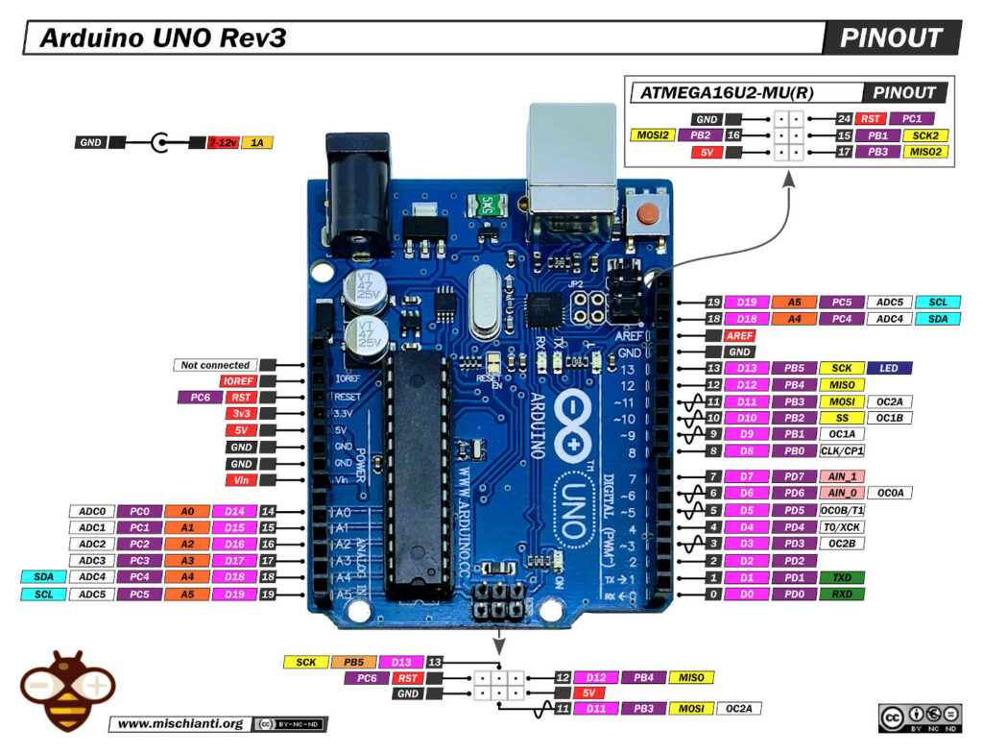Pinout of ARDUINO Board and ATMega328PU

So the new connection schema become like so:

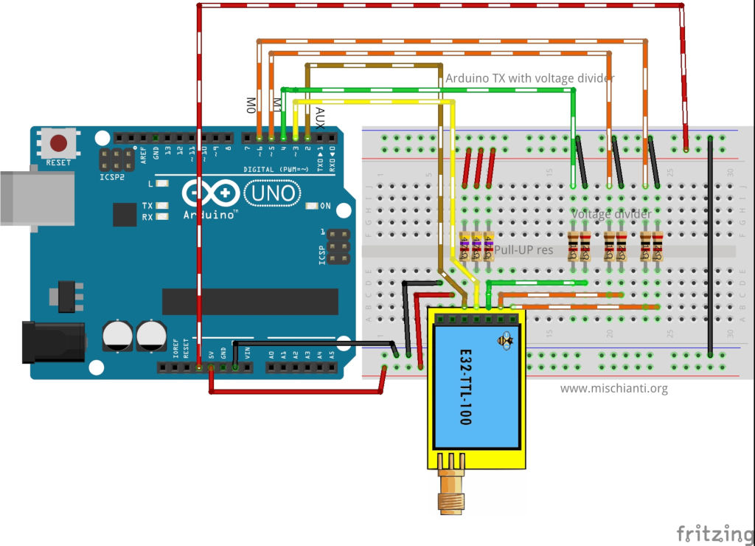LoRa E32-TTL-100 Arduino Fully Connected schema with AUX on interrupt

Now with AUX on interrupt pin we can use It to wake Arduino.

When you are in Sleep mode the e32 put on the buffer the data recived and go immediately LOW, when data is ready return HIGHT, LOW It’s perfect to wake the microcontroller.



LoRa e32 AUX pin on reception

* [Arduino wake up](https://mischianti.org/lora-e32-device-for-arduino-esp32-or-esp8266-wor-wake-on-radio-the-microcontroller-also-and-new-arduino-shield-part-6/#Arduino_wake_up)
  + [Library PowerDown](https://mischianti.org/lora-e32-device-for-arduino-esp32-or-esp8266-wor-wake-on-radio-the-microcontroller-also-and-new-arduino-shield-part-6/#Library_PowerDown)
  + [How to put in sleep Arduino](https://mischianti.org/lora-e32-device-for-arduino-esp32-or-esp8266-wor-wake-on-radio-the-microcontroller-also-and-new-arduino-shield-part-6/#How_to_put_in_sleep_Arduino)
  + [Arduino UNO shield](https://mischianti.org/lora-e32-device-for-arduino-esp32-or-esp8266-wor-wake-on-radio-the-microcontroller-also-and-new-arduino-shield-part-6/#Arduino_UNO_shield)
    - [Now we are going to do a massive production.](https://mischianti.org/lora-e32-device-for-arduino-esp32-or-esp8266-wor-wake-on-radio-the-microcontroller-also-and-new-arduino-shield-part-6/#Now_we_are_going_to_do_a_massive_production)
    - [Shopping List](https://mischianti.org/lora-e32-device-for-arduino-esp32-or-esp8266-wor-wake-on-radio-the-microcontroller-also-and-new-arduino-shield-part-6/#Shopping_List)
    - [Assembly video](https://mischianti.org/lora-e32-device-for-arduino-esp32-or-esp8266-wor-wake-on-radio-the-microcontroller-also-and-new-arduino-shield-part-6/#Assembly_video)
* [Thanks](https://mischianti.org/lora-e32-device-for-arduino-esp32-or-esp8266-wor-wake-on-radio-the-microcontroller-also-and-new-arduino-shield-part-6/#Thanks)

## Arduino wake up

As the e32 device Arduino have some sleep type, but for this test we are going to use power-down mode.

### Library PowerDown

To manage power saving and sleep of Arduino device exist a beautiful library called LowPower.

You can download It directly [here](https://github.com/rocketscream/Low-Power/archive/master.zip) or you can go to the [Git repository](https://github.com/rocketscream/Low-Power).

You must download the library and put It on Arduino library folder

### How to put in sleep Arduino

The command to put on power down the microcontroller is quite simple

|  |  |
| --- | --- |
| 1  2  3 | // Enter power down state with ADC and BOD module disabled.  // Wake up when wake up pin is low.  LowPower.powerDown(SLEEP_FOREVER, ADC_OFF, BOD_OFF); |

But we must specify that the device must wake when AUX pin go LOW

|  |  |
| --- | --- |
| 1  2  3  4  5  6  7  8  9 | // Allow wake up pin to trigger interrupt on low.  attachInterrupt(1, AUX_PIN, LOW);    // Enter power down state with ADC and BOD module disabled.  // Wake up when wake up pin is low.  LowPower.powerDown(SLEEP_FOREVER, ADC_OFF, BOD_OFF);    // Disable external pin interrupt on wake up pin.  detachInterrupt(1); |

So the code to receive transmission become so:

|  |  |
| --- | --- |
| 1  2  3  4  5  6  7  8  9  10  11  12  13  14  15  16  17  18  19  20  21  22  23  24  25  26  27  28  29  30  31  32  33  34  35  36  37  38  39  40  41  42  43  44  45  46  47  48  49  50  51  52  53  54  55  56  57  58  59  60  61  62  63  64  65  66  67  68  69  70  71  72  73  74  75  76  77  78  79  80  81  82  83  84  85  86  87  88  89  90  91  92  93  94  95  96  97  98  99  100  101  102  103  104  105  106  107  108  109  110  111  112  113  114  115  116  117  118  119  120  121  122  123  124  125  126  127  128  129  130  131  132  133  134  135  136  137 | /*   * LoRa E32-TTL-100   * Receive fixed transmission message on channel.   * <https://mischianti.org/lora-e32-device-for-arduino-esp32-or-esp8266-wor-wake-on-radio-the-microcontroller-also-and-new-arduino-shield-part-6/>   *   * E32-TTL-100----- Arduino UNO or esp8266   * M0         ----- 3.3v (To config) GND (To send) 7 (To dinamically manage)   * M1         ----- 3.3v (To config) GND (To send) 6 (To dinamically manage)   * TX         ----- RX PIN 3 (PullUP)   * RX         ----- TX PIN 4 (PullUP & Voltage divider)   * AUX        ----- PIN 2 (PullUP)   * VCC        ----- 3.3v/5v   * GND        ----- GND   *   */  #include "Arduino.h"  #include "LowPower.h"    #include "LoRa_E32.h"  // ---------- Arduino pins --------------  //LoRa_E32 e32ttl(4, 5, 3, 7, 6);  LoRa_E32 e32ttl(4, 5, 3); // Config without connect M0 M1  // Use pin 2 as wake up pin    **const** **int** wakeUpPin = 3;    //#include <SoftwareSerial.h>  //SoftwareSerial mySerial(4, 5); // Arduino RX <-- e32 TX, Arduino TX --> e32 RX  //LoRa_E32 e32ttl(&mySerial, 3, 7, 6);  // -------------------------------------  **void** printParameters(**struct** Configuration configuration);  **void** printModuleInformation(**struct** ModuleInformation moduleInformation);    **void** wakeUp()  {      Serial.println("WAKE!");  }    //The setup function is called once at startup of the sketch  **void** setup()  {      Serial.begin(9600);  **while** (!Serial) {          ; // wait for serial port to connect. Needed for native USB      }      delay(100);        e32ttl.begin();    //  e32ttl.resetModule();      // After set configuration comment set M0 and M1 to low      // and reboot if you directly set HIGH M0 and M1 to program  //  ResponseStructContainer c;  //  c = e32ttl.getConfiguration();  //  Configuration configuration = *(Configuration*) c.data;  //  configuration.ADDL = 3;  //  configuration.ADDH = 0;  //  configuration.CHAN = 0x04;  //  configuration.OPTION.fixedTransmission = FT_FIXED_TRANSMISSION;  //  configuration.OPTION.wirelessWakeupTime = WAKE_UP_250;  //  //    configuration.OPTION.fec = FEC_1_ON;  //    configuration.OPTION.ioDriveMode = IO_D_MODE_PUSH_PULLS_PULL_UPS;  //    configuration.OPTION.transmissionPower = POWER_20;  //  //    configuration.SPED.airDataRate = AIR_DATA_RATE_010_24;  //    configuration.SPED.uartBaudRate = UART_BPS_9600;  //    configuration.SPED.uartParity = MODE_00_8N1;  //  //  e32ttl.setConfiguration(configuration, WRITE_CFG_PWR_DWN_SAVE);  //  printParameters(configuration);      // ---------------------------      Serial.println();      Serial.println("Start listening!");      e32ttl.setMode(MODE_2_POWER_SAVING);        // Allow wake up pin to trigger interrupt on low.      attachInterrupt(1, wakeUp, LOW);        // Enter power down state with ADC and BOD module disabled.      // Wake up when wake up pin is low.      LowPower.powerDown(SLEEP_FOREVER, ADC_OFF, BOD_OFF);        // Disable external pin interrupt on wake up pin.      detachInterrupt(1);      Serial.println("OK listening!");      }    // The loop function is called in an endless loop  **void** loop()  {  **if** (e32ttl.available()  > 1){          ResponseContainer rs = e32ttl.receiveMessage();          // First of all get the data          String message = rs.data;          Serial.print("Received --> ");          Serial.print(rs.status.getResponseDescription());          Serial.print(" - ");          Serial.println(message);      }      delay(125);  }    **void** printParameters(**struct** Configuration configuration) {      Serial.println("----------------------------------------");        Serial.print(F("HEAD : "));  Serial.print(configuration.HEAD, BIN);Serial.print(" ");Serial.print(configuration.HEAD, DEC);Serial.print(" ");Serial.println(configuration.HEAD, HEX);      Serial.println(F(" "));      Serial.print(F("AddH : "));  Serial.println(configuration.ADDH, DEC);      Serial.print(F("AddL : "));  Serial.println(configuration.ADDL, DEC);      Serial.print(F("Chan : "));  Serial.print(configuration.CHAN, DEC); Serial.print(" -> "); Serial.println(configuration.getChannelDescription());      Serial.println(F(" "));      Serial.print(F("SpeedParityBit     : "));  Serial.print(configuration.SPED.uartParity, BIN);Serial.print(" -> "); Serial.println(configuration.SPED.getUARTParityDescription());      Serial.print(F("SpeedUARTDatte  : "));  Serial.print(configuration.SPED.uartBaudRate, BIN);Serial.print(" -> "); Serial.println(configuration.SPED.getUARTBaudRate());      Serial.print(F("SpeedAirDataRate   : "));  Serial.print(configuration.SPED.airDataRate, BIN);Serial.print(" -> "); Serial.println(configuration.SPED.getAirDataRate());        Serial.print(F("OptionTrans        : "));  Serial.print(configuration.OPTION.fixedTransmission, BIN);Serial.print(" -> "); Serial.println(configuration.OPTION.getFixedTransmissionDescription());      Serial.print(F("OptionPullup       : "));  Serial.print(configuration.OPTION.ioDriveMode, BIN);Serial.print(" -> "); Serial.println(configuration.OPTION.getIODroveModeDescription());      Serial.print(F("OptionWakeup       : "));  Serial.print(configuration.OPTION.wirelessWakeupTime, BIN);Serial.print(" -> "); Serial.println(configuration.OPTION.getWirelessWakeUPTimeDescription());      Serial.print(F("OptionFEC          : "));  Serial.print(configuration.OPTION.fec, BIN);Serial.print(" -> "); Serial.println(configuration.OPTION.getFECDescription());      Serial.print(F("OptionPower        : "));  Serial.print(configuration.OPTION.transmissionPower, BIN);Serial.print(" -> "); Serial.println(configuration.OPTION.getTransmissionPowerDescription());        Serial.println("----------------------------------------");    }  **void** printModuleInformation(**struct** ModuleInformation moduleInformation) {      Serial.println("----------------------------------------");      Serial.print(F("HEAD BIN: "));  Serial.print(moduleInformation.HEAD, BIN);Serial.print(" ");Serial.print(moduleInformation.HEAD, DEC);Serial.print(" ");Serial.println(moduleInformation.HEAD, HEX);        Serial.print(F("Freq.: "));  Serial.println(moduleInformation.frequency, HEX);      Serial.print(F("Version  : "));  Serial.println(moduleInformation.version, HEX);      Serial.print(F("Features : "));  Serial.println(moduleInformation.features, HEX);      Serial.println("----------------------------------------");    } |

The result is that the Serial stop on line 91, when we receive the message the e32 wake itself and put AUX LOW, so Arduino wake with interrupt on AUX pin.

Here the sending sketch:

|  |  |
| --- | --- |
| 1  2  3  4  5  6  7  8  9  10  11  12  13  14  15  16  17  18  19  20  21  22  23  24  25  26  27  28  29  30  31  32  33  34  35  36  37  38  39  40  41  42  43  44  45  46  47  48  49  50  51  52  53  54  55  56  57  58  59  60  61  62  63  64  65  66  67  68  69  70  71  72  73  74  75  76  77  78  79  80  81  82  83  84  85  86  87  88  89  90  91  92  93  94  95  96  97  98  99  100  101  102  103  104  105  106  107  108  109  110 | /*   * LoRa E32-TTL-100   * Send fixed broadcast transmission message to a specified channel.   * <https://mischianti.org/lora-e32-device-for-arduino-esp32-or-esp8266-wor-wake-on-radio-the-microcontroller-also-and-new-arduino-shield-part-6/>   *   */  #include "Arduino.h"  #include "LoRa_E32.h"    // ---------- esp8266 pins --------------  LoRa_E32 e32ttl(D2, D3, D5, D7, D6); //, D5); //, D7, D6); // Config without connect AUX and M0 M1  // -------------------------------------    **void** printParameters(**struct** Configuration configuration);  **void** printModuleInformation(**struct** ModuleInformation moduleInformation);  //The setup function is called once at startup of the sketch  **void** setup()  {      Serial.begin(9600);  **while** (!Serial) {          ; // wait for serial port to connect. Needed for native USB      }      delay(100);    **while** (!e32ttl.begin()) {              delay(2000); // wait for serial port to connect. Needed for native USB          }        e32ttl.setMode(MODE_1_WAKE_UP);    //  e32ttl.resetModule();      // After set configuration comment set M0 and M1 to low      // and reboot if you directly set HIGH M0 and M1 to program      ResponseStructContainer c;      c = e32ttl.getConfiguration();      Configuration configuration = *(Configuration*) c.data;      printParameters(configuration);    //  configuration.SPED.uartBaudRate = UART_BPS_9600;  //  configuration.SPED.airDataRate = AIR_DATA_RATE_010_24;      configuration.ADDL = 0x01;      configuration.ADDH = 0x00;      configuration.CHAN = 0x04;      configuration.OPTION.fixedTransmission = FT_FIXED_TRANSMISSION;      configuration.OPTION.wirelessWakeupTime = WAKE_UP_750;            configuration.OPTION.fec = FEC_1_ON;          configuration.OPTION.ioDriveMode = IO_D_MODE_PUSH_PULLS_PULL_UPS;          configuration.OPTION.transmissionPower = POWER_20;            configuration.SPED.airDataRate = AIR_DATA_RATE_010_24;          configuration.SPED.uartBaudRate = UART_BPS_9600;          configuration.SPED.uartParity = MODE_00_8N1;          e32ttl.setConfiguration(configuration, WRITE_CFG_PWR_DWN_SAVE);      printParameters(configuration);      // ---------------------------      }  **int** i = 0;  // The loop function is called in an endless loop  **void** loop()  {      i++;      String mess = "Message to 00 03 04 deviceMessage to  ";      String compMEss = mess+i;        Serial.print(compMEss);      Serial.print(" - ");      ResponseStatus rs = e32ttl.sendFixedMessage(0, 3, 0x04, compMEss);      Serial.println(rs.getResponseDescription());        delay(8000);    }    **void** printParameters(**struct** Configuration configuration) {      Serial.println("----------------------------------------");        Serial.print(F("HEAD : "));  Serial.print(configuration.HEAD, BIN);Serial.print(" ");Serial.print(configuration.HEAD, DEC);Serial.print(" ");Serial.println(configuration.HEAD, HEX);      Serial.println(F(" "));      Serial.print(F("AddH : "));  Serial.println(configuration.ADDH, DEC);      Serial.print(F("AddL : "));  Serial.println(configuration.ADDL, DEC);      Serial.print(F("Chan : "));  Serial.print(configuration.CHAN, DEC); Serial.print(" -> "); Serial.println(configuration.getChannelDescription());      Serial.println(F(" "));      Serial.print(F("SpeedParityBit     : "));  Serial.print(configuration.SPED.uartParity, BIN);Serial.print(" -> "); Serial.println(configuration.SPED.getUARTParityDescription());      Serial.print(F("SpeedUARTDatte  : "));  Serial.print(configuration.SPED.uartBaudRate, BIN);Serial.print(" -> "); Serial.println(configuration.SPED.getUARTBaudRate());      Serial.print(F("SpeedAirDataRate   : "));  Serial.print(configuration.SPED.airDataRate, BIN);Serial.print(" -> "); Serial.println(configuration.SPED.getAirDataRate());        Serial.print(F("OptionTrans        : "));  Serial.print(configuration.OPTION.fixedTransmission, BIN);Serial.print(" -> "); Serial.println(configuration.OPTION.getFixedTransmissionDescription());      Serial.print(F("OptionPullup       : "));  Serial.print(configuration.OPTION.ioDriveMode, BIN);Serial.print(" -> "); Serial.println(configuration.OPTION.getIODroveModeDescription());      Serial.print(F("OptionWakeup       : "));  Serial.print(configuration.OPTION.wirelessWakeupTime, BIN);Serial.print(" -> "); Serial.println(configuration.OPTION.getWirelessWakeUPTimeDescription());      Serial.print(F("OptionFEC          : "));  Serial.print(configuration.OPTION.fec, BIN);Serial.print(" -> "); Serial.println(configuration.OPTION.getFECDescription());      Serial.print(F("OptionPower        : "));  Serial.print(configuration.OPTION.transmissionPower, BIN);Serial.print(" -> "); Serial.println(configuration.OPTION.getTransmissionPowerDescription());        Serial.println("----------------------------------------");    }  **void** printModuleInformation(**struct** ModuleInformation moduleInformation) {      Serial.println("----------------------------------------");      Serial.print(F("HEAD BIN: "));  Serial.print(moduleInformation.HEAD, BIN);Serial.print(" ");Serial.print(moduleInformation.HEAD, DEC);Serial.print(" ");Serial.println(moduleInformation.HEAD, HEX);        Serial.print(F("Freq.: "));  Serial.println(moduleInformation.frequency, HEX);      Serial.print(F("Version  : "));  Serial.println(moduleInformation.version, HEX);      Serial.print(F("Features : "));  Serial.println(moduleInformation.features, HEX);      Serial.println("----------------------------------------");    } |

### Arduino UNO shield

I create also an Arduino shield very usefully to use.

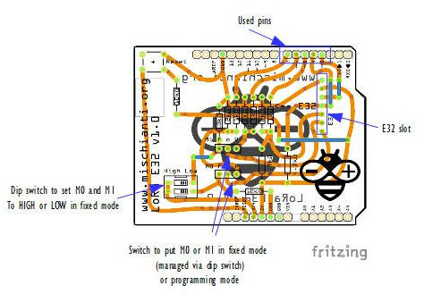Arduino LoRa E32 shield explained

With this board you can use this device directly without problem or voltage divider.

The configuration is this:

|  |  |
| --- | --- |
| 1 | LoRa_E32 e32ttl(4, 5, 3, 7, 6); |

Than you can use all examples inside the library, you can use pin 6 and 7 to do a full connection or disable they and put M0 and M1 as you want with dipswitch.

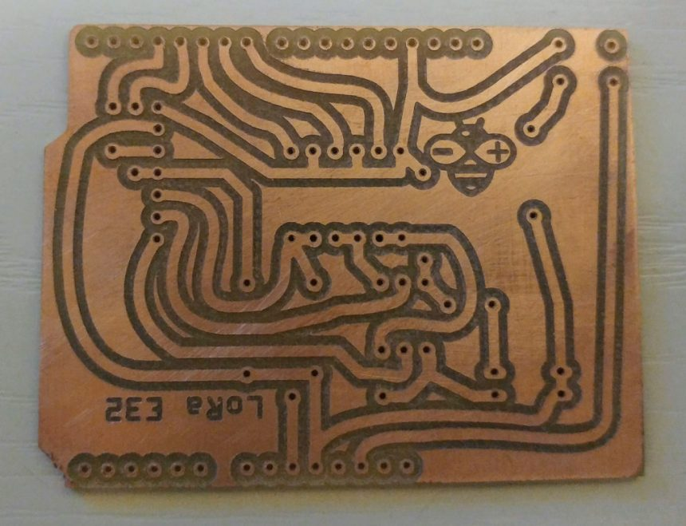Milled Arduino Shield LoRa EBYTE E32 copper clad

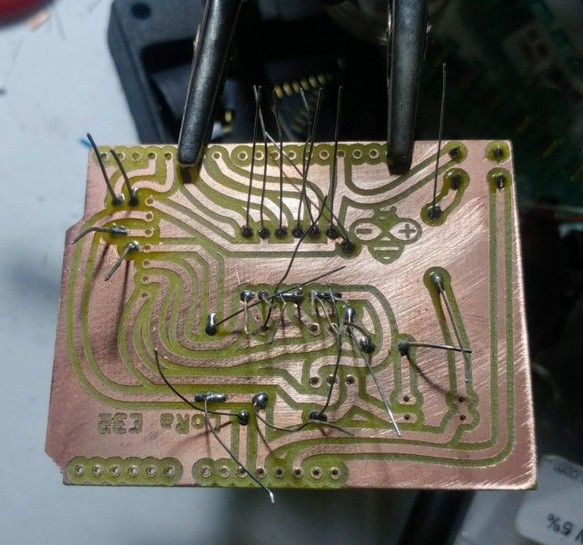Milled Arduino Shield LoRa EBYTE E32 start soldering

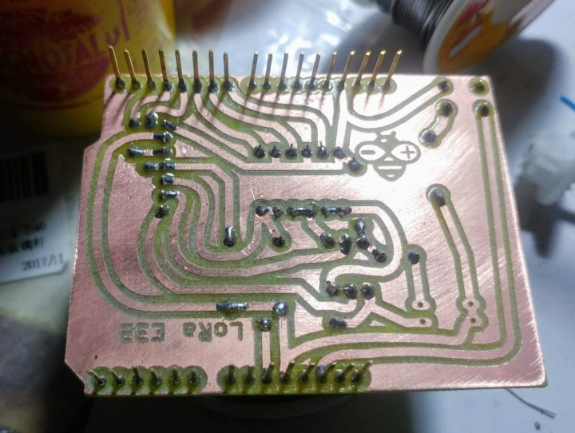Milled Arduino Shield LoRa EBYTE E32 soldering complete bottom

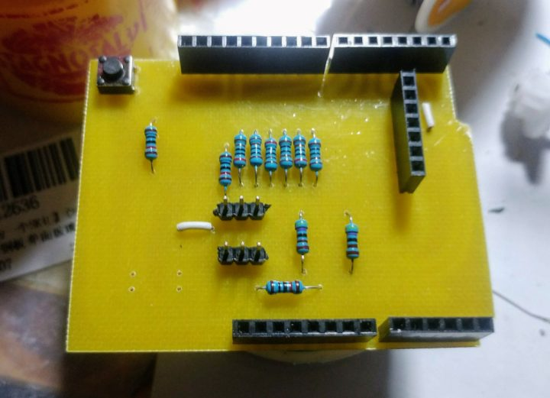Milled Arduino Shield LoRa EBYTE E32 soldering complete

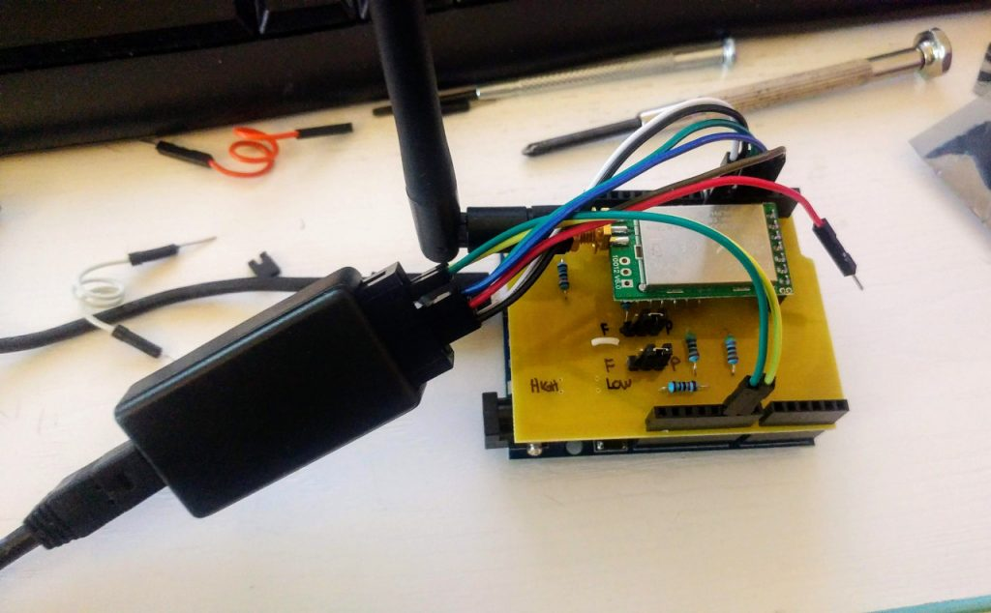Milled Arduino Shield LoRa EBYTE E32 Check with Logic Analyzer

Here the first test, seems all ok.

LoRa E32 request configuration logic analyzer Arduino

#### Now we are going to do a massive production.

Ready to go

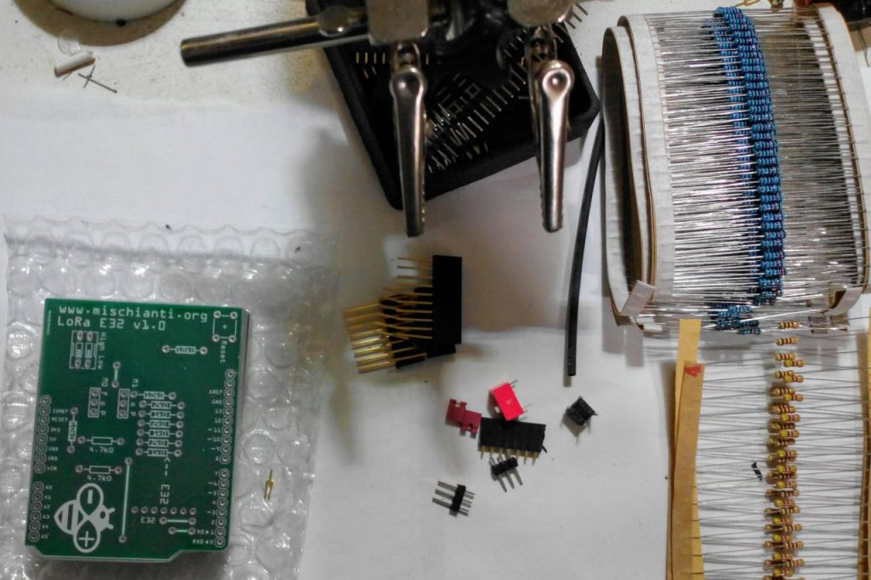Arduino shield LoRa E32 start soldering PCB

The shield have some jumper and dip switch to configure M0 and M1.  
If you want set M0 and M1 to a fixed value you must put jumper to F, if you want control via pin to P.  
If you set to F you must put dip switch on property value Low or High.

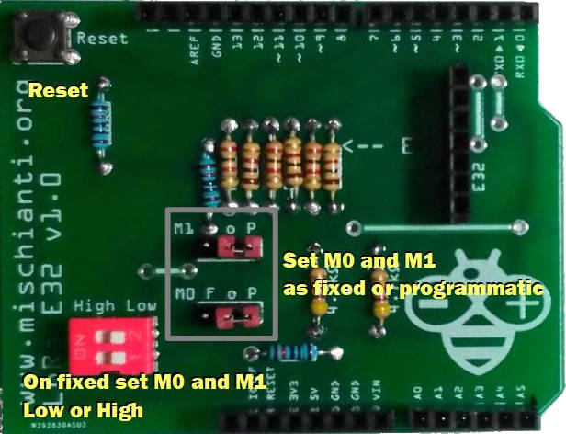Arduino shield photo UP with description

#### Shopping List

You can find here [AliExpress (433MHz 5Km)](https://s.click.aliexpress.com/e/eOHotRkU) - [AliExpress (433MHz 8Km)](https://s.click.aliexpress.com/e/_DkWxBOv) - [AliExpress (433MHz 16Km)](https://s.click.aliexpress.com/e/_DevlDR3) - [AliExpress (868MHz 915MHz 5.5Km)](https://s.click.aliexpress.com/e/_DDjTmop) - [AliExpress (868MHz 915MHz 8Km)](https://s.click.aliexpress.com/e/_DdCkJG5)

| **Amount** | **Part Type** | **Properties** |
| --- | --- | --- |
| 1 | Lora E32-TTL-100 | variant 1; voltage 3-5V; type Basic |
| 1 | [DIP SWITCH](http://s.click.aliexpress.com/e/NZtN5Plm) | channels 1; package dipswitch-02 |
| 2 | [Generic male header](http://s.click.aliexpress.com/e/KJ8Wt9Hq) – 3 pins | pins 3; pin spacing 0.1in (2.54mm); hole size 1.0mm,0.508mm; form  (male); package THT; row single |
| 1 | [Arduino Uno (Rev3)](http://s.click.aliexpress.com/e/F8ApsT0M) | type Arduino UNO (Rev3) |
| 3 | 4.7kΩ [Resistor](http://s.click.aliexpress.com/e/dJnu3JGy) | bands 4; tolerance ±5%; pin spacing 400 mil; package THT; resistance 4.7kΩ |
| 3 | 1kΩ [Resistor](http://s.click.aliexpress.com/e/dJnu3JGy) | bands 4; tolerance ±5%; pin spacing 400 mil; package THT; resistance 1kΩ |
| 3 | 2kΩ [Resistor](http://s.click.aliexpress.com/e/dJnu3JGy) | bands 4; tolerance ±5%; pin spacing 400 mil; package THT; resistance 2kΩ |
| 3 | 10kΩ [Resistor](http://s.click.aliexpress.com/e/dJnu3JGy) | bands 4; tolerance ±5%; pin spacing 400 mil; package THT; resistance 10kΩ |
| 1 | [Momentary Tactile Push Button](http://s.click.aliexpress.com/e/Ey2ZviwM) | package [THT] |
| 1 | [Generic female header](http://s.click.aliexpress.com/e/4iYQ45Ks) – 7 pins | Pin spacing 0.1in (2.54mm); |
| 2 | [Generic male/female header](http://s.click.aliexpress.com/e/pEa0y11q) – 8 pins | Pin spacing 0.1in (2.54mm); |
| 1 | [Generic male/female header](http://s.click.aliexpress.com/e/pEa0y11q) – 6 pins | Pin spacing 0.1in (2.54mm); |
| 1 | [Generic male/female header](http://s.click.aliexpress.com/e/pEa0y11q) – 10 pins | Pin spacing 0.1in (2.54mm); |

You can get the PCB from PCBWay 10 at 5$ [PCBWay](https://www.pcbway.com/project/shareproject/LoRa_E32_Series_device_Arduino_shield.html?from=mischianti723)

[](https://www.pcbway.com/project/shareproject/LoRa_E32_Series_device_Arduino_shield.html?from=mischianti723)

Here my Crtistmas present

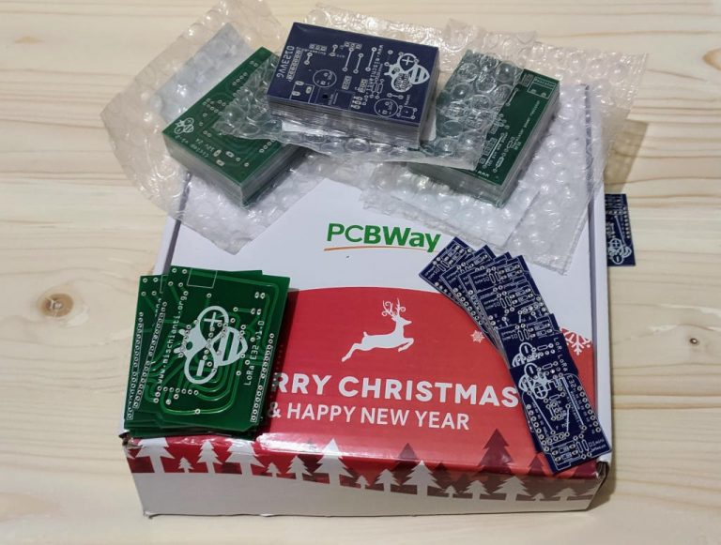PCBWay Cristmas box

I chose this manufacturer because at the same cost it offers excellent quality, in the first screen it is possible to make countless options suitable for every need.

The board as you can see on various photo is very beautiful and simply to solder.

#### Assembly video

Here the soldering video.

Here the result

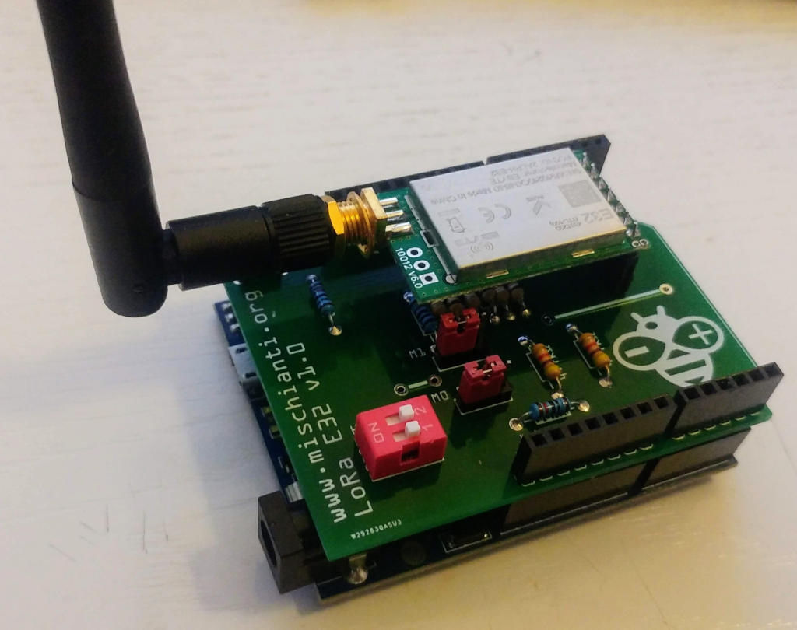LoRa E32 Arduino shield mounted

## Thanks

# Ebyte LoRa E32 device for Arduino, esp32 or esp8266: WOR (wake on radio) microcontroller and new WeMos D1 mini shield – Part 7

BY [RENZO MISCHIANTI](https://mischianti.org/author/reef/) · PUBLISHED 17 JANUARY 2020 · UPDATED 16 JUNE 2023

**Spread the love**

**0**

Shares

We have seen how this device (E32 UART LoRa based on popular SX1276/SX1278 Wireless Modules ) manages power saving, but If we use power saving only for the e32 the microcontroller continue to rest active, but we can use AUX pin to resolve this problem.

[Support Forum](https://mischianti.org/forums/forum/mischiantis-libraries/ebyte-lora-e32-uart-devices/)

[](https://mischianti.org/wp-content/uploads/2019/09/ebyte-lora-exx-pinout-1.jpg)sx1278 sx1276 wireless lora uart module serial 3000m arduino 433 rf

You can find module here [AliExpress (433MHz 5Km)](https://s.click.aliexpress.com/e/eOHotRkU) - [AliExpress (433MHz 8Km)](https://s.click.aliexpress.com/e/_DkWxBOv) - [AliExpress (433MHz 16Km)](https://s.click.aliexpress.com/e/_DevlDR3) - [AliExpress (868MHz 915MHz 5.5Km)](https://s.click.aliexpress.com/e/_DDjTmop) - [AliExpress (868MHz 915MHz 8Km)](https://s.click.aliexpress.com/e/_DdCkJG5)

**If you have trouble** **like freeze device, you must put a pull-up 4.7k resistor or better connect to the device AUX pin.**

Instead the breadboard schema we used since now, but we are going to do some fix, instead of D2 and D3 we are going to use D3 and D4, so SDA and SCL (i2c protocol) remain free.

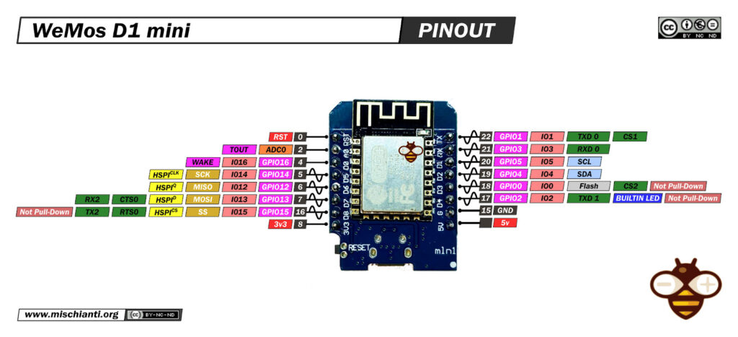

WeMos D1 mini esp8266 pinout mischianti low resolution

So the new connection schema become like so:

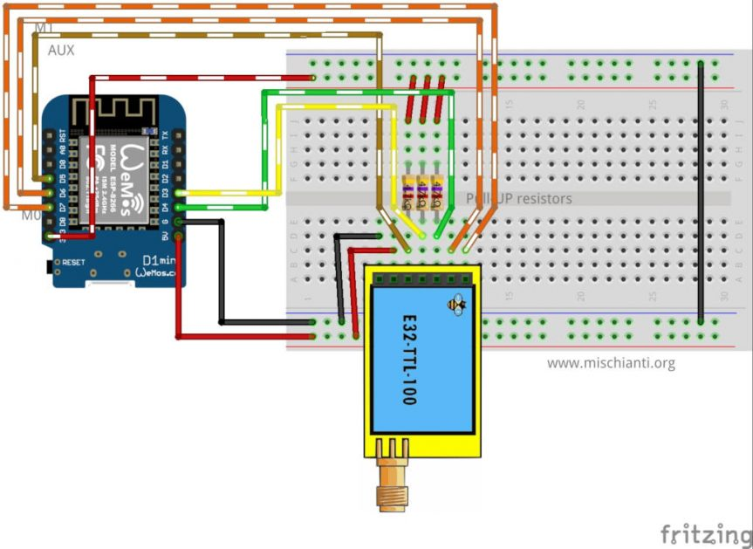LoRa E32-TTL-100 and Wemos D1 mini fully connected

When you are in Sleep mode the e32 put on the buffer the data recived and go immediately LOW, when data is ready return HIGHT, LOW It’s perfect to wake the microcontroller.



LoRa e32 AUX pin on reception

* [WeMos D1 mini wake up](https://mischianti.org/lora-e32-device-for-arduino-esp32-or-esp8266-wor-wake-on-radio-microcontroller-and-new-wemos-d1-mini-shield-part-7/#WeMos_D1_mini_wake_up)
  + [How to put in sleep WeMos D1 mini](https://mischianti.org/lora-e32-device-for-arduino-esp32-or-esp8266-wor-wake-on-radio-microcontroller-and-new-wemos-d1-mini-shield-part-7/#How_to_put_in_sleep_WeMos_D1_mini)
* [WeMos D1 mini shield](https://mischianti.org/lora-e32-device-for-arduino-esp32-or-esp8266-wor-wake-on-radio-microcontroller-and-new-wemos-d1-mini-shield-part-7/#WeMos_D1_mini_shield)
  + [Now we are going to soldering.](https://mischianti.org/lora-e32-device-for-arduino-esp32-or-esp8266-wor-wake-on-radio-microcontroller-and-new-wemos-d1-mini-shield-part-7/#Now_we_are_going_to_soldering)
  + [Shopping List](https://mischianti.org/lora-e32-device-for-arduino-esp32-or-esp8266-wor-wake-on-radio-microcontroller-and-new-wemos-d1-mini-shield-part-7/#Shopping_List)
  + [Assembly video](https://mischianti.org/lora-e32-device-for-arduino-esp32-or-esp8266-wor-wake-on-radio-microcontroller-and-new-wemos-d1-mini-shield-part-7/#Assembly_video)
* [Thanks](https://mischianti.org/lora-e32-device-for-arduino-esp32-or-esp8266-wor-wake-on-radio-microcontroller-and-new-wemos-d1-mini-shield-part-7/#Thanks)

## WeMos D1 mini wake up

As the e32 device, WeMos have some sleep type, but for this test we are going to use Light sleep with GPIO wake up.

Refer to “[WeMos D1 mini (esp8266), the three type of sleep mode to manage energy savings – Part 4](https://mischianti.org/wemos-d1-mini-esp8266-the-three-type-of-sleep-mode-to-manage-energy-savings-part-4/)” for a detailed description on sleep mode.

### How to put in sleep WeMos D1 mini

The command to put on power down the microcontroller is this

|  |  |
| --- | --- |
| 1  2  3  4  5  6 | wifi_set_opmode(NULL_MODE);  wifi_fpm_set_sleep_type(LIGHT_SLEEP_T);  wifi_fpm_open();  wifi_fpm_set_wakeup_cb(callback);  wifi_fpm_do_sleep(FPM_SLEEP_MAX_TIME);  delay(1000); |

But we must specify that the device must wake when AUX pin go LOW

|  |  |
| --- | --- |
| 1  2  3  4  5  6  7  8  9  10 | // Allow wake up pin to trigger interrupt on low.  gpio_pin_wakeup_enable(GPIO_ID_PIN(AUX_PIN), GPIO_PIN_INTR_LOLEVEL);    // Enter light sleep.  wifi_set_opmode(NULL_MODE);  wifi_fpm_set_sleep_type(LIGHT_SLEEP_T);  wifi_fpm_open();  wifi_fpm_set_wakeup_cb(callback);  wifi_fpm_do_sleep(FPM_SLEEP_MAX_TIME);  delay(1000); |

So the code to receive transmission become so:

|  |  |
| --- | --- |
| 1  2  3  4  5  6  7  8  9  10  11  12  13  14  15  16  17  18  19  20  21  22  23  24  25  26  27  28  29  30  31  32  33  34  35  36  37  38  39  40  41  42  43  44  45  46  47  48  49  50  51  52  53  54  55  56  57  58  59  60  61  62  63  64  65  66  67  68  69  70  71  72  73  74  75  76  77  78  79  80  81  82  83  84  85  86  87  88  89  90  91  92  93  94  95  96  97  98  99  100  101  102  103  104  105  106  107  108  109  110  111  112  113  114  115  116  117  118  119 | /*   * LoRa E32-TTL-100   * Receive fixed transmission message on channel and wake up.   * [https://mischianti.org](https://mischianti.org/)   *   * E32-TTL-100----- Arduino UNO or esp8266   * M0         ----- LOW   * M1         ----- HIGH   * TX         ----- RX PIN D3 (PullUP)   * RX         ----- TX PIN D4 (PullUP)   * AUX        ----- PIN D5   * VCC        ----- 5v   * GND        ----- GND   *   */  #include "Arduino.h"  #include "LoRa_E32.h"  #include <ESP8266WiFi.h>    #define FPM_SLEEP_MAX_TIME           0xFFFFFFF  **void** callback() {    Serial.println("Callback");    Serial.flush();  }    // ---------- esp8266 pins --------------  LoRa_E32 e32ttl(D3, D4, D5);  // Arduino RX <-- e32 TX, Arduino TX --> e32 RX  // -------------------------------------  **void** printParameters(**struct** Configuration configuration);  //The setup function is called once at startup of the sketch  **void** setup()  {      Serial.begin(9600);  **while** (!Serial) {          ; // wait for serial port to connect. Needed for native USB      }      delay(100);        e32ttl.begin();          e32ttl.setMode(MODE_2_POWER_SAVING);    //  e32ttl.resetModule();      // After set configuration comment set M0 and M1 to low      // and reboot if you directly set HIGH M0 and M1 to program      ResponseStructContainer c;      c = e32ttl.getConfiguration();      Configuration configuration = *(Configuration*) c.data;      printParameters(configuration);        configuration.ADDL = 3;      configuration.ADDH = 0;      configuration.CHAN = 0x04;      configuration.OPTION.fixedTransmission = FT_FIXED_TRANSMISSION;      configuration.OPTION.wirelessWakeupTime = WAKE_UP_250;        configuration.OPTION.fec = FEC_1_ON;      configuration.OPTION.ioDriveMode = IO_D_MODE_PUSH_PULLS_PULL_UPS;      configuration.OPTION.transmissionPower = POWER_20;        configuration.SPED.airDataRate = AIR_DATA_RATE_010_24;      configuration.SPED.uartBaudRate = UART_BPS_9600;      configuration.SPED.uartParity = MODE_00_8N1;        e32ttl.setConfiguration(configuration, WRITE_CFG_PWR_DWN_SAVE);      printParameters(configuration);      // ---------------------------      delay(1000);      Serial.println();      Serial.println("Start sleep!");        //wifi_station_disconnect(); //not needed      gpio_pin_wakeup_enable(GPIO_ID_PIN(D5), GPIO_PIN_INTR_LOLEVEL);      wifi_set_opmode(NULL_MODE);      wifi_fpm_set_sleep_type(LIGHT_SLEEP_T);      wifi_fpm_open();      wifi_fpm_set_wakeup_cb(callback);      wifi_fpm_do_sleep(FPM_SLEEP_MAX_TIME);      delay(1000);        Serial.println();      Serial.println("Start listening!");    }    // The loop function is called in an endless loop  **void** loop()  {  **if** (e32ttl.available()  > 1){          ResponseContainer rs = e32ttl.receiveMessage();          // First of all get the data          String message = rs.data;            Serial.println(rs.status.getResponseDescription());          Serial.println(message);      }  }    **void** printParameters(**struct** Configuration configuration) {      Serial.println("----------------------------------------");        Serial.print(F("HEAD : "));  Serial.print(configuration.HEAD, BIN);Serial.print(" ");Serial.print(configuration.HEAD, DEC);Serial.print(" ");Serial.println(configuration.HEAD, HEX);      Serial.println(F(" "));      Serial.print(F("AddH : "));  Serial.println(configuration.ADDH, DEC);      Serial.print(F("AddL : "));  Serial.println(configuration.ADDL, DEC);      Serial.print(F("Chan : "));  Serial.print(configuration.CHAN, DEC); Serial.print(" -> "); Serial.println(configuration.getChannelDescription());      Serial.println(F(" "));      Serial.print(F("SpeedParityBit     : "));  Serial.print(configuration.SPED.uartParity, BIN);Serial.print(" -> "); Serial.println(configuration.SPED.getUARTParityDescription());      Serial.print(F("SpeedUARTDatte  : "));  Serial.print(configuration.SPED.uartBaudRate, BIN);Serial.print(" -> "); Serial.println(configuration.SPED.getUARTBaudRate());      Serial.print(F("SpeedAirDataRate   : "));  Serial.print(configuration.SPED.airDataRate, BIN);Serial.print(" -> "); Serial.println(configuration.SPED.getAirDataRate());        Serial.print(F("OptionTrans        : "));  Serial.print(configuration.OPTION.fixedTransmission, BIN);Serial.print(" -> "); Serial.println(configuration.OPTION.getFixedTransmissionDescription());      Serial.print(F("OptionPullup       : "));  Serial.print(configuration.OPTION.ioDriveMode, BIN);Serial.print(" -> "); Serial.println(configuration.OPTION.getIODroveModeDescription());      Serial.print(F("OptionWakeup       : "));  Serial.print(configuration.OPTION.wirelessWakeupTime, BIN);Serial.print(" -> "); Serial.println(configuration.OPTION.getWirelessWakeUPTimeDescription());      Serial.print(F("OptionFEC          : "));  Serial.print(configuration.OPTION.fec, BIN);Serial.print(" -> "); Serial.println(configuration.OPTION.getFECDescription());      Serial.print(F("OptionPower        : "));  Serial.print(configuration.OPTION.transmissionPower, BIN);Serial.print(" -> "); Serial.println(configuration.OPTION.getTransmissionPowerDescription());        Serial.println("----------------------------------------");    } |

The result is that the Serial stop on line 91, when we receive the message the e32 wake itself and put AUX LOW, so Arduino wake with interrupt on AUX pin.

Here the sending sketch:

|  |  |
| --- | --- |
| 1  2  3  4  5  6  7  8  9  10  11  12  13  14  15  16  17  18  19  20  21  22  23  24  25  26  27  28  29  30  31  32  33  34  35  36  37  38  39  40  41  42  43  44  45  46  47  48  49  50  51  52  53  54  55  56  57  58  59  60  61  62  63  64  65  66  67  68  69  70  71  72  73  74  75  76  77  78  79  80  81  82  83  84  85  86  87  88  89  90  91  92  93  94  95  96  97  98  99  100  101  102  103  104  105  106  107  108 | /*   * LoRa E32-TTL-100   * Send fixed broadcast transmission message to a specified channel.   * [https://mischianti.org](https://mischianti.org/)   *   * E32-TTL-100----- Arduino UNO or esp8266   * M0         ----- HIGH   * M1         ----- LOW   * TX         ----- RX PIN D3 (PullUP)   * RX         ----- TX PIN D4 (PullUP)   * AUX        ----- PIN D5   * VCC        ----- 5v   * GND        ----- GND   *   */  #include "Arduino.h"  #include "LoRa_E32.h"    LoRa_E32 e32ttl(D3, D4, D5);  // -------------------------------------    **void** printParameters(**struct** Configuration configuration);    //The setup function is called once at startup of the sketch  **void** setup()  {      Serial.begin(9600);  **while** (!Serial) {          ; // wait for serial port to connect. Needed for native USB      }      delay(100);    **while** (!e32ttl.begin()) {              delay(2000); // wait for serial port to connect. Needed for native USB          }        e32ttl.setMode(MODE_1_WAKE_UP);    //  e32ttl.resetModule();      // After set configuration comment set M0 and M1 to low      // and reboot if you directly set HIGH M0 and M1 to program      ResponseStructContainer c;      c = e32ttl.getConfiguration();      Configuration configuration = *(Configuration*) c.data;      printParameters(configuration);    //  configuration.SPED.uartBaudRate = UART_BPS_9600;  //  configuration.SPED.airDataRate = AIR_DATA_RATE_010_24;      configuration.ADDL = 0x01;      configuration.ADDH = 0x00;      configuration.CHAN = 0x04;      configuration.OPTION.fixedTransmission = FT_FIXED_TRANSMISSION;      configuration.OPTION.wirelessWakeupTime = WAKE_UP_750;            configuration.OPTION.fec = FEC_1_ON;          configuration.OPTION.ioDriveMode = IO_D_MODE_PUSH_PULLS_PULL_UPS;          configuration.OPTION.transmissionPower = POWER_20;            configuration.SPED.airDataRate = AIR_DATA_RATE_010_24;          configuration.SPED.uartBaudRate = UART_BPS_9600;          configuration.SPED.uartParity = MODE_00_8N1;          e32ttl.setConfiguration(configuration, WRITE_CFG_PWR_DWN_SAVE);      printParameters(configuration);      // ---------------------------      }  **int** i = 0;  // The loop function is called in an endless loop  **void** loop()  {      i++;      String mess = "Message to 00 03 04 deviceMessage to  ";      String compMEss = mess+i;        Serial.print(compMEss);      Serial.print(" - ");      ResponseStatus rs = e32ttl.sendFixedMessage(0, 3, 0x04, compMEss);      Serial.println(rs.getResponseDescription());        delay(8000);    }    **void** printParameters(**struct** Configuration configuration) {      Serial.println("----------------------------------------");        Serial.print(F("HEAD : "));  Serial.print(configuration.HEAD, BIN);Serial.print(" ");Serial.print(configuration.HEAD, DEC);Serial.print(" ");Serial.println(configuration.HEAD, HEX);      Serial.println(F(" "));      Serial.print(F("AddH : "));  Serial.println(configuration.ADDH, DEC);      Serial.print(F("AddL : "));  Serial.println(configuration.ADDL, DEC);      Serial.print(F("Chan : "));  Serial.print(configuration.CHAN, DEC); Serial.print(" -> "); Serial.println(configuration.getChannelDescription());      Serial.println(F(" "));      Serial.print(F("SpeedParityBit     : "));  Serial.print(configuration.SPED.uartParity, BIN);Serial.print(" -> "); Serial.println(configuration.SPED.getUARTParityDescription());      Serial.print(F("SpeedUARTDatte  : "));  Serial.print(configuration.SPED.uartBaudRate, BIN);Serial.print(" -> "); Serial.println(configuration.SPED.getUARTBaudRate());      Serial.print(F("SpeedAirDataRate   : "));  Serial.print(configuration.SPED.airDataRate, BIN);Serial.print(" -> "); Serial.println(configuration.SPED.getAirDataRate());        Serial.print(F("OptionTrans        : "));  Serial.print(configuration.OPTION.fixedTransmission, BIN);Serial.print(" -> "); Serial.println(configuration.OPTION.getFixedTransmissionDescription());      Serial.print(F("OptionPullup       : "));  Serial.print(configuration.OPTION.ioDriveMode, BIN);Serial.print(" -> "); Serial.println(configuration.OPTION.getIODroveModeDescription());      Serial.print(F("OptionWakeup       : "));  Serial.print(configuration.OPTION.wirelessWakeupTime, BIN);Serial.print(" -> "); Serial.println(configuration.OPTION.getWirelessWakeUPTimeDescription());      Serial.print(F("OptionFEC          : "));  Serial.print(configuration.OPTION.fec, BIN);Serial.print(" -> "); Serial.println(configuration.OPTION.getFECDescription());      Serial.print(F("OptionPower        : "));  Serial.print(configuration.OPTION.transmissionPower, BIN);Serial.print(" -> "); Serial.println(configuration.OPTION.getTransmissionPowerDescription());        Serial.println("----------------------------------------");    } |

## WeMos D1 mini shield

I create also a WeMos D1 mini shield very usefully to use.

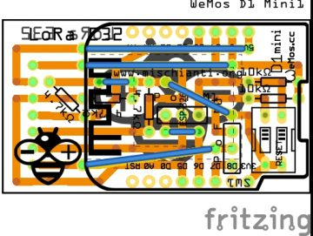LoRa E32-TTL-100 and Wemos D1 fully connected shield old version

The configuration is this:

|  |  |
| --- | --- |
| 1 | LoRa_E32 e32ttl(D3, D4, D5, D7, D6); |

Than you can use all examples inside the library, you can use pin D6 and D7 to do a full connection or disable they and put M0 and M1 as you want with dipswitch.

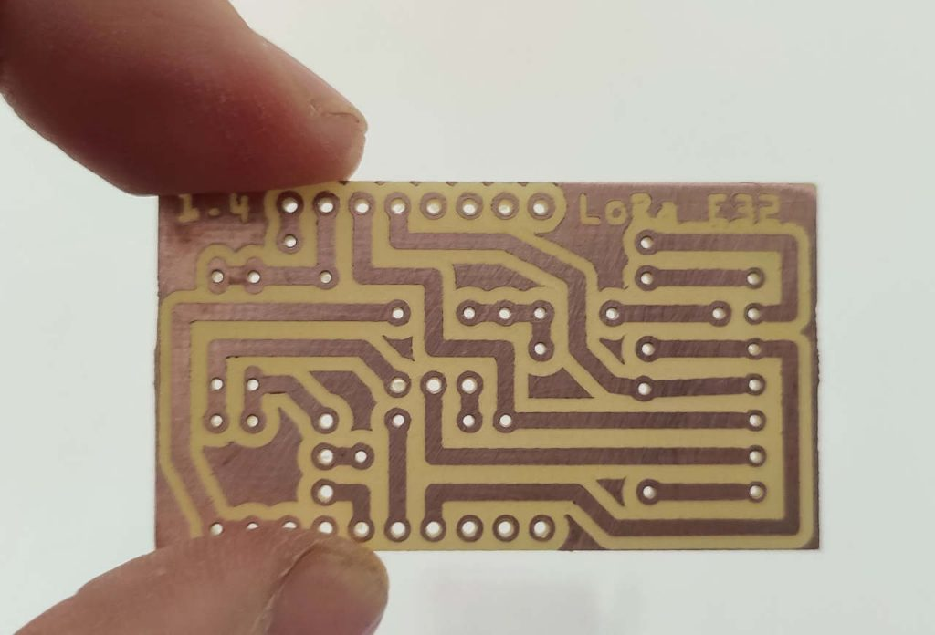Milled WeMos D1 Shield LoRa EBYTE E32

### Now we are going to soldering.

Ready to go

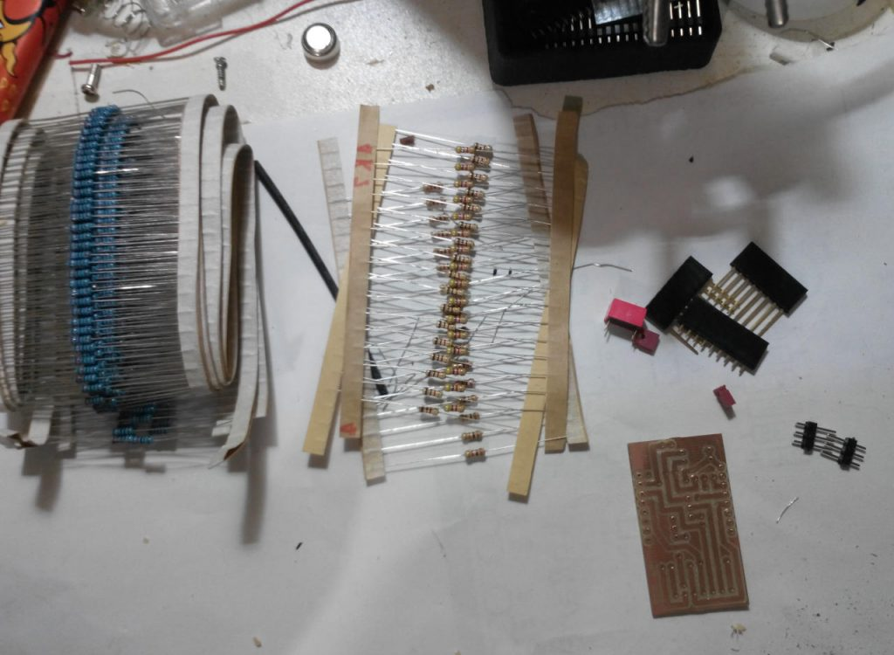WeMos D1 mini LoRa E32 shield start soldering

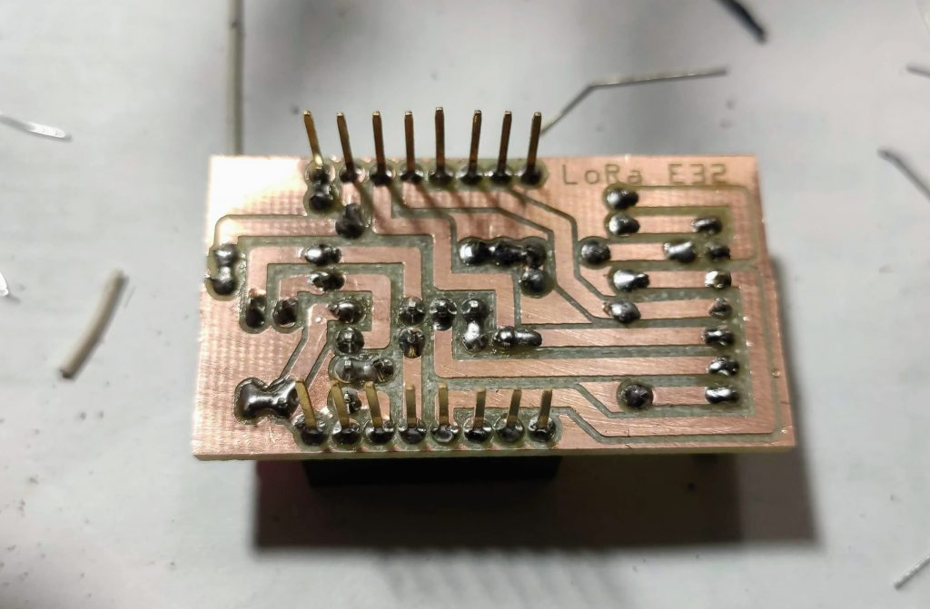Milled WeMos D1 Shield LoRa EBYTE E32 bottom

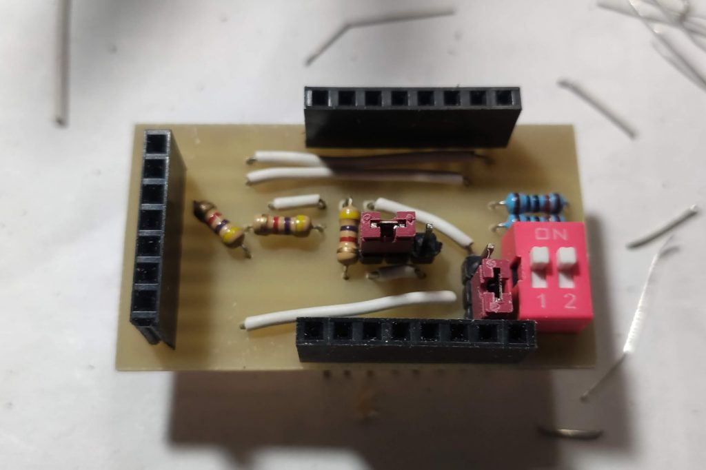Milled WeMos D1 Shield LoRa EBYTE E32 up

Here the result of milled PCB

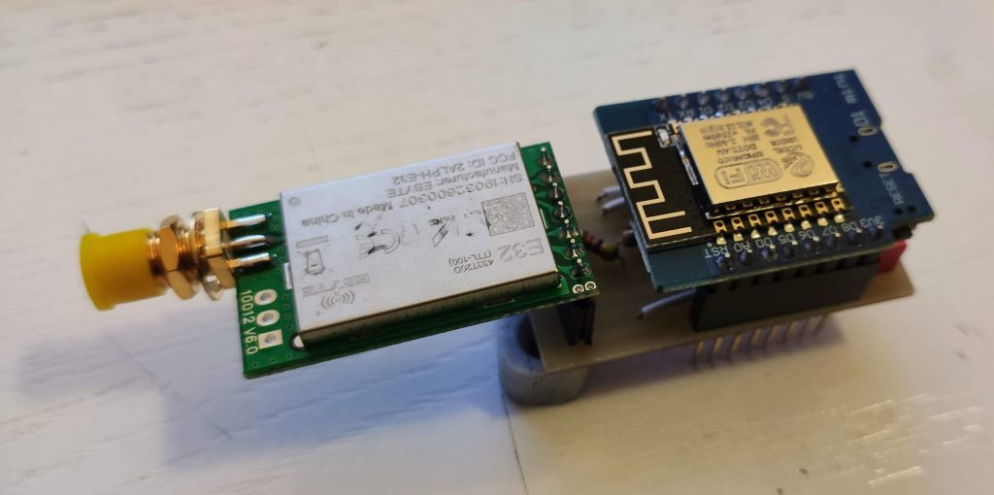Milled WeMos D1 Shield LoRa EBYTE E32 mounted

Here the result with ordered PCB

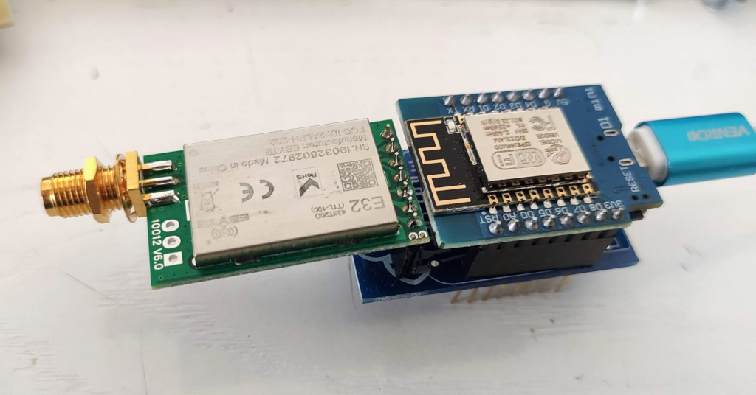WeMos D1 Shield LoRa EBYTE E32 mounted

The shield have some jumper and dip switch to configure M0 and M1.  
If you want set M0 and M1 to a fixed value you must put jumper to F, if you want control via pin to P.  
If you set to F you must put dip switch on property value Low or High.

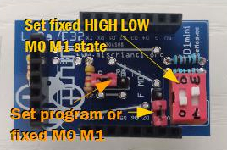WeMos D1 mini shield photo UP with description

### Shopping List

You can find here [AliExpress (433MHz 5Km)](https://s.click.aliexpress.com/e/eOHotRkU) - [AliExpress (433MHz 8Km)](https://s.click.aliexpress.com/e/_DkWxBOv) - [AliExpress (433MHz 16Km)](https://s.click.aliexpress.com/e/_DevlDR3) - [AliExpress (868MHz 915MHz 5.5Km)](https://s.click.aliexpress.com/e/_DDjTmop) - [AliExpress (868MHz 915MHz 8Km)](https://s.click.aliexpress.com/e/_DdCkJG5)

| **Amount** | **Part Type** | **Properties** |
| --- | --- | --- |
| 1 | Lora E32-TTL-100 | variant 1; voltage 3-5V; type Basic |
| 1 | [DIP SWITCH](http://s.click.aliexpress.com/e/NZtN5Plm) | channels 1; package dipswitch-02 |
| 2 | [Generic male header](http://s.click.aliexpress.com/e/KJ8Wt9Hq) – 3 pins | pins 3; pin spacing 0.1in (2.54mm); hole size 1.0mm,0.508mm; form  (male); package THT; row single |
| 1 | [WeMos D1 mini](http://s.click.aliexpress.com/e/rf3J28NS) | type esp8266 |
| 3 | 4.7kΩ [Resistor](http://s.click.aliexpress.com/e/dJnu3JGy) | bands 4; tolerance ±5%; pin spacing 400 mil; package THT; resistance 4.7kΩ |
| 3 | 2kΩ [Resistor](http://s.click.aliexpress.com/e/dJnu3JGy) | bands 4; tolerance ±5%; pin spacing 400 mil; package THT; resistance 2kΩ |
| 1 | [Generic female header](http://s.click.aliexpress.com/e/4iYQ45Ks) – 7 pins | Pin spacing 0.1in (2.54mm); |
| 2 | [Generic male/female header](http://s.click.aliexpress.com/e/pEa0y11q) – 8 pins | Pin spacing 0.1in (2.54mm); |

You can get pcb without additional costs here from [PCBWay](https://www.pcbway.com/project/shareproject/LoRa_E32_Series_device_WeMos_D1_mini_shield_RF_8km_range.html?from=mischianti723)

[](https://www.pcbway.com/project/shareproject/LoRa_E32_Series_device_WeMos_D1_mini_shield_RF_8km_range.html?from=mischianti723)

Here my Crtistmas present

PCBWay Cristmas box

I chose this manufacturer because at the same cost it offers excellent quality, in the first screen it is possible to make countless options suitable for every need.

The board as you can see on various photo is very beautiful and simply to solder.

### Assembly video

Here the soldering video.

Here the result

WeMos D1 Shield LoRa EBYTE E32 mounted

## Thanks

# Ebyte LoRa E32 device for Arduino, esp32 or esp8266: WOR (wake on radio) and new ESP32 shield – 8

BY [RENZO MISCHIANTI](https://mischianti.org/author/reef/) · PUBLISHED 14 APRIL 2021 · UPDATED 16 JUNE 2023

**Spread the love**

[**1**](https://mischianti.org/ebyte-lora-e32-device-for-arduino-esp32-or-esp8266-wor-wake-on-radio-and-new-esp32-shield-8/)

**1**

Share

[Support Forum](https://mischianti.org/forums/forum/mischiantis-libraries/ebyte-lora-e32-uart-devices/)

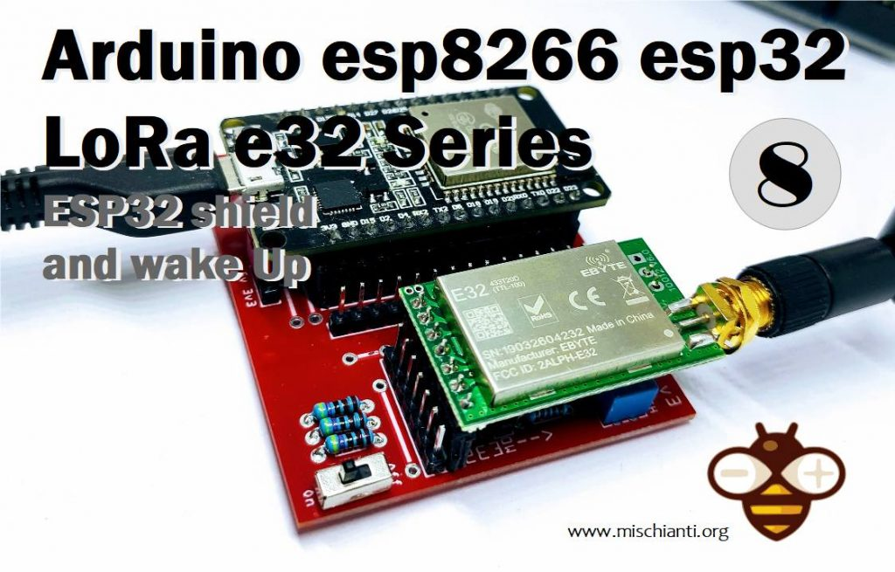

LoRa E32 E22 ESP32 shield PCB and wake up from WOR

We have seen how this device (E32 UART LoRa based on popular SX1276/SX1278 Wireless Modules ) manages power saving, but If we use power saving only for the e32 the microcontroller continue to rest active, but we can use AUX pin to resolve this problem.

[](https://mischianti.org/wp-content/uploads/2019/09/ebyte-lora-exx-pinout-1.jpg)sx1278 sx1276 wireless lora uart module serial 3000m arduino 433 rf

You can find module here [AliExpress (433MHz 5Km)](https://s.click.aliexpress.com/e/eOHotRkU) - [AliExpress (433MHz 8Km)](https://s.click.aliexpress.com/e/_DkWxBOv) - [AliExpress (433MHz 16Km)](https://s.click.aliexpress.com/e/_DevlDR3) - [AliExpress (868MHz 915MHz 5.5Km)](https://s.click.aliexpress.com/e/_DDjTmop) - [AliExpress (868MHz 915MHz 8Km)](https://s.click.aliexpress.com/e/_DdCkJG5)

**If you have trouble** **like freeze device, you must put a pull-up 4.7k resistor or better connect to the device AUX pin.**

We are going to do this connections to support wake on radio, we use Serial2 for communication, 21 for M0 and 19 for M1, and GPIO15, an RTC pin, for AUX so we can wake our device without problem.  
I advise you to read the tutorial on energy saving with ESP32 “[ESP32 practical power saving](https://mischianti.org/category/tutorial/esp32-tutorial/esp32-practical-power-saving/)“.

[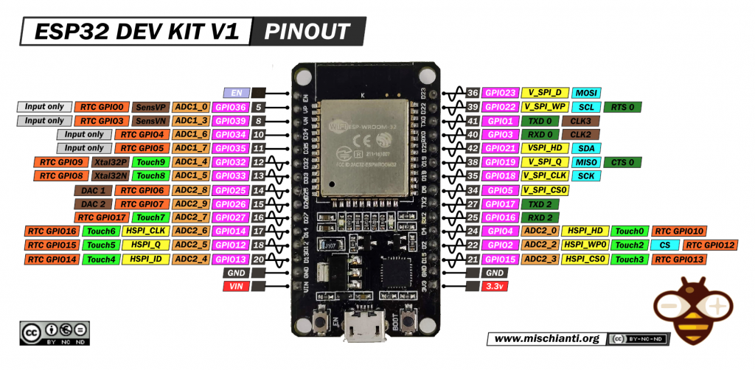](https://mischianti.org/wp-content/uploads/2020/11/ESP32-DOIT-DEV-KIT-v1-pinout-mischianti.png)

So the new connection schema become like so:

[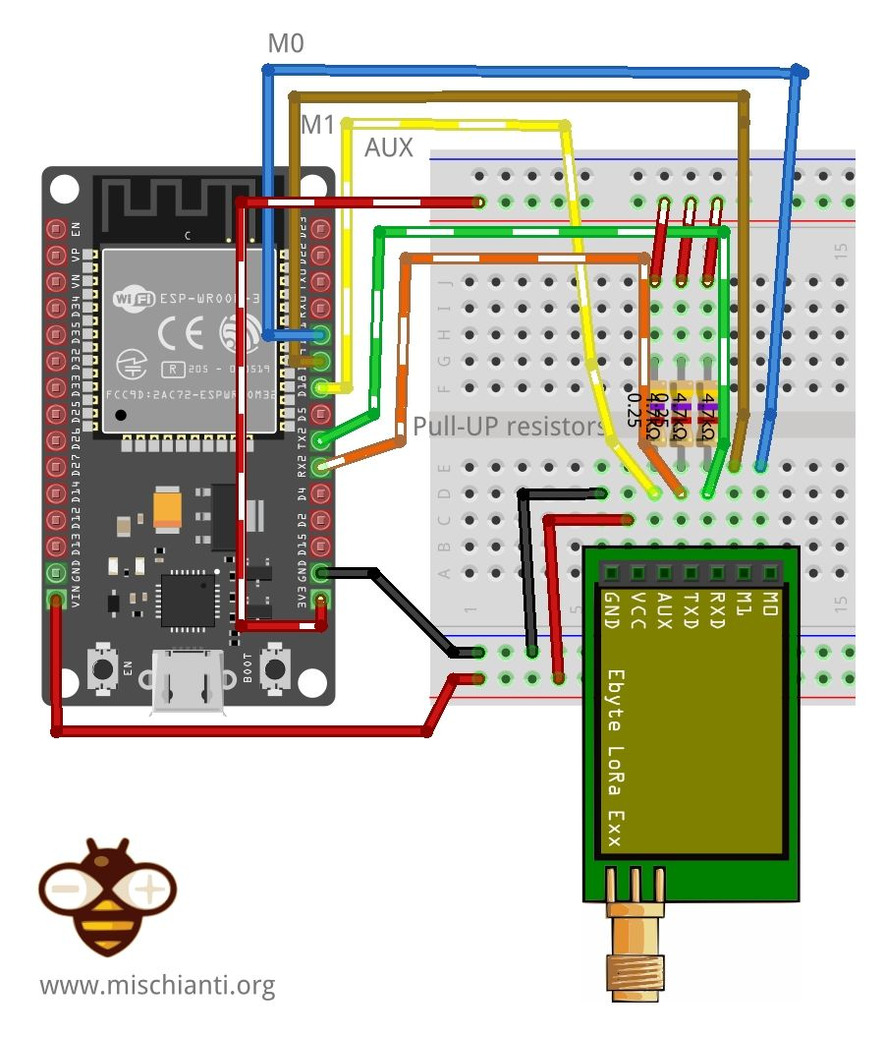](https://mischianti.org/wp-content/uploads/2021/02/EByte_LoRa_E32_E22_ESP32_DEV_KIT_V1_VD_PU_Fully_connected_bb.jpg)EByte LoRa E32 E22 ESP32 DEV KIT V1 Fully connected breadboard

When you are in Sleep mode the e32 put on the buffer the data recived and go immediately LOW, when data is ready return HIGHT, LOW It’s perfect to wake the microcontroller.

[](https://mischianti.org/wp-content/uploads/2019/10/e32auxPinOnReception.jpg)LoRa e32 AUX pin on reception

* [ESP32 wake up](https://mischianti.org/ebyte-lora-e32-device-for-arduino-esp32-or-esp8266-wor-wake-on-radio-and-new-esp32-shield-8/#ESP32_wake_up)
  + [How to put in light sleep ESP32](https://mischianti.org/ebyte-lora-e32-device-for-arduino-esp32-or-esp8266-wor-wake-on-radio-and-new-esp32-shield-8/#How_to_put_in_light_sleep_ESP32)
  + [How to put in deep sleep](https://mischianti.org/ebyte-lora-e32-device-for-arduino-esp32-or-esp8266-wor-wake-on-radio-and-new-esp32-shield-8/#How_to_put_in_deep_sleep)
* [ESP32 DOIT DEV KIT v1 shield v1](https://mischianti.org/ebyte-lora-e32-device-for-arduino-esp32-or-esp8266-wor-wake-on-radio-and-new-esp32-shield-8/#ESP32_DOIT_DEV_KIT_v1_shield_v1)
  + [Now we are going to soldering.](https://mischianti.org/ebyte-lora-e32-device-for-arduino-esp32-or-esp8266-wor-wake-on-radio-and-new-esp32-shield-8/#Now_we_are_going_to_soldering)
* [New versione shared v3](https://mischianti.org/ebyte-lora-e32-device-for-arduino-esp32-or-esp8266-wor-wake-on-radio-and-new-esp32-shield-8/#New_versione_shared_v3)
* [Shopping List](https://mischianti.org/ebyte-lora-e32-device-for-arduino-esp32-or-esp8266-wor-wake-on-radio-and-new-esp32-shield-8/#Shopping_List)
* [Thanks](https://mischianti.org/ebyte-lora-e32-device-for-arduino-esp32-or-esp8266-wor-wake-on-radio-and-new-esp32-shield-8/#Thanks)

## ESP32 wake up

As the e32 device, the esp32 have some sleep type, but for this test we are going to use Light sleep with GPIO wake up.

Refer to “[ESP32 practical power saving](https://mischianti.org/category/tutorial/esp32-tutorial/esp32-practical-power-saving/)” for a detailed description on sleep mode.

### How to put in light sleep ESP32

The command to put on power down the microcontroller is this

|  |  |
| --- | --- |
| 1  2  3  4  5 | //Go to sleep now  Serial.println("Going to sleep now");  delay(100);  esp_light_sleep_start();  delay(1000); |

But we must specify that the device must wake when AUX pin go LOW

|  |  |
| --- | --- |
| 1  2  3  4  5  6  7  8 | //wifi_station_disconnect(); //not needed  esp_sleep_enable_ext0_wakeup(GPIO_NUM_15,LOW);    //Go to sleep now  Serial.println("Going to sleep now");  delay(100);  esp_light_sleep_start();  delay(1000); |

So the code to receive the alarm from a data transmission becomes like this:

|  |  |
| --- | --- |
| 1  2  3  4  5  6  7  8  9  10  11  12  13  14  15  16  17  18  19  20  21  22  23  24  25  26  27  28  29  30  31  32  33  34  35  36  37  38  39  40  41  42  43  44  45  46  47  48  49  50  51  52  53  54  55  56  57  58  59  60  61  62  63  64  65  66  67  68  69  70  71  72  73  74  75  76  77  78  79  80  81  82  83  84  85  86  87  88  89  90  91  92  93  94  95  96  97  98  99  100  101  102  103  104  105  106  107  108  109  110  111  112  113  114  115  116  117  118  119  120  121  122  123  124  125  126  127  128  129  130  131  132  133  134  135  136  137  138  139  140  141 | /*   * LoRa E32-TTL-100   * Receive fixed transmission message on channel and wake up.   * <https://mischianti.org/>   *   * E32        ----- esp32   * M0         ----- 19 (or GND)   * M1         ----- 21 (or 3.3v)   * RX         ----- TX2 (PullUP)   * TX         ----- RX2 (PullUP)   * AUX        ----- 15  (PullUP)   * VCC        ----- 3.3v/5v   * GND        ----- GND   *   */  #include "Arduino.h"  #include "LoRa_E32.h"  #include <WiFi.h>    #define FPM_SLEEP_MAX_TIME           0xFFFFFFF  **void** callback() {    Serial.println("Callback");    Serial.flush();  }    // ---------- esp8266 pins --------------  //LoRa_E32 e32ttl(RX, TX, AUX, M0, M1);  // Arduino RX <-- e22 TX, Arduino TX --> e22 RX  //LoRa_E32 e32ttl(D3, D4, D5, D7, D6); // Arduino RX <-- e22 TX, Arduino TX --> e22 RX AUX M0 M1  //LoRa_E32 e32ttl(D2, D3); // Config without connect AUX and M0 M1    //#include <SoftwareSerial.h>  //SoftwareSerial mySerial(D2, D3); // Arduino RX <-- e22 TX, Arduino TX --> e22 RX  //LoRa_E32 e32ttl(&mySerial, D5, D7, D6); // AUX M0 M1  // -------------------------------------    // ---------- Arduino pins --------------  //LoRa_E32 e32ttl(4, 5, 3, 7, 6); // Arduino RX <-- e22 TX, Arduino TX --> e22 RX AUX M0 M1  //LoRa_E32 e32ttl(4, 5); // Config without connect AUX and M0 M1    //#include <SoftwareSerial.h>  //SoftwareSerial mySerial(4, 5); // Arduino RX <-- e22 TX, Arduino TX --> e22 RX  //LoRa_E32 e32ttl(&mySerial, 3, 7, 6); // AUX M0 M1  // -------------------------------------    // ---------- esp32 pins --------------  LoRa_E32 e32ttl(**&**Serial2, 15, 21, 19); //  RX AUX M0 M1    //LoRa_E32 e32ttl(&Serial2, 22, 4, 18, 21, 19, UART_BPS_RATE_9600); //  esp32 RX <-- e22 TX, esp32 TX --> e22 RX AUX M0 M1  // -------------------------------------  **void** printParameters(struct Configuration configuration);  //The setup function is called once at startup of the sketch  **void** **setup**()  {      Serial.begin(9600);  **while** (**!**Serial) {          ; // wait for serial port to connect. Needed for native USB      }      delay(100);        e32ttl.begin();          e32ttl.setMode(MODE_2_POWER_SAVING);    //  e32ttl.resetModule();      // After set configuration comment set M0 and M1 to low      // and reboot if you directly set HIGH M0 and M1 to program      ResponseStructContainer c;      c **=** e32ttl.getConfiguration();      Configuration configuration **=** **\***(Configuration**\***) c.data;      printParameters(configuration);        configuration.ADDL **=** 3;      configuration.ADDH **=** 0;      configuration.CHAN **=** 0x04;      configuration.OPTION.fixedTransmission **=** FT_FIXED_TRANSMISSION;      configuration.OPTION.wirelessWakeupTime **=** WAKE_UP_250;        configuration.OPTION.fec **=** FEC_1_ON;      configuration.OPTION.ioDriveMode **=** IO_D_MODE_PUSH_PULLS_PULL_UPS;      configuration.OPTION.transmissionPower **=** POWER_20;        configuration.SPED.airDataRate **=** AIR_DATA_RATE_010_24;      configuration.SPED.uartBaudRate **=** UART_BPS_9600;      configuration.SPED.uartParity **=** MODE_00_8N1;        e32ttl.setConfiguration(configuration, WRITE_CFG_PWR_DWN_SAVE);      printParameters(configuration);      // ---------------------------      delay(1000);      Serial.println();      Serial.println("Start sleep!");        esp_sleep_enable_ext0_wakeup(GPIO_NUM_15,**LOW**);        //Go to sleep now      Serial.println("Going to sleep now");      delay(100);        esp_light_sleep_start();        delay(1000);        Serial.println();      Serial.println("Start listening!");    }    // The loop function is called in an endless loop  **void** **loop**()  {  **if** (e32ttl.available()  > 1){          ResponseContainer rs **=** e32ttl.receiveMessage();          // First of all get the data          String message **=** rs.data;            Serial.println(rs.status.getResponseDescription());          Serial.println(message);      }  }    **void** printParameters(struct Configuration configuration) {      Serial.println("----------------------------------------");        Serial.print(F("HEAD : "));  Serial.print(configuration.HEAD, BIN);Serial.print(" ");Serial.print(configuration.HEAD, DEC);Serial.print(" ");Serial.println(configuration.HEAD, HEX);      Serial.println(F(" "));      Serial.print(F("AddH : "));  Serial.println(configuration.ADDH, DEC);      Serial.print(F("AddL : "));  Serial.println(configuration.ADDL, DEC);      Serial.print(F("Chan : "));  Serial.print(configuration.CHAN, DEC); Serial.print(" -> "); Serial.println(configuration.getChannelDescription());      Serial.println(F(" "));      Serial.print(F("SpeedParityBit     : "));  Serial.print(configuration.SPED.uartParity, BIN);Serial.print(" -> "); Serial.println(configuration.SPED.getUARTParityDescription());      Serial.print(F("SpeedUARTDatte  : "));  Serial.print(configuration.SPED.uartBaudRate, BIN);Serial.print(" -> "); Serial.println(configuration.SPED.getUARTBaudRate());      Serial.print(F("SpeedAirDataRate   : "));  Serial.print(configuration.SPED.airDataRate, BIN);Serial.print(" -> "); Serial.println(configuration.SPED.getAirDataRate());        Serial.print(F("OptionTrans        : "));  Serial.print(configuration.OPTION.fixedTransmission, BIN);Serial.print(" -> "); Serial.println(configuration.OPTION.getFixedTransmissionDescription());      Serial.print(F("OptionPullup       : "));  Serial.print(configuration.OPTION.ioDriveMode, BIN);Serial.print(" -> "); Serial.println(configuration.OPTION.getIODroveModeDescription());      Serial.print(F("OptionWakeup       : "));  Serial.print(configuration.OPTION.wirelessWakeupTime, BIN);Serial.print(" -> "); Serial.println(configuration.OPTION.getWirelessWakeUPTimeDescription());      Serial.print(F("OptionFEC          : "));  Serial.print(configuration.OPTION.fec, BIN);Serial.print(" -> "); Serial.println(configuration.OPTION.getFECDescription());      Serial.print(F("OptionPower        : "));  Serial.print(configuration.OPTION.transmissionPower, BIN);Serial.print(" -> "); Serial.println(configuration.OPTION.getTransmissionPowerDescription());        Serial.println("----------------------------------------");    } |

The result is that the Serial stop on line 98, when we receive the message the e32 wake itself and put AUX LOW, so esp32 wake with interrupt on AUX pin.

Here the sending sketch

|  |  |
| --- | --- |
| 1  2  3  4  5  6  7  8  9  10  11  12  13  14  15  16  17  18  19  20  21  22  23  24  25  26  27  28  29  30  31  32  33  34  35  36  37  38  39  40  41  42  43  44  45  46  47  48  49  50  51  52  53  54  55  56  57  58  59  60  61  62  63  64  65  66  67  68  69  70  71  72  73  74  75  76  77  78  79  80  81  82  83  84  85  86  87  88  89  90  91  92  93  94  95  96  97  98  99  100  101  102  103  104  105  106  107  108  109  110  111  112  113  114  115 | /*   * LoRa E32-TTL-100   * Send fixed transmission message to a specified point.   *   *   * E32        ----- esp32   * M0         ----- 19 (or 3.3v)   * M1         ----- 21 (or GND)   * RX         ----- TX2 (PullUP)   * TX         ----- RX2 (PullUP)   * AUX        ----- 15  (PullUP)   * VCC        ----- 3.3v/5v   * GND        ----- GND   *   */  #include "Arduino.h"  #include "LoRa_E32.h"    // ---------- esp8266 pins --------------  //LoRa_E32 e32ttl(RX, TX, AUX, M0, M1);  // Arduino RX <-- e22 TX, Arduino TX --> e22 RX  //LoRa_E32 e32ttl(D3, D4, D5, D7, D6); // Arduino RX <-- e22 TX, Arduino TX --> e22 RX AUX M0 M1  //LoRa_E32 e32ttl(D2, D3); // Config without connect AUX and M0 M1    //#include <SoftwareSerial.h>  //SoftwareSerial mySerial(D2, D3); // Arduino RX <-- e22 TX, Arduino TX --> e22 RX  //LoRa_E32 e32ttl(&mySerial, D5, D7, D6); // AUX M0 M1  // -------------------------------------    // ---------- Arduino pins --------------  //LoRa_E32 e32ttl(4, 5, 3, 7, 6); // Arduino RX <-- e22 TX, Arduino TX --> e22 RX AUX M0 M1  //LoRa_E32 e32ttl(4, 5); // Config without connect AUX and M0 M1    //#include <SoftwareSerial.h>  //SoftwareSerial mySerial(4, 5); // Arduino RX <-- e22 TX, Arduino TX --> e22 RX  //LoRa_E32 e32ttl(&mySerial, 3, 7, 6); // AUX M0 M1  // -------------------------------------    // ---------- esp32 pins --------------  LoRa_E32 e32ttl(**&**Serial2, 15, 21, 19); //  RX AUX M0 M1    //LoRa_E32 e32ttl(&Serial2, 22, 4, 18, 21, 19, UART_BPS_RATE_9600); //  esp32 RX <-- e22 TX, esp32 TX --> e22 RX AUX M0 M1  // -------------------------------------    **void** printParameters(struct Configuration configuration);  **void** printModuleInformation(struct ModuleInformation moduleInformation);  //The setup function is called once at startup of the sketch  **void** **setup**()  {      Serial.begin(9600);  **while** (**!**Serial) {          ; // wait for serial port to connect. Needed for native USB      }      delay(100);        e32ttl.begin();          e32ttl.setMode(MODE_1_WAKE_UP);        // After set configuration comment set M0 and M1 to low      // and reboot if you directly set HIGH M0 and M1 to program      ResponseStructContainer c;      c **=** e32ttl.getConfiguration();      Configuration configuration **=** **\***(Configuration**\***) c.data;      configuration.ADDL **=** 0x01;      configuration.ADDH **=** 0x00;      configuration.CHAN **=** 0x04;      configuration.OPTION.fixedTransmission **=** FT_FIXED_TRANSMISSION;      configuration.OPTION.wirelessWakeupTime **=** WAKE_UP_2000;      e32ttl.setConfiguration(configuration, WRITE_CFG_PWR_DWN_SAVE);      printParameters(configuration);      c.close();      // ---------------------------  }    // The loop function is called in an endless loop  **void** **loop**()  {      delay(2000);        Serial.println("Send message to 00 03 04");      ResponseStatus rs **=** e32ttl.sendFixedMessage(0, 3, 0x04, "Message to 00 03 04 device");      Serial.println(rs.getResponseDescription());  }    **void** printParameters(struct Configuration configuration) {      Serial.println("----------------------------------------");        Serial.print(F("HEAD : "));  Serial.print(configuration.HEAD, BIN);Serial.print(" ");Serial.print(configuration.HEAD, DEC);Serial.print(" ");Serial.println(configuration.HEAD, HEX);      Serial.println(F(" "));      Serial.print(F("AddH : "));  Serial.println(configuration.ADDH, BIN);      Serial.print(F("AddL : "));  Serial.println(configuration.ADDL, BIN);      Serial.print(F("Chan : "));  Serial.print(configuration.CHAN, DEC); Serial.print(" -> "); Serial.println(configuration.getChannelDescription());      Serial.println(F(" "));      Serial.print(F("SpeedParityBit     : "));  Serial.print(configuration.SPED.uartParity, BIN);Serial.print(" -> "); Serial.println(configuration.SPED.getUARTParityDescription());      Serial.print(F("SpeedUARTDatte  : "));  Serial.print(configuration.SPED.uartBaudRate, BIN);Serial.print(" -> "); Serial.println(configuration.SPED.getUARTBaudRate());      Serial.print(F("SpeedAirDataRate   : "));  Serial.print(configuration.SPED.airDataRate, BIN);Serial.print(" -> "); Serial.println(configuration.SPED.getAirDataRate());        Serial.print(F("OptionTrans        : "));  Serial.print(configuration.OPTION.fixedTransmission, BIN);Serial.print(" -> "); Serial.println(configuration.OPTION.getFixedTransmissionDescription());      Serial.print(F("OptionPullup       : "));  Serial.print(configuration.OPTION.ioDriveMode, BIN);Serial.print(" -> "); Serial.println(configuration.OPTION.getIODroveModeDescription());      Serial.print(F("OptionWakeup       : "));  Serial.print(configuration.OPTION.wirelessWakeupTime, BIN);Serial.print(" -> "); Serial.println(configuration.OPTION.getWirelessWakeUPTimeDescription());      Serial.print(F("OptionFEC          : "));  Serial.print(configuration.OPTION.fec, BIN);Serial.print(" -> "); Serial.println(configuration.OPTION.getFECDescription());      Serial.print(F("OptionPower        : "));  Serial.print(configuration.OPTION.transmissionPower, BIN);Serial.print(" -> "); Serial.println(configuration.OPTION.getTransmissionPowerDescription());        Serial.println("----------------------------------------");    }  **void** printModuleInformation(struct ModuleInformation moduleInformation) {      Serial.println("----------------------------------------");      Serial.print(F("HEAD BIN: "));  Serial.print(moduleInformation.HEAD, BIN);Serial.print(" ");Serial.print(moduleInformation.HEAD, DEC);Serial.print(" ");Serial.println(moduleInformation.HEAD, HEX);        Serial.print(F("Freq.: "));  Serial.println(moduleInformation.frequency, HEX);      Serial.print(F("Version  : "));  Serial.println(moduleInformation.version, HEX);      Serial.print(F("Features : "));  Serial.println(moduleInformation.features, HEX);      Serial.println("----------------------------------------");    } |

### How to put in deep sleep

To manage deep sleep is more difficult, because you must consider that the **AUX pin must be an RTC pin**(like GPIO15) when you put in sleep you must hold down the pin to preserve the WOR mode.

When the device is waked from deep sleep reboot, so you lost the message you receive, and you must send another message if you want that receiver read the message.

So the core code that manage deep sleep and wake is

|  |  |
| --- | --- |
| 1  2  3  4  5  6  7  8  9  10  11  12  13  14  15  16  17  18  19  20  21  22  23  24  25  26  27  28  29  30  31  32  33  34  35  36  37  38  39  40  41  42  43  44  45  46  47  48  49 | esp_sleep_wakeup_cause_t wakeup_reason;        wakeup_reason **=** esp_sleep_get_wakeup_cause();    **if** (ESP_SLEEP_WAKEUP_EXT0 **==** wakeup_reason) {          Serial.println("Waked up from external GPIO!");            gpio_hold_dis(GPIO_NUM_21);          gpio_hold_dis(GPIO_NUM_19);            gpio_deep_sleep_hold_dis();            e32ttl.setMode(MODE_0_NORMAL);            delay(1000);            e32ttl.sendFixedMessage(0, DESTINATION_ADDL, 23, "We have waked up from message, but we can't read It!");      }**else**{          e32ttl.setMode(MODE_2_POWER_SAVING);            delay(1000);          Serial.println();          Serial.println("Start sleep!");          delay(100);    **if** (ESP_OK **==** gpio_hold_en(GPIO_NUM_21)){              Serial.println("HOLD 21");          }**else**{              Serial.println("NO HOLD 21");          }  **if** (ESP_OK **==** gpio_hold_en(GPIO_NUM_19)){                  Serial.println("HOLD 19");              }**else**{                  Serial.println("NO HOLD 19");              }            esp_sleep_enable_ext0_wakeup(GPIO_NUM_15,**LOW**);            gpio_deep_sleep_hold_en();          //Go to sleep now          Serial.println("Going to sleep now");          esp_deep_sleep_start();            delay(1);      }  //  e32ttl.setMode(MODE_0_NORMAL);  //  delay(1000);      Serial.println();      Serial.println("Wake and start listening!"); |

You can see that I use gpio_hold_en to se the pin to preserve state and gpio_deep_sleep_hold_en to activate preservation (Read “[ESP32 practical power saving: preserve gpio status, external and ULP wake up](https://mischianti.org/esp32-practical-power-saving-preserve-gpio-status-external-and-ulp-wake-up-5/)” to go in deep), and gpio_hold_dis with gpio_deep_sleep_hold_dis to deactivate.

Then I use wakeup_reason = esp_sleep_get_wakeup_cause(); to check why the device exited from deep sleep, the command esp_sleep_enable_ext0_wakeup(GPIO_NUM_15,LOW); to put AUX pin in listening and finally esp_deep_sleep_start(); to activate deep sleep.

|  |  |
| --- | --- |
| 1  2  3  4  5  6  7  8  9  10  11  12  13  14  15  16  17  18  19  20  21  22  23  24  25  26  27  28  29  30  31  32  33  34  35  36  37  38  39  40  41  42  43  44  45  46  47  48  49  50  51  52  53  54  55  56  57  58  59  60  61  62  63  64  65  66  67  68  69  70  71  72  73  74  75  76  77  78  79  80  81  82  83  84  85  86  87  88  89  90  91  92  93  94  95  96  97  98  99  100  101  102  103  104  105  106  107  108  109  110  111  112  113  114  115  116  117  118  119  120  121  122  123  124  125  126  127  128  129  130  131  132  133  134  135  136  137  138  139  140  141  142  143  144  145  146  147  148  149  150  151  152  153  154  155  156  157  158  159  160  161  162  163  164  165  166  167  168  169  170  171  172  173  174  175  176  177  178  179  180  181  182  183  184  185  186  187  188  189  190  191  192 | /*   * EBYTE LoRa E32   * Stay in sleep mode and wait a wake up WOR message   *   * You must configure the address with 0 3 23 with WOR receiver enable   * and pay attention that WOR period must be the same of sender   *   *   * [https://mischianti.org](https://mischianti.org/)   *   * E32        ----- esp32   * M0         ----- 19 (or 3.3v)   * M1         ----- 21 (or GND)   * RX         ----- TX2 (PullUP)   * TX         ----- RX2 (PullUP)   * AUX        ----- 15  (PullUP)   * VCC        ----- 3.3v/5v   * GND        ----- GND   *   */    // with this DESTINATION_ADDL 2 you must set  // WOR SENDER configuration to the other device and  // WOR RECEIVER to this device  #define DESTINATION_ADDL 2    // If you want use RSSI uncomment //#define ENABLE_RSSI true  // and use relative configuration with RSSI enabled  //#define ENABLE_RSSI true    #include "Arduino.h"  #include "LoRa_E32.h"  #include <WiFi.h>    #include "soc/rtc_cntl_reg.h"  #include "soc/rtc.h"  #include "driver/rtc_io.h"    #define FPM_SLEEP_MAX_TIME           0xFFFFFFF  **void** callback() {    Serial.println("Callback");    Serial.flush();  }    **void** printParameters(struct Configuration configuration);    // ---------- esp8266 pins --------------  //LoRa_E32 e32ttl(RX, TX, AUX, M0, M1);  // Arduino RX <-- e22 TX, Arduino TX --> e22 RX  //LoRa_E32 e32ttl(D3, D4, D5, D7, D6); // Arduino RX <-- e22 TX, Arduino TX --> e22 RX AUX M0 M1  //LoRa_E32 e32ttl(D2, D3); // Config without connect AUX and M0 M1    //#include <SoftwareSerial.h>  //SoftwareSerial mySerial(D2, D3); // Arduino RX <-- e22 TX, Arduino TX --> e22 RX  //LoRa_E32 e32ttl(&mySerial, D5, D7, D6); // AUX M0 M1  // -------------------------------------    // ---------- Arduino pins --------------  //LoRa_E32 e32ttl(4, 5, 3, 7, 6); // Arduino RX <-- e22 TX, Arduino TX --> e22 RX AUX M0 M1  //LoRa_E32 e32ttl(4, 5); // Config without connect AUX and M0 M1    //#include <SoftwareSerial.h>  //SoftwareSerial mySerial(4, 5); // Arduino RX <-- e22 TX, Arduino TX --> e22 RX  //LoRa_E32 e32ttl(&mySerial, 3, 7, 6); // AUX M0 M1  // -------------------------------------    // ---------- esp32 pins --------------  LoRa_E32 e32ttl(**&**Serial2, 15, 21, 19); //  RX AUX M0 M1    //LoRa_E32 e32ttl(&Serial2, 22, 4, 18, 21, 19, UART_BPS_RATE_9600); //  esp32 RX <-- e22 TX, esp32 TX --> e22 RX AUX M0 M1  // -------------------------------------    //The setup function is called once at startup of the sketch  **void** **setup**()  {      Serial.begin(9600);  **while** (**!**Serial) {          ; // wait for serial port to connect. Needed for native USB      }      delay(100);        e32ttl.begin();        // After set configuration comment set M0 and M1 to low      // and reboot if you directly set HIGH M0 and M1 to program      ResponseStructContainer c;      c **=** e32ttl.getConfiguration();      Configuration configuration **=** **\***(Configuration**\***) c.data;      configuration.ADDL **=** 0x03;      configuration.ADDH **=** 0x00;      configuration.CHAN **=** 0x04;      configuration.OPTION.fixedTransmission **=** FT_FIXED_TRANSMISSION;      configuration.OPTION.wirelessWakeupTime **=** WAKE_UP_2000;      e32ttl.setConfiguration(configuration, WRITE_CFG_PWR_DWN_SAVE);      printParameters(configuration);      c.close();      // ---------------------------          esp_sleep_wakeup_cause_t wakeup_reason;        wakeup_reason **=** esp_sleep_get_wakeup_cause();    **if** (ESP_SLEEP_WAKEUP_EXT0 **==** wakeup_reason) {          Serial.println("Waked up from external GPIO!");            gpio_hold_dis(GPIO_NUM_21);          gpio_hold_dis(GPIO_NUM_19);            gpio_deep_sleep_hold_dis();            e32ttl.setMode(MODE_0_NORMAL);            delay(1000);            e32ttl.sendFixedMessage(0, DESTINATION_ADDL, 23, "We have waked up from message, but we can't read It!");      }**else**{          e32ttl.setMode(MODE_2_POWER_SAVING);            delay(1000);          Serial.println();          Serial.println("Start sleep!");          delay(100);    **if** (ESP_OK **==** gpio_hold_en(GPIO_NUM_21)){              Serial.println("HOLD 21");          }**else**{              Serial.println("NO HOLD 21");          }  **if** (ESP_OK **==** gpio_hold_en(GPIO_NUM_19)){                  Serial.println("HOLD 19");              }**else**{                  Serial.println("NO HOLD 19");              }            esp_sleep_enable_ext0_wakeup(GPIO_NUM_15,**LOW**);            gpio_deep_sleep_hold_en();          //Go to sleep now          Serial.println("Going to sleep now");          esp_deep_sleep_start();            delay(1);      }  //  e32ttl.setMode(MODE_0_NORMAL);  //  delay(1000);      Serial.println();      Serial.println("Wake and start listening!");    }    // The loop function is called in an endless loop  **void** **loop**()  {  **if** (e32ttl.available()  > 1){          Serial.println("Message arrived!");          ResponseContainer rs **=** e32ttl.receiveMessage();          // First of all get the data          String message **=** rs.data;            Serial.println(rs.status.getResponseDescription());          Serial.println(message);            e32ttl.setMode(MODE_0_NORMAL);            delay(1000);            e32ttl.sendFixedMessage(0, DESTINATION_ADDL, 23, "We have received the message!");      }  }    **void** printParameters(struct Configuration configuration) {      Serial.println("----------------------------------------");        Serial.print(F("HEAD : "));  Serial.print(configuration.HEAD, BIN);Serial.print(" ");Serial.print(configuration.HEAD, DEC);Serial.print(" ");Serial.println(configuration.HEAD, HEX);      Serial.println(F(" "));      Serial.print(F("AddH : "));  Serial.println(configuration.ADDH, DEC);      Serial.print(F("AddL : "));  Serial.println(configuration.ADDL, DEC);      Serial.print(F("Chan : "));  Serial.print(configuration.CHAN, DEC); Serial.print(" -> "); Serial.println(configuration.getChannelDescription());      Serial.println(F(" "));      Serial.print(F("SpeedParityBit     : "));  Serial.print(configuration.SPED.uartParity, BIN);Serial.print(" -> "); Serial.println(configuration.SPED.getUARTParityDescription());      Serial.print(F("SpeedUARTDatte  : "));  Serial.print(configuration.SPED.uartBaudRate, BIN);Serial.print(" -> "); Serial.println(configuration.SPED.getUARTBaudRate());      Serial.print(F("SpeedAirDataRate   : "));  Serial.print(configuration.SPED.airDataRate, BIN);Serial.print(" -> "); Serial.println(configuration.SPED.getAirDataRate());        Serial.print(F("OptionTrans        : "));  Serial.print(configuration.OPTION.fixedTransmission, BIN);Serial.print(" -> "); Serial.println(configuration.OPTION.getFixedTransmissionDescription());      Serial.print(F("OptionPullup       : "));  Serial.print(configuration.OPTION.ioDriveMode, BIN);Serial.print(" -> "); Serial.println(configuration.OPTION.getIODroveModeDescription());      Serial.print(F("OptionWakeup       : "));  Serial.print(configuration.OPTION.wirelessWakeupTime, BIN);Serial.print(" -> "); Serial.println(configuration.OPTION.getWirelessWakeUPTimeDescription());      Serial.print(F("OptionFEC          : "));  Serial.print(configuration.OPTION.fec, BIN);Serial.print(" -> "); Serial.println(configuration.OPTION.getFECDescription());      Serial.print(F("OptionPower        : "));  Serial.print(configuration.OPTION.transmissionPower, BIN);Serial.print(" -> "); Serial.println(configuration.OPTION.getTransmissionPowerDescription());        Serial.println("----------------------------------------");    } |

## ESP32 DOIT DEV KIT v1 shield v1

I will also create a shield for esp32 which is very useful for prototyping.

[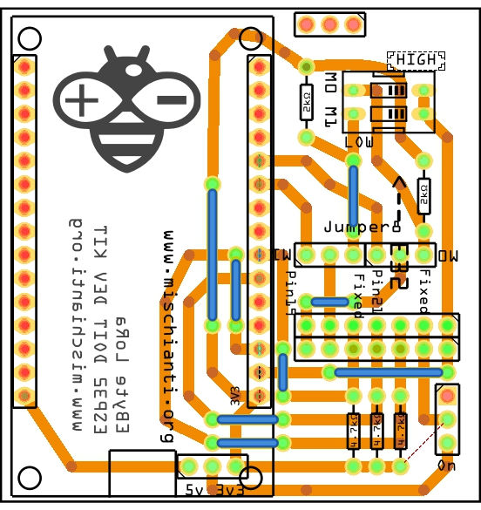](https://mischianti.org/wp-content/uploads/2021/02/LoRa-E32-E22-ESP32-DEV-KIT-V1-shield-PCB-v2-lateral.jpg)LoRa E32 E22 ESP32 DEV KIT V1 shield PCB v2 lateral

The configuration is this:

|  |  |
| --- | --- |
| 1 | LoRa_E32 e32ttl(&Serial2, 15, 21, 19); |

Than you can use all examples inside the library, you can use pin GPIO21 and GPIO19 to do a full connection or disable they and put M0 and M1 as you want with dipswitch.

[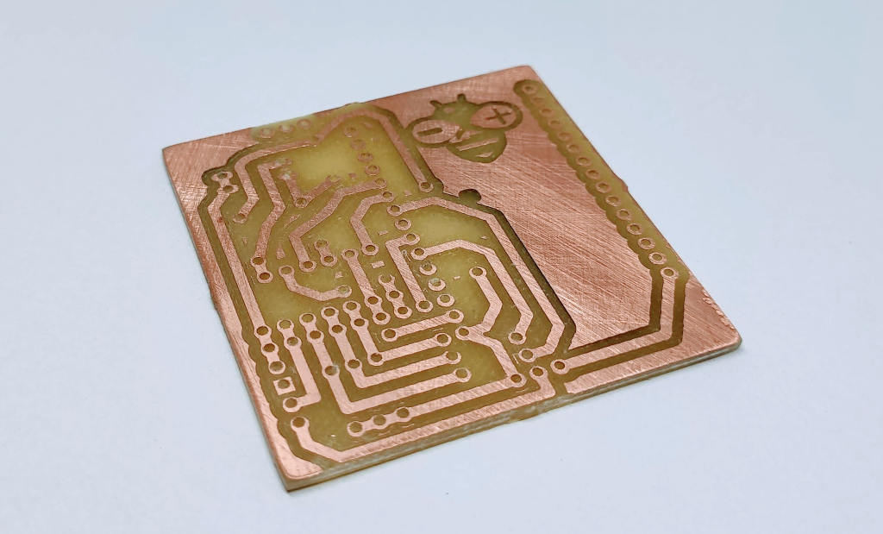](https://mischianti.org/wp-content/uploads/2021/02/LoRa-E32-E22-ESP32-DEV-KIT-V1-shield-PCB-v2-lateral-milled.jpg)LoRa E32 E22 ESP32 DEV KIT V1 shield PCB v2 lateral milled

### Now we are going to soldering.

[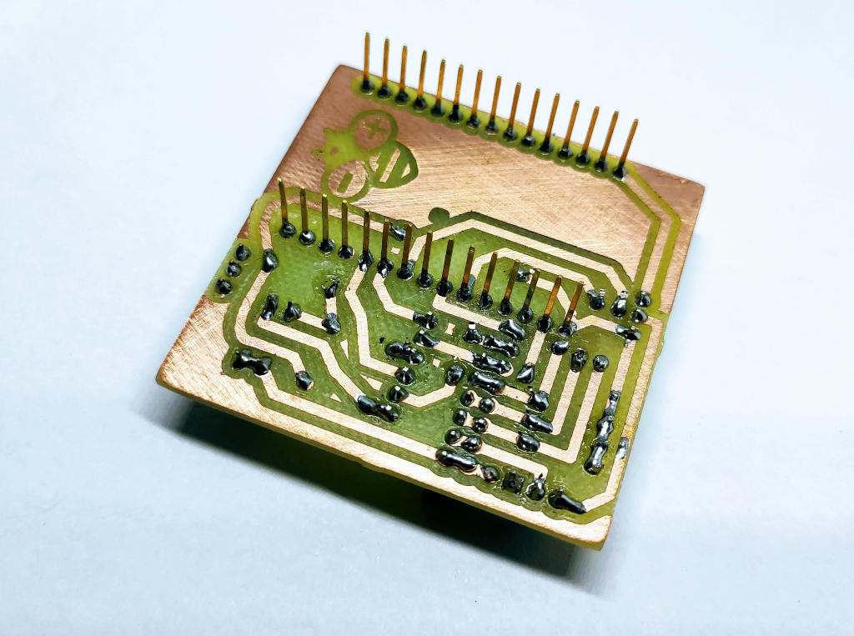](https://mischianti.org/wp-content/uploads/2021/02/LoRa-E32-E22-ESP32-DEV-KIT-V1-shield-PCB-v2-lateral-soldered-bottom-photo.jpg)LoRa E32 E22 ESP32 DEV KIT V1 shield PCB v2 lateral soldered bottom photo

[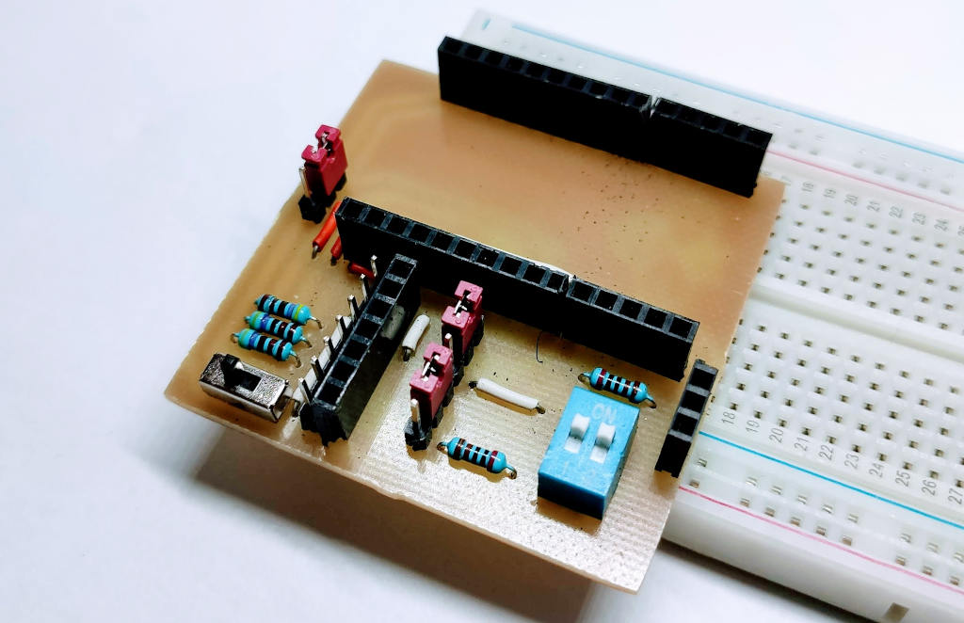](https://mischianti.org/wp-content/uploads/2021/02/LoRa-E32-E22-ESP32-DEV-KIT-V1-shield-PCB-v2-lateral-soldered-photo.jpg)LoRa E32 E22 ESP32 DEV KIT V1 shield PCB v2 lateral soldered photo

Here the result of milled PCB

[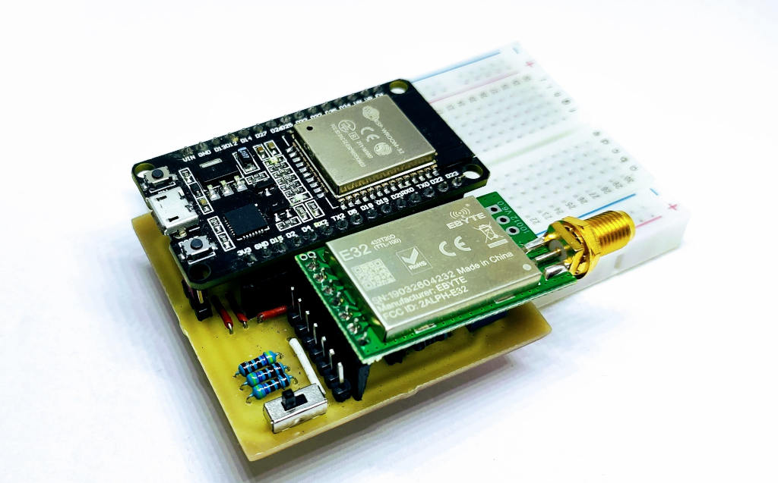](https://mischianti.org/wp-content/uploads/2021/02/LoRa-E32-E22-ESP32-DEV-KIT-V1-shield-PCB-v2-lateral-complete-photo.jpg)LoRa E32 E22 ESP32 DEV KIT V1 shield PCB v2 lateral complete

The shield have some jumper and dip switch to configure M0 and M1.  
If you want set M0 and M1 to a fixed value you must put jumper to F, if you want control via pin to P.  
If you set to F you must put dip switch on property value Low or High.

[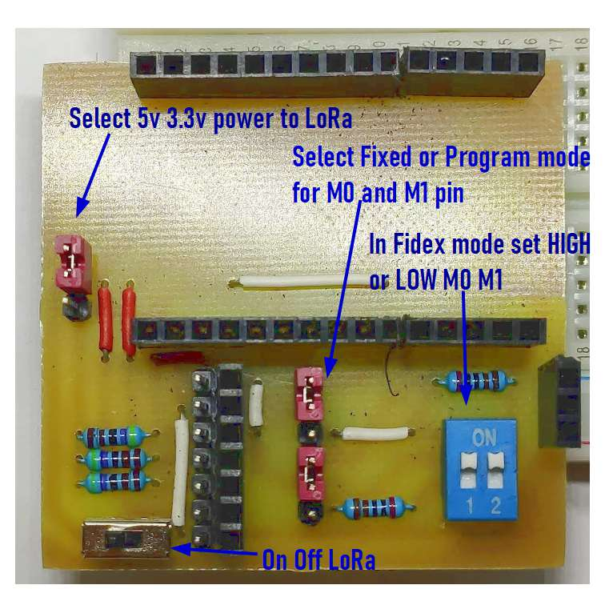](https://mischianti.org/wp-content/uploads/2021/02/LoRa-E32-E22-ESP32-DEV-KIT-V1-shield-PCB-v2-lateral-explained.jpg)LoRa E32 E22 ESP32 DEV KIT V1 shield PCB v2 lateral explained

## New versione shared v3

Now I put the open source PCB on free hosting of PCBWay, the “evolved” PCB is this:

[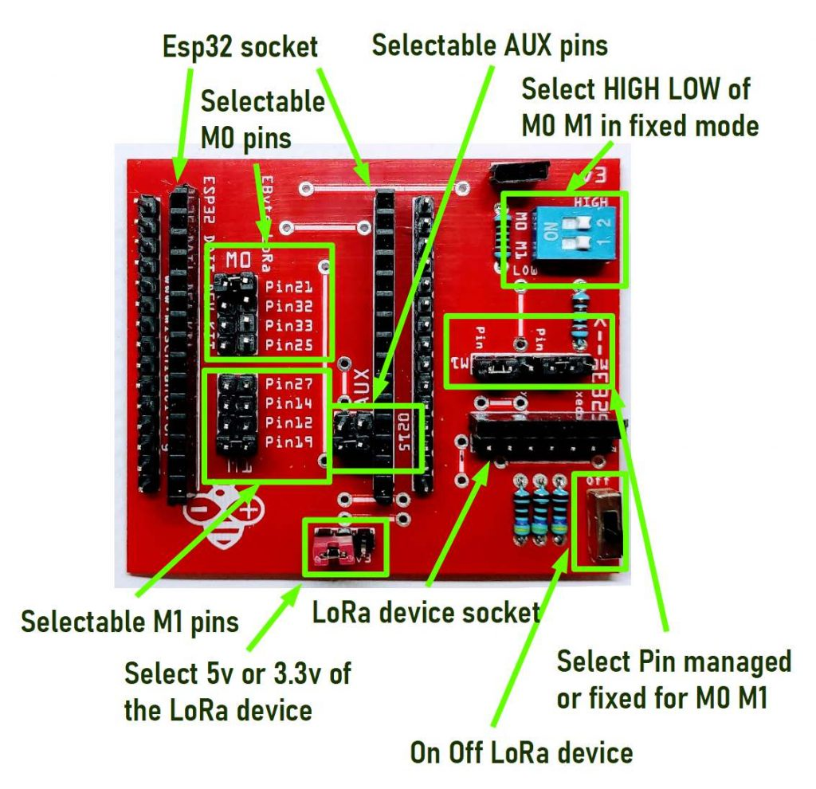](https://mischianti.org/wp-content/uploads/2021/04/esp32-doit-dev-kit-v1-shield-LoRa-EByte-E32-E22-description.jpg)esp32 doit dev kit v1 shield LoRa EByte E32 E22 description

Order the PCB (you can order from PCBWay 5$ for 10pcs) [PCBWay](https://www.pcbway.com/project/shareproject/LoRa_ESP32_DEV_KIT_v1_shield_for_EByte_E32_E22__RF_8km_12km_range.html?from=mischianti723)

[](https://www.pcbway.com/project/shareproject/LoRa_ESP32_DEV_KIT_v1_shield_for_EByte_E32_E22__RF_8km_12km_range.html?from=mischianti723)

[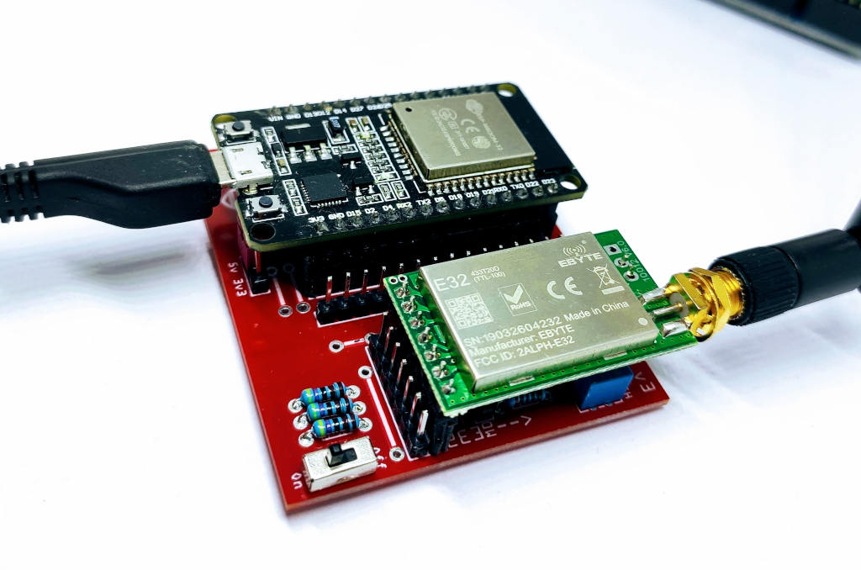](https://mischianti.org/wp-content/uploads/2021/04/esp32-DOIT-DEV-KIT-v1-EByte-LoRa-E32-shield-main.jpg)esp32 DOIT DEV KIT v1 EByte LoRa E32 shield main

## Shopping List

You can find the LoRa devices here on [AliExpress (433MHz 5Km)](https://s.click.aliexpress.com/e/eOHotRkU) - [AliExpress (433MHz 8Km)](https://s.click.aliexpress.com/e/_DkWxBOv) - [AliExpress (433MHz 16Km)](https://s.click.aliexpress.com/e/_DevlDR3) - [AliExpress (868MHz 915MHz 5.5Km)](https://s.click.aliexpress.com/e/_DDjTmop) - [AliExpress (868MHz 915MHz 8Km)](https://s.click.aliexpress.com/e/_DdCkJG5)

You can find the ESP32 DEV KIT here on [ESP32 Dev Kit v1](https://s.click.aliexpress.com/e/_BfhH1zIB) - [TTGO T-Display 1.14 ESP32](https://s.click.aliexpress.com/e/_dYXhHDz) - [NodeMCU V3 V2 ESP8266 Lolin32](https://s.click.aliexpress.com/e/_dX7xZnt) - [NodeMCU ESP-32S](https://s.click.aliexpress.com/e/_DekJaq1) - [WeMos Lolin32](https://s.click.aliexpress.com/e/_Dmp4wZT) - [WeMos Lolin32 mini](https://s.click.aliexpress.com/e/_DeboaY1) - [ESP32-CAM programmer](https://s.click.aliexpress.com/e/_98hjfN) - [ESP32-CAM bundle](https://s.click.aliexpress.com/e/_DF0bBwv) - [ESP32-WROOM-32](https://s.click.aliexpress.com/e/_9j2te7) - [ESP32-S](https://s.click.aliexpress.com/e/_AmwyQf)

| **Amount** | **Part Type** | **Properties** |
| --- | --- | --- |
| 1 | Lora E32-TTL-100 | variant 1; voltage 3-5V; type Basic |
| 1 | [DIP SWITCH](http://s.click.aliexpress.com/e/NZtN5Plm) | channels 1; package dipswitch-02 |
| 2 | [Generic male header](http://s.click.aliexpress.com/e/KJ8Wt9Hq) – 3 pins | pins 3; pin spacing 0.1in (2.54mm); hole size 1.0mm,0.508mm; form  (male); package THT; row single |
| 1 | ESP32 DOIT DEVKIT v1 | type esp8266 |
| 3 | 4.7kΩ [Resistor](http://s.click.aliexpress.com/e/dJnu3JGy) | bands 4; tolerance ±5%; pin spacing 400 mil; package THT; resistance 4.7kΩ |
| 3 | 2kΩ [Resistor](http://s.click.aliexpress.com/e/dJnu3JGy) | bands 4; tolerance ±5%; pin spacing 400 mil; package THT; resistance 2kΩ |
|  | [Generic female header](http://s.click.aliexpress.com/e/4iYQ45Ks) | Pin spacing 0.1in (2.54mm); |
|  | [Generic male/female header](http://s.click.aliexpress.com/e/pEa0y11q) | Pin spacing 0.1in (2.54mm); |

You can get pcb without additional costs here from [PCBWay](https://www.pcbway.com/project/shareproject/LoRa_ESP32_DEV_KIT_v1_shield_for_EByte_E32_E22__RF_8km_12km_range.html?from=mischianti723)

[](https://www.pcbway.com/project/shareproject/LoRa_ESP32_DEV_KIT_v1_shield_for_EByte_E32_E22__RF_8km_12km_range.html?from=mischianti723)

I chose this manufacturer because at the same cost it offers excellent quality, in the first screen it is possible to make countless options suitable for every need.

[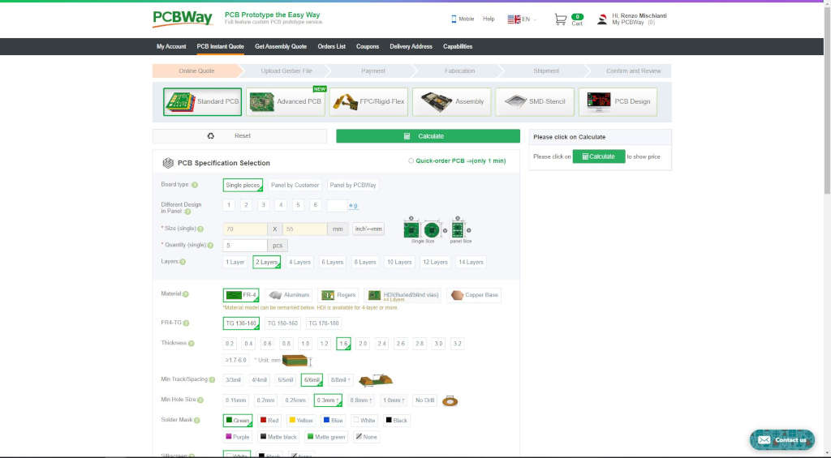](https://mischianti.org/wp-content/uploads/2020/01/PCBWayOptionPage.jpg)PCBWay Option Page

The board as you can see on various photo is very beautiful and simply to solder.

Here the soldering video of the version 1 of the PCB.

## Thanks

# Ebyte LoRa E32 with STM32: WOR (wake on radio) and new STM32 shield – 9

BY [RENZO MISCHIANTI](https://mischianti.org/author/reef/) · PUBLISHED 4 DECEMBER 2023 · UPDATED 4 DECEMBER 2023

**Spread the love**

[**1**](https://mischianti.org/ebyte-lora-e32-with-stm32-wor-wake-on-radio-and-new-stm32-shield-9/)[**1**](http://reddit.com/submit?url=https%3A%2F%2Fmischianti.org%2Febyte-lora-e32-with-stm32-wor-wake-on-radio-and-new-stm32-shield-9%2F&title=Ebyte%20LoRa%20E32%20with%20STM32%3A%20WOR%20%28wake%20on%20radio%29%20and%20new%20STM32%20shield%20-%209)

**2**

Shares

[Support Forum](https://mischianti.org/forums/forum/mischiantis-libraries/ebyte-lora-e32-uart-devices/)

We have seen how this device (E32 UART LoRa based on popular SX1276/SX1278 Wireless Modules ) manages power saving, but If we use power saving only for the e32, the microcontroller continues to rest active, but we can use the AUX pin to resolve this problem.



sx1278 sx1276 wireless lora uart module serial 3000m arduino 433 rf

Here my selection of LoRa E32 [AliExpress (433MHz 5Km)](https://s.click.aliexpress.com/e/eOHotRkU) - [AliExpress (433MHz 8Km)](https://s.click.aliexpress.com/e/_DkWxBOv) - [AliExpress (433MHz 16Km)](https://s.click.aliexpress.com/e/_DevlDR3) - [AliExpress (868MHz 915MHz 5.5Km)](https://s.click.aliexpress.com/e/_DDjTmop) - [AliExpress (868MHz 915MHz 8Km)](https://s.click.aliexpress.com/e/_DdCkJG5)

* [STM32F1 Blue pill wiring](https://mischianti.org/ebyte-lora-e32-with-stm32-wor-wake-on-radio-and-new-stm32-shield-9/#STM32F1_Blue_pill_wiring)
* [STM32F4 Black pill wiring](https://mischianti.org/ebyte-lora-e32-with-stm32-wor-wake-on-radio-and-new-stm32-shield-9/#STM32F4_Black_pill_wiring)
* [AUX pin behavior](https://mischianti.org/ebyte-lora-e32-with-stm32-wor-wake-on-radio-and-new-stm32-shield-9/#AUX_pin_behavior)
* [STM32 wake up](https://mischianti.org/ebyte-lora-e32-with-stm32-wor-wake-on-radio-and-new-stm32-shield-9/#STM32_wake_up)
  + [How to put in light sleep STM32](https://mischianti.org/ebyte-lora-e32-with-stm32-wor-wake-on-radio-and-new-stm32-shield-9/#How_to_put_in_light_sleep_STM32)
* [Configuration for STM32 LoRa Shield](https://mischianti.org/ebyte-lora-e32-with-stm32-wor-wake-on-radio-and-new-stm32-shield-9/#Configuration_for_STM32_LoRa_Shield)
* [Thanks](https://mischianti.org/ebyte-lora-e32-with-stm32-wor-wake-on-radio-and-new-stm32-shield-9/#Thanks)

## STM32F1 Blue pill wiring

Pinout STM32 STM32F1 STM32F103 STM32F103C8 low resolution

We are going to make this connection to support wake on radio, we use Serial2 for communication, PB0 for M0 and PB10 for M1, and A0, the wake pin, for AUX so we can wake our device without a problem.  
I advise you to read the tutorial on energy saving with STM32 “STM32 power saving”.

So the new connection schema becomes like so:

STM32F1 Blue Pill EByte LoRa Exx fully connected

## STM32F4 Black pill wiring

STM32 STM32F401 STM32F401CCU6 pinout low resolution

We are going to make this connection to support wake on radio, we use Serial2 for communication, PB0 for M0 and PB2 for M1, and A0, the wake pin, for AUX so we can wake our device without a problem.  
I advise you to read the tutorial on energy saving with STM32 “STM32 power saving”.

STM32F4 Black Pill EByte LoRa Exx fully connected

## AUX pin behavior

When you are in Sleep mode, the e32 puts on the buffer the data received and go immediately LOW. When data is ready, return HIGHT, LOW It’s perfect to wake the microcontroller.

LoRa e32 AUX pin on reception

## STM32 wake up

As the e32 device, the stm32 has some sleep type, but for this test, we are going to use Light sleep with GPIO wake up.

Refer to “STM32 power saving” for a detailed description of sleep mode.

### How to put in light sleep STM32

The command to put on power down the microcontroller is this

|  |  |
| --- | --- |
| 103  104  105  106  107  108  109 | Serial.println("Start SLEEP mode in ");  **for** (**int** i **=** 10;i>0;i**--**) { Serial.print(i); Serial.print(" "); } Serial.println( "OK!" );  delay(1000);    LowPower.sleep();    delay(1000); |

But we must specify that the device must wake when the AUX pin goes LOW

|  |  |
| --- | --- |
| 97  98  99  100  101 | // Configure low power  LowPower.begin();  // Attach a wakeup interrupt on pin, calling repetitionsIncrease when the device is woken up  // Last parameter (LowPowerMode) should match with the low power state used: in this example LowPower.sleep()  LowPower.attachInterruptWakeup(pin, wakedUp, **LOW**, SLEEP_MODE); |

So the code to receive the alarm from a data transmission becomes like this:

|  |  |
| --- | --- |
| 1  2  3  4  5  6  7  8  9  10  11  12  13  14  15  16  17  18  19  20  21  22  23  24  25  26  27  28  29  30  31  32  33  34  35  36  37  38  39  40  41  42  43  44  45  46  47  48  49  50  51  52  53  54  55  56  57  58  59  60  61  62  63  64  65  66  67  68  69  70  71  72  73  74  75  76  77  78  79  80  81  82  83  84  85  86  87  88  89  90  91  92  93  94  95  96  97  98  99  100  101  102  103  104  105  106  107  108  109  110  111  112  113  114  115  116  117  118  119  120  121  122  123  124  125  126  127  128  129  130  131  132  133  134  135  136  137  138  139  140  141  142  143  144  145  146  147  148  149  150  151  152  153  154  155  156  157  158 | /*   * EBYTE LoRa E32   * Stay in sleep mode and wait a wake up WOR message   *   * You must configure the address with 0 3 23 with WOR receiver enable   * and pay attention that WOR period must be the same of sender   *   *   * [https://mischianti.org](https://mischianti.org/)   *   * E32        ----- stm32   * M0         ----- PB0 (or 3.3v)   * M1         ----- PB10 (or GND)   * RX         ----- PA2 TX2 (PullUP)   * TX         ----- PA3 RX2 (PullUP)   * AUX        ----- PA0  (PullUP)   * VCC        ----- 3.3v/5v   * GND        ----- GND   *   */    // with this DESTINATION_ADDL 2 you must set  // WOR SENDER configuration to the other device and  // WOR RECEIVER to this device  #define DESTINATION_ADDL 2    #include "Arduino.h"  #include "LoRa_E32.h"  #include "STM32LowPower.h"    **void** wakedUp() {      // randomly you can read this, but normally reset block every time the execution      Serial.println("Wake-Up callback!");  }    **void** printParameters(struct Configuration configuration);    // ---------- esp8266 pins --------------  //LoRa_E32 e32ttl(RX, TX, AUX, M0, M1);  // Arduino RX <-- e22 TX, Arduino TX --> e22 RX  //LoRa_E32 e32ttl(D3, D4, D5, D7, D6); // Arduino RX <-- e22 TX, Arduino TX --> e22 RX AUX M0 M1  //LoRa_E32 e32ttl(D2, D3); // Config without connect AUX and M0 M1    //#include <SoftwareSerial.h>  //SoftwareSerial mySerial(D2, D3); // Arduino RX <-- e22 TX, Arduino TX --> e22 RX  //LoRa_E32 e32ttl(&mySerial, D5, D7, D6); // AUX M0 M1  // -------------------------------------    // ---------- Arduino pins --------------  //LoRa_E32 e32ttl(4, 5, 3, 7, 6); // Arduino RX <-- e22 TX, Arduino TX --> e22 RX AUX M0 M1  //LoRa_E32 e32ttl(4, 5); // Config without connect AUX and M0 M1    //#include <SoftwareSerial.h>  //SoftwareSerial mySerial(4, 5); // Arduino RX <-- e22 TX, Arduino TX --> e22 RX  //LoRa_E32 e32ttl(&mySerial, 3, 7, 6); // AUX M0 M1  // -------------------------------------    // ---------- esp32 pins --------------  //LoRa_E32 e32ttl(&Serial2, 15, 21, 19); //  RX AUX M0 M1    //LoRa_E32 e32ttl(&Serial2, 22, 4, 18, 21, 19, UART_BPS_RATE_9600); //  esp32 RX <-- e22 TX, esp32 TX --> e22 RX AUX M0 M1  // -------------------------------------    // ---------------- STM32 --------------------  HardwareSerial Serial2(USART2);   // PA3  (RX)  PA2  (TX)    LoRa_E32 e32ttl(**&**Serial2, PA0, PB0, PB10); //  RX AUX M0 M1  // -------------------------------------------------    **const** **int** pin **=** SYS_WKUP1;    //The setup function is called once at startup of the sketch  **void** **setup**()  {      Serial.begin(9600);  **while** (**!**Serial) {          ; // wait for serial port to connect. Needed for native USB      }      delay(100);        e32ttl.begin();        // After set configuration comment set M0 and M1 to low      // and reboot if you directly set HIGH M0 and M1 to program  //  ResponseStructContainer c;  //  c = e32ttl.getConfiguration();  //  Configuration configuration = *(Configuration*) c.data;  //  configuration.ADDL = 0x03;  //  configuration.ADDH = 0x00;  //  configuration.CHAN = 0x04;  //  configuration.OPTION.fixedTransmission = FT_FIXED_TRANSMISSION;  //  configuration.OPTION.wirelessWakeupTime = WAKE_UP_2000;  //  e32ttl.setConfiguration(configuration, WRITE_CFG_PWR_DWN_SAVE);  //  printParameters(configuration);  //  c.close();      // ---------------------------      e32ttl.setMode(MODE_2_POWER_SAVING);      // Configure low power      LowPower.begin();      // Attach a wakeup interrupt on pin, calling repetitionsIncrease when the device is woken up      // Last parameter (LowPowerMode) should match with the low power state used: in this example LowPower.sleep()      LowPower.attachInterruptWakeup(pin, wakedUp, **LOW**, SLEEP_MODE);        Serial.println("Start SLEEP mode in ");  **for** (**int** i **=** 10;i>0;i**--**) { Serial.print(i); Serial.print(" "); } Serial.println( "OK!" );      delay(1000);        LowPower.sleep();        delay(1000);        //  e32ttl.setMode(MODE_0_NORMAL);  //  delay(1000);      Serial.println();      Serial.println("Wake and start listening!");  }    // The loop function is called in an endless loop  **void** **loop**()  {  **if** (e32ttl.available()  > 1){          Serial.println("Message arrived!");          ResponseContainer rs **=** e32ttl.receiveMessage();          // First of all get the data          String message **=** rs.data;            Serial.println(rs.status.getResponseDescription());          Serial.println(message);            e32ttl.setMode(MODE_0_NORMAL);            delay(1000);            e32ttl.sendFixedMessage(0, DESTINATION_ADDL, 23, "We have received the message!");      }  }    **void** printParameters(struct Configuration configuration) {      Serial.println("----------------------------------------");        Serial.print(F("HEAD : "));  Serial.print(configuration.HEAD, BIN);Serial.print(" ");Serial.print(configuration.HEAD, DEC);Serial.print(" ");Serial.println(configuration.HEAD, HEX);      Serial.println(F(" "));      Serial.print(F("AddH : "));  Serial.println(configuration.ADDH, DEC);      Serial.print(F("AddL : "));  Serial.println(configuration.ADDL, DEC);      Serial.print(F("Chan : "));  Serial.print(configuration.CHAN, DEC); Serial.print(" -> "); Serial.println(configuration.getChannelDescription());      Serial.println(F(" "));      Serial.print(F("SpeedParityBit     : "));  Serial.print(configuration.SPED.uartParity, BIN);Serial.print(" -> "); Serial.println(configuration.SPED.getUARTParityDescription());      Serial.print(F("SpeedUARTDatte  : "));  Serial.print(configuration.SPED.uartBaudRate, BIN);Serial.print(" -> "); Serial.println(configuration.SPED.getUARTBaudRate());      Serial.print(F("SpeedAirDataRate   : "));  Serial.print(configuration.SPED.airDataRate, BIN);Serial.print(" -> "); Serial.println(configuration.SPED.getAirDataRate());        Serial.print(F("OptionTrans        : "));  Serial.print(configuration.OPTION.fixedTransmission, BIN);Serial.print(" -> "); Serial.println(configuration.OPTION.getFixedTransmissionDescription());      Serial.print(F("OptionPullup       : "));  Serial.print(configuration.OPTION.ioDriveMode, BIN);Serial.print(" -> "); Serial.println(configuration.OPTION.getIODroveModeDescription());      Serial.print(F("OptionWakeup       : "));  Serial.print(configuration.OPTION.wirelessWakeupTime, BIN);Serial.print(" -> "); Serial.println(configuration.OPTION.getWirelessWakeUPTimeDescription());      Serial.print(F("OptionFEC          : "));  Serial.print(configuration.OPTION.fec, BIN);Serial.print(" -> "); Serial.println(configuration.OPTION.getFECDescription());      Serial.print(F("OptionPower        : "));  Serial.print(configuration.OPTION.transmissionPower, BIN);Serial.print(" -> "); Serial.println(configuration.OPTION.getTransmissionPowerDescription());        Serial.println("----------------------------------------");    } |

The result is that the Serial stop on line 98. When we receive the message, the e32 wake itself and puts AUX LOW, so esp32 wake with interrupt on AUX pin.

Here is the sending sketch:

|  |  |
| --- | --- |
| 1  2  3  4  5  6  7  8  9  10  11  12  13  14  15  16  17  18  19  20  21  22  23  24  25  26  27  28  29  30  31  32  33  34  35  36  37  38  39  40  41  42  43  44  45  46  47  48  49  50  51  52  53  54  55  56  57  58  59  60  61  62  63  64  65  66  67  68  69  70  71  72  73  74  75  76  77  78  79  80  81  82  83  84  85  86  87  88  89  90  91  92  93  94  95  96  97  98  99  100  101  102  103  104  105  106  107  108  109  110  111  112  113  114  115  116  117  118  119  120  121  122  123  124  125  126  127  128  129  130  131  132 | /*   * LoRa E32   * Send fixed broadcast transmission message to a specified channel.   * <https://mischianti.org/lora-e32-device-for-arduino-esp32-or-esp8266-fixed-transmission-part-4/>   *   * E32        ----- stm32   * M0         ----- PB0 (or GND)   * M1         ----- PB10 (or GND)   * RX         ----- PA2 TX2 (PullUP)   * TX         ----- PA3 RX2 (PullUP)   * AUX        ----- PA0  (PullUP)   * VCC        ----- 3.3v/5v   * GND        ----- GND   *   */  #include "Arduino.h"  #include "LoRa_E32.h"    // ---------- esp8266 pins --------------  //LoRa_E32 e32ttl(RX, TX, AUX, M0, M1);  // Arduino RX <-- e220 TX, Arduino TX --> e220 RX  //LoRa_E32 e32ttl(D3, D4, D5, D7, D6); // Arduino RX <-- e220 TX, Arduino TX --> e220 RX AUX M0 M1  //LoRa_E32 e32ttl(D2, D3); // Config without connect AUX and M0 M1    //#include <SoftwareSerial.h>  //SoftwareSerial mySerial(D2, D3); // Arduino RX <-- e220 TX, Arduino TX --> e220 RX  //LoRa_E32 e32ttl(&mySerial, D5, D7, D6); // AUX M0 M1  // -------------------------------------    // ---------- Arduino pins --------------  // LoRa_E32 e32ttl(4, 5, 3, 7, 6); // Arduino RX <-- e220 TX, Arduino TX --> e220 RX AUX M0 M1  //LoRa_E32 e32ttl(4, 5); // Config without connect AUX and M0 M1    //#include <SoftwareSerial.h>  //SoftwareSerial mySerial(4, 5); // Arduino RX <-- e220 TX, Arduino TX --> e220 RX  //LoRa_E32 e32ttl(&mySerial, 3, 7, 6); // AUX M0 M1  // -------------------------------------    // ------------- Arduino Nano 33 IoT -------------  // LoRa_E32 e32ttl(&Serial1, 2, 4, 6); //  RX AUX M0 M1  // -------------------------------------------------    // ------------- Arduino MKR WiFi 1010 -------------  // LoRa_E32 e32ttl(&Serial1, 0, 2, 4); //  RX AUX M0 M1  // -------------------------------------------------    // ---------- esp32 pins --------------  // LoRa_E32 e32ttl(&Serial2, 15, 21, 19); //  RX AUX M0 M1    //LoRa_E32 e32ttl(&Serial2, 22, 4, 18, 21, 19, UART_BPS_RATE_9600); //  esp32 RX <-- e220 TX, esp32 TX --> e220 RX AUX M0 M1  // -------------------------------------  // ---------------- STM32 --------------------  HardwareSerial Serial2(USART2);   // PA3  (RX)  PA2  (TX)    LoRa_E32 e32ttl(**&**Serial2, PA0, PB0, PB10); //  RX AUX M0 M1  // -------------------------------------------------    **void** printParameters(struct Configuration configuration);  **void** printModuleInformation(struct ModuleInformation moduleInformation);  //The setup function is called once at startup of the sketch  **void** **setup**()  {      Serial.begin(9600);  **while** (**!**Serial) {          ; // wait for serial port to connect. Needed for native USB      }      delay(100);        e32ttl.begin();        // After set configuration comment set M0 and M1 to low      // and reboot if you directly set HIGH M0 and M1 to program  //  ResponseStructContainer c;  //  c = e32ttl.getConfiguration();  //  Configuration configuration = *(Configuration*) c.data;  //  configuration.ADDL = 0x03;  //  configuration.ADDH = 0x00;  //  configuration.CHAN = 0x05;  //  configuration.OPTION.fixedTransmission = FT_FIXED_TRANSMISSION;  //  e32ttl.setConfiguration(configuration, WRITE_CFG_PWR_DWN_SAVE);  //  c.close();  //  //  //  ResponseStructContainer c1;  //  c1 = e32ttl.getConfiguration();  //  Configuration configuration1 = *(Configuration*) c1.data;  //  printParameters(configuration1);  //  c1.close();      // ---------------------------  }    // The loop function is called in an endless loop  **void** **loop**()  {      delay(2000);        Serial.println("Send message to 00 03 04");      ResponseStatus rs **=** e32ttl.sendFixedMessage(0, 3, 0x04, "Message to 00 03 04 device");      Serial.println(rs.getResponseDescription());  }    **void** printParameters(struct Configuration configuration) {      Serial.println("----------------------------------------");        Serial.print(F("HEAD : "));  Serial.print(configuration.HEAD, BIN);Serial.print(" ");Serial.print(configuration.HEAD, DEC);Serial.print(" ");Serial.println(configuration.HEAD, HEX);      Serial.println(F(" "));      Serial.print(F("AddH : "));  Serial.println(configuration.ADDH, BIN);      Serial.print(F("AddL : "));  Serial.println(configuration.ADDL, BIN);      Serial.print(F("Chan : "));  Serial.print(configuration.CHAN, DEC); Serial.print(" -> "); Serial.println(configuration.getChannelDescription());      Serial.println(F(" "));      Serial.print(F("SpeedParityBit     : "));  Serial.print(configuration.SPED.uartParity, BIN);Serial.print(" -> "); Serial.println(configuration.SPED.getUARTParityDescription());      Serial.print(F("SpeedUARTDatte  : "));  Serial.print(configuration.SPED.uartBaudRate, BIN);Serial.print(" -> "); Serial.println(configuration.SPED.getUARTBaudRate());      Serial.print(F("SpeedAirDataRate   : "));  Serial.print(configuration.SPED.airDataRate, BIN);Serial.print(" -> "); Serial.println(configuration.SPED.getAirDataRate());        Serial.print(F("OptionTrans        : "));  Serial.print(configuration.OPTION.fixedTransmission, BIN);Serial.print(" -> "); Serial.println(configuration.OPTION.getFixedTransmissionDescription());      Serial.print(F("OptionPullup       : "));  Serial.print(configuration.OPTION.ioDriveMode, BIN);Serial.print(" -> "); Serial.println(configuration.OPTION.getIODroveModeDescription());      Serial.print(F("OptionWakeup       : "));  Serial.print(configuration.OPTION.wirelessWakeupTime, BIN);Serial.print(" -> "); Serial.println(configuration.OPTION.getWirelessWakeUPTimeDescription());      Serial.print(F("OptionFEC          : "));  Serial.print(configuration.OPTION.fec, BIN);Serial.print(" -> "); Serial.println(configuration.OPTION.getFECDescription());      Serial.print(F("OptionPower        : "));  Serial.print(configuration.OPTION.transmissionPower, BIN);Serial.print(" -> "); Serial.println(configuration.OPTION.getTransmissionPowerDescription());        Serial.println("----------------------------------------");    }  **void** printModuleInformation(struct ModuleInformation moduleInformation) {      Serial.println("----------------------------------------");      Serial.print(F("HEAD BIN: "));  Serial.print(moduleInformation.HEAD, BIN);Serial.print(" ");Serial.print(moduleInformation.HEAD, DEC);Serial.print(" ");Serial.println(moduleInformation.HEAD, HEX);        Serial.print(F("Freq.: "));  Serial.println(moduleInformation.frequency, HEX);      Serial.print(F("Version  : "));  Serial.println(moduleInformation.version, HEX);      Serial.print(F("Features : "));  Serial.println(moduleInformation.features, HEX);      Serial.println("----------------------------------------");    } |

Here the Serial output of the 2 devices mixed

|  |  |
| --- | --- |
| 1  2  3  4  5  6  7  8 | Start SLEEP mode in  10 9 8 7 6 5 4 3 2 1 OK!  Send message to 00 03 04  Success  Wake and start listening!  Message arrived!  Success  Message to 00 03 04 deviceMessage to 00 03 04 device |

## Configuration for STM32 LoRa Shield

I release a new shield for STM32F1 blue pill and

STM32F1 blue pill EByte LoRa Exx shield

[Unleashing IoT Potential: Integrating STM32F1 Blue-Pill with EByte LoRa E32, E22, and E220 Shields](https://mischianti.org/unleashing-iot-potential-integrating-stm32f1-blue-pill-with-ebyte-lora-e32-e22-and-e220-shields/)

STM32F4 black pill, and I think It’s very useful for prototyping and more.

STM32F4 black pill EByte LoRa Exx shield

[Unleashing IoT Potential: Integrating STM32F4 Black-Pill with EByte LoRa E32, E22, and E220 Shield](https://mischianti.org/unleashing-iot-potential-integrating-stm32f4-black-pill-with-ebyte-lora-e32-e22-and-e220-shield/)

The configuration is this:

|  |  |
| --- | --- |
| 1  2  3  4 | // -------------------- STM32 ----------------------  HardwareSerial Serial2(USART2);   // PA3  (RX)  PA2  (TX)  LoRa_E32 e32ttl(&Serial2, PA0, PB0, PB10); //  RX AUX M0 M1  // ------------------------------------------------- |

for this jumper configuration

STM32F1 blue pill EByte LoRa Exx shield

## Thanks

# Multiple LoRa Nodes Communication with Master LoRa Node

## LoRa Two Way Communication with Multiple Nodes

[](https://iotprojectsideas.com/author/alsan/) [**Alsan Parajuli**](https://iotprojectsideas.com/author/alsan/)March 12, 2022

4 11 minutes read

[Facebook](https://www.facebook.com/sharer.php?u=https://iotprojectsideas.com/multiple-lora-nodes-communication-with-master-lora-node/) [X](https://twitter.com/intent/tweet?text=Multiple%20LoRa%20Nodes%20Communication%20with%20Master%20LoRa%20Node&url=https://iotprojectsideas.com/multiple-lora-nodes-communication-with-master-lora-node/) [LinkedIn](https://www.linkedin.com/shareArticle?mini=true&url=https://iotprojectsideas.com/multiple-lora-nodes-communication-with-master-lora-node/&title=Multiple%20LoRa%20Nodes%20Communication%20with%20Master%20LoRa%20Node) [Tumblr](https://www.tumblr.com/share/link?url=https://iotprojectsideas.com/multiple-lora-nodes-communication-with-master-lora-node/&name=Multiple%20LoRa%20Nodes%20Communication%20with%20Master%20LoRa%20Node) [Pinterest](https://pinterest.com/pin/create/button/?url=https://iotprojectsideas.com/multiple-lora-nodes-communication-with-master-lora-node/&description=Multiple%20LoRa%20Nodes%20Communication%20with%20Master%20LoRa%20Node&media=https://iotprojectsideas.com/wp-content/uploads/2022/03/Multiple-LoRa-Nodes-Communication-with-Master-LoRa-Node-using-Arduino-and-SX1278-LoRa-Module.jpg) [Reddit](https://reddit.com/submit?url=https://iotprojectsideas.com/multiple-lora-nodes-communication-with-master-lora-node/&title=Multiple%20LoRa%20Nodes%20Communication%20with%20Master%20LoRa%20Node) [Messenger](https://www.facebook.com/dialog/send?app_id=5303202981&display=popup&link=https://iotprojectsideas.com/multiple-lora-nodes-communication-with-master-lora-node/&redirect_uri=https://iotprojectsideas.com/multiple-lora-nodes-communication-with-master-lora-node/)

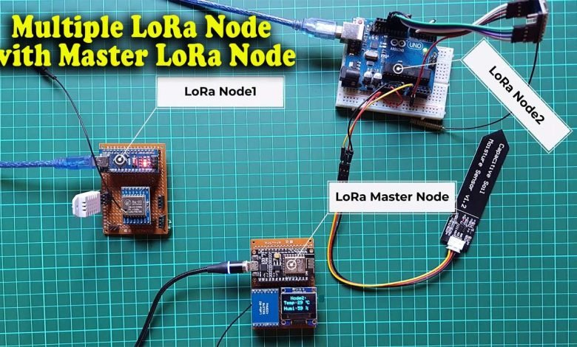

Today in this tutorial, we will learn to make **Multiple LoRa Nodes communication** with the **Master LoRa Node**. But, before getting started with this tutorial, let’s have a quick overview of our previous [**Arduino**](https://iotprojectsideas.com/multiple-lora-nodes-communication-with-master-lora-node/)and **SX1278 LoRa** transceiver modules.

Table Of Contents

1. [Quick Overview of Previous LoRa SX1278 based Projects](https://iotprojectsideas.com/multiple-lora-nodes-communication-with-master-lora-node/#quick-overview-of-previous-lora-sx1278-based-projects)
2. [Overview: Multiple LoRa Nodes Communication with Master LoRa Node](https://iotprojectsideas.com/multiple-lora-nodes-communication-with-master-lora-node/#overview-multiple-lora-nodes-communication-with-master-lora-node)
3. [Working of Multiple LoRa Nodes Communication](https://iotprojectsideas.com/multiple-lora-nodes-communication-with-master-lora-node/#working-of-multiple-lora-nodes-communication)
4. [Components Required](https://iotprojectsideas.com/multiple-lora-nodes-communication-with-master-lora-node/#components-required)
5. [Circuit Diagram of Multiple LoRa Communication](https://iotprojectsideas.com/multiple-lora-nodes-communication-with-master-lora-node/#circuit-diagram-of-multiple-lora-communication)
   * [Master LoRa Node Circuit:](https://iotprojectsideas.com/multiple-lora-nodes-communication-with-master-lora-node/#master-lora-node-circuit)
   * [Arduino LoRa Node1 Circuit:](https://iotprojectsideas.com/multiple-lora-nodes-communication-with-master-lora-node/#arduino-lora-node1-circuit)
   * [Arduino LoRa Node2 Circuit:](https://iotprojectsideas.com/multiple-lora-nodes-communication-with-master-lora-node/#arduino-lora-node2-circuit)
   * [Project PCB Gerber File & PCB Ordering Online](https://iotprojectsideas.com/multiple-lora-nodes-communication-with-master-lora-node/#project-pcb-gerber-file-pcb-ordering-online)
6. [Arduino Multiple LoRa Nodes Programming:](https://iotprojectsideas.com/multiple-lora-nodes-communication-with-master-lora-node/#arduino-multiple-lora-nodes-programming)
   * [Master LoRa Node Program Code:](https://iotprojectsideas.com/multiple-lora-nodes-communication-with-master-lora-node/#master-lora-node-program-code)
   * [Arduino LoRa Node1 Program Code:](https://iotprojectsideas.com/multiple-lora-nodes-communication-with-master-lora-node/#arduino-lora-node1-program-code)
   * [Arduino LoRa Node1 Program Code:](https://iotprojectsideas.com/multiple-lora-nodes-communication-with-master-lora-node/#toc_0.911595446630584)
7. [LoRa Nodes Codes Explanation:](https://iotprojectsideas.com/multiple-lora-nodes-communication-with-master-lora-node/#lora-nodes-codes-explanation)
8. [Conclusion](https://iotprojectsideas.com/multiple-lora-nodes-communication-with-master-lora-node/#conclusion)

## Quick Overview of Previous LoRa SX1278 based Projects

In the first tutorial, I explained the maximum basic things including the **SX1278 LoR**a module **Pinout**, **technical specifications**, and its interfacing with the [Arduino](https://iotprojectsideas.com/multiple-lora-nodes-communication-with-master-lora-node/). I demonstrated a simple LoRa one-way communication project. It was an [**agriculture monitoring and automatic irrigation system**](http://iotprojectsideas.com/lora-based-iot-smart-irrigation-system-with-esp8266-blynk/). In which I monitored multiple sensors like **soil moisture sensor**, **DS18B20 temperature sensor**, and **DHT22 Temperature & Humidity sensor** remotely using LoRa **SX1278**module on **Blynk IoT Platform**.

Then I made a **long-range** [**LoRa wireless two-way communication system**](http://iotprojectsideas.com/lora-based-two-way-wireless-communication-system-with-arduino/) using the same **433Mhz SX1278** LoRaTransceiver modules. In this project, I interfaced DHT22 sensor and **16×2 I2C LCD** on the first LoRa Node. While on the second LoRa node I interface the **DS18B20**temperature sensor and **OLED**Display.

Here I was simply sending the **DHT22**temperature and humidity value from the First Node to the Second Node and then I was printing those values on the **I2C OLED**display module. While on the other side I used a **DS18B20**temperature sensor and I was able to send the temperature value to the first node and then print its value on a **16×2 i2c LCD** display. You can easily modify this project to [**monitor multiple sensors**](http://iotprojectsideas.com/lora-based-wireless-weather-station-using-arduino-esp32/) and control multiple devices as per your requirement.

## Overview: Multiple LoRa Nodes Communication with Master LoRa Node

In today’s tutorial, you will learn how to perform **Multiple LoRa Nodes** **Communication**with the **Master Lora Node**. Here, I have three LoRa modules, you can use more if you have. So, in this demonstration, I am using one as the **Master LoRa node** and the other two as the **LoRa end devices**.

To the **LoRa Node1,** a **capacitive soil moisture sensor** is connected which I am going to use to measure the **Relative Humidity of soil**. But, you can replace this sensor with any other sensor of your requirement. In a **LoRa Node2**, the **DHT22 temperature & humidity sensor** is connected.

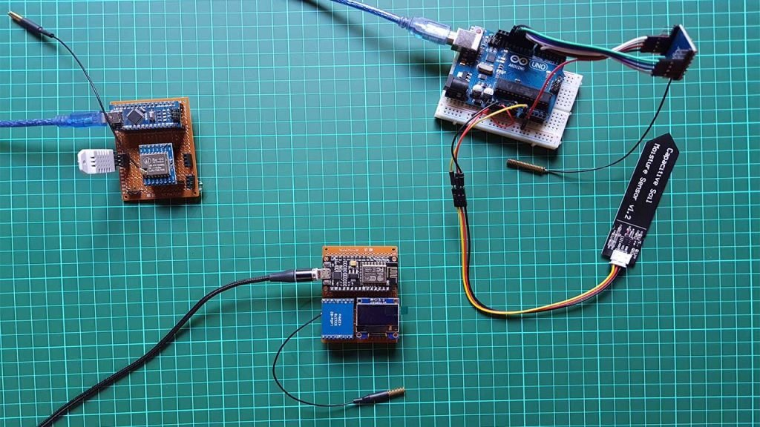

To the **master LoRa Node,** a **0.96 inch i2c supported Oled display** module is connected which is used for displaying the data received from the other two LoRa end devices. So, you can see it in the image below. I have connected two different sensors to the [**Arduino**](https://iotprojectsideas.com/multiple-lora-nodes-communication-with-master-lora-node/)**LoRa nodes** or **LoRa end devices.** We will send those sensor values to the **master LoRa Node** and print them on OLED Display along with the **Node1** or **Node2** information.  You can add multiple **LoRa Nodes** with different sensors connected. So, let’s go ahead and check how this system works.

## Working of Multiple LoRa Nodes Communication

Here, **Master LoRa Node** sends a request to the **LoRa end devices**. For this, I created a timer using the **millis() function**. So, for the first **5 seconds**, the **Master LoRa node** sends multiple requests to the **LoRa Node1** and receives Soil Moisture Sensor data from the **LoRa Node1**. Then for the next **5 seconds**, it receives temperature and humidity data from the **LoRa Node2.** You can change this time duration in the program code.

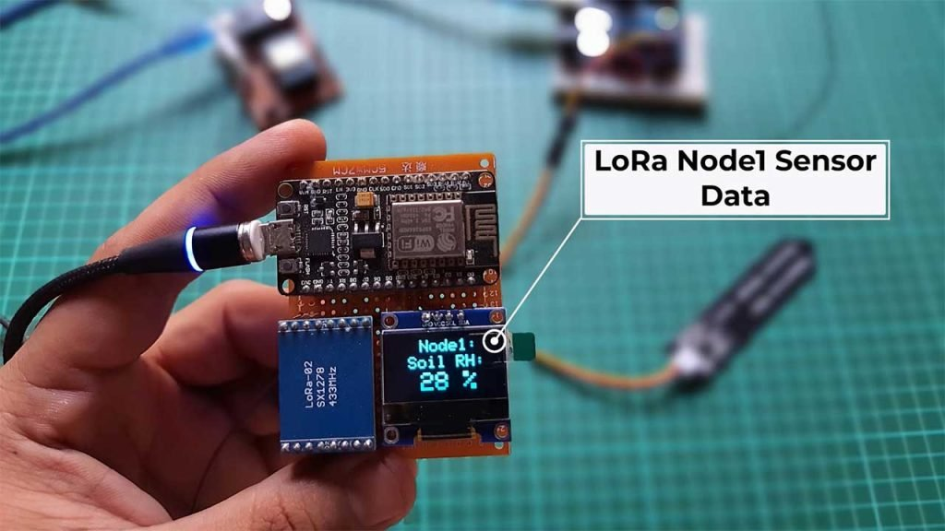

Those received sensor data from LoRa Nodes are printed on **OLED Display** Module. On the top of the Display, the **Node name** is printed. So you won’t have any confusion about from which node you are receiving data. This entire system is based on **two-way communication**. Thus you can also send commands to remote **LoRa nodes** to control devices.

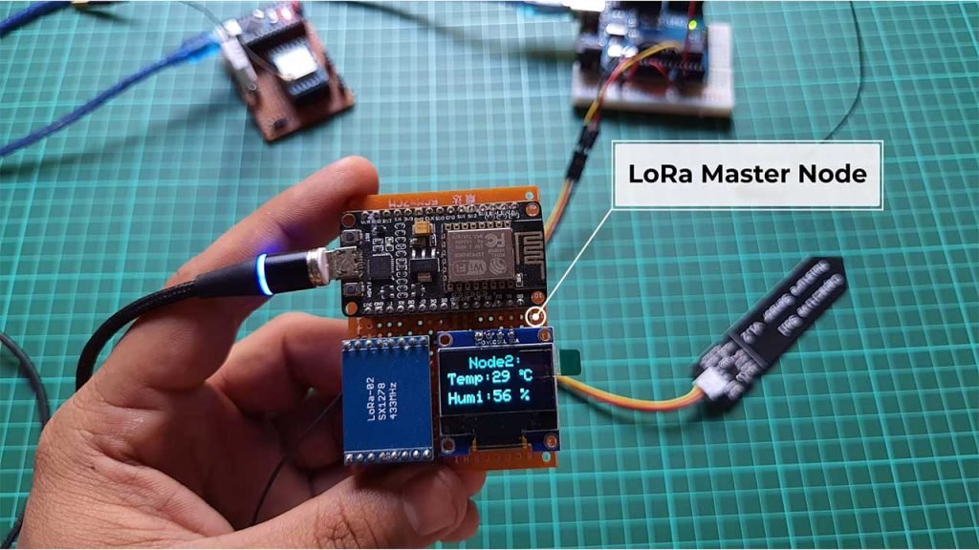

You can DIY your own **LoRaWAN**project by converting this **Master Node** to **LoRa Gateway**. This is the main reason for using the **NodeMCU ESP8266 12E Board** on Master Node instead of the [Arduino](https://iotprojectsideas.com/multiple-lora-nodes-communication-with-master-lora-node/) board. Because, using the nodemcu ESP8266 board I can easily send sensor data to IoT platforms like **Thingspeak, Blynk IoT,**[**Arduino**](https://iotprojectsideas.com/multiple-lora-nodes-communication-with-master-lora-node/)**IoT Cloud, Ubidots, AWS IoT**, etc. It’s totally up to you how you modify and for what purpose you use this project. So, I hope you already got an idea of what you are going to learn here.

## Components Required

All the components required for making Multiple LoRa Nodes Communication with Master LoRa Node are provided below. You can purchase all the components online from Amazon.

| **S.N** | **Components Name** | **Quantity** | **Get Products from Amazon** |
| --- | --- | --- | --- |
| 1 | NodeMCU ESP8266-12E Board | 1 | <https://amzn.to/3sCrEbj> |
| 2 | Capacitive Soil Moisture Sensor | 1 | <https://amzn.to/3nyL9y7> |
| 3 | DHT22 Temperature & Humidity Sensor | 1 | <https://amzn.to/32VEw1X> |
| 4 | 0.96" I2C OLED Display | 1 | <https://amzn.to/3kvENyc> |
| 5 | [Arduino](https://iotprojectsideas.com/multiple-lora-nodes-communication-with-master-lora-node/) Nano | 2 | <https://amzn.to/3Hf7zvN> |
| 6 | LoRa SX1278 Transceiver Module | 3 | <https://amzn.to/3G6xapO> |
| 7 | Few jumpers wires | 20 | <https://amzn.to/3klh0A4> |

***\*Please Note***: These are affiliate links. I may make a commission if you buy the components through these links. I would appreciate your support in this way!

## Circuit Diagram of Multiple LoRa Communication

Now, let us see how we can connect **Multiple LoRa Nodes with Master LoRa Node**. The circuit diagram and explanation of each LoRa node are provided below.

### Master LoRa Node Circuit:

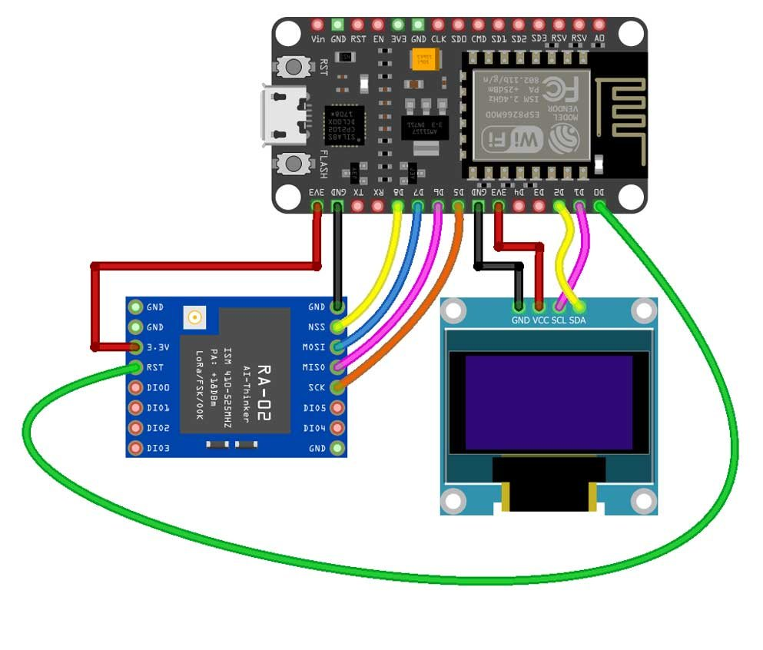

This is the circuit diagram of the Master LoRa Node. The VCC of the **SX1278 Lora module** is connected with the 3.3V of the NodeMCU. The **MISO**Pin of the LoRa module is connected with the NodeMCU pin D6. The **MOSI**pin is connected with the NodeMCU pin D7. The **SCK**pin of the LoRa module is connected with NodeMCU pin D5. The **NSS**pin is connected with pin D8 and the ground pin of the LoRa module is connected with the NodeMCU GND. The VCC and GND pins of the **SSD1306 Oled display module** are connected with the **NodeMCU**3.3V and GND pins. The **SDA**and **SCL**pins of the **Oled display** module are connected with the **NodeMCU I2C** pins D1 and D2.

### Arduino LoRa Node1 Circuit:

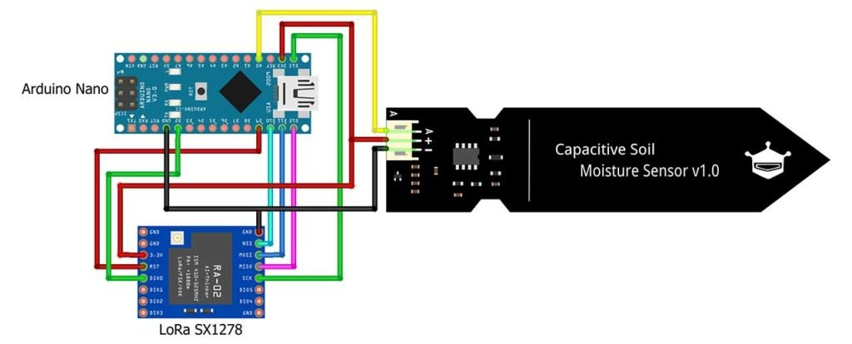

This is the circuit diagram of the **LoRa Node1**. The connection of the **SX1278 Lora module**, and Capacitive Soil Moisture Sensor remains exactly as shown here. The **VCC**of the LoRa module is connected with the **3.3V**of the [Arduino](https://iotprojectsideas.com/multiple-lora-nodes-communication-with-master-lora-node/). The **MISO**Pin of the LoRa module is connected with [**Arduino**](https://iotprojectsideas.com/multiple-lora-nodes-communication-with-master-lora-node/)**’s pin 12**. The **MOSI**pin is connected with the Arduino’s pin 11. The **SCK**pin of the LoRa module is connected with **Arduino’s pin 13**. The **NSS**pin is connected with the Arduino’s pin 10 and the ground pin of the LoRa module is connected with the Arduino’s GND.

The **data wire (yellow)** of the **capacitive soil moisture sensor** is connected with Analog pin **A0**while the other two **Red**and **Black**wire of the soil moisture sensor is connected with the Arduino’s **3.3V**and **GND**.

### Arduino LoRa Node2 Circuit:

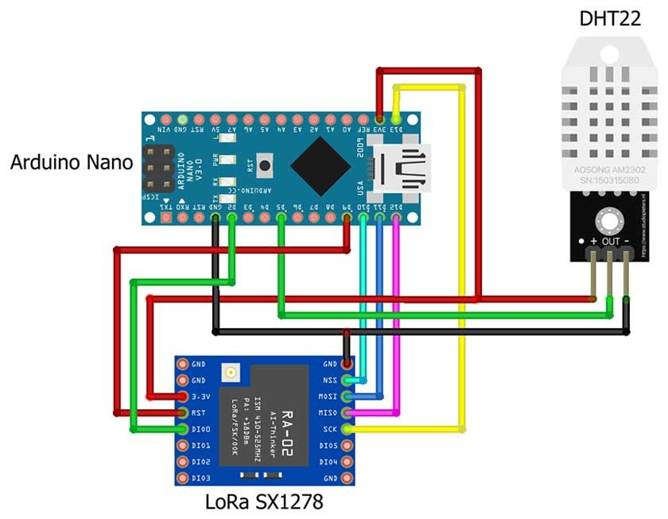

This is the circuit diagram of the **LoRa Node2**. The connection of the **SX1278 Lora module** remains exactly the same as **LoRa Node1.**

**Out**pin of the **DHT22**sensor is connected to the **D5**pin of the [Arduino](https://iotprojectsideas.com/multiple-lora-nodes-communication-with-master-lora-node/). Whereas **VCC**and **GND**are connected to **3.3V**and **GND**pins of [Arduino](https://iotprojectsideas.com/multiple-lora-nodes-communication-with-master-lora-node/) respectively.

### Project PCB Gerber File & PCB Ordering Online

You can simply assemble the circuit on a breadboard. But To remove messy wiring and give a clean look, I designed a PCB prototype for this project. It is also helpful for troubleshooting without any errors. You can download the Gerber file of my PCB Design from the link attached below. The PCB looks like the image shown below.

* 
* 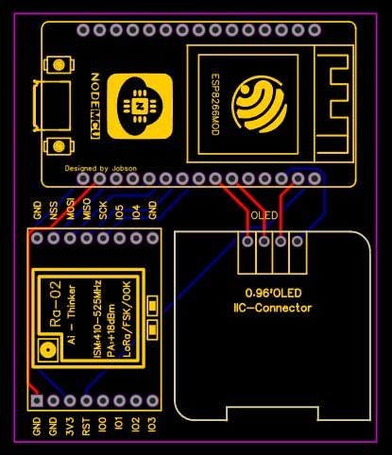
* 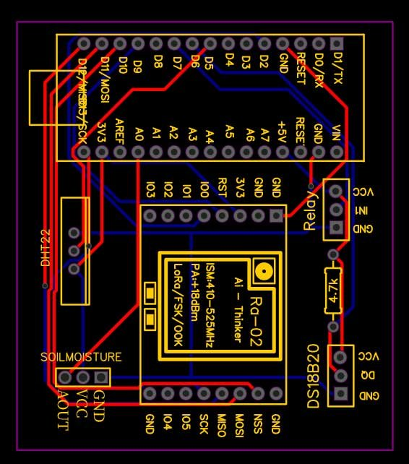
* 

LoRa based IoT Smart Irrigation System with ESP8266 Gateway PCB

I provided the Gerber File for ***Multiple LoRa Nodes Communication with Master LoRa Node* PCB** below.

[Download Arduino Nodes PCB Gerber File](http://iotprojectsideas.com/wp-content/uploads/2022/01/Gerber_PCB_Lora_Sensor_Node.zip)

[Download Master Node Gerber File](http://iotprojectsideas.com/wp-content/uploads/2022/01/Gerber_PCB_Lora-Gateway.zip)

You can simply download the Gerber File and order your custom PCB from [PCBWay](https://www.pcbway.com/?from=theiotprojects09)

Visit the PCBWay official website by clicking here: [https://www.PCBWay.com/](https://www.pcbway.com/?from=theiotprojects09). Simply upload your Gerber File to the Website and place an order. I prefer **PCBWay**for ordering custom PCBs. **PCBWay**is a place that brings manufacturers and customers together. They have more than a decade of experience in this field of fabrication, prototyping, and assembling PCBs. **PCBWay**have proved their focus to their customers’ needs in terms of cost-effectiveness, delivery, and quality. And this can be proved by their outstanding customer reviews.

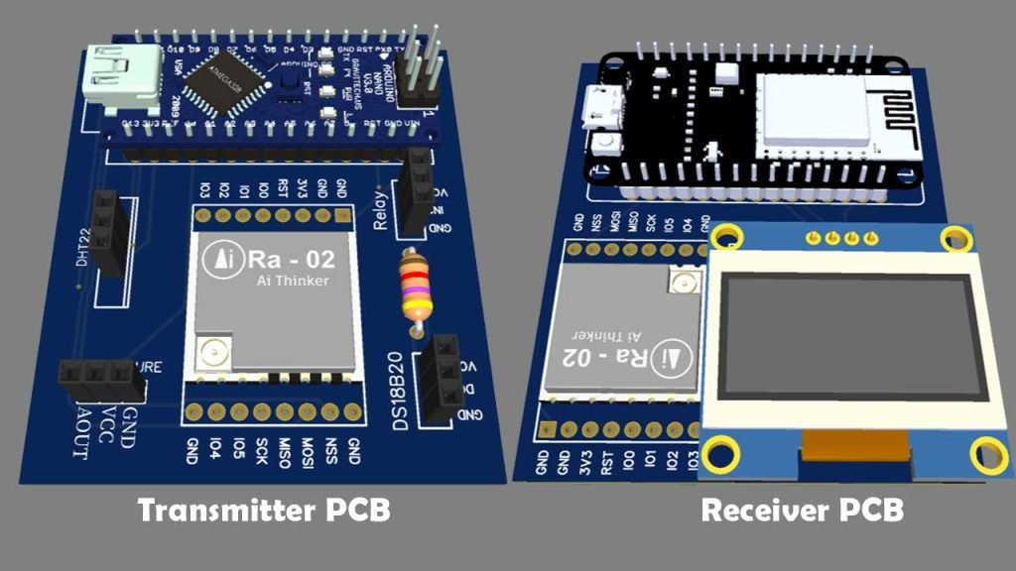

## Arduino Multiple LoRa Nodes Programming:

Before you start programming, first of all, make sure you download and install all the necessary library files.

* [LoRa.h Library](https://github.com/sandeepmistry/arduino-LoRa)
* [DHT.h Library](https://www.arduino.cc/reference/en/libraries/dht-sensor-library/)
* [Adafruit_GFX.h Library](https://github.com/adafruit/Adafruit-GFX-Library)
* [Adafruit_SSD1306.h Library](https://github.com/adafruit/Adafruit_SSD1306)

As this project is based on multiple LoRa Nodes. Therefore, each LoRa Node has its own code. In this demonstration, we have three LoRa nodes. So, we will have three different codes. First, let’s start with the Master LoRa node.

### Master LoRa Node Program Code:

/*

Master Lora Node

The IoT Projects

*/

#include <SPI.h> // include libraries

#include <LoRa.h>

#include <Adafruit_GFX.h>

#include <Adafruit_SSD1306.h>

#define ss 15 //GPIO 15

#define rst 16 //GPIO 16

#define dio0 4 //GPIO 4

#define SCREEN_WIDTH 128 // OLED display width, in pixels

#define SCREEN_HEIGHT 64 // OLED display height, in pixels

// Declaration for an SSD1306 display connected to I2C (SDA, SCL pins)

#define OLED_RESET -1 // Reset pin # (or -1 if sharing [Arduino](https://iotprojectsideas.com/multiple-lora-nodes-communication-with-master-lora-node/) reset pin)

Adafruit_SSD1306 display**(**SCREEN_WIDTH, SCREEN_HEIGHT, &Wire, OLED_RESET**)**;

byte MasterNode = 0xFF;

byte Node1 = 0xBB;

byte Node2 = 0xCC;

String SenderNode = "";

String outgoing; // outgoing message

byte msgCount = 0; // count of outgoing messages

String incoming = "";

// Tracks the time since last event fired

unsigned long previousMillis = 0;

unsigned long int previoussecs = 0;

unsigned long int currentsecs = 0;

unsigned long currentMillis = 0;

int interval = 1 ; // updated every 1 second

int Secs = 0;

int temperature;

int humidity;

int soilmoisturepercent;

int soilMoistureValue;

void setup**()** **{**

Serial.begin**(**115200**)**; // initialize serial

display.begin**(**SSD1306_SWITCHCAPVCC, 0x3C**)**;

delay**(**500**)**;

display.clearDisplay**()**;

display.setTextColor**(**WHITE**)**;

**while** **(**!Serial**)**;

Serial.println**(**"LoRa Master Node"**)**;

LoRa.setPins**(**ss, rst, dio0**)**;

**if** **(**!LoRa.begin**(**433E6**))** **{**

Serial.println**(**"Starting LoRa failed!"**)**;

**while** **(**1**)**;

**}**

**}**

void loop**()** **{**

currentMillis = millis**()**;

currentsecs = currentMillis / 1000;

**if** **((**unsigned long**)(**currentsecs - previoussecs**)** **>**= interval**)** **{**

Secs = Secs + 1;

//Serial.println(Secs);

**if** **(** Secs **>**= 11 **)**

**{**

Secs = 0;

**}**

**if** **(** **(**Secs **>**= 1**)** && **(**Secs **<**= 5**)** **)**

**{**

String message = "10";

sendMessage**(**message, MasterNode, Node1**)**;

**}**

**if** **(** **(**Secs **>**= 6 **)** && **(**Secs **<**= 10**))**

**{**

String message = "20";

sendMessage**(**message, MasterNode, Node2**)**;

**}**

previoussecs = currentsecs;

**}**

// parse for a packet, and call onReceive with the result:

onReceive**(**LoRa.parsePacket**())**;

**}**

void sendMessage**(**String outgoing, byte MasterNode, byte otherNode**)** **{**

LoRa.beginPacket**()**; // start packet

LoRa.write**(**otherNode**)**; // add destination address

LoRa.write**(**MasterNode**)**; // add sender address

LoRa.write**(**msgCount**)**; // add message ID

LoRa.write**(**outgoing.length**())**; // add payload length

LoRa.print**(**outgoing**)**; // add payload

LoRa.endPacket**()**; // finish packet and send it

msgCount++; // increment message ID

**}**

void onReceive**(**int packetSize**)** **{**

**if** **(**packetSize == 0**)** **return**; // if there's no packet, return

// read packet header bytes:

int recipient = LoRa.read**()**; // recipient address

byte sender = LoRa.read**()**; // sender address

**if** **(** sender == 0XBB **)**

SenderNode = "Node1:";

**if** **(** sender == 0XCC **)**

SenderNode = "Node2:";

byte incomingMsgId = LoRa.read**()**; // incoming msg ID

byte incomingLength = LoRa.read**()**; // incoming msg length

**while** **(**LoRa.available**())** **{**

incoming += **(**char**)**LoRa.read**()**;

**}**

**if** **(**incomingLength != incoming.length**())** **{** // check length for error

//Serial.println("error: message length does not match length");

;

**return**; // skip rest of function

**}**

// if the recipient isn't this device or broadcast,

**if** **(**recipient != Node1 && recipient != MasterNode**)** **{**

// Serial.println("This message is not for me.");

;

**return**; // skip rest of function

**}**

// if message is for this device, or broadcast, print details:

//Serial.println("Received from: 0x" + String(sender, HEX));

//Serial.println("Sent to: 0x" + String(recipient, HEX));

//Serial.println("Message ID: " + String(incomingMsgId));

// Serial.println("Message length: " + String(incomingLength));

// Serial.println("Message: " + incoming);

//Serial.println("RSSI: " + String(LoRa.packetRssi()));

// Serial.println("Snr: " + String(LoRa.packetSnr()));

// Serial.println();

**if** **(** sender == 0XCC **)**

**{**

String t = getValue**(**incoming, ',', 0**)**; // Temperature

String h = getValue**(**incoming, ',', 1**)**; // Humidity

temperature = t.toInt**()**;

humidity = h.toInt**()**;

incoming = "";

//clear display

display.clearDisplay**()**;

display.setTextSize**(**2**)**;

display.setCursor**(**30, 0**)**;

display.print**(**SenderNode**)**;

// display temperature

display.setTextSize**(**2**)**;

display.setCursor**(**0, 20**)**;

display.print**(**"Temp: "**)**;

display.setCursor**(**60, 20**)**;

display.print**(**temperature**)**;

display.print**(**" "**)**;

display.setTextSize**(**1**)**;

display.cp437**(true)**;

display.write**(**167**)**;

display.setTextSize**(**2**)**;

display.print**(**"C"**)**;

// display humidity

display.setTextSize**(**2**)**;

display.setCursor**(**0, 45**)**;

display.print**(**"Humi: "**)**;

display.setCursor**(**60, 45**)**;

display.print**(**humidity**)**;

display.print**(**" %"**)**;

**}**

**if** **(** sender == 0XBB **)**

**{**

String v = getValue**(**incoming, ',', 0**)**; // Soil Moisture Value

String p = getValue**(**incoming, ',', 1**)**; // Soil Moisture percentage

soilMoistureValue = v.toInt**()**;

soilmoisturepercent = p.toInt**()**;

incoming = "";

//clear display

display.clearDisplay**()**;

display.setTextSize**(**2**)**;

display.setCursor**(**35, 0**)**;

display.print**(**SenderNode**)**;

display.setCursor**(**20, 20**)**; //oled display

display.setTextSize**(**2**)**;

display.println**(**"Soil RH:"**)**;

display.setCursor**(**35, 40**)**; //oled display

display.setTextSize**(**3**)**;

display.print**(**soilmoisturepercent**)**;

display.setCursor**(**70, 40**)**;

display.setTextSize**(**3**)**;

display.println**(**" %"**)**;

display.display**()**;

**}**

display.display**()**;

**}**

String getValue**(**String data, char separator, int index**)**

**{**

int found = 0;

int strIndex**[]** = **{** 0, -1 **}**;

int maxIndex = data.length**()** - 1;

**for** **(**int i = 0; i **<**= maxIndex && found **<**= index; i++**)** **{**

**if** **(**data.charAt**(**i**)** == separator || i == maxIndex**)** **{**

found++;

strIndex**[**0**]** = strIndex**[**1**]** + 1;

strIndex**[**1**]** = **(**i == maxIndex**)** ? i + 1 : i;

**}**

**}**

**return** found **>** index ? data.substring**(**strIndex**[**0**]**, strIndex**[**1**])** : "";

**}**

### Arduino LoRa Node1 Program Code:

/*

Lora Node1

The IoT Projects

*/

#include <SPI.h> // include libraries

#include <LoRa.h>

#define ss 10

#define rst 9

#define dio0 2

String outgoing; // outgoing message

byte msgCount = 0; // count of outgoing messages

byte MasterNode = 0xFF;

byte Node1 = 0xBB;

int AirValue = 590; //you need to replace this value with Value_1

int WaterValue = 300; //you need to replace this value with Value_2

int SensorPin = A0;

int soilMoistureValue = 0;

int soilmoisturepercent = 0;

String Mymessage = "";

void setup**()** **{**

Serial.begin**(**115200**)**; // initialize serial

**while** **(**!Serial**)**;

Serial.println**(**"LoRa Node1"**)**;

LoRa.setPins**(**ss, rst, dio0**)**;

**if** **(**!LoRa.begin**(**433E6**))** **{**

Serial.println**(**"Starting LoRa failed!"**)**;

**while** **(**1**)**;

**}**

**}**

void loop**()** **{**

soilMoistureValue = analogRead**(**SensorPin**)**; //put Sensor insert into soil

soilmoisturepercent = map**(**soilMoistureValue, AirValue, WaterValue, 0, 100**)**;

// parse for a packet, and call onReceive with the result:

onReceive**(**LoRa.parsePacket**())**;

**}**

void onReceive**(**int packetSize**)** **{**

**if** **(**packetSize == 0**)** **return**; // if there's no packet, return

// read packet header bytes:

int recipient = LoRa.read**()**; // recipient address

byte sender = LoRa.read**()**; // sender address

byte incomingMsgId = LoRa.read**()**; // incoming msg ID

byte incomingLength = LoRa.read**()**; // incoming msg length

String incoming = "";

**while** **(**LoRa.available**())** **{**

incoming += **(**char**)**LoRa.read**()**;

**}**

**if** **(**incomingLength != incoming.length**())** **{** // check length for error

// Serial.println("error: message length does not match length");

;

**return**; // skip rest of function

**}**

// if the recipient isn't this device or broadcast,

**if** **(**recipient != Node1 && recipient != MasterNode**)** **{**

//Serial.println("This message is not for me.");

;

**return**; // skip rest of function

**}**

Serial.println**(**incoming**)**;

int Val = incoming.toInt**()**;

**if** **(**Val == 10**)**

**{**

Mymessage = Mymessage + soilMoistureValue + "," + soilmoisturepercent;

sendMessage**(**Mymessage, MasterNode, Node1**)**;

delay**(**100**)**;

Mymessage = "";

**}**

**}**

void sendMessage**(**String outgoing, byte MasterNode, byte Node1**)** **{**

LoRa.beginPacket**()**; // start packet

LoRa.write**(**MasterNode**)**; // add destination address

LoRa.write**(**Node1**)**; // add sender address

LoRa.write**(**msgCount**)**; // add message ID

LoRa.write**(**outgoing.length**())**; // add payload length

LoRa.print**(**outgoing**)**; // add payload

LoRa.endPacket**()**; // finish packet and send it

msgCount++; // increment message ID

**}**

### Arduino LoRa Node1 Program Code:

/*

Lora Node2

The IoT Projects

*/

#include <SPI.h> // include libraries

#include <LoRa.h>

#include <DHT.h>

#define DHTPIN 5 //pin where the dht22 is connected

DHT dht**(**DHTPIN, DHT22**)**;

#define ss 10

#define rst 9

#define dio0 2

String outgoing; // outgoing message

byte msgCount = 0; // count of outgoing messages

byte MasterNode = 0xFF;

byte Node2 = 0xCC;

float temperature;

float humidity;

String Mymessage = "";

String incoming = "";

void setup**()** **{**

Serial.begin**(**115200**)**; // initialize serial

dht.begin**()**;

**while** **(**!Serial**)**;

Serial.println**(**"LoRa Node2"**)**;

LoRa.setPins**(**ss, rst, dio0**)**;

**if** **(**!LoRa.begin**(**433E6**))** **{**

Serial.println**(**"Starting LoRa failed!"**)**;

**while** **(**1**)**;

**}**

**}**

void loop**()** **{**

temperature = dht.readTemperature**()**;

humidity = dht.readHumidity**()**;

// parse for a packet, and call onReceive with the result:

onReceive**(**LoRa.parsePacket**())**;

**}**

void onReceive**(**int packetSize**)** **{**

**if** **(**packetSize == 0**)** **return**; // if there's no packet, return

// read packet header bytes:

int recipient = LoRa.read**()**; // recipient address

byte sender = LoRa.read**()**; // sender address

byte incomingMsgId = LoRa.read**()**; // incoming msg ID

byte incomingLength = LoRa.read**()**; // incoming msg length

String incoming = "";

**while** **(**LoRa.available**())** **{**

incoming += **(**char**)**LoRa.read**()**;

**}**

**if** **(**incomingLength != incoming.length**())** **{** // check length for error

// Serial.println("error: message length does not match length");

;

**return**; // skip rest of function

**}**

// if the recipient isn't this device or broadcast,

**if** **(**recipient != Node2 && recipient != MasterNode**)** **{**

//Serial.println("This message is not for me.");

;

**return**; // skip rest of function

**}**

Serial.println**(**incoming**)**;

int Val = incoming.toInt**()**;

**if** **(**Val == 20**)**

**{**

Mymessage = Mymessage + temperature + "," + humidity;

sendMessage**(**Mymessage, MasterNode, Node2**)**;

delay**(**100**)**;

Mymessage = "";

**}**

**}**

void sendMessage**(**String outgoing, byte MasterNode, byte Node2**)** **{**

LoRa.beginPacket**()**; // start packet

LoRa.write**(**MasterNode**)**; // add destination address

LoRa.write**(**Node2**)**; // add sender address

LoRa.write**(**msgCount**)**; // add message ID

LoRa.write**(**outgoing.length**())**; // add payload length

LoRa.print**(**outgoing**)**; // add payload

LoRa.endPacket**()**; // finish packet and send it

msgCount++; // increment message ID

**}**

**The pin connections...**  
  
The module has 7 connections: GND and VCC (off course), RX and TX (off course) AUX-pin, M0 and M1.  
  
The RX of the module needs to be connected to the TX of a microcontroller (or other serial device like a USB/serial adapter). The TX must be connected to the RX of the controller device.  
  
Make sure you read the manual for proper voltage levels on the IO-pins of the device. They seem not to be very keen on 5V on the IO pins. But mine are working a quite long time now with only a resistor in the RX line. (read the remarks on this in the manual if you want to use a 5V microcontroller).  
  
For the power supply there seem to be a lot topics on forums that indicate that this is critical for the operation of the modules. Mine keep working on the 5V that is fetched of the Arduino Nano 5V pins. The Arduino is powered via a USB port.  
  
The **AUX-pin** is an output that indicates if the module is busy doing something.  
The "IDLE" state of the pin is HIGH. This means that most actions can take place when this pin is logic 1. If the pin is low, it means that there is data being send, received, or that the module is initializing.  
How to read and act upon this pin => manual.  
  
The M0 and M1 pins are the mode select pins.  
There are 4 modes.  
Mode 0 is where M0 and M1 are 0, this means, the module can send or receive data. This is called "Normal mode".  
Mode 3 (called "Sleep mode": M0 and M1 are logic 1) is where the initialization can be performed. Also the reading of the stored settings, reset and so can be accomplished in this mode.  
  
**Initialization**  
  
The module needs to be put into mode 3 (M0 and M1 logic 1).  
By sending serial commands you can read the current configuration, reset the module or change the configuration.  
  
By sending 0xC4 0xC4 0xC4 (three times 0xC4) you can reset the module. My advice is to reset the module after altering settings for the module.  
To read the current settings, you need to send 0xC1 0xC1 0xC1 (three times 0xC1).  
Reading the version number is done by sending three times 0xC3  
  
**Then, changing the setting..**  
  
In sleep mode (M0 and M1 are logic 1), this can be done by sending 0xC0 OR 0xC2, followed by 5 other bytes. (difference between 0xC0 and xC2 as header is that with C0, the settings are stored at power down, 0xC2 does not store the settings @power down)  
  
These 5 other bytes are settings for the HIGH ADDRESS BYTE, then the LOW ADDRESS BYTE, then the SPED settings, then the CHAN setting and last, the OPTION settings.  
  
The default settings for the UART are 9600 8N1. The UART settings can be changed by altering the SPED byte.  
  
Important settings are the HIGH and LOW ADDRESS bytes. You can choose them freely.  
Make sure you change the default settings for these addresses before starting the TX/RX action.  
Both modules can't have the same addresses if they listen to the same channel..  
  
Then you need to change the CHAN settings.  
My opinion is that it's best to give the TX and RX different channels.  
  
The CHAN settings change the frequency the module listens to when it's ready to receive data.  
  
In the OPTION settings, it's best to choose between FIXED or TRANSPARANT transmission mode.  
The difference between them are that in FIXED mode, the module only listens to the broadcast that is started with the proper HIGH and LOW address of the module (and the right channel).  
In TRANSPARENT mode the RX module captures everything that is broadcasted in the chosen channel.  
  
For instance.  
  
TX and RX are in fixed mode.  
RX is configured with HIGH address = 0x00 and LOW address 0x01 on channel 0x04.  
To send data from the TX to RX, you need to send <0x00 0x01 0x04 data>  
  
The data can be everything with a maximum of 512bytes before a buffer overrun takes place.  
The modules have a maximum capacity of 54 bytes in a single package.  
As soon as the RF part of the module starts sending data, the AUX pin goes low.  
  
So in FIXED mode, first send the HIGH, LOW address byte, followed by the channel, and then the data.  
  
In TRANSPARANT mode, no need to send the address of the module.  
  
When this option is chosen in the OPTION settings, you start the broadcast with 0XFF 0XFF (or 0x00 0x00). Followed by the channel and the data.  
Example: <0xFF 0XFF 0X04 data> will send the data to all modules that are in transparent mode listening to channel 4.  
  
**The AUX pin.**  
  
During transmitting the AUX pin goes low until all data is send by the RF part of the module.  
  
It's adviced to wait a few more milliseconds before starting a new action after the AUX pin goes HIGH again (refer to the manual for timing).  
  
During configuration of the module (for instance at wake up), the AUX pin goes low to indicate there is something going on, and please wait until the module is ready (again, after the AUX pin goes HIGH, wait a few ms).  
  
During receiving data, the AUX pin goes low about 5ms before the received serial data is send to the microcontroller (or other device).  
It's best to monitor this pin to see what's going on, and make the microprocessor wake up, or start listening to the data that is about to show up.